- Open the application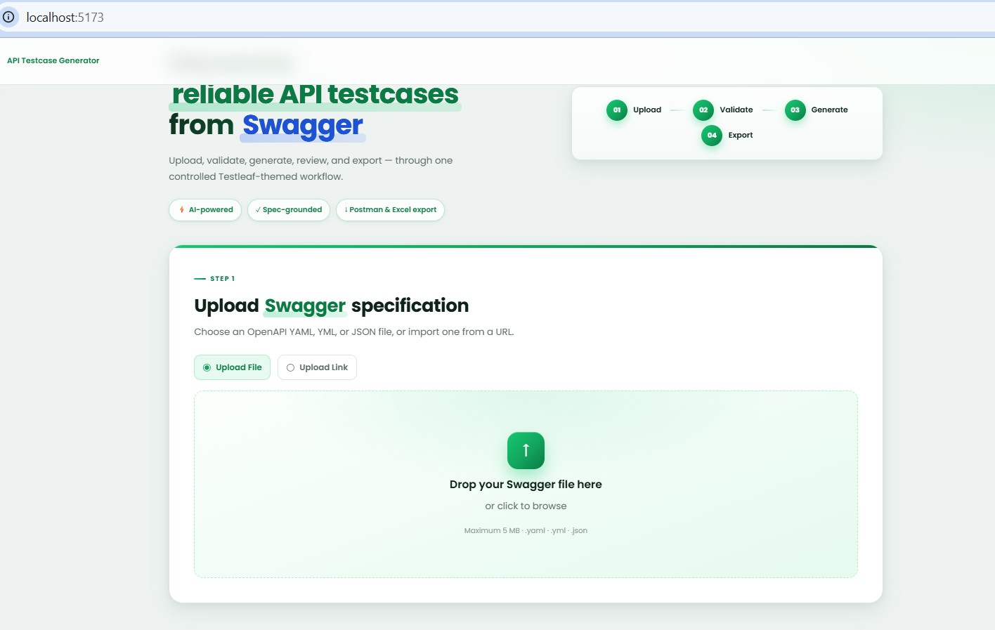
- upload link any(Jason or yaml)
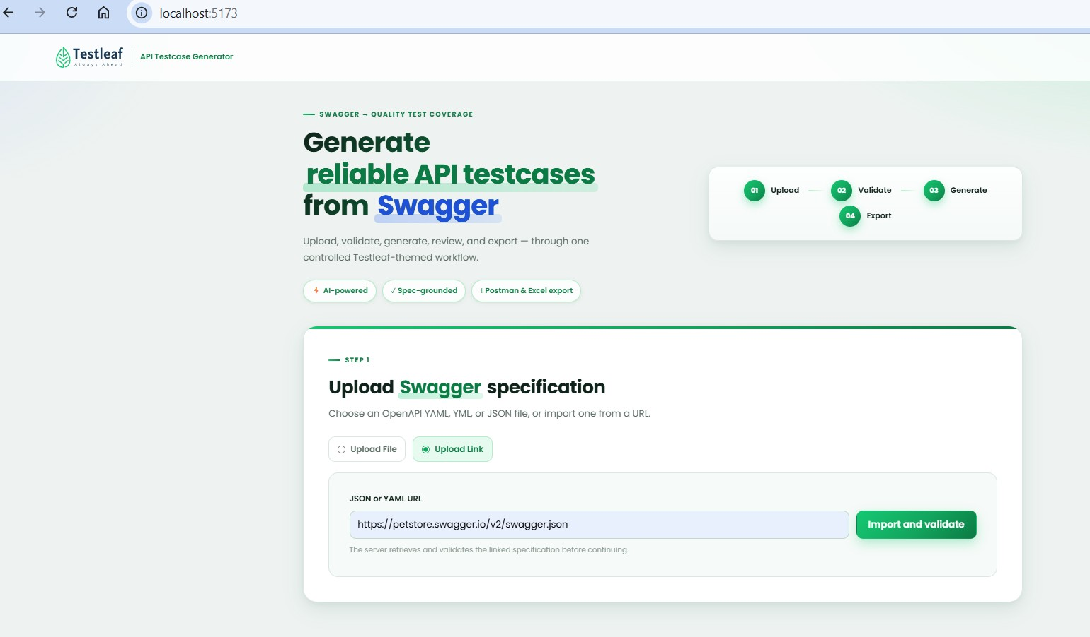
- click on import and validate (applicate will validate the file and import it if it is correct)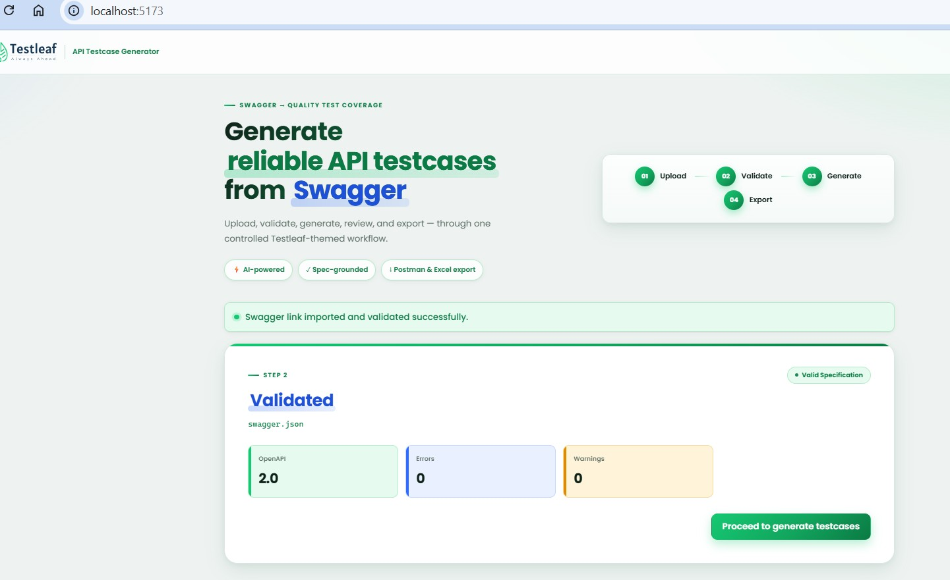
- Now click on “Proceed to generate testcases” and testcases will be generated
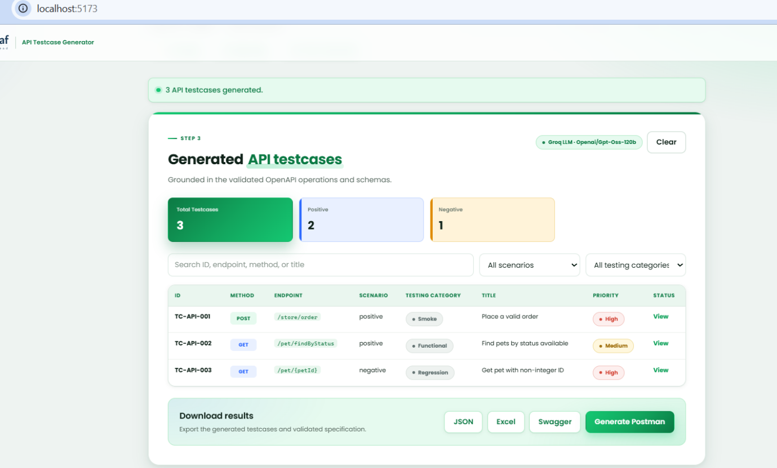
- Here we can see that there is dropdown for “ALL TESTING CATEGORIES”
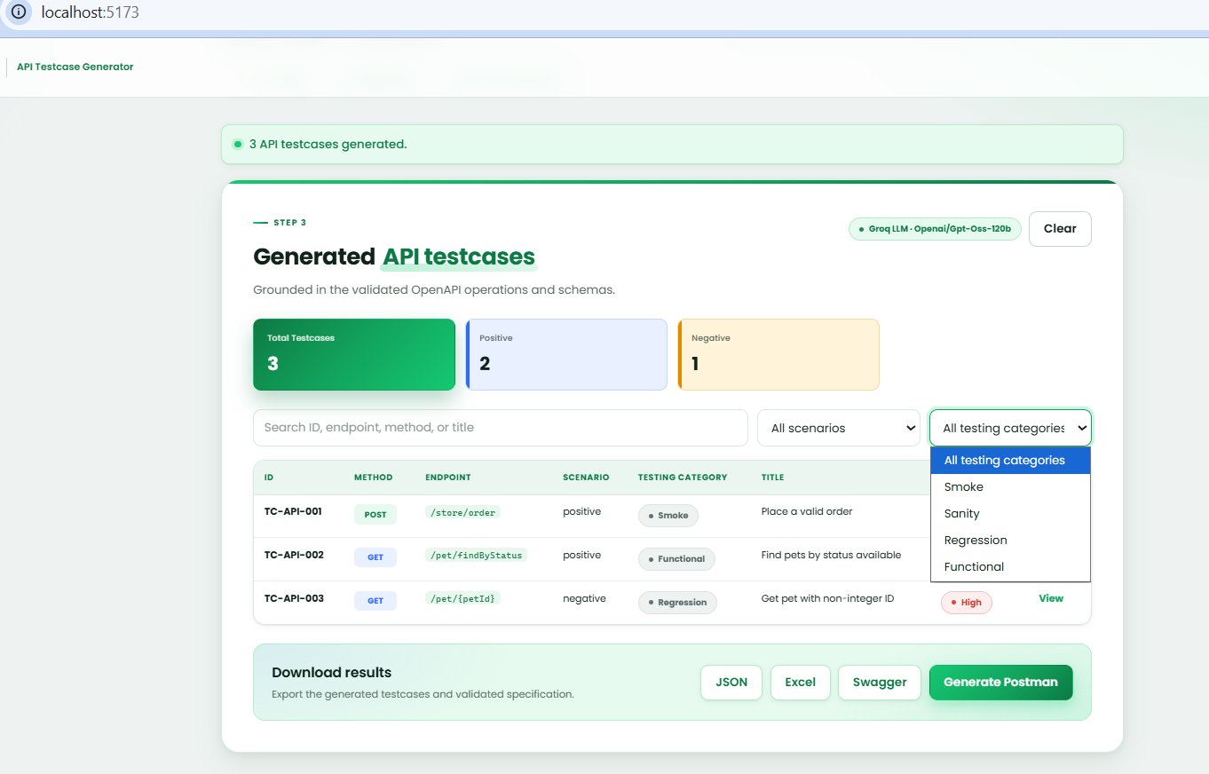
- If user select “Smoke” only testcases related to smoke category will be displayed
