AI Food Waste Predictor: Machine-Learning-Based
Prediction and Prescriptive Reduction of Food Waste
Praneeth Reddy¹, Aishwarya Reddy², Vaishno Devi³ and Sushama Rani Dutta⁴
Department of Computer Science and Engineering,
Koneru Lakshmaiah Education Foundation, Hyderabad
Abstract
Food waste is a common problem in food-service operations, especially when more food is prepared than customers finally need. The amount required is not the same for every situation. It can change with the number of guests, type of event, food quantity, storage conditions, previous purchasing patterns, season, preparation method, location and pricing. This work develops an AI Food Waste Predictor to estimate expected food waste from these conditions and use the prediction to support preparation planning. The main experiment uses the Food Waste Prediction Dataset. Before training, the data is cleaned and checked for missing values, duplicate records and unusual values. Additional features such as food per guest and guest and quantity categories are created, categorical variables are encoded, and numerical variables are standardized. An 80:20 split is used for training and testing. Seven regression models are compared: Linear Regression, Decision Tree, Random Forest, K-Nearest Neighbors, Support Vector Regression, Gradient Boosting and a Stacking Ensemble. Performance is measured with MAE, RMSE and R². Gradient Boosting gives the highest R² of 0.9211, while Random Forest follows with 0.9174. The work also adds feature-importance and SHAP-based analysis where supported, along with a simple decision layer that connects the predicted waste to preparation recommendations and possible waste and cost savings. The results show that machine learning can provide useful support for planning food preparation and reducing avoidable waste in food-service settings.
Keywords: Artificial Intelligence, Food Waste Prediction, Machine Learning, Regression, Random Forest, Gradient Boosting, Explainable AI, SHAP, Sustainability, Food-Service Management
1 Introduction
Food is wasted at different stages between production and consumption, and food-service businesses are an important part of this problem. When prepared food is left over, the loss is larger than the food itself. The water, energy, labour, transport and money used to produce and handle that food have also been spent. For restaurants, catering services and similar businesses, avoiding unnecessary preparation can therefore help from both an environmental and a financial point of view.
One practical difficulty is deciding how much food should be prepared before an event or service begins. Guest numbers may change, different events can have different levels of demand, and factors such as season, menu, storage conditions and previous purchasing behaviour can affect the final amount of waste. A fixed rule such as preparing the same quantity per guest may work in one situation but not in another. Machine learning offers a way to learn these patterns from earlier observations instead of depending only on a single fixed rule.
Recent work has explored machine learning for demand forecasting, AI-based waste monitoring, postharvest-loss prediction and technology selection in hospitality. These studies show that operational data can be useful for planning and monitoring food waste. However, many approaches focus on only one part of the problem, such as forecasting demand, measuring waste after it occurs, or selecting an AI technology. The present work focuses directly on food-waste quantity. It compares several regression models, adds an explainability step, and connects the prediction to a simple preparation decision. The overall aim is practical: estimate likely waste early enough that a food-service manager can make a better preparation choice.
2 Literature Survey
Recent research shows that the focus of food-waste studies is gradually moving from simply measuring waste towards predicting it and trying to prevent it. Hübner et al. studied machine-learning demand forecasting in a bakery and also considered its environmental effects. Rodrigues et al. compared machine-learning methods for short-term catering demand forecasting with the aim of reducing wasted meals. Other studies have looked at AI-based hospitality waste management, smart monitoring systems and predictive approaches.
Guo et al. used data-driven and knowledge-informed neural networks to estimate postharvest food losses, while Cejas examined AI technologies for restaurant management using the MS-TORO approach. Sigala et al. investigated AI-based waste-tracking devices in HORECA environments. More recent work has also considered stacking ensembles for food-demand forecasting and the combination of Temporal Fusion Transformers with reinforcement learning for restaurant forecasting and preparation decisions. Research using historical sales and weather information has further shown the value of contextual variables in restaurant demand prediction. Explainable machine-learning methods have also been used to study factors related to food-waste behaviour.
Taken together, these studies suggest that food-waste prediction becomes more useful when the surrounding preparation context is considered. They also point towards combining prediction with an operational decision. This project follows that direction by comparing several regression models for direct food-waste prediction and then adding explainability and a simple preparation recommendation.
2.1 Literature Survey Table
Main area | Main idea / benefit | Methods or approach
ML demand forecasting + LCA | Bakery returns and environmental impacts | Demand forecasting; LCA
AI-driven hospitality waste management | Smart tracking and predictive systems | Case study; interviews
Postharvest loss estimation | Estimate food losses at different levels | FNN; KiNN
Restaurant technology decision support | Support technology selection | MS-TORO; fuzzy TOPSIS
AI waste tracking | Operational food-waste reduction | Computer vision; deep learning
Short-term demand forecasting | Reduce wasted meals in catering | RF; LSTM; ML comparison
Predictive FLW model | Consumer-segment waste prediction | Decision Tree; Neural Network
Stacking demand forecast | Preventive waste reduction | RF; SVR; XGBoost; LSTM; Ridge

Figure 1. Conceptual illustration of researchers using AI-based analysis to support food-waste reduction (original illustration; not a photograph of the cited authors).
3 Problem Statement
Food-service waste is influenced by several variables at the same time. Guest count, event type, prepared quantity, storage conditions, purchase history, season, preparation method, location and pricing may all change from one situation to another. Because these factors interact, a simple rule based only on the number of guests may not give a consistent estimate.
The problem addressed in this project is to build a lightweight machine-learning approach that can estimate food-waste quantity from historical food-service observations and then use that estimate to support a preparation decision. The approach should also make it possible to examine model performance and understand the factors behind a prediction.
4 Proposed Methodology
The main experiment uses the Food Waste Prediction Dataset. The workflow starts with data inspection and cleaning, followed by feature engineering, model training and evaluation. After comparing the models, the selected model can be used to predict waste for a new event. Feature importance and a simple what-if calculation are then used to make the prediction easier to understand and apply.
The overall workflow is: Pre-processing → Feature Engineering → Model Training → Explainability → Decision Support.
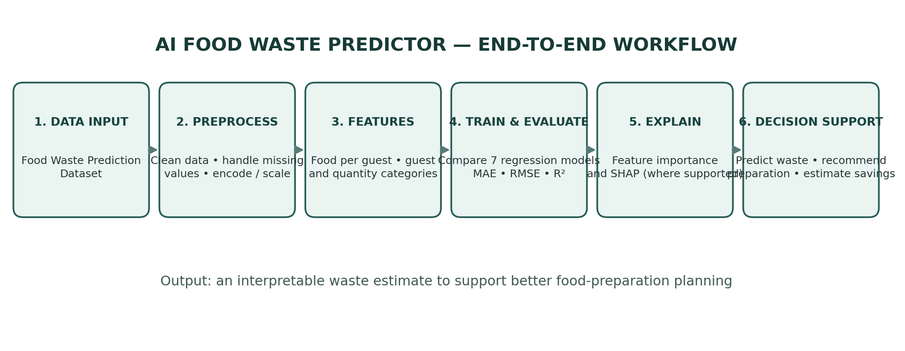
Figure 4. End-to-end workflow of the proposed AI Food Waste Predictor.
Pre-processing includes cleaning the data, handling missing values, checking duplicates and outliers, encoding categories and scaling numerical variables.
Feature engineering creates Food_Per_Guest, Guest_Category and Quantity_Category so that the models can use more useful representations of the original information.
Model training compares Linear Regression, Decision Tree, Random Forest, KNN, SVR, Gradient Boosting and Stacking.
Explainability uses feature importance and SHAP where the selected model supports these methods.
4.1 Dataset Description
Three datasets are considered in the project, with different roles. The Food Waste by Country dataset gives broad geographic and sector-level context. The Restaurant Food Waste Dataset provides a large operational view covering restaurants, dishes, quantities, sales, leftovers, donations and weather. The Food Waste Prediction Dataset is the smaller dataset used for the main supervised-learning experiment.
Dataset | Records / structure | Role
Food Waste by Country | 214 records; 12 columns | Country-level context and benchmarking
Restaurant Food Waste Dataset | ≈960,003 records; 43 columns | High-volume restaurant operational context
Food Waste Prediction Dataset | 1,782 records; 11 attributes | Primary supervised-learning experiment
4.2 Data Preprocessing
• Column names are cleaned and the shape, data types and summary statistics are checked.
• Missing values and duplicate rows are measured and inspected.
• Numerical outliers in guest count, food quantity and waste amount are checked using the IQR rule.
• Food_Per_Guest is calculated as Quantity of Food divided by Number of Guests.
• Guest_Category and Quantity_Category are added as derived features.
• Numerical variables use median imputation and standardization.
• Categorical variables use most-frequent imputation and one-hot encoding.
• The processed data is split into 80% training data and 20% testing data.
Operation | Purpose
Remove invalid/duplicate records | Improve data quality
Median / most-frequent imputation | Preserve usable observations
IQR rule | Limit extreme-value distortion
One-hot categorical encoding | Convert categories to numeric form
Standardize numerical features | Put variables on comparable scales
80:20 split | Evaluate generalization
4.3 Regression Models and Evaluation
Seven regression models are compared: Linear Regression, Decision Tree, Random Forest, K-Nearest Neighbors, Support Vector Regression, Gradient Boosting and a Stacking Ensemble. The Stacking Ensemble uses Random Forest, Decision Tree and Gradient Boosting as base learners and Linear Regression as the final estimator. The purpose is to allow different models to contribute to the final prediction.
Model performance is measured using MAE, RMSE and R². MAE and RMSE show the size of prediction errors, where lower values are preferred. R² indicates how much of the variation in the target is explained by the model, so higher values are generally preferred.
5 Algorithm
1. Load the dataset and inspect its shape, columns, data types and summary statistics.
2. Clean unwanted spaces from column names.
3. Check missing values and visualize missingness.
4. Identify and remove duplicate rows.
5. Detect numerical outliers using the IQR rule.
6. Create Food_Per_Guest and the demand-related categories.
7. Separate numerical and categorical feature groups.
8. Apply median imputation and standardization to numerical variables.
9. Apply most-frequent imputation and one-hot encoding to categorical variables.
10. Split the processed data into 80% training and 20% testing data.
11. Train Linear Regression, Decision Tree, Random Forest, KNN, SVR and Gradient Boosting.
12. Train the Stacking Ensemble using the tree-based models and Linear Regression as the final estimator.
13. Predict the test set for each model and calculate MAE, RMSE and R².
14. Compare the models and identify the model with the highest R².
15. Use feature importance and SHAP for supported tree-based models.
16. Estimate a 95% prediction interval from the residual standard deviation.
17. Calculate a preparation recommendation and a scenario-based estimate of waste and cost savings.
6 Explainability and Prescriptive Decision Layer
A prediction is easier to use when the person receiving it can also understand what influenced it. The project therefore uses feature importance and, where supported, SHAP values. Feature importance gives a general view of which variables matter to the model, while SHAP can show how individual features contribute to a particular prediction.
The decision layer uses the predicted waste to create a simple preparation recommendation. A what-if scenario can also be calculated to show what the waste and cost could look like if a chosen reduction percentage were achieved. These savings are only potential values based on the assumptions in the scenario; they are not treated as experimentally measured savings.
7 Results and Analysis
The executed Python experiment was evaluated on the test set using MAE, RMSE and R². The results show a clear difference between the models. Gradient Boosting produced the highest R², while Random Forest had the lowest MAE among the reported models.
Model | MAE | RMSE | R²
Linear Regression | 4.1437 | 5.3746 | 0.7319
Decision Tree | 1.9198 | 3.9743 | 0.8534
Random Forest | 1.8204 | 2.9827 | 0.9174
KNN | 3.9667 | 5.2184 | 0.7473
SVR | 4.1013 | 5.7685 | 0.6912
Gradient Boosting | 2.1663 | 2.9150 | 0.9211
Gradient Boosting recorded an R² of 0.9211, followed by Random Forest at 0.9174. The result suggests that the tree-based boosting and ensemble approaches were able to capture the relationships in the available food-service data more effectively than the simpler regression and distance-based approaches in this experiment.
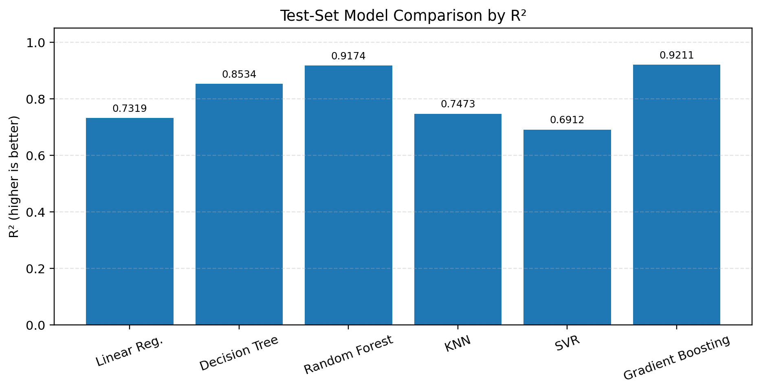
Figure 2. R² comparison for the six models with reported test-set metrics. Gradient Boosting has the highest R² (0.9211), closely followed by Random Forest (0.9174).
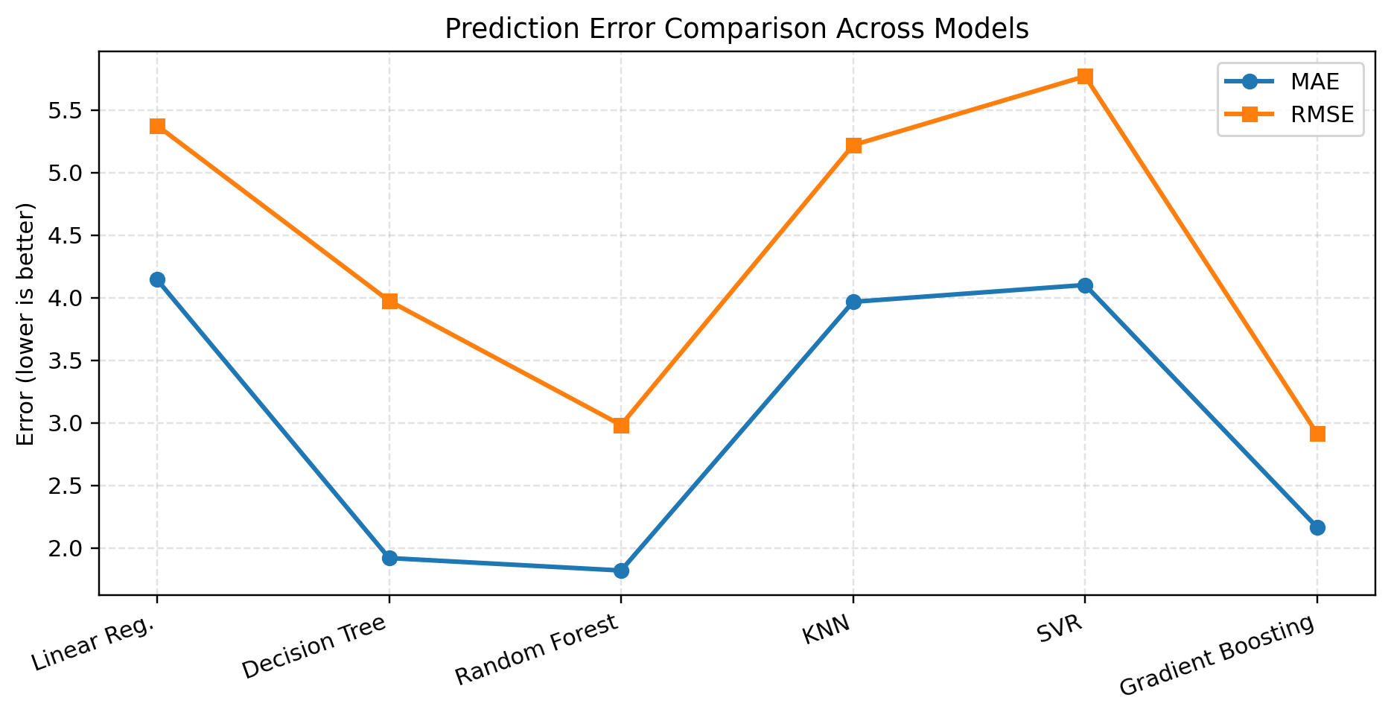
Figure 3. MAE and RMSE comparison across models. Lower values indicate smaller prediction errors; Random Forest has the lowest reported MAE, while Gradient Boosting has the lowest reported RMSE.
7.1 New Event / Decision-Support Output
To illustrate how the decision-support part can be used, the project considers a wedding event with 350 guests. The example uses Meat as the food type, a prepared quantity of 500, refrigerated storage, frequent purchase history, summer season, buffet preparation, an urban location and high pricing. The executed model gives a predicted waste of 18.76 units.
Input / Output | Value
Food type | Meat
Guests | 350
Event | Wedding
Prepared quantity | 500
Storage | Refrigerated
Purchase history | Frequent
Season | Summer
Preparation | Buffet
Location | Urban
Pricing | High
Predicted food waste | 18.76
Potential waste saved | 1.88
Scenario reduction | 30% (assumption, not measured)
Cost per waste unit | ₹120 (assumption)
Potential cost saving | ₹225.08
Under the illustrative scenario, the reported potential waste reduction is 1.88 units and the estimated potential cost saving is ₹225.08. These figures depend on the assumptions used in the scenario and should therefore be viewed as possible savings rather than measured savings from a real intervention.
8 Conclusion
This project treats food-waste prediction as something that can be used before waste occurs, rather than only as a measurement after food has already been discarded. The experiment compares seven regression approaches and uses practical food-service information such as guest count, food quantity, event type, storage and other contextual variables to estimate expected waste.
An important part of the work is what happens after the prediction. Feature importance and SHAP can help explain the model output, while the decision layer connects the predicted waste with a preparation recommendation and a what-if estimate of possible savings. In this way, the system moves from simply asking how much waste might occur to considering what could be changed in the preparation process.
The current results provide a useful starting point for applying machine learning to food-waste management. Future versions could include image-based food recognition, real-time IoT or smart-bin measurements, multiple food-service locations, changing menu conditions, reinforcement learning for dynamic preparation decisions, and real-world studies to test whether the recommendations lead to measurable reductions in waste.
9 Future Work
• Add image-based food recognition to estimate plate waste and classify discarded food.
• Connect real-time IoT or smart-bin measurements to the prediction pipeline.
• Extend the model to multiple food-service locations and changing menu scenarios.
• Study reinforcement learning for dynamic preparation and inventory decisions.
• Test preparation recommendations through real intervention studies.
10 References
1. Hübner, Nicolas, et al. “Machine-Learning-Based Demand Forecasting against Food Waste: Life Cycle Environmental Impacts and Benefits of a Bakery Case Study.” Journal of Industrial Ecology, vol. 28, no. 5, 2024, pp. 1117–1131. doi:10.1111/jiec.13528.
2. Clark, Quintana M., et al. “Exploring the Potential of AI-Driven Food Waste Management Strategies Used in the Hospitality Industry for Application in Household Settings.” Frontiers in Artificial Intelligence, vol. 7, 2025, article 1429477. doi:10.3389/frai.2024.1429477.
3. Guo, Xuezhen, et al. “Predicting Postharvest Food Losses at National and Sub-National Levels Using Data-Driven and Knowledge-Based Neural Networks.” Sustainability, vol. 17, no. 10, 2025, article 4552. doi:10.3390/su17104552.
4. Cejas, Roxanne. “Food Waste Reduction AI Technologies in Restaurant Management: An MS-TORO Approach.” Processes, vol. 13, no. 8, 2025, article 2419. doi:10.3390/pr20252419.
5. Sigala, Evangelia G., et al. “Reducing Food Waste in the HORECA Sector Using AI-Based Waste-Tracking Devices.” Waste Management, vol. 198, 2025, pp. 77–86. doi:10.1016/j.wasman.2025.02.044.
6. Li, et al. “Predicting Food Leftovers in Shared Dining: A Machine Learning Approach.” International Journal of Contemporary Hospitality Management, vol. 37, no. 10, 2025, pp. 3304–3326. doi:10.1108/IJCHM-02-2025-0283.
7. “A Stacking Ensemble Model for Food Demand Forecasting: A Preventative Approach to Food Waste Reduction.” Cleaner Logistics and Supply Chain, vol. 15, 2025, article 100225. doi:10.1016/j.clscn.2025.100225.
8. “Multi-Horizon Food Waste Forecasting and Reduction in Multi-Cuisine Restaurants Using Temporal Fusion Transformers and Reinforcement Learning.” 2025 2nd International Conference on Recent Trends in Electrical, Electronics and Computing Technologies (ICRTEECT), 2025. doi:10.1109/ICRTEECT67512.2025.11448632.
9. “Development of an AI-Based Restaurant Menu Demand Prediction Model Utilizing Sales and Meteorological Data.” 2025.
10. Ghuriani, Veena, et al. “An Extension of the Theory of Planned Behavior with Machine Learning to Predict Household Food Waste in India.” Journal of Food Technology Research, vol. 12, no. 4, 2025. doi:10.18488/jftr.v12i4.4625.

