Specification Details

**Cognizant Technology Pvt Ltd**

**07/9/2012**

Sawant, Aishwarya (Cognizant)

The document will serve as a source of truth for understanding the complex implementation for True Comp Actuate Implementation. This can be reused in projects across Cognizant. The document will also serve to provide design suggestions, innovations and ideas to clients across organization, which would lead to overall cost savings and value add to organization.

Index

Publication Record 2

Purpose 2

Objective 2

Scope 2

Prerequisite 2

Indented Audience 2

Product Information 3

Acronyms and Definitions 3

Assumptions and Dependencies 3

Solution Approach 3

Current Architecture/ Problem Statement 3

Approach used 4

Design Details 4

General information 6

Entities and Components 6

Draft layout copy 7

Layout of Compensation Summary report 7

Layout of Compensation Detail report 8

# Publication Record

|  |  |  |  |
| --- | --- | --- | --- |
| **Version** | **Date Revised** | **Primary Author** | **Summary of Changes** |
| **Actuate_COE_Specification_Detail** | | | |
| 1.0 | 07/09/2012 | Aishwarya Savant | Creation of the Specification Details for Actuate COE. |

# Purpose

The design document provides Solution approach and aspects which have formed the base for below problem solution. This design should be supported by a case study.

# Objective

The document will serve as a source of truth for understanding the complex implementation. These complex implementations can be reused in projects across Cognizant. The document will also serve to provide design suggestions, innovations and ideas to clients across organization, which would lead to overall cost savings and value add to organization.

# Scope

The document will contains the current and the future state of the system, i.e.; pre and post implementation of the value add to the system. This document is supported by the diagrammatical flows of overall initiative and snapshots of the reports.

# Prerequisite

1. Knowledge on Enterprise Report design tool.
2. Understanding on Callidus, True Comp Actuate Implementation and there data models.
3. Understanding on Oracle PL/SQL

# Indented Audience

The document is applicable to:

1. Actuate Center Of Excellence group
2. Audience with fair knowledge of True Comp and Actuate
3. Projects with Actuate True Comp implementation
4. Business Users/ Business Analyst

# Product Information

|  |  |
| --- | --- |
| **Callidus Tools** | True Comp |
| True Information |
| **Reporting tool** | Actuate version 9.x |
| **Oracle Database** | Oracle 10 |
| **Suite version** | True Comp Callidus 5.x |

# Acronyms and Definitions

|  |  |
| --- | --- |
| **Acronyms** | **Definition** |
| DM | Data Mart |
| TC | True Comp |
| TI | True Information |
| ETL | Extract Load and Transform |
| ACL | Access Control List |

# Assumptions and Dependencies

The document is specific to design solutions implemented using Actuate Enterprise e-Report designer and Callidus Suite of Products.

Reasonable knowledge about the following area is required:

* Actuate Enterprise e-Report Designer
* Informatica Power Mart and ETL process
* Common Windows related tasks
* Relational Database management
* Use of SQL

# Solution Approach

## Current Architecture/ Problem Statement

Currently there are two reports in the system.

* + Compensation Payout Summary
  + Compensation Payout Detail.

These reports act as a Compensation statement for providing details about Payout Summary and Payout Details, for the individuals. The Summary report provides the summarized information for individual payouts while detail reports have the detail break out of their achieved compensation. These reports have the default functionality for its security settings. Currently every individual is able to see his own report. The implementation lacked the functionality of true appraisal which should be done by the Manager before the statements are released to larger group. The motive of catering these values add was a way to provide the business and manager with functionality to evaluate their sub-ordinate data/payout before they release their reports.

To achieve this approach it was decided to release the reports to Managers 15-20 days before the actual reports are available to the field. According to required functionality the Manager should be able to view there sub-ordinates reports and not their own, without releasing the statements to field. In this way Managers can view their peer’s reports and discuss with them about their performance over the year. In case if the manager find any discrepancy in the report data the payouts can be put on hold way before releasing the statements, which would ensure wrong payout amounts are not credited to sub-ordinate employees and Incentive statements to be reviewed and signed off before they are published.

The organization has different level of positions for their employees, as other organizations do. For e.g. Senior Sales executive, Sales executive, etc. This is an initiative was to generate reports where Managers can view there sub-ordinate reports/Incentive statements and not their own.

These critical reports should be able to help Management and customer to:

* + Review details of their sub-ordinates before these details are published to individuals.
  + Managers to have a one-on-one discussion with their subordinates to review the performance and payouts throughout the year.

## Approach used

Here is the brief description of approach used:

* Every report page has their own security settings. When anyone views report page, the access to view the page totally depends on whether the user has permissions to access the page.
* One can access the page if UserACL contains your user id as a comma separated string.
* To make sure Manager can view their sub-ordinates report pages and not their own, an approach to get a dynamically created security string for every individual was taken.
* When a reports executes for a participant a security string would be created, this security string will contain, which individual report pages he can access.
* Turn off the default security provided by Actuate.
* Alter the security of every report page. Assign dynamic security string to every report page.
* New reports are created to incorporate this functionality.

## Design Details

To implement the security

* Create a new report which is copy of old one.
* Add a Data Stream and a Textual Query Source.
* In the properties tab of textual query source add the below query

select substr(SYS_CONNECT_BY_PATH(positionseq, ','),2) name_list

from (

select 123 USERID, POSITIONSEQ , count(*) OVER ( partition by USERID ) cnt,

ROW_NUMBER () OVER ( partition by userid order by positionseq) seq from (

SELECT 123 USERID, POSITIONSEQ FROM padimension B WHERE B.PAKEY IN

( select a.ancestorpakey from pareporting a where a.descendantpakey = :prmPAKey

and relativedistance<>0

)

) )

where seq=cnt

start with

seq=1

connect by prior

seq+1=seq

and prior

userid = userid

* Override the Sub OnRead( ) method of DataRow
* Add the below code in OnRead()

prmpositionseqstring = name_list

prmpositionseqstring is a string variable which is used to collect the output from above query.

* Drag and drop the sequential section/any other section where we want the security to be implemented (call it as "ReportPages") in the content slot after the data stream.

This section can contain data to be displayed for the report. It should carry details/data for which we are implementing the security functionality.

* Override the method Sub SetSecurity( row As AcDataRow )of the sequential section "ReportPages"

Sub SetSecurity( row As AcDataRow )

Super::SetSecurity( row )

'Insert your code here

ACL = prmpositionseqstring

End Sub

* Create a parameter prmpositionseqstring of data type String.
* Edit the below properties of all the previous Sequential Sections in Hierarchy

Set Security 🡪 Cascade Security 🡪 False

This will ensure that no default security is applied to the report.

## General information

* The report is deployed in Actuate Server hosted on Callidus environment.
* Language option for reports on the True Information Portal is be default set as “US English”, en_US.
* Supporting libraries for report are as follows:
  + CallidusPortal_Base.rol
  + CallidusPortal_Global.bas
  + ReportLibrary.rol
  + ReportLibrary_Global.bas

## Entities and Components

* PL/SQL code and packages
* True Information Portal – Dashboard
* True Information Portal – User Reports/Statements
* Actuate reports
  + Following are names of newly created reports as a part of implementation
    - Manager Compensation Summary
    - Manager Compensation Detail
    - Compensation Summary
    - Compensation Detail

## Draft layout copy

### Layout of Compensation Summary report

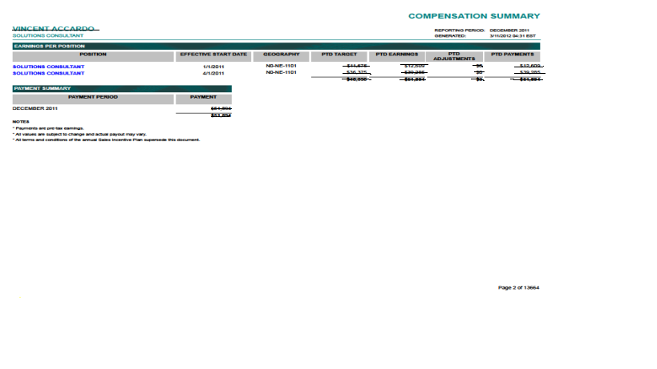

### Layout of Compensation Detail report

