**Module Name**

KCNQ1Analysis.py

**Credits**

Aishwarya Shankar - wrote and documented KCNQ1Analysis.py

Jennifer Benbow - researched and acquired sequence data to pass as input file to the program

**Motivation**

This module was created and is used as part of a team project for the CS 123A Bioinformatics course taught by Professor Leonard Wesley at San Jose State University. With the research focus of the project being on finding an ideal animal model for the KCNQ1 amino acid sequence to study Long QT Syndrome, KCNQ1Analysis.py enabled conducting MSA and phylogenetic tree-building on acquired KCNQ1 sequence data to be able to identify a potential animal model which would be helpful in clinical research of the disease.

**Language Used**

Python

**Demo Images**

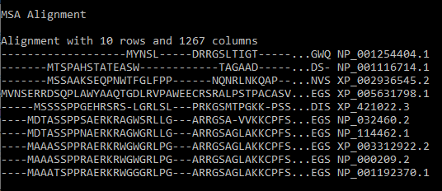

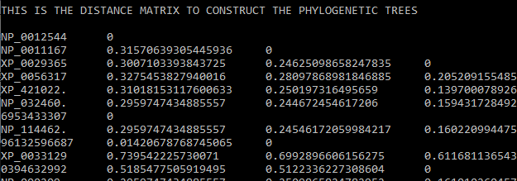

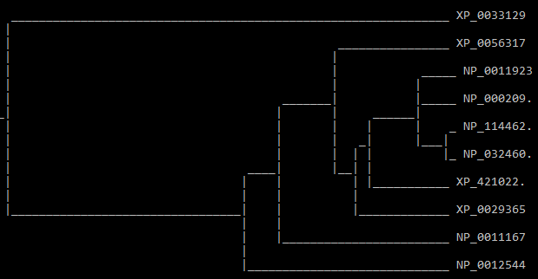

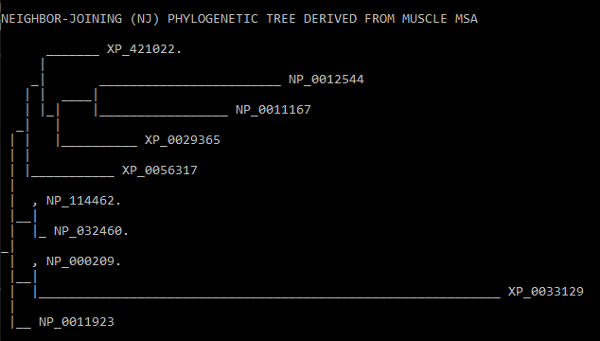

**Features and Functionality**

KCNQ1Analysis.py takes in an input text file called sequencesfile.txt containing sequence data in fasta format. It then runs multiple sequence alignment (MSA) on the sequences using the MUSCLE executable and writes the results to .fasta and .phylip files. Utilizing the correct packages and modules from BioPython, the program then constructs and displays the distance matrix derived from the MSA and then shows the UPGMA and Neighbor-Joining (NJ) phylogenetic trees based off of the distance matrix.

**Code Examples**

Invoking the MUSCLE tool



Creating distance matrix based off of the resulting alignment



Neighbor-Joining (NJ) Tree Construction



**Installation**

In order to successfully execute KCNQ1Analysis.py, Python must be installed on your machine. You must also install BioPython using pip, which is a set of libraries for biological computation. Various modules from BioPython are used in KCNQ1Analysis.py, such as AlignIO, SeqIO, and Phylo. The MUSCLE executable file must also be downloaded from <https://www.drive5.com/muscle/downloads.htm>. The correct version of the executable must be downloaded based on the operating system (OS) present in your machine.

**How to Use**

Place the MUSCLE executable file, KCNQ1Analysis.py, and a text file of your choice containing sequences in fasta format in the same directory. The text file should be named as sequences.txt. Navigate to the directory you placed the file in from your command prompt. Execute the program by typing “python KCNQ1Analysis.py”. Results from the execution will be displayed on the command prompt. Complete alignment fasta and phylip files will also appear in the working directory and can be viewed.