IBMS
Project Report
Microservices Architecture and Cloud Computing Design
Integrated Banking Management System
Four Spring Boot services • Docker Compose • MySQL • Nginx API gateway

Abstract
IBMS is an academic Integrated Banking Management System implemented as four Spring Boot services: Auth, Transaction, Notification, and Loan. Each service owns a separate logical MySQL database. An Nginx gateway routes client traffic, and Docker Compose starts the services with a local MySQL container. Transaction calls Auth to verify account ownership; Loan calls Notification after application submission. The local stack and its gateway API flows were verified. An AWS architecture using EC2, private RDS MySQL, security groups, and Terraform is documented but has not been provisioned or applied.

1. Introduction and objectives
The project demonstrates how an application can be divided into independently deployable service boundaries and run consistently in containers. The implementation provides credential registration and verification, account and transaction workflows, basic notifications, and loan applications. The cloud component presents an infrastructure-as-code deployment plan without incurring cloud charges during development.
- Keep business capabilities and persistence separated by service.
- Provide REST APIs through one Nginx entry point in both local and proposed AWS deployments.
- Demonstrate internal service calls using OpenFeign.
- Externalize database credentials, RDS endpoint, and internal service URLs through environment variables.
- Include reproducible SQL setup, an API demonstration script, requirements, this report, and a combined presentation.

2. Architecture and service responsibilities
Local request path: API client → Nginx at localhost:8080 → the matching service container. The local MySQL container stores four logical databases. In the AWS design, EC2 hosts Docker Compose and Nginx on port 80, while a private RDS MySQL instance hosts the same four logical databases.
Service | Port | Database | Implemented API/business behavior
Auth | 8081 | auth_db | Register users; BCrypt password hashing; credential verification; safe profile lookup.
Transaction | 8082 | transaction_db | Account creation after Auth lookup; deposits, withdrawals, transfers; account and transaction lookup.
Notification | 8083 | notification_db | Create notifications and list them by user ID.
Loan | 8084 | loan_db | Submit and retrieve loan applications; mark new applications PENDING and call Notification.

The synchronous service calls use HTTP/OpenFeign. Transaction requests Auth at GET /auth/users/{id} before account creation. Loan posts a notification to Notification. Each service accesses only its own database; user IDs are scalar references between service data stores.

3. Implementation details

3.1 Authentication
Registration validates required fields, email format, and length constraints; normalizes email; rejects duplicates; and stores a BCrypt hash. Login verifies credentials and returns a profile without the password. User lookup returns HTTP 404 for an unknown ID. Login does not issue a token, and the APIs do not enforce authorization; these are documented limitations.

3.2 Account and transaction behavior
Accounts begin at zero and have unique generated account numbers. Monetary values use BigDecimal in the service and DECIMAL(19,2) in MySQL. Deposit, withdrawal, and transfer operations lock relevant account rows and write ledger entries within database transactions. Insufficient funds, invalid amounts, same-account transfers, and missing accounts are rejected without committing partial balance changes.

3.3 Loan and notification behavior
The Loan API accepts and persists a loan application with PENDING status, then calls the Notification API to create a LOAN notification. Notification exposes create and per-user list routes. These are basic academic workflows rather than a full loan approval or messaging platform.

4. Data model and SQL
Database | Table | Key fields and constraints
auth_db | users | id, name, unique email, BCrypt password hash, optional phone.
transaction_db | accounts | id, user_id, unique account_number, DECIMAL(19,2) balance.
transaction_db | transactions | id, account_id, optional destination_account_id, type, DECIMAL(19,2) amount, status.
notification_db | notifications | id, user_id, message, type.
loan_db | loan_applications | id, user_id, amount, status.

The submission SQL folder contains create_database.sql, create_tables.sql, and insert_data.sql. They were executed in order against a throwaway MySQL 8.4 container. Verification found one sample user, account, transaction, notification, and loan record across the four databases. The demo password is represented in the SQL as a BCrypt hash.

5. Local deployment and verification
From A004_Project/Project/src, start the complete stack with docker compose up --build -d. The database is initialized by the Compose MySQL init directory, services wait on database availability, and Nginx publishes port 8080. Run ./scripts/demo.sh to check /health and make one real request per service through the gateway. The script registers a unique user, creates an account, creates a notification, submits a loan application, and prints PASS/FAIL results. Demo records remain in the local volume.
The packaged deployment was rebuilt and verified from its new location. Gateway health returned HTTP 200; Auth registration returned HTTP 201; Transaction account creation, Notification creation, and Loan submission returned HTTP 200. The SQL scripts passed separately on a throwaway MySQL instance. The verification is local only and does not establish AWS runtime behavior.

6. Swagger API documentation screenshots
The following supplied screenshots show each service’s Swagger/OpenAPI UI and route documentation. They are interface/documentation evidence, not screenshots of a completed transaction or proof of a deployed AWS system.

Auth service and service API
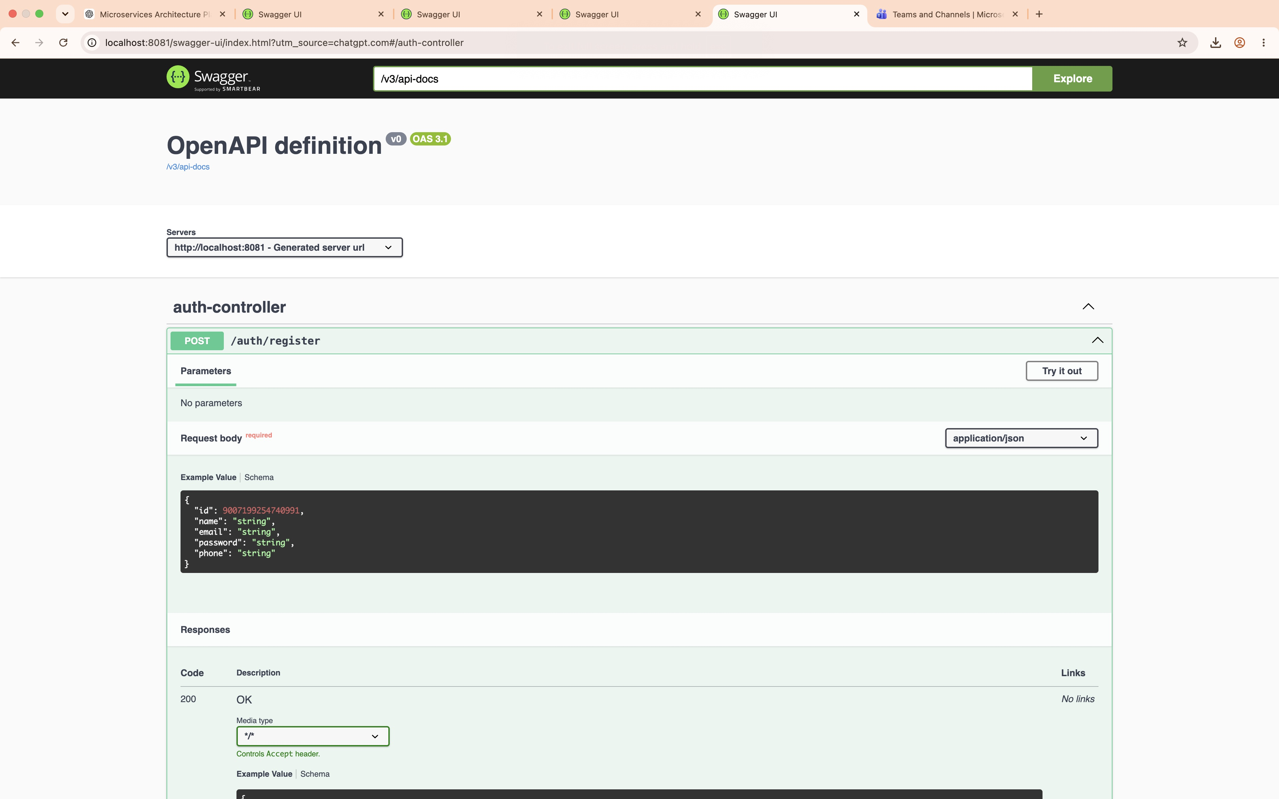
Figure 1. Auth API documentation, including the registration endpoint.
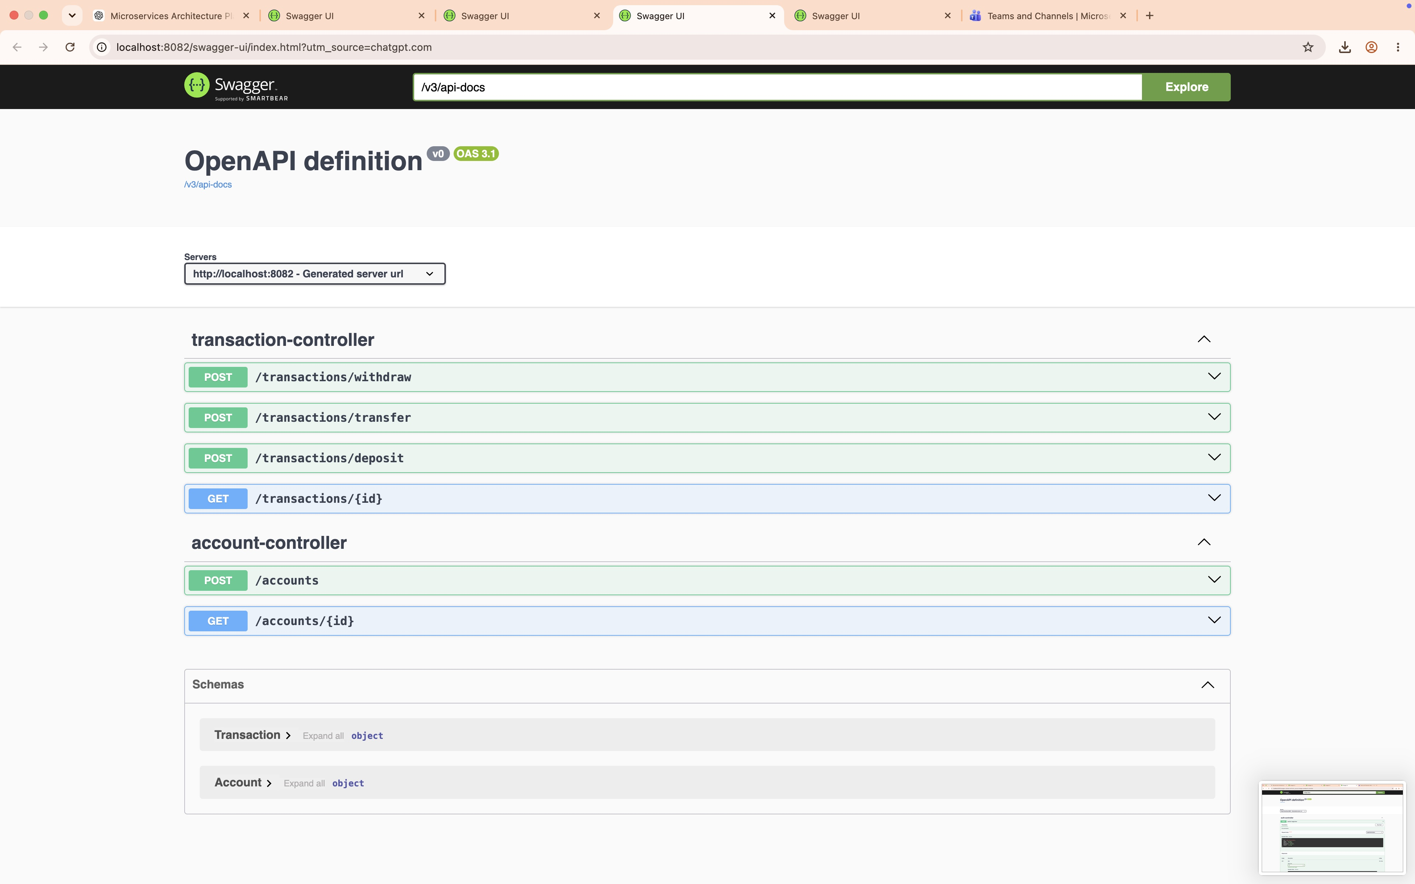
Figure 2. Transaction and account API documentation.

Notification service and service API
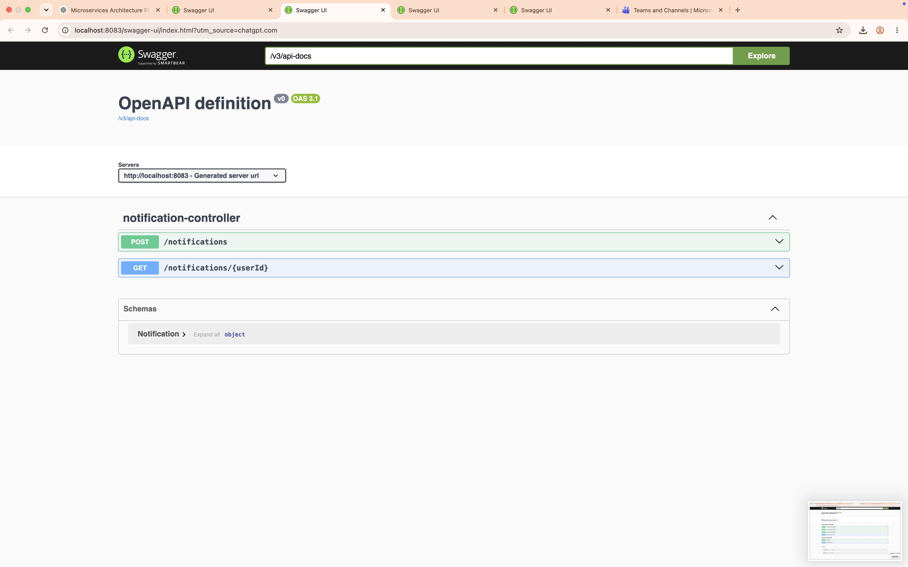
Figure 3. Notification API documentation.
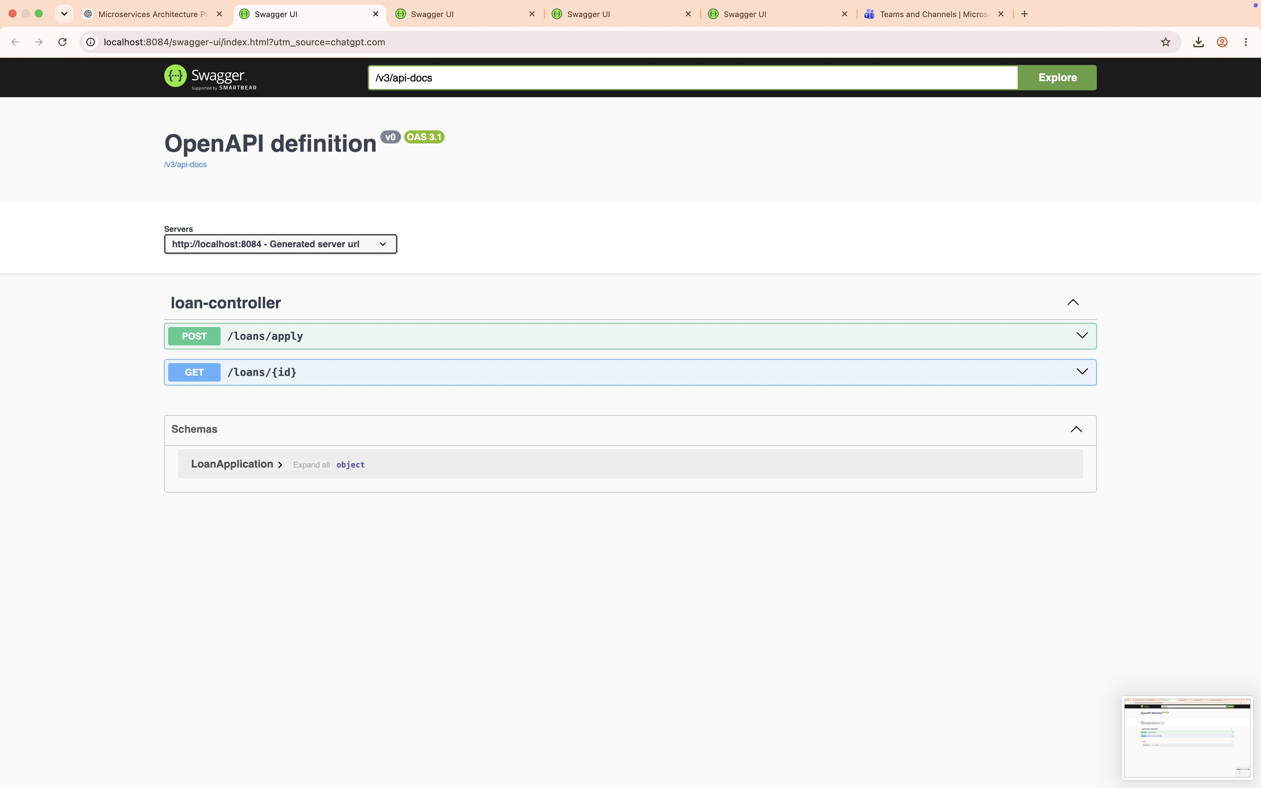
Figure 4. Loan application API documentation.

7. AWS cloud design (not deployed)
The proposed cloud topology places Docker Compose and Nginx on an EC2 instance, exposing HTTP on port 80. A private AWS RDS for MySQL instance stores auth_db, transaction_db, notification_db, and loan_db. Terraform declares EC2, RDS, an RDS DB subnet group, and EC2/RDS security groups. The EC2 security group permits HTTP and restricts SSH to a configured CIDR; the RDS security group permits port 3306 only from the EC2 security group. RDS is configured non-public.
The AWS Compose file reads MYSQL_RDS_HOST, DB_USERNAME, DB_PASSWORD, and service URL environment variables. A one-shot db-init service runs the shared SQL database-creation script against RDS before application services start. The documented workflow is provision (Terraform init/validate/plan and owner-approved apply), configure endpoint and credentials on EC2, clone/copy source and run the AWS Compose deployment script, then verify the gateway, APIs, container status, and logs.
Status boundary: Terraform init -backend=false and validate were run successfully. No Terraform plan, apply, AWS credentials, or AWS resource provisioning were used. AWS costs may include EC2, RDS, storage, and data transfer. The deployment remains an architecture/design and should not be described as a live cloud deployment.

8. Limitations, security, and future work
- Academic demonstration only; not production banking software.
- Login does not issue JWT/session credentials and API endpoints do not enforce authorization.
- No idempotency keys, formal audit trail, approval controls, payment rails, or comprehensive resilience strategy.
- The local stack is a single-node Compose environment; it does not demonstrate high availability or autoscaling.
- AWS deployment requires cost review, secure secret management, TLS, backup/restore planning, monitoring, and explicit account-owner approval.

9. Conclusion
The submission provides four service boundaries, isolated logical databases, gateway routing, internal service calls, SQL setup, and a repeatable local Compose demonstration. Local deployment and SQL initialization have been verified. The AWS design is documented and validated syntactically but remains unprovisioned, making the deliverable’s implementation status explicit and cost-conscious.

