**Contract Management System V1 - REST API Specification**

**System Description:**

The Contract Management system is a simple application which maintains contract details of customers, namely

* **Customer ID** -> ID of the customer
* **Customer Name** -> Name of the customer
* **Contract Start Date** -> Start date of the contract (yyyy-MM-dd)
* **Contract End Date** -> End date of the contract (yyyy-MM-dd)
* **Contract Conditions**-> Terms and conditions of the contract
* **Contract Price**-> Cost of the contract
* **Contract Last Modified Date** -> Date of Last contract entry
* **Contract Author** -> Name of person who saved the contract details to system

The application was developed using MEAN stack, where the front end is an angular app and the backend consists of business logic as REST APIs and data layer hosted on NodeJS server using ExpressJS and Mongo DB serving as backend (Via Mongoose ODM).

**Pre-requisites:**

The Application’s backend hosted on <http://localhost:3000/> NodeJS server should be up and running, along with database connection to Mongo DB established successfully on <http://localhost:27017/>

**Required Testing Tools:**

The REST APIs can be tested via Postman Desktop App. Click [here](https://www.getpostman.com/) for installation

**REST Request Headers:**

|  |  |
| --- | --- |
| **Key** | **Value** |
| Accept | application/json |
| Content-Type | application/json |

**Response Status Codes:**

Following are the response status codes produced by the RESPT APIs of Contract Management System

|  |  |
| --- | --- |
| **Response Code** | **Description** |
| 200 | Successful Retrieval |
| 500 | Operation Failure |
| 204 | No Data Found |
| 400 | Bad Request  (i.e) Invalid Customer ID |
| 201 | Successful Addition  Successful Update |
| 202 | Successful Deletion |

**REST Operations:**

The application exposes following CRUD REST APIs/Operations in managing customer contracts, as follows

1. **Retrieve all customers with their latest contract**

**Http Method:** GET

**Resource URL:** <http://localhost:3000/customers/>

**Sample Request:**

No Request body is required, only resource URI is used

**Sample Response:**

[

{

"contract": [

{

"version": 1,

"_id": "5bbf60fd53537304a44c86f4",

"customerID": "100100",

"startDate": "2018-01-17T00:00:00.000Z",

"endDate": "2022-01-17T00:00:00.000Z",

"conditions": "new payment due in 2 months",

"price": 123456,

"author": "ash v",

"lastModifiedDate": "2018-10-11T14:41:01.462Z",

"__v": 0

}

],

"_id": "5bbf60fd53537304a44c86f5",

"customerID": "100100",

"customerName": "mike ross",

"__v": 0

},

{

"contract": [

{

"version": 1,

"_id": "5bbf618353537304a44c86f7",

"customerID": "100101",

"startDate": "2018-09-17T00:00:00.000Z",

"endDate": "2025-01-17T00:00:00.000Z",

"conditions": "payments to be made on time",

"price": 2323232,

"author": "ash v",

"lastModifiedDate": "2018-10-11T14:43:15.800Z",

"__v": 0

}

],

"_id": "5bbf618353537304a44c86f8",

"customerID": "100101",

"customerName": "harvey spectre",

"__v": 0

}

]

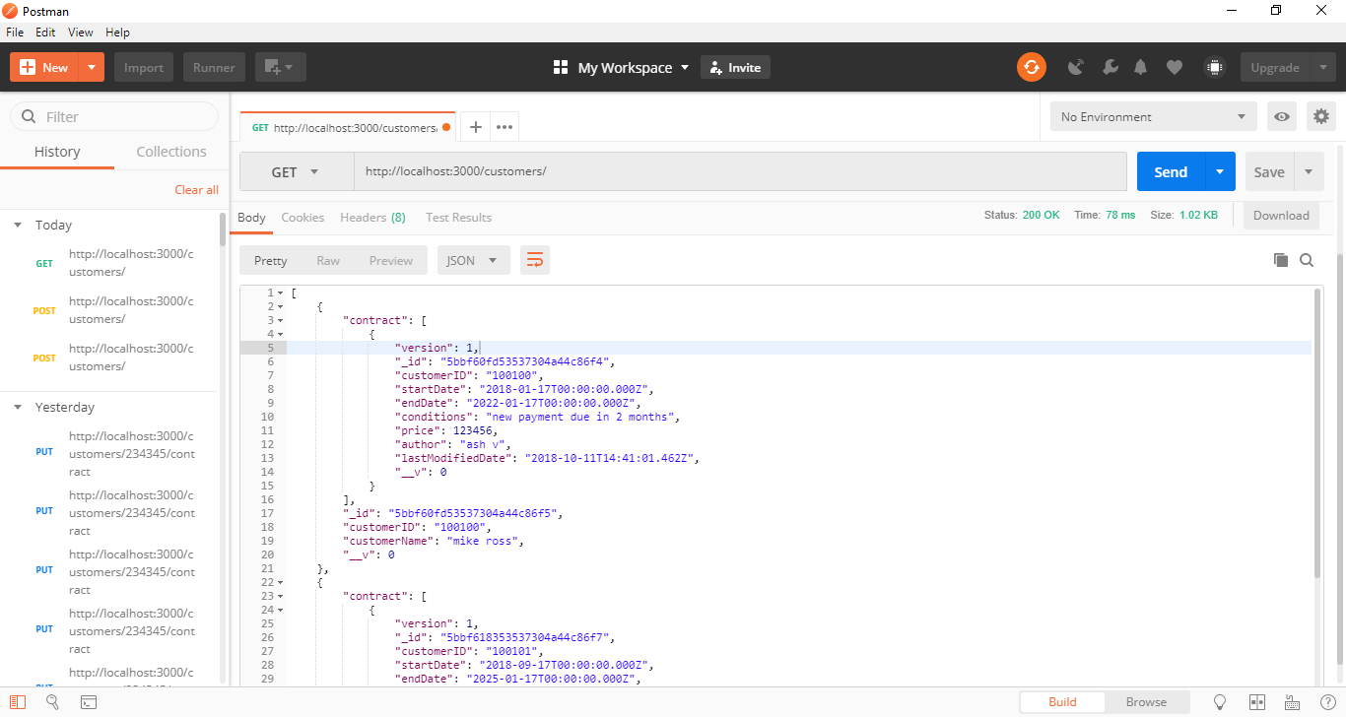

1. **Retrieve specific customer**

**Http Method:** GET

**Resource URL:** <http://localhost:3000/customers/:cid/>

Where, cid – is the Customer ID for the which the details are requested

**Sample URL:** <http://localhost:3000/customers/100100/>

**Sample Request:**

No Request body required, only resourse URI with intended Customer ID is used

**Sample Response:**

**{**

**"contract": [**

**{**

**"version": 1,**

**"_id": "5bbf60fd53537304a44c86f4",**

**"customerID": "100100",**

**"startDate": "2018-01-17T00:00:00.000Z",**

**"endDate": "2022-01-17T00:00:00.000Z",**

**"conditions": "new payment due in 2 months",**

**"price": 123456,**

**"author": "ash v",**

**"lastModifiedDate": "2018-10-11T14:41:01.462Z",**

**"__v": 0**

**}**

**],**

**"_id": "5bbf60fd53537304a44c86f5",**

**"customerID": "100100",**

**"customerName": "mike ross",**

**"__v": 0**

**}**

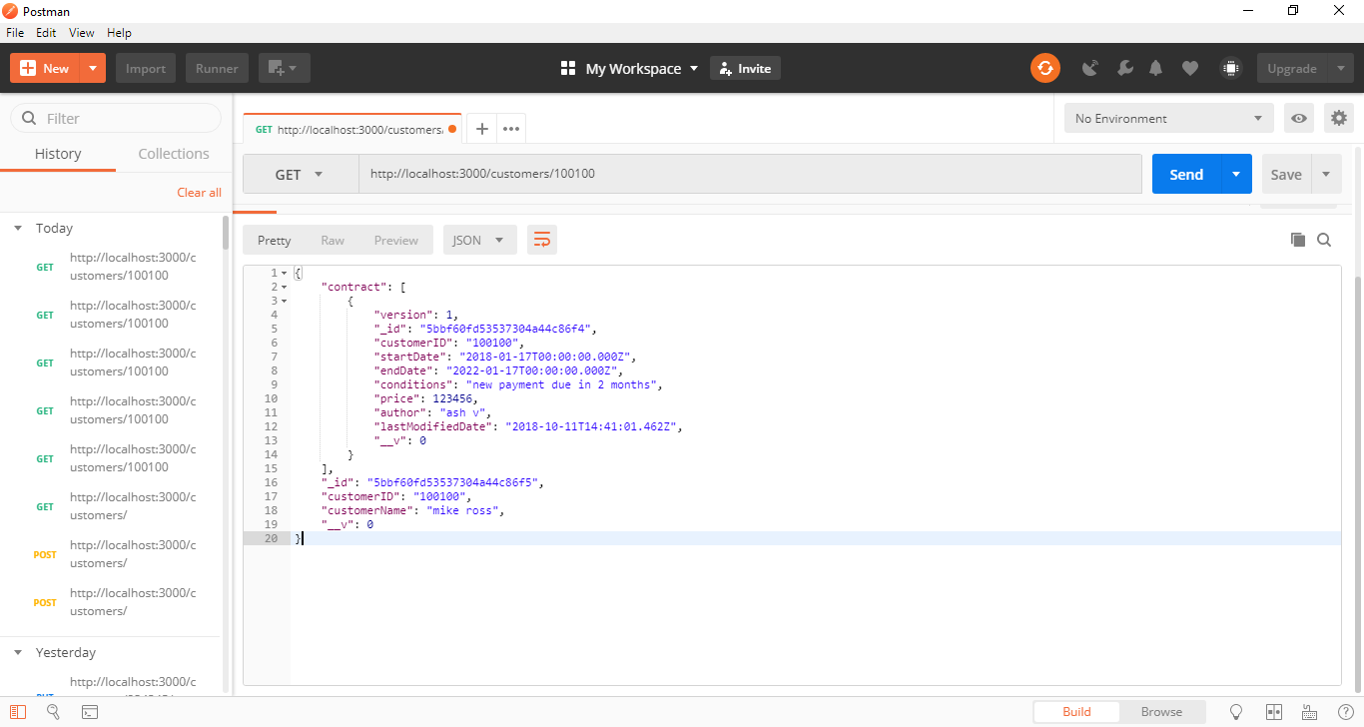

1. **Retrieve all customer with all versions of contracts**

**Http Method:** GET

**Resource URL:** <http://localhost:3000/customers/contracts>/

**Sample Request:**

No request body is required, only resource URI is used

**Sample Response:**

**[**

**{**

**"contract": [**

**{**

**"version": 1,**

**"_id": "5bbf60fd53537304a44c86f4",**

**"customerID": "100100",**

**"startDate": "2018-01-17T00:00:00.000Z",**

**"endDate": "2022-01-17T00:00:00.000Z",**

**"conditions": "new payment due in 2 months",**

**"price": 123456,**

**"author": "ash v",**

**"lastModifiedDate": "2018-10-11T14:41:01.462Z",**

**"__v": 0**

**},**

**{**

**"version": 1,**

**"_id": "5bbf6c1c4c841d1dfc7bccb9",**

**"customerID": "100100",**

**"startDate": "2018-09-02T00:00:00.000Z",**

**"endDate": "2025-01-07T00:00:00.000Z",**

**"conditions": "6 weeks notice to end contract",**

**"price": 2990909,**

**"author": "ash v",**

**"lastModifiedDate": "2018-10-11T15:28:28.225Z",**

**"__v": 0**

**},**

**{**

**"version": 1,**

**"_id": "5bbf6c5c81aa0d12c8ec762b",**

**"customerID": "100100",**

**"startDate": "2018-09-02T00:00:00.000Z",**

**"endDate": "2025-01-07T00:00:00.000Z",**

**"conditions": "6 weeks notice to end contract",**

**"price": 2990909,**

**"author": "ash v",**

**"lastModifiedDate": "2018-10-11T15:29:32.789Z",**

**"__v": 0**

**}**

**],**

**"_id": "5bbf60fd53537304a44c86f5",**

**"customerID": "100100",**

**"customerName": "jessica pearson",**

**"__v": 0**

**},**

**{**

**"contract": [**

**{**

**"version": 1,**

**"_id": "5bbf618353537304a44c86f7",**

**"customerID": "100101",**

**"startDate": "2018-09-17T00:00:00.000Z",**

**"endDate": "2025-01-17T00:00:00.000Z",**

**"conditions": "payments to be made on time",**

**"price": 2323232,**

**"author": "ash v",**

**"lastModifiedDate": "2018-10-11T14:43:15.800Z",**

**"__v": 0**

**}**

**],**

**"_id": "5bbf618353537304a44c86f8",**

**"customerID": "100101",**

**"customerName": "harvey spectre",**

**"__v": 0**

**},**

**{**

**"contract": [**

**{**

**"version": 1,**

**"_id": "5bbf6aeb4c841d1dfc7bccb6",**

**"customerID": "100102",**

**"startDate": "2017-09-21T00:00:00.000Z",**

**"endDate": "2023-01-27T00:00:00.000Z",**

**"conditions": "lease period cannot be extended",**

**"price": 2323232,**

**"author": "ash v",**

**"lastModifiedDate": "2018-10-11T15:23:23.809Z",**

**"__v": 0**

**}**

**],**

**"_id": "5bbf6aeb4c841d1dfc7bccb7",**

**"customerID": "100102",**

**"customerName": "jessica pearson",**

**"__v": 0**

**}**

**]**

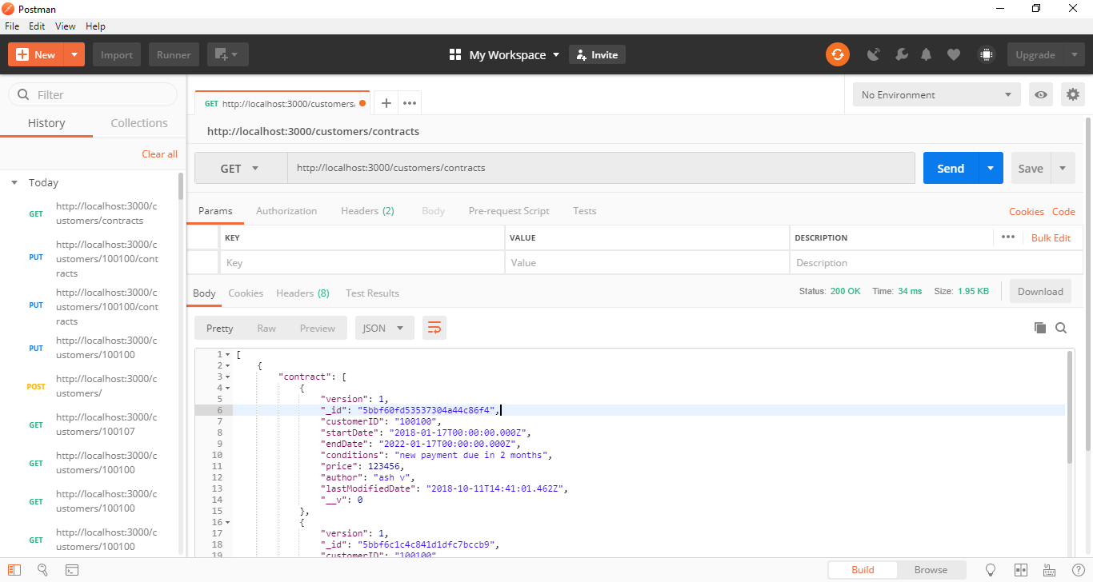

1. **Add a new Customer**

**Http Method:** POST

**Resource URL:** <http://localhost:3000/customers/>

Where, cid – is the Customer ID for the which the details are requested

**Sample Request:**

**{**

**"customerID":"100102",**

**"customerName":"Jessica Pearson",**

**"contract":[**

**{"startDate":"2017-09-21",**

**"endDate":"2023-01-27",**

**"conditions":"Lease Period cannot be extended",**

**"price":"2323232",**

**"author":"Ash V"}**

**]**

**}**

**Sample Response:**

**{**

**"contract": [**

**{**

**"version": 1,**

**"_id": "5bbf6aeb4c841d1dfc7bccb6",**

**"customerID": "100102",**

**"startDate": "2017-09-21T00:00:00.000Z",**

**"endDate": "2023-01-27T00:00:00.000Z",**

**"conditions": "lease period cannot be extended",**

**"price": 2323232,**

**"author": "ash v",**

**"lastModifiedDate": "2018-10-11T15:23:23.809Z",**

**"__v": 0**

**}**

**],**

**"_id": "5bbf6aeb4c841d1dfc7bccb7",**

**"customerID": "100102",**

**"customerName": "jessica pearson",**

**"__v": 0**

**}**

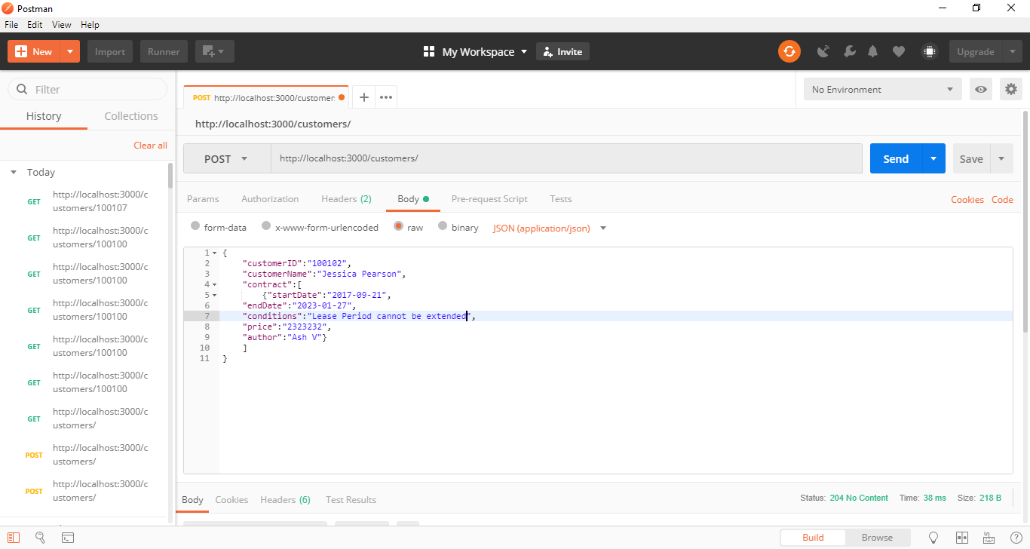

1. **Update existing Customer with new contract details, while retaining the previous contracts**

**Http Method:** PUT

**Resource URL:** <http://localhost:3000/customers/>:cid/contracts

Where, cid – is the Customer ID for the which the new contracts needs update

**Sample Request:**

**{**

**"customerID":"100102",**

**"customerName":"Jessica Pearson",**

**"contract":[**

**{"startDate":"2018-09-02",**

**"endDate":"2025-01-07",**

**"conditions":"6 weeks notice to end contract",**

**"price":"2990909",**

**"author":"Ash V"}**

**]**

**}**

**Sample Response:**

**{**

**"contract": [**

**{**

**"version": 1,**

**"_id": "5bbf60fd53537304a44c86f4",**

**"customerID": "100100",**

**"startDate": "2018-01-17T00:00:00.000Z",**

**"endDate": "2022-01-17T00:00:00.000Z",**

**"conditions": "new payment due in 2 months",**

**"price": 123456,**

**"author": "ash v",**

**"lastModifiedDate": "2018-10-11T14:41:01.462Z",**

**"__v": 0**

**},**

**{**

**"version": 1,**

**"_id": "5bbf6c1c4c841d1dfc7bccb9",**

**"customerID": "100100",**

**"startDate": "2018-09-02T00:00:00.000Z",**

**"endDate": "2025-01-07T00:00:00.000Z",**

**"conditions": "6 weeks notice to end contract",**

**"price": 2990909,**

**"author": "ash v",**

**"lastModifiedDate": "2018-10-11T15:28:28.225Z",**

**"__v": 0**

**},**

**{**

**"version": 1,**

**"_id": "5bbf6c5c81aa0d12c8ec762b",**

**"customerID": "100100",**

**"startDate": "2018-09-02T00:00:00.000Z",**

**"endDate": "2025-01-07T00:00:00.000Z",**

**"conditions": "6 weeks notice to end contract",**

**"price": 2990909,**

**"author": "ash v",**

**"lastModifiedDate": "2018-10-11T15:29:32.789Z",**

**"__v": 0**

**}**

**],**

**"_id": "5bbf60fd53537304a44c86f5",**

**"customerID": "100100",**

**"customerName": "jessica pearson",**

**"__v": 0**

**}**

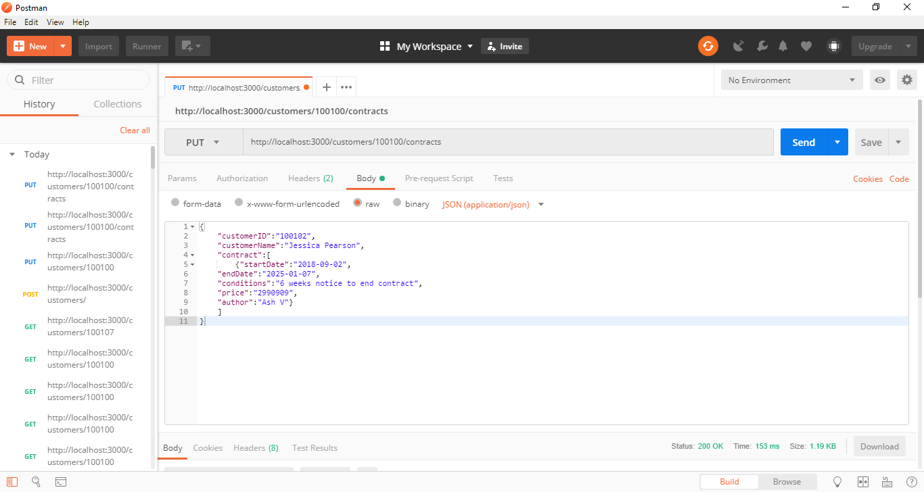

1. **Delete a specific customer**

**Http Method:** DELETE

**Resource URL:** <http://localhost:3000/customers/:cid>

Where, cid – is the customer ID whose details are requested for deletion

Sample URL: <http://localhost:3000/customers/101010>

**Sample Request:**

No Request body, only resourse URI is used

**Sample Response:**

{

"n": 1,

"ok": 1

}