**Contract Management System V1 – Application User Manual**

**System Description:**

The Contract Management system is a simple application which maintains contract details of customers, namely

* **Customer ID** -> ID of the customer
* **Customer Name** -> Name of the customer
* **Contract Start Date** -> Start date of the contract (yyyy-MM-dd)
* **Contract End Date** -> End date of the contract (yyyy-MM-dd)
* **Contract Conditions**-> Terms and conditions of the contract
* **Contract Price**-> Cost of the contract
* **Contract Last Modified Date** -> Date of Last contract entry
* **Contract Author** -> Name of person who saved the contract details to system

The application was developed using MEAN stack, where the front end is an angular app and the backend consists of business logic as REST APIs and data layer hosted on NodeJS server using ExpressJS and Mongo DB serving as backend (Via Mongoose ODM).

The application supports the following CRUD operations,

* Add new customer
* Update existing customer with new Contract, while retaining their old contracts
* Delete a customer
* View all customers latest contract details

**Pre-requisites:**

* The Application’s backend hosted on <http://localhost:3000/> NodeJS server should be up and running, along with database connection to Mongo DB established successfully on <http://localhost:27017/>
* The AngularJS frontend of the application, hosted on <http://localhost:4200/> should be up and running

**CRUD Operations on Angular App**

1. **Open** <http://localhost:4200>
2. **Initial Screen**

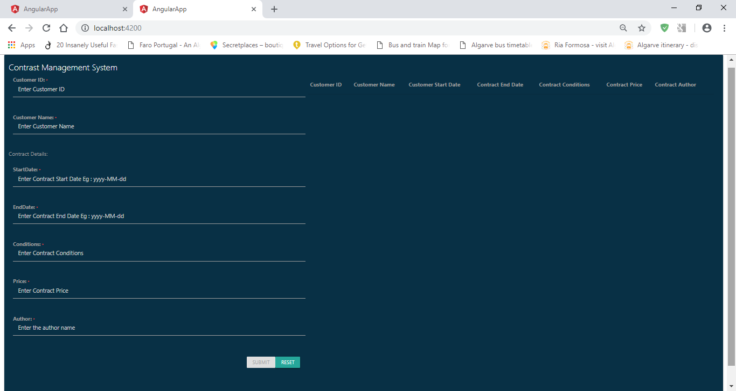

1. **Add new customer**

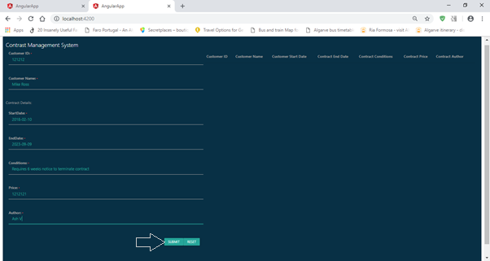

1. **New Customer details saved successfully**

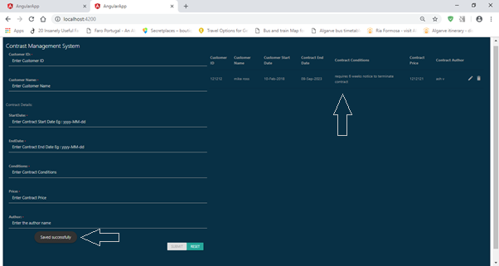

1. **Update customer contract details**

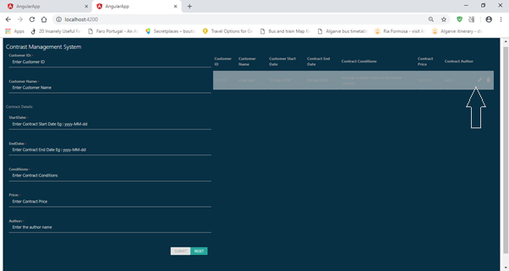

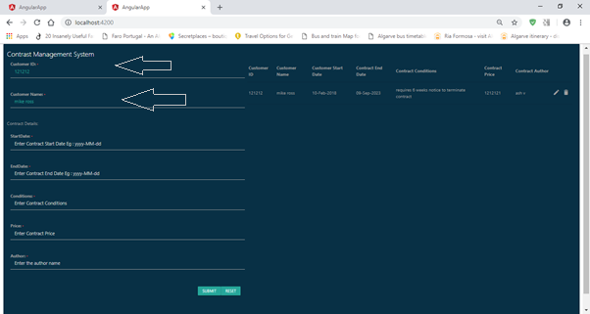

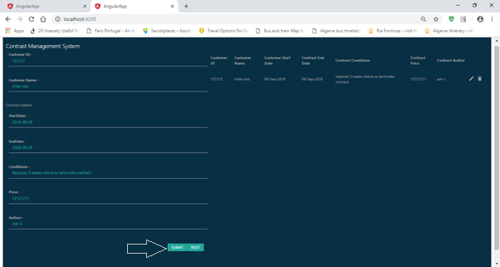

1. **Update to contract was successful**

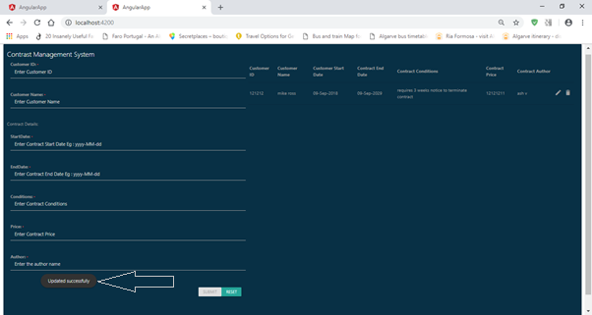

1. **Delete customer details**

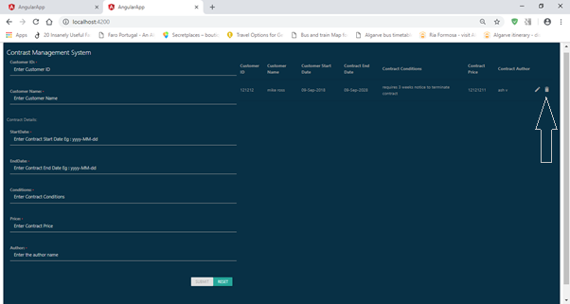

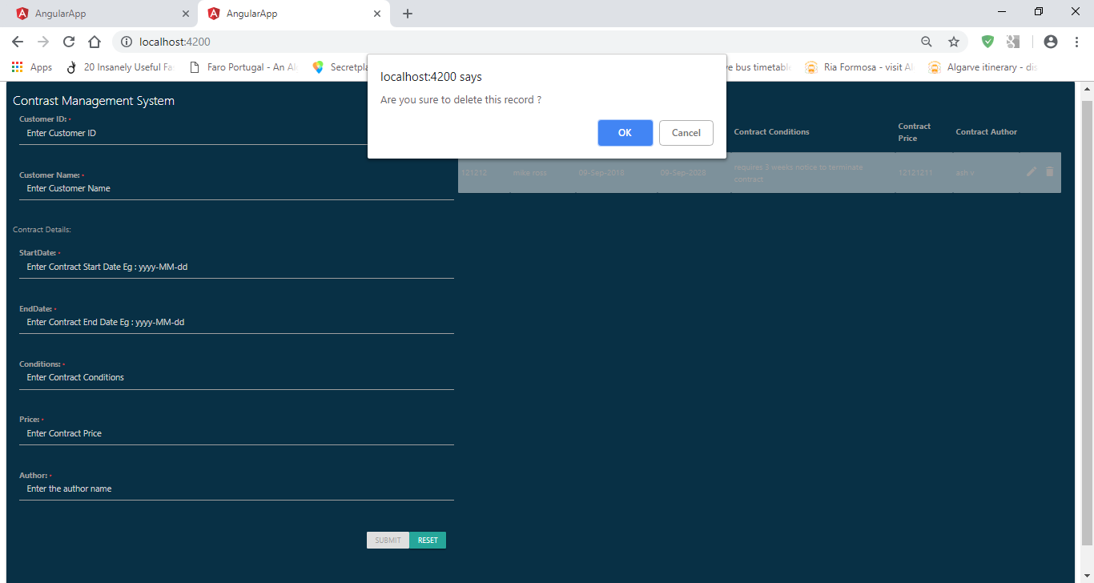

1. **Customer Delete was successful**

