Program Structures and Algorithms

Spring 2023(SEC – 1)

NAME: Aishwarya Venkatesan

NUID: 001569213

**Task:** To solve 3-SUM using quadratic, quadrithmic and quadratic with calipers and calculate timing observations for different time complexities.

**Relationship Conclusion:** As the value of N(number of integers) increases, the raw time per run has a much higher value for cubic solution. For a quadratic solution, as the value of N doubles, the time for execution does not have a very large change as compared to the cubic solution.

For N = 4000, time taken for cubic solution is 9.658s and quadratic solution is 0.07s

For N = 8000, cubic solution is 78.11s and quadratic solution is 0.4s

For larger values of N, time taken for computations is much lesser for quadratic solutions. Hence the quadratic solution works best for any value of N.

**Evidence to support that conclusion:**

| N | Number of runs | Time per run | Cubic | Quadrithmic | Quadratic | Quadratic with calipers |
| --- | --- | --- | --- | --- | --- | --- |
|  |  |  |  |  |  |  |
| 250 | 100 | Raw time | 2.49 | 0.24 | 0.19 | 0.02 |
|  |  | Normalized time | 0.16 | 0.48 | 3.04 | 0.32 |
|  |  |  |  |  |  |  |
| 500 | 50 | Raw time | 20.16 | 2 | 1.02 | 0.2 |
|  |  | Normalized time | 0.16 | 0.89 | 4.08 | 0.8 |
|  |  |  |  |  |  |  |
| 1000 | 20 | Raw time | 157.65 | 10.4 | 4 | 2.2 |
|  |  | Normalized time | 0.16 | 1.04 | 4 | 2.2 |
|  |  |  |  |  |  |  |
| 2000 | 10 | Raw time | 1228.1 | 54.1 | 14.7 | 10 |
|  |  | Normalized time | 0.15 | 1.23 | 3.67 | 2.5 |
|  |  |  |  |  |  |  |
| 4000 | 5 | Raw time | 9685.8 | 267.4 | 74.4 | 55.4 |
|  |  | Normalized time | 0.15 | 1.4 | 4.65 | 3.46 |
|  |  |  |  |  |  |  |
| 8000 | 3 | Raw time | 78110.33 | 1291 | 475.33 | 293 |
|  |  | Normalized time | 0.15 | 1.56 | 7.43 | 4.58 |
|  |  |  |  |  |  |  |
| 16000 | 2 | Raw time | 638260.5 | 5580 | 1976 | 1556.5 |
|  |  | Normalized time | 0.16 | 1.56 | 7.72 | 6.08 |

**Graphical Representation:**

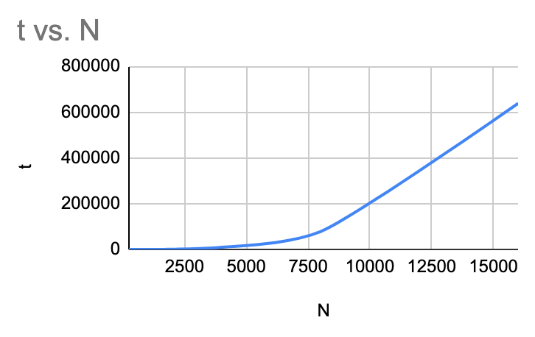

Graph for cubic solution

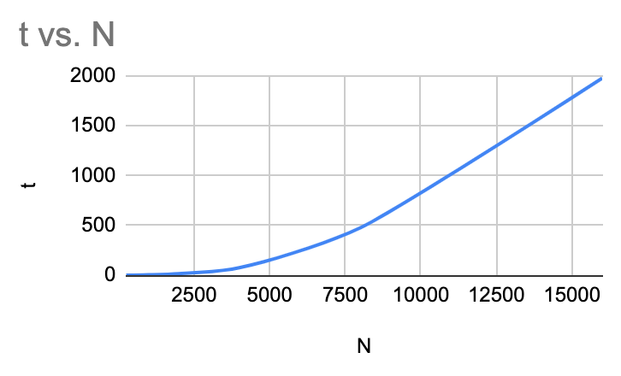

Graph for quadratic solution

**Unit Test Screenshots:**

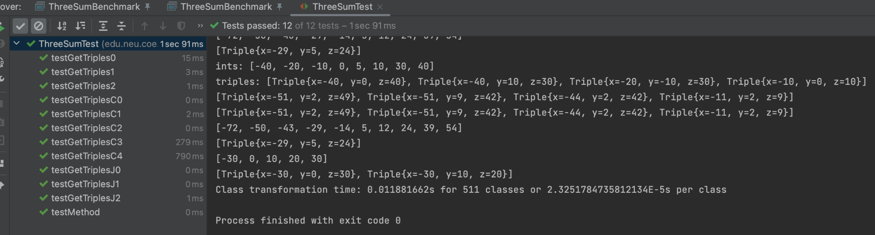

**Quadratic:**

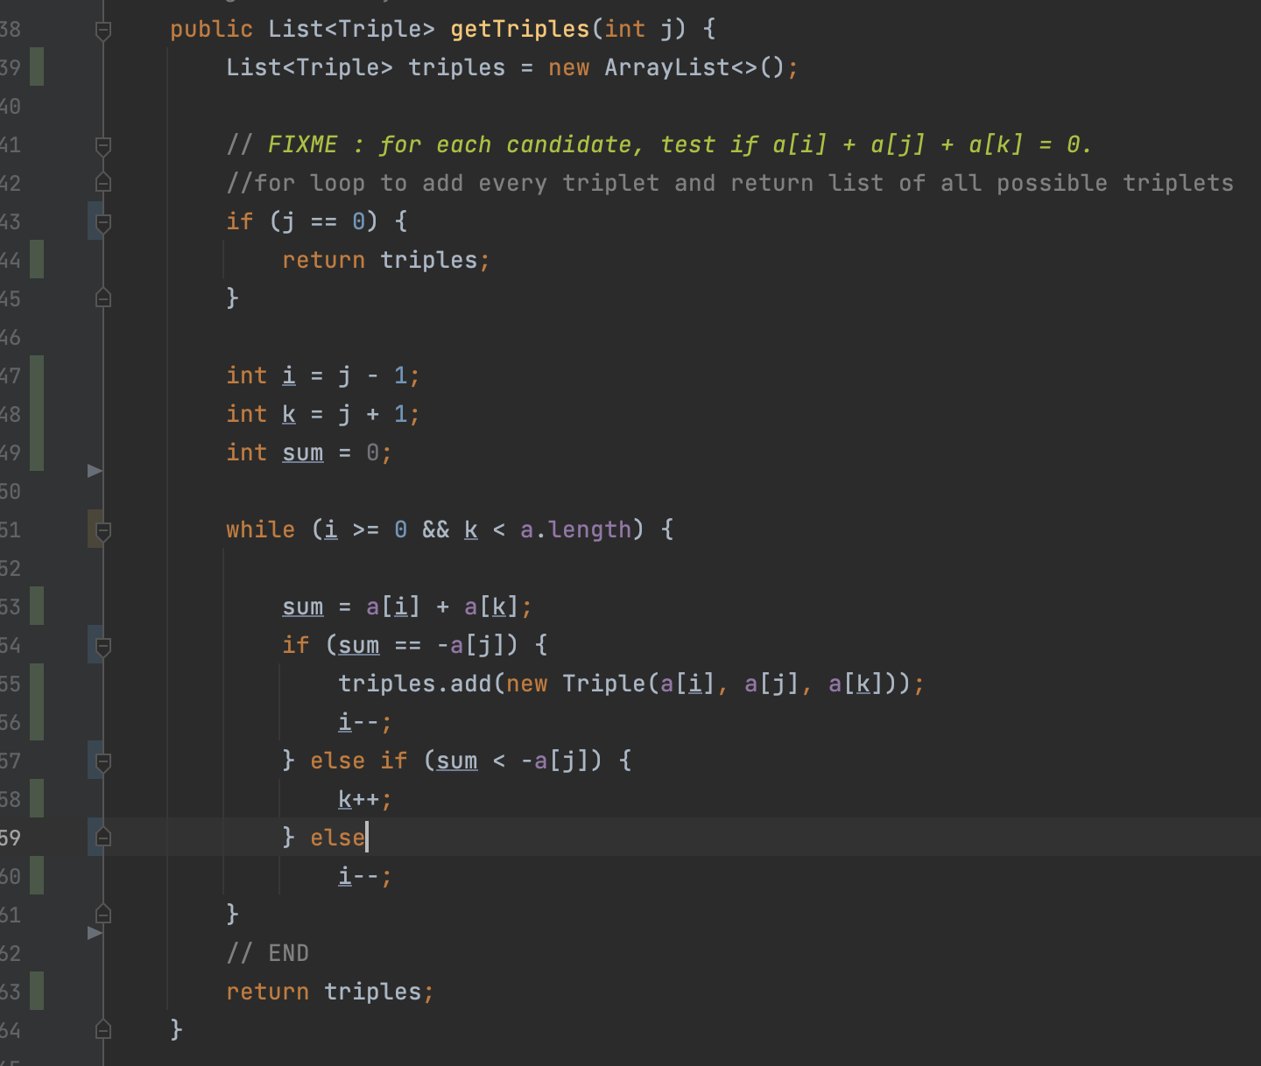

**Quadratic with calipers:**

