Program Structures and Algorithms

Spring 2023(SEC –1)

NAME: Aishwarya Venkatesan

NUID: 001569213

**Task:** To implement height-weighted Quick Union with Path Compression. develop a UF ("union-find") client that takes an integer value n from the command line to determine the number of "sites." Then generates random pairs of integers between 0 and n-1, calling connected() to determine if they are connected and union(). Determine the relationship between the number of objects (*n*) and the number of pairs (*m*) generated.

**Relationship Conclusion:** For n objects , the number of pairs (m) generated is related as m = ½ * n * log(n)

**Evidence to support that conclusion:**

| Value of n | Number of connections m | 0.5* n * log(n) |
| --- | --- | --- |
|  |  |  |
| 120 | 149 | 124.7508748 |
| 240 | 285 | 285.625349 |
| 480 | 1136 | 643.497897 |
| 960 | 2514 | 1431.490192 |
| 1920 | 5114 | 3151.96918 |
| 3840 | 13417 | 6881.915951 |
| 7680 | 35557 | 14919.78708 |
| 15360 | 94738 | 32151.48454 |

**Graphical Representation:**

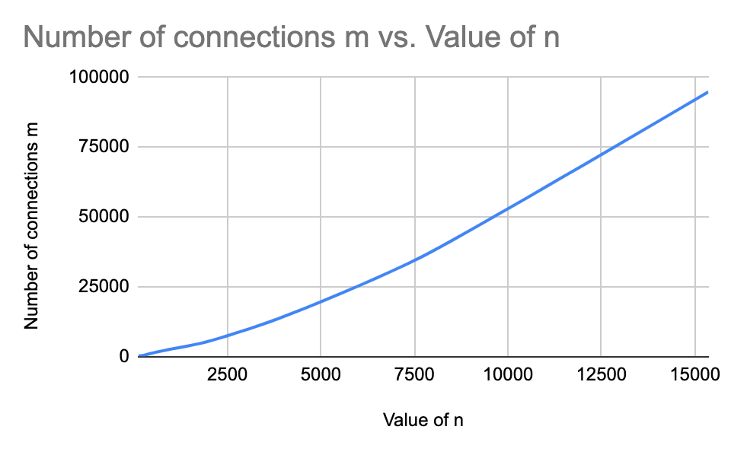

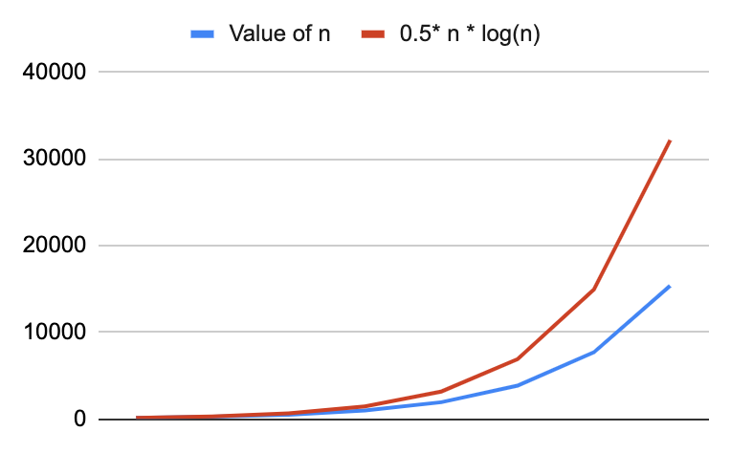

**Unit Test Screenshots:**

