Program Structures and Algorithms

Spring 2023(SEC –1)

NAME: Aishwarya Venkatesan

NUID: 00169213

**Task:** Part-1 To implement 3 methods, repeat, getClock and toMillisecs of Timer class

Part -2: To implement InsertionSort

Part -3: Create a main program and calculate time taken for insertion sort for different values of N for random, ordered, partiallyOrdered and reverseOrdered array.

**Relationship Conclusion:**

By order of growth,

Ordered < Partially Ordered < Random < Reversed

**Evidence to support that conclusion:**

| Values of N | Random | Ordered | Partially Ordered | Reverse Ordered |
| --- | --- | --- | --- | --- |
|  |  |  |  |  |
| 500 | 0.006 | 0.002 | 0.012 | 0.008 |
| 1000 | 0.001 | 0.002 | 0.001 | 0.006 |
| 2000 | 0.0045 | 0.004 | 0.003 | 0.005 |
| 4000 | 0.0065 | 0.00875 | 0.0105 | 0.00625 |
| 8000 | 0.01275 | 0.009125 | 0.01075 | 0.0185 |

**Graphical Representation:**

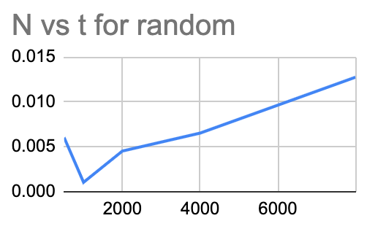

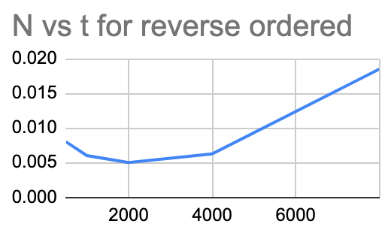

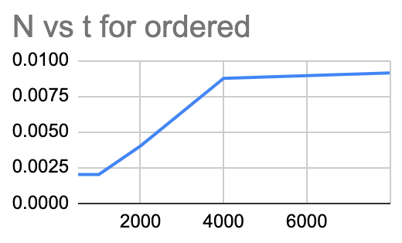

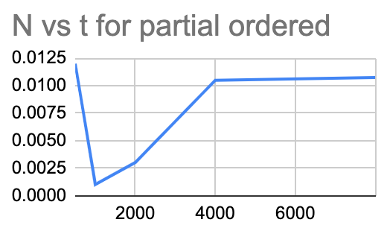

**Unit Test Screenshots:**

**Timer Test:**

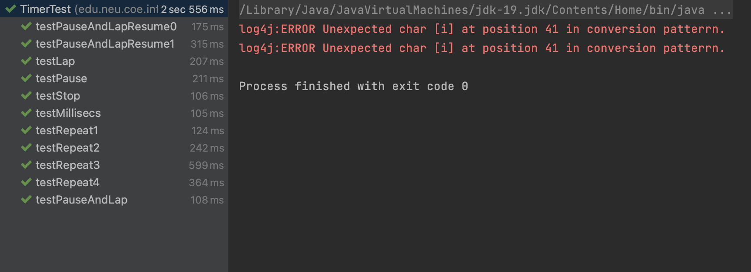

**Sort test:**

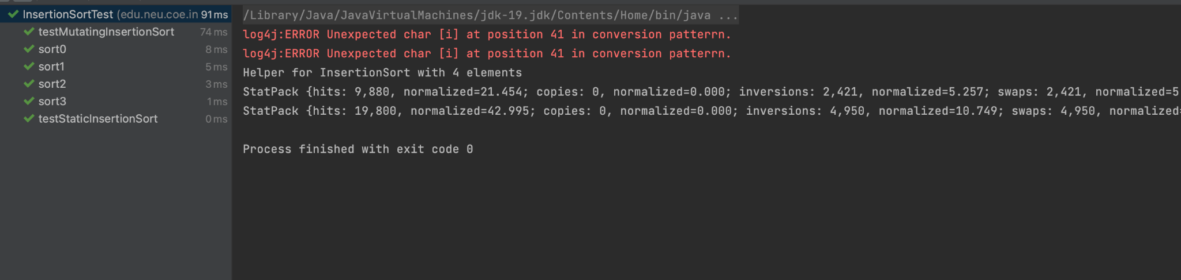

**repeat function:**

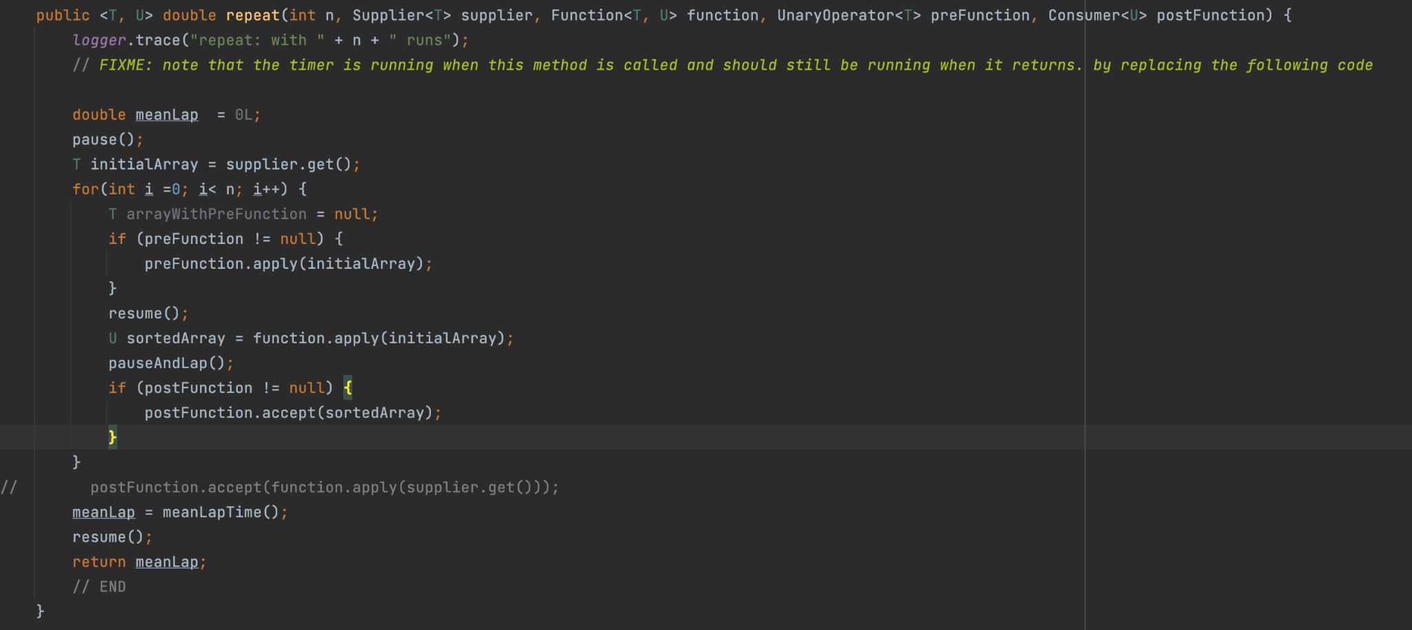

**getClock and toMillis:**

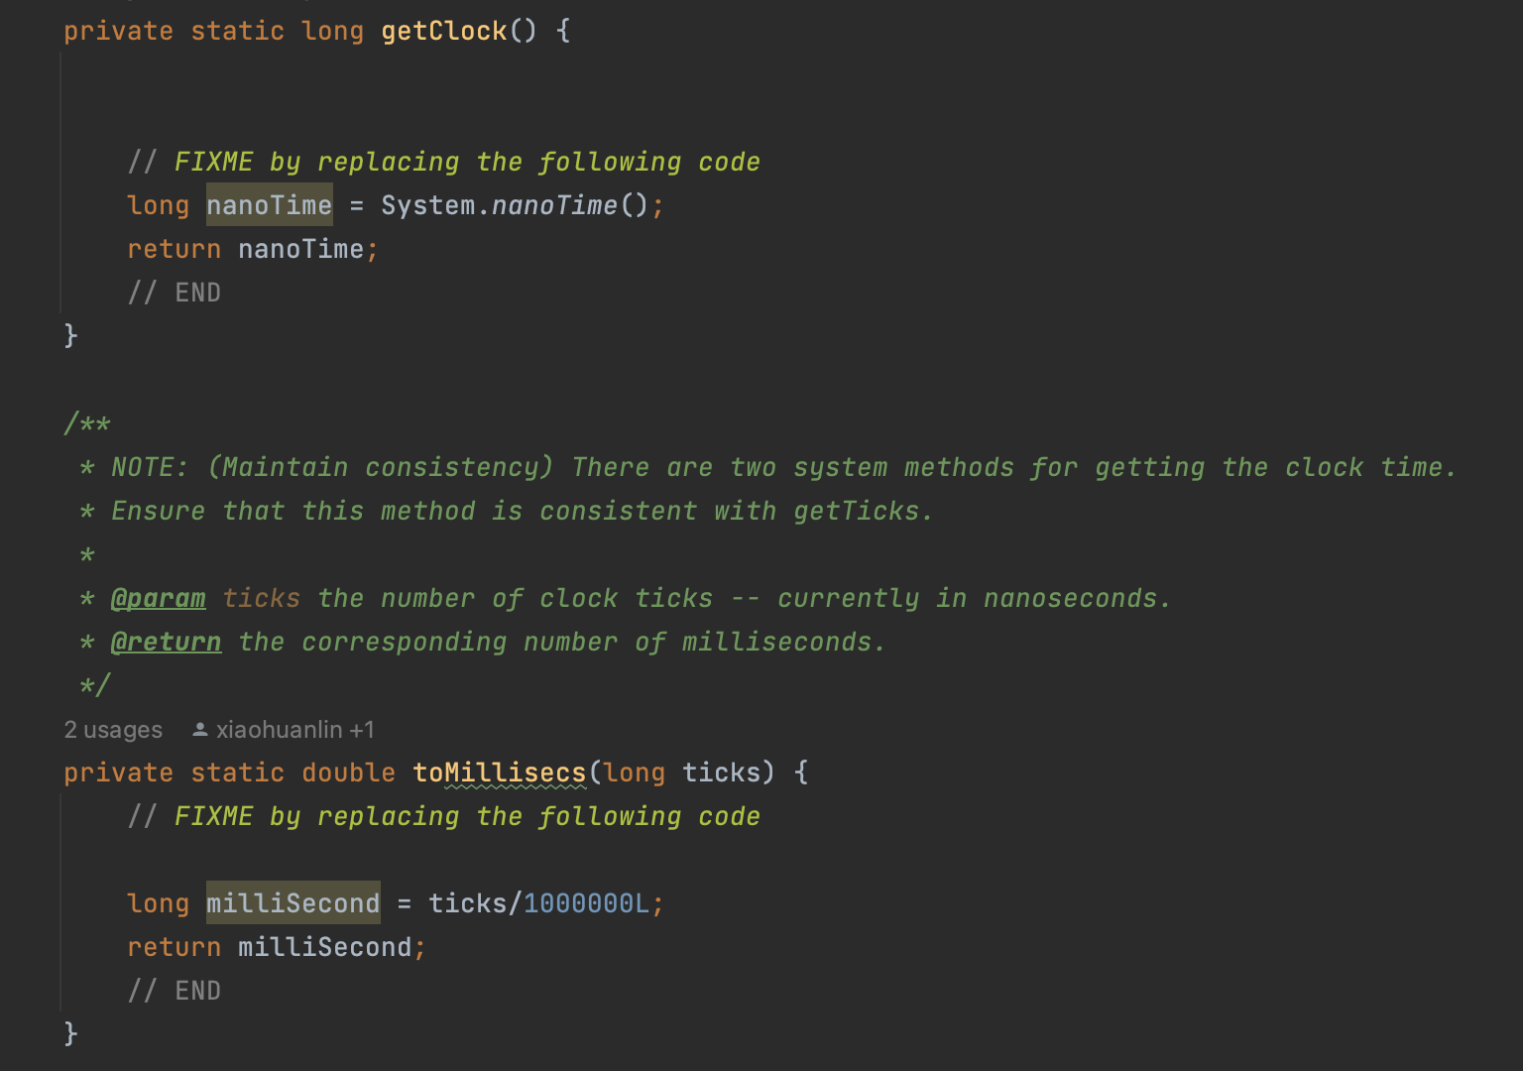

**sort function:**

