DEVELOPMENT AND DEBUGGING OF CLEARANCE OPTMIZATION ENGINE

A Practice School Report submitted to Manipal University in partial fulfilment of the requirement for the award of the degree of

BACHELOR OF TECHNOLOGY
in
Computer Science & Engineering

Submitted by
Hema Sai Aishwarya V
130905580
Under the guidance of

SUNIL CHOWDARY PRAKASH K AITHAL

Senior Manager & Assistant Professor(Senior Scale)
Oracle Retail


DEPARTMENT OF COMPUTER SCIENCE & ENGINEERING
<May/June/July> 2017

DEPARTMENT OF COMPUTER SCIENCE & ENGINEERING

Manipal
28 June,2017

CERTIFICATE

This is to certify that the project titled DEVELOPMENT AND DEBUGGING OF CLEARANCE OPTIMIZATION ENGINE is a record of the bonafide work done by HEMA SAI AISHWARYA V(Reg. No. 130905580) submitted in partial fulfilment of the requirements for the award of the Degree of Bachelor of Technology (B.Tech.) in COMPUTER SCIENCE & ENGINEERING of Manipal Institute of Technology, Manipal, Karnataka, (A Constituent Institute of Manipal University), during the academic year 2016-17.

Prakash K Aithal  Assistant Professor (Senior Scale),  CSE Dept.  M.I.T, MANIPAL | Prof. Dr. Ashalatha Nayak  HOD, CSE Dept.  M.I.T, MANIPAL



Project Completion Letter

ACKNOWLEDGMENTS

I would like to express my sincere gratitude to Oracle Retail Global Business Unit for giving me such a wonderful opportunity. I am very grateful to have Mr. Sunil Chowdary and Mr. Venkatasalam Karuppusamy as my external guides . I would like to thank them for being so helpful and supportive throughout the project.

I would like to thank Dr Gopalakrishna Prabhu(Director) and Dr Ashalatha Nayak (H.O.D., Dept. Of CSE) for giving me the opportunity to carry out my project work in such a prestigious organization.

I would also like to thank my Project Guide Mr. Prakash K Aithal (Assistant Professor-Senior Scale,Dept. Of CSE) for his constant support and guidance throughout the project.

ABSTRACT

One of the fastest growing sections of the economy is retailing. Retailing comprises buying service or a merchandise from an agent, importer manufacturer, wholesaler or other retailer and selling it to customers for their personal use. The future of retailing needs that businesses adapt to changing consumer needs and use intelligence to drive repeat customers at each channel. Oracle Clearance Optimization Engine (COE) is mainly used for the weekly model run batch process. Issues and feedback’s from consumers are very common for a very well established product in a product development company. Our Sustenance Engineering (SE) team work for resolving issues and including the code enhancements into all the products sold.

For the COE product there may be issues or feedbacks raised by the internal organization or from the customers; so after the issue is logged, it needs to be fixed and the resolution requires to follow a Software development Life Cycle.

Using Sustenance Engineering we can maintain and improve existing software and can extend the value of present products. The organization can provide the software to the customer, which is reliable and robust. There are many other features in COE where the retailer could optimize his valuable resources.

With the help of Sustenance Engineering on COE, the reliable and efficient code lines had been delivered to the customer and had made profits for Oracle Retail. Sustenance engineering thus extends the life of a product.

IE Developer Tools, BugDB have been used for bug resolution process.

Table of Contents
 |  |  |  |  | Page No
Acknowledgement |  |  |  |  | I
Abstract |  |  |  |  | Ii
List Of Tables |  |  |  |  | iv
List Of Figures |  |  |  |  | V
Chapter 1 |  |  | INTRODUCTION |  | 1
 | 1.1 | Area of work |  |  | 1
 | 1.2 | Motivation |  |  | 2
 | 1.3 | Objective |  |  | 3
 | 1.4 | Target Specification |  |  | 3
 | 1.5 | Project Work Schedule |  |  | 4
 | 1.6 | Organization of the Report |  |  | 4
Chapter 2 |  |  | BACKGROUND THEORY and/or LITERATURE REVIEW
 | 2.1 | Sustaining engineering in clearance optimization engine |  |  | 6
 | 2.2 | Literature Review |  |  | 7
Chapter 3 |  |  | METHODOLOGY
 | 3.1 | Methodology |  |  | 10
 | 3.2 | Design and modelling |  |  | 13
 | 3.3 | Tools used |  |  | 22
 | 3.4 | Libraries used |  |  | 23
 | 3.5 | Code inspection |  |  | 25
Chapter 4 |  |  | RESULT ANALYSIS
 | 4.1 | Bug fixes |  |  | 28
 | 4.2 | Development of COE 14.0.5 |  |  | 30
Chapter 5 |  |  | CONCLUSION AND FUTURE SCOPE
 | 5.1 | Summary |  |  | 36
 | 5.2 | Conclusion |  |  | 36
 | 5.3 | Future scope of work |  |  | 36
REFERENCES
PROJECT DETAILS

LIST OF TABLES

Table No | Table Title | Page No
4.1 | Few bugs solved | 28
4.2 | List of bugs | 32

LIST OF FIGURES

Figure No | Figure Title | Page No
2.1 | Hierarchy of the sustaining engineering | 6
2.2 | Relationship between COE and item planning | 9
3.1 | Bug solving process | 10
3.2 | Overview of the whole system | 16
3.3 | The sub parts of the whole system | 17
3.4 | The sub-parts of the client side system. | 18
3.5 | The sub-parts of the Transformer in the client side. | 19
3.6 | The sub-parts of the Actions in the client side. | 20
3.7 | Control Flow Diagram | 20
3.8 | Class Diagram | 21
3.9 | Use case Diagram | 21
4.1 | Bug3 Before fixing the bug | 29
4.2 | Bug3 After fixing the bug | 29
4.3 | Bug8 | 29
4.4 | Oracle Fusion Middleware Overview | 31

CHAPTER 1
INTRODUCTION

The chapter comprises the brief description about retail world, the contribution of Oracle Retail in maintaining the retail business and fulfilling the customer demands to the expectation. It also includes overview of the Clearance Optimization Engine (COE). Further it covers the role played by the Sustaining Engineering team that maintains and enhances existing software and extends the value of the current products. Motivation is explained for the project, followed by the objectives of the project. This chapter also explains the organization of the project report.

  - AREA OF WORK

One of the fastest growing sectors of the economy is retailing. Retailing comprises buying service or a merchandise from an agent, importer manufacturer, wholesaler or other retailer and selling it to customers for their personal use. With Oracle Retail, retailers can keep pace with their consumers and can transform the way business is done. Only Oracle allows creating a unified view of the material that delivers economic value to the whole business, from in-store operations to corporate strategy to logistical management and supply chain. Oracle Retail is the result of Oracle's strategic acquisition of best-of-breed applications.

The Oracle Retail ERP Suite has wide variety of applications to execute the retail business operations which can be classified into following:-

1. MOM(Merchandise Operations Management)
2. SCM(Supply Chain Management)
3. Planning and Optimization
4. ISO(Integrated Store Operations)

My team works on Integrated Store Operations and some products of Planning and Optimization. The ISO is a set of retail store applications to maintain the store operations effectively.
* ORPOS(Oracle Retail Point Of Sale/Service) - Handles Back Office, Central Office, and Returns Management.
* ORSIM(Oracle Retail Store Inventory Management) - Merchandising, count stock, Handle inventory while selling, Inventory Management.
Under Planning and Optimization
*ORMDO/COE(Oracle Retail Markdown Optimization/Clearance Optimization Engine) - Recommends markdowns and make forecasts on basis of given scenarios.

Oracle works with vendors of all sizes to redesign the client experience, reinvigorate working experience and re-imagine growth.

    - Sustenance Engineering

Sustaining engineering is the part of the development of the software which is not related to agile software development. Here is the definition of sustaining engineering by a scientist Tvan Fosson:
“Consideration of the social and environmental effects of software projects in managing the project. Managing a software project in order to maximize the positive and minimize the negative social and environmental effects of the project.”
Sustaining Engineering involves resolving product issues by analyzing existing products, doing research on how to resolve those issues and improvise the product.

1.2 MOTIVATION

Issues and feedbacks from clients are very usual for a very well-known product in a product development company. Solving issues for this product, which is used by large clientele, is tough, time consuming and involves lot of aids. My project aims at explaining why that is so and gives you an outline of the Sustenance Engineering teamwork for resolving issues and incorporating the code improvements into all the products sold.

Now for the COE product there may be issues or feedbacks’ raised by the internal organization or from the customers, so after the issue is logged, it needs to be fixed and the resolution requires to follow a Software development Life Cycle. My project has given me an opportunity to go through the SDLC to fix the issues raised. The approach and process are being nicely explained in my comprehensive report. The important thing in a product development company is the issue would only be resolved if the issue is generic and not specific to certain type of retail businesses. So, the analysis phase of SDLC, we are supposed to verify whether it is generic or specific.

1.3 OBJECTIVE

The project is basically pure research on particular software product and enhances the performance and minimizes the errors in the software. This task needs quick adaptation of software code, its structure, algorithms and performance. Based on your research about the software, one can decide that whether the issue reported by customer is actually a bug or it’s just the actual functionality of the software. In short thorough understanding of software architecture is the first thing which is required.

The other task involves problem finding and solving ability. In this project sustaining engineer has to develop the exact environment that customer has and then perform the test on the product COE. Once problem is found out, the researcher has to open the code, batches or user interface. He/she has to learn and understand each and every aspect of the issue; and finally accomplishes the solution.

The main objectives of the internship are:
• To resolve the issues (bugs/defects) and feedbacks of customers in an efficient and effective way by optimizing the recourses.
• To contribute in developing of the product (COE 14.0.5), which is functionally and technically correct than the previously released versions.

The objective of the project is reliability. The organization can provide the software to the customer, which is reliable and robust. The second most important objective is reusability. Generally organization uses the same code which is in the previous versions with little modifications at the time of new version release. So if the old code is error free then the new version will automatically become reliable. Third benefit from this project is income. If customer demands more functionality which is specific to his business requirements, he will demand this functionality from the organization. The organization will give this project to Sustaining Engineering team and will earn money. This project provides a good research experience to the interns. The project allows the intern to interact with software architects and software researchers. The interns also get the chance to communicate with the end users of the software and can get the feedback of their work.

1.4 TARGET SPECIFICATION

Using Sustaining Engineering we can retain and enhance existing software and spread the worth of existing products. The process of sustaining engineering identifies the software solution to help the developer discover and capture the untapped features of the existing product. This helps Oracle to develop a more new reliable and flawless product for its customers. Sustaining engineering thus extends the life of a product.

1.5 PROJECT WORK SCHEDULE

- January 2017
Tech Stack confirmation

- February 2017
Environments upgrade SRs

- March 2017
1st Code drop

- April 2017
Documentation
2nd Code drop

- May 2017
3rd/ Final Code drop

- June 2017
Software Deployment
Submission of report & evaluation

1.6 ORGANIZATION OF THE REPORT

This project report consists of the following five chapters:

Chapter 1: Introduction: This chapter contains an introduction to basic concepts of Retail world and the overview of the COE product and the task performed by our SE team. It then explains the motivation for the project, followed by the objectives of the project.

Chapter 2: Background Theory: In this chapter we will be discussing the brief history of Oracle Retail, its products (COE) and product consumers. This chapter provides introduction to the project title, followed by the literature review which explains background theory and also brief the time to time developments in the various versions of product from the time product started till the present day.

Chapter 3: Methodology: This chapter will cover the detailed explanation of methodology that is being used to make this project complete and effective. The process followed to achieve the objective of the project that will accomplish a perfect result is also described. Also the technologies used in the proposed work are explained in detail.

Chapter 4: Result Analysis: In this chapter, we will discuss on result and analysis of few of the defects which were resolved as a part of this project. It also explains the significance of the obtained results, followed by the Conclusions.

Chapter 5: Conclusion and Future Scope of Work: This chapter provides a summary of the work, and then explains the conclusions. It also explains the future scope of the work.

CHAPTER 2
BACKGROUND THEORY / LITERATURE REVIEW

2.1 SUSTAINING ENGINEERING IN CLEARANCE OPTIMIZATION ENGINE

The work of Sustaining Engineering starts as soon as the software product releases. Job of Stores team is to maintain the product, after it is delivered to the client. During this maintenance phase, hundreds of bugs are fixed and new functionalities are added to the given product owing to customer requirements. Using Sustaining Engineering we can maintain and improve existing software and can extend the value of current products. The process of Sustaining Engineering identifies the software solution to help the developer to discover and capture the untapped features of the existing product. This helps Oracle to develop a more new reliable and flawless product for its customers.
Sustaining engineering thus extends the life of a product. The process involves the following steps:-
- Requirement Analysis
- Software solution and implementation
- Source code control and configuration management
- Documentation
- Quality Assurance test plan design and execution
- Formal release procedures

The basic hierarchy of the sustaining engineering is shown below:
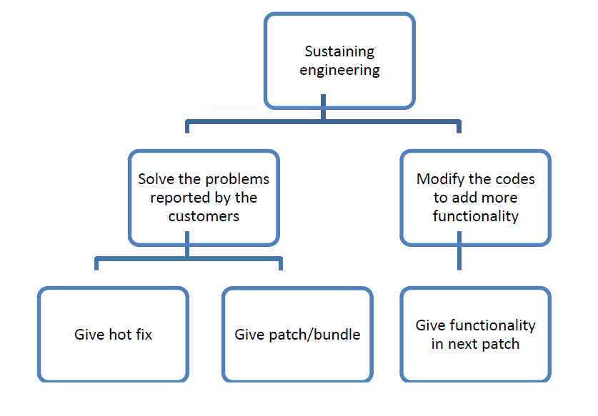
Fig 2.1 Hierarchy of the sustaining engineering
2.2 LITERATURE REVIEW

2.2.1 About Oracle

Oracle started more than thirty years ago when Larry Ellison saw a chance which other companies missed: a description of a working prototype for a relational database. Ellison and co-founders Ed Oates and Bob Miner realized the incredible business potential of the relational database model but they may not have comprehended that the company they established would transform the face of business computing.

Throughout its past Oracle has showed it can build for the future on the foundation of its inventions and, its knowledge of client challenges and successes analyzed by the best business and technical minds in the world. Today Oracle is the gold standard for database technology and applications in enterprises throughout the world. Oracle is the world's second largest independent software company and it is also the world's leading supplier of information management software. The acquisition of Sun gives Oracle a leadership role in the hardware arena as well.

Now Oracle technology can be found in nearly every business, and in the data centers of 100 of the Fortune Global 100 companies. Oracle is the first software company to develop and deploy 100 percent internet-enabled enterprise software across its entire product line: database, business applications, application development, and decision support tools.

Novelty is the engine of Oracle's success. Oracle was one of the first companies to make its business applications available through the internet an idea that is now pervasive.

2.2.2 Products Offered

Oracle offers a vast variety of products, which include:
• Oracle databases
• Oracle fusion middleware
• Oracle applications
• Server and storage systems
• Development tools

2.2.3Industries Catered

Oracle’s industry solutions leverage the vast portfolio of products to address complex business processes relevant to each industry. The various industries catered include:

• Retail
• Aerospace and Defense
• Automotive
• Communications
• Financial Services
• Healthcare
• Insurance
• Oil and Gas

2.2.4 Acquisitions

Through its acquisition activities, Oracle seeks to strengthen its product offerings, accelerate innovation, meet customer demand more rapidly, and expand partner opportunities. Some of the major acquisitions include:
• Sun Microsystems in April, 2009
• Retek in April, 2005
• PeopleSoft in January, 2005
• Thor Technologies in November, 2005

2.2.5 Oracle Retail

Oracle Retail is a Global Business Unit (GBU) of Oracle Corporation, headed by Mike Webster. Oracle Retail offers the industry's most complete and integrated suite of software applications and hardware for retail—including applications, middleware, database, servers, storage, virtualization solutions, and operating systems. Oracle Retail is the result of Oracle's strategic acquisition of best-of-breed applications.

2.2.6 Oracle Retail Clearance Optimization Engine

The Clearance Optimization Engine (COE) provides the What If RMI interface that Item Planning Configured for COE can access using the RPAS special expression. This allows the IP application to produce in-season price recommendations and forecasts that account for planned promotions and future markdowns in the product life cycle. The forecast includes a sales plan and an optimal price plan. COE produces its recommendations during the weekly model run. The results of the model run are stored in the database. These results can be extracted using the sendback files. They are then available for use by IP.Users have the ability to perform real-time What-If scenarios from within Item Planning and alter plans in order to see the results of those changes. The changes include planning a markdown, changing future prices, changing an order, changing the exit date, changing the salvage value, and changing the sell-through target.

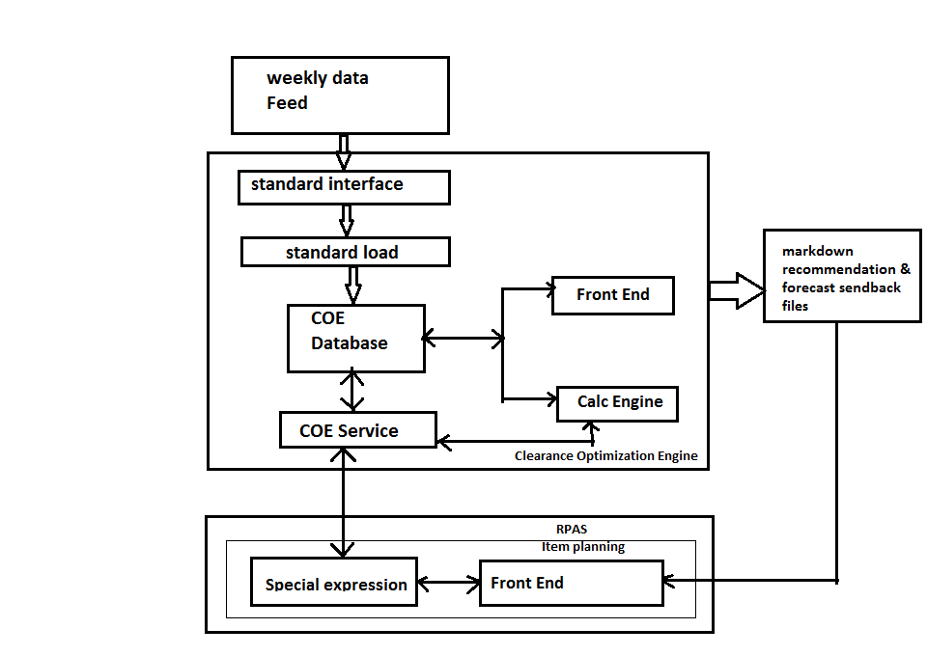
Fig 2.2 Relationship Between COE and Item Planning

CHAPTER 3
METHODOLOGY

In this chapter, how the work is accomplished in SE COE team is explained in detail. This involves the planning and execution of software projects for the purpose of existing product enhancement including Feature Additions and Bug Fixes. There are different languages and technologies used at each and every level of the product. If there are any issues for this sold product, then that should be resolved and incorporated in all the products, which are sold. Such product maintenance projects are very frequently in competition with new product development for internal engineering resources.

3.1METHODOLOGY

Entire Methodology involved in bug solving process has been explained in following diagram:

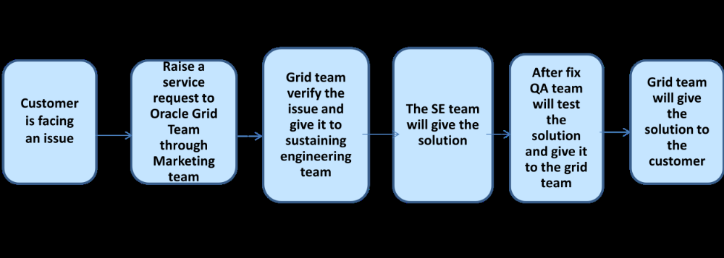
Fig 3.1 Bug Solving Process

We have followed the following stages of sustaining engineering in resolving the issues:

Stage I: Logging of issues and feedbacks by customer:
After the COE product is sold, there is a marketing team in the organization, which collects feedbacks and issues faced by the customers. The information might be passed through phone, email or by person. The feedback may be to add new functionality to the COE or remove existing functionality or modify the existing functionality. After collecting the issues they pass it on to strategizing team
Stage II: Segregating the issues which are to be solved:
The strategizing team analyses the issues and feedback of customers and issues faced, and then prioritizes the problems based on the urgency, feasibility and many other criteria. The urgency in retail domain means, the severity of the issue faced by the retailer (customer) in terms of data loss or any other business impact.

Stage III: Segregating the issues based on required date:
The GRID team then decides which bugs or functionalities should be fixed early than the next version release date of the product. Based on the required date, the bugs or functionalities fall in two buckets:

(i) Before next version release date.
(ii) Not before next version release date.

Stage IV: Segregation issues based on major functionality:
In the sustenance engineering team, the specific bugs would be allocated to specific teams based on the functionality, which is getting impacted by the bug. So, one of the team member would be assigned this bug or functionality change.

Stage V: Fixing the issue or adding functionality:
- Analysis: As a part of the bug or feedback passed to us by GRID people, they send us relevant information and documents regarding the issue. These are called bug documents. Then we analyze the issue, which means first we completely understand the functionalities of product, related to the bug. We can find the information about all the functionalities from the well-versed internal oracle documents. After getting an in-depth overview the first step we do is to try to recreate the issue in our local COE product and try to see whether the issue persists at our end also. If there is something happening other than what they have mentioned, then we would do some research whether it is behaving as per the expected functionality or deviating from it.
- Design: After analyzing the issue you would come to know whether or not the design of the system is going to be affected to fix the issue. Or there might be a need to design a new module to fix the issue. In any case then we should talk to the design architect (DA) and confirm whether the design change is really required, because we never know the design change might not be useful for all the customers. Any design change or code fix should be done keeping all the customers in mind, not for an individual customer. If the change is specific to any one customer then the team decides not to go ahead for fixing it
- Development/Code Enhancement:
Here we need to get the modules of the COE, which are going to be changed in case if the fix does not require creating new modules.
Debugging the code:
This is basically done using the internet explorer developer tools.

- Testing the fixed issue:
Unit testing: After fixing the issue, you will have that unit specifically, noting all the outputs, which will later be used as test cases for the bug. In some cases we need to make out a list containing all the possible cases that the module might be used. Then test the module for each and every scenario, note the outputs in a file which might be referred later as a successful test reviewed by code review person, architects. This is very important and must be done. The fix might violate some other functionalities or cause more issues. After unit testing we make documents for the bug, collectively called as bug documents which mainly specifies how the issue has been caused and how it is fixed, the version no of the fixed modules, any cross product impact and other information which is basically used in future for reference and solving similar type of issue. Then we need to submit the code fix for the review. Then the Code Reviewer (CR) asks us to give the explanation for the fix and passes it further if everything is all right. The experienced members in the team only do CR’s and it would only passed if everything is up to the desired outcomes.

System Testing: The fixes, which we make, are sent as PATCH which is the collection of nearly up to 300 fixes to Quality Assurance (QA) team; they follow the following protocol to test the system after applying all the fixes:
There are three types of test cases, which are been checked on the system, high priority low priority and medium priority.
All the high priority test cases must be passed.
70% of the medium priority test cases must be passed.
50% of the low priority test cases must be passed.
QA team might use different methods to run the test cases on the system like manual and automated. There is an internal automation framework, which can test the system where all the test cases are automatically run one after the other. If any of the three conditions fails then the PATCH won’t be released. Then the issue will be reported to SE team again and SE team will restart SDLC process from analysis to fix the issue. Hence the SE team follows Iterative model of SDLC.

5. Deployment of resolution: The successfully tested patch is ready for release as a new revision of the product. There are deployment documents which are prepared by the deployment team. The team uploads this patch and the deployment documents to the central server where the customers can directly access it. The customer can just apply the fix for just only his issue by the steps given in the bug document or install the patch as a whole by following the steps in the deployment documents. After applying the fix the customer lets the team know whether his issue has been successfully fixed or not, to 17
close the bug on our side. So the above document explains how the issue or feedback is resolved in a product development company.

Installation/Access for Product

Lux Installation
Lux library 2.3 was installed. In the first code drop, the LUX 2.0 was replaced by 2.3 and necessary changes were done.

SVN Access
It’s a software versioning and revision control system distributed as free software under the Apache License Developers use Subversion to maintain current and historical versions of files such as source code, web pages, and documentation.

Bug DB Access
There were number of pre and post release bugs, all posted in Bug DB. It is Oracle’s Defect and enhancement requests training system. All the issues that I solved were considered from bugs logged in BugDB for the product and its specific version.

Remote Server Access
For post release bugs, I got access for our product’s remote server where I looked into DB sync with product.

Grid Designer Access
It shows the property of grids of your product, including all its skeletal information and source of data and derivations taken for display in product. We can make changes here as well for making our grids perform as required.

3.2 DESIGN AND MODELLING

3.2.1People

● View Only: The worksheet is read-only. Sort and _lter the worksheet data but you cannot change it or take markdowns for it.
● Submitter: You can edit the worksheet, take or remove markdowns, perform whatif and optimize-to-budget analyses, and submit the worksheet for approval. However, you cannot approve (or decline) the changes made to a worksheet.
● Approver: You can only approve or decline submitted worksheets. You may not submit worksheets.

3.2.2 Functional Requirements

To perform most of these tasks, you must first login and select Markdowns from the Main Menu. You can initiate most of the following tasks from the Worksheet Summaries screen that appears.

● Reviewing Markdown Suggestions.
- Steps: Select a worksheet by clicking its link in the Key column (or the equivalent column that contains links to worksheets).
- Purpose: Each week, Markdown Optimization analyzes your most recent sale and inventory data to calculate markdown recommendations. The goal of the recommendation for each item is to maximize gross margin and sell through.

● Viewing Forecasts for One or More Worksheets.
- Steps: Select the worksheet(s) to include by clicking the corresponding checkbox. From the Action list box, select Show Recommended Forecast, and click Apply.
- Purpose: Before you change a markdown price for an item, it's a good idea to view its forecast.

● Asking What If.
- Steps: Select a worksheet by clicking its link in the Key column. On the Items Worksheet, select the item(s) you want to analyze, then select What If from the Action list box, and click Apply. On the What If screen, select the Price Ladder and the Override Price. Click Recalculate to see the way these price changes impact the forecasted sales, inventory, and gross margin.
- Purpose: After reviewing an item's forecast, you might decide that you would like to see how changes to the markdown schedule would alter its forecast.

● Applying the Optimize-to-Budget Feature.

- Steps: Select the worksheet that includes the items you want to markdown by clicking its link in the Key column. On the Items Worksheet, select the item(s) to which you
want to apply the budget. From the Action list, select Optimize to Budget, and click Apply.
- Purpose: If you are not sure how to apply your markdown dollars, use the Markdown Optimization optimize-to-budget feature. The optimize-to-budget feature assesses items with pending markdowns and applies the markdown budget dollars to items that can yield higher gross margin and sell through.

● Taking Recommended Markdown.
- Steps: Select the worksheet that includes the items you want to mark down by clicking its link in the Key column. On the Items Worksheet, select the item(s) for which you want to take markdowns, and then select Take Markdown or Take Markdown Adv from the Action list box and click Apply. Click Save to save your changes and update the Summary Metrics at the bottom of the worksheet.
- Purpose: Once you decide which items you would like to mark down, you are ready to take your markdowns and save them.

● Submitting Worksheets for Approval.
- Steps: Once you have taken markdowns (from steps above), click Submit.
- Purpose: Your markdown decisions are not submitted for approval unless you take this step.

● Approving Worksheets.
- Steps: Once a worksheet has been submitted, return to the Worksheet Summaries screen. Select the checkbox next to each worksheet that you want to approve. Select Approve from the Action list box and click Apply.
- Purpose: You must have approval access rights to complete this task.

● Managing Worksheets.
- Steps: From the Action list box on the Worksheet Summaries screen or on a worksheet, select Sort Table, Filter Table, or Modify Columns. Note: The Filter Table action is not available on the Worksheet Summaries screen, and it may not be available on all tabs on the worksheets
- Purpose: Worksheets are the starting point for your markdown analysis. You can set up your worksheets to display the data in whatever way you prefer.

● Exporting Data or Printing Data.
- Steps: Select the worksheet you want to export by clicking its link in the Key column. On the Items Worksheet, select the item(s) you want to export, select Print or Export from the Action list box, and click Apply.
- Purpose: At any point in the markdown process, you can export a worksheet to a spreadsheet. Note: Support should be given to the latest MS Office.

● Managing Business Rules.
- Steps: From the Main Menu, click Business Rule Property Manager.
- Purpose: Business rules are your company guidelines that Markdown Optimization uses when making pricing and markdown decisions. You may want to access business rules to determine why or why not Markdown Optimization made a markdown recommendation. In addition, you may want to change a business rule setting. Note: You can access Business Rule Manager only if your user account has been assigned the rights to do so.

● Reviewing Reports
- Steps: From the Main Menu, click Reports.
- Purpose: Reports to display data with a metrics that can help you in business decision

3.2.1 Data Flow Diagram
Explains understanding of request that what are the attributes taken and processed by server taking different levels.

Level 0
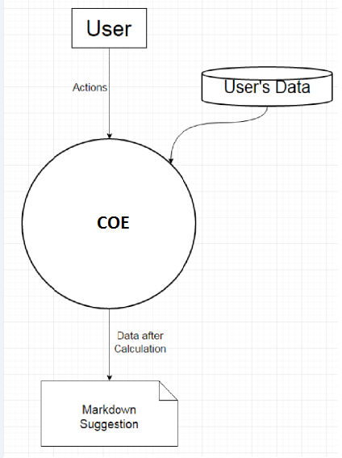
Fig 3.2 Overview of the whole system

The data dictionary:
● Actions: an option from drop down.
● Data after Calculation: HTML and JavaScript.

Level 1

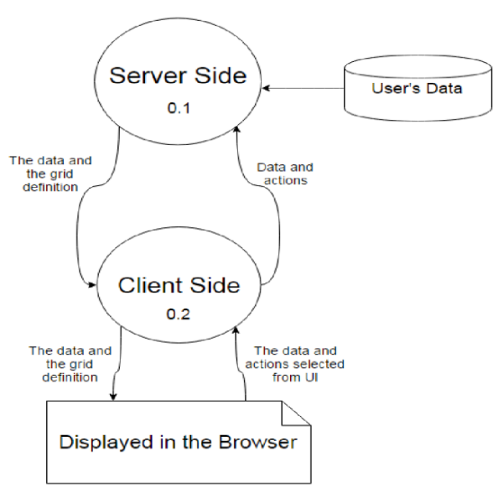
Fig 3.3 The sub parts of the whole system

The data dictionary:
● The data and the grid definition: JSON
● The data and actions selected from UI: drop down, string, integer
● Data and actions: String

Level 2

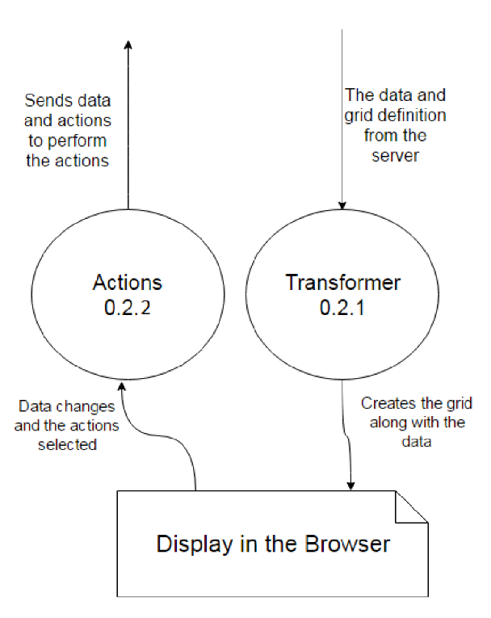
Fig3.4 The sub-parts of the client side system.

The data dictionary:
● Data and actions to perform actions: JSON and String
● The data and the grid definition from the server: JSON
● The grid along with the data: JSON
● Data Changes and actions selected: Option from drop-down, string and integer.

Level 3

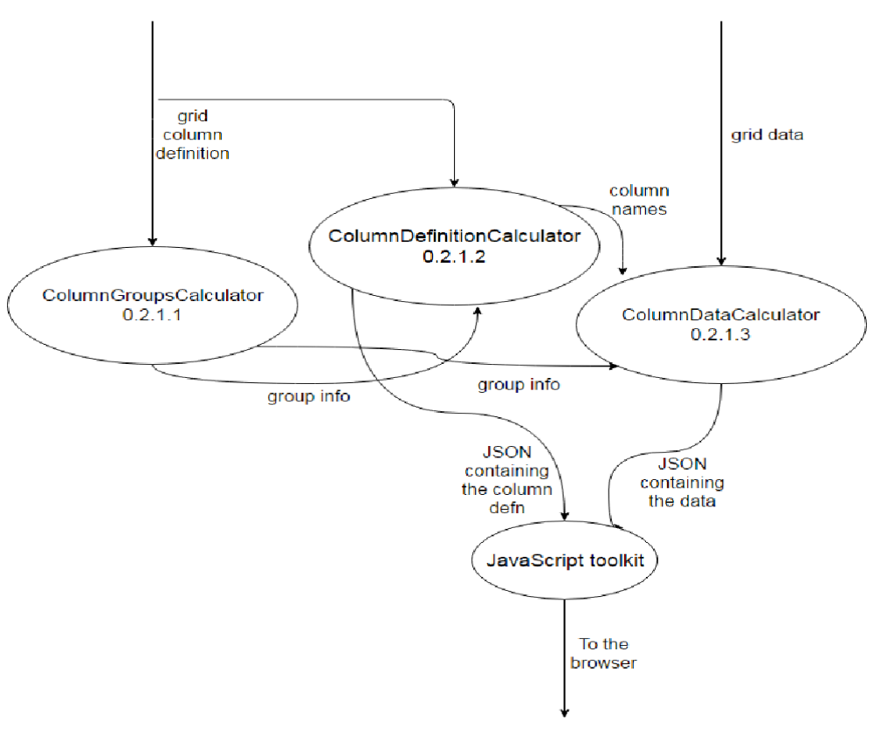
Fig3.5 The sub-parts of the Transformer in the client side.

The data dictionary:
● Grid column definition: JSON
● Grid data: JSON
● Group info: Array
● To the browser: HTML and JavaScript.

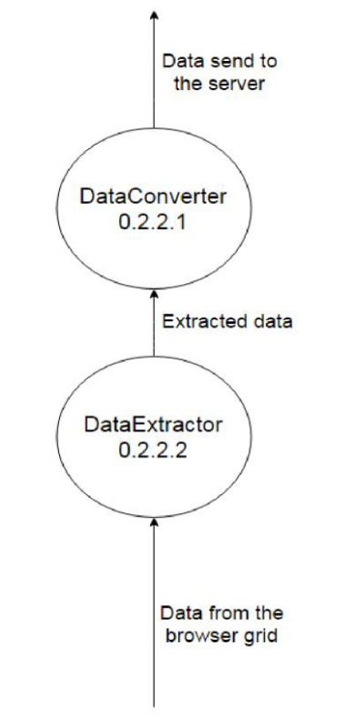
Fig3.6 The sub-parts of the Actions in the client side.

The data dictionary:
● Data send to server: String
● Extracted data: Array, strings and integers
● Data from browser: drop-down menu, integer and strings.

3.2.2 Control Flow graph
The main functions along with their control flow is shown in the diagram, functions with sub-functions are also broken to show their internal control flow:

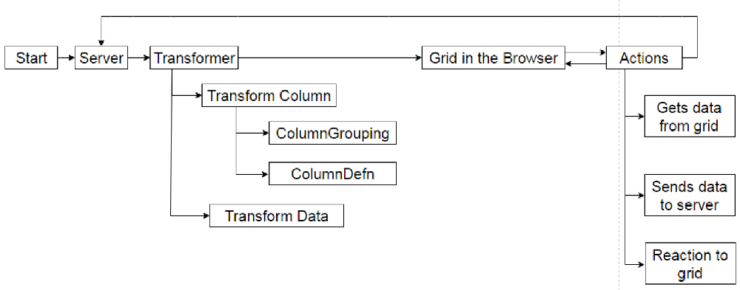
Fig3.7 Control Flow Diagram
3.2.3 Class diagram with interaction

These are the major classes which we re-designed:

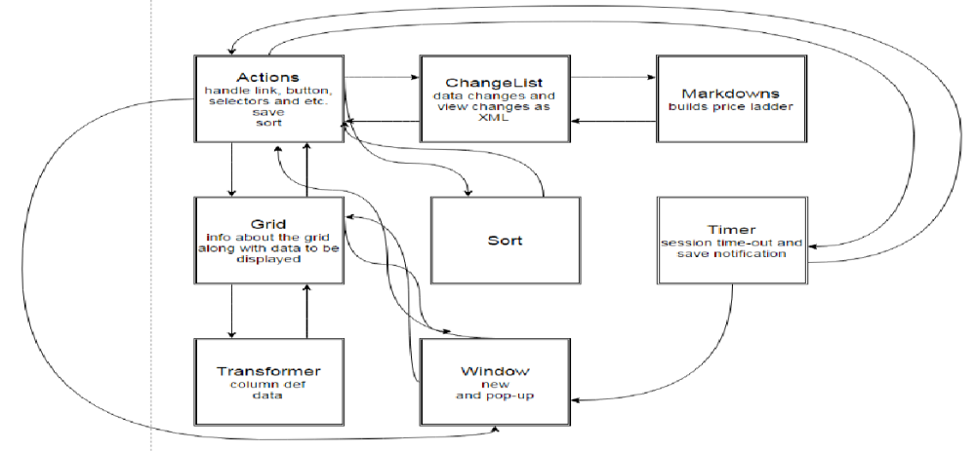
Fig3.8 Class Diagram

3.2.3 Use Cases

The functions that the each type of user can use are shown in the diagram:

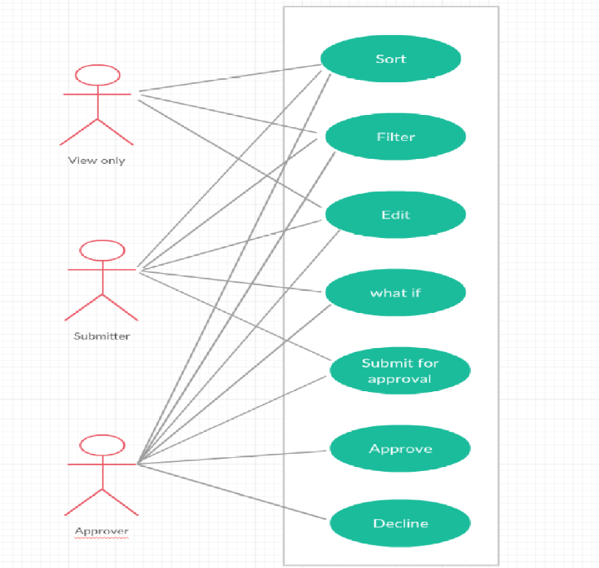
Fig3.9 Usecase Diagram

3.3 TOOLS USED

The following section briefly mentions about the tools and technologies, which are involved in the process of resolution:

BugDB is an oracle’s internal tool where the bugs or issues are logged and users can track the statuses.
Tools used for Debugging – IE Developer Tools

Used Developer Tool of IE 11 to debug source code to large extend with ease. This reduced major effort of making code changes then deploying in server and running again to see effects of changes made. With this, any snippet written is checked then and there in developer tool and if found reasonable can be finally appended in source code as a fix.

The F12 tools is a suite of on-demand tools that is built into every installation of Windows Internet Explorer. F12 tools is available anytime, on any page, and enables website developers to quickly debug JavaScript, HTML, and Cascading Style Sheets(CSS), as well track down performance problems on a webpage or network.

The several features provided are:

● DOM Explorer tool

The DOM Explorer tool enables you to see the arrangement of your webpage as it's being shown in the browser and lets you revise your HTML and styles which will be viewed in a live page
Debugging and development are simplified by:
1. Find out the reason behind an element not shown at the right size or place.
2. We can find out the media queries and CSS elements used on an element.
3. Testing various colors to see which one looks best.

● Console tool

The Console tool allows interaction with the running code:
1. Helps in injecting code into a live site and changing variable values using console’s command line
2. Console Debugging API can be used to send out debug information.
3. Enables you to see browser status codes as well as error messages.
Features:
1. Console Debugging API methods for grouping , counting and timing
2. IntelliSense auto completion suggestions on the command line reduce typos, speed up input .
Development and debugging tasks it makes easier:
1. Targeting specific iFrames.
2. Timing code execution down to the statement with new timing methods.
3. Changing the value of a variable in running code without reloading.

● The Debugger tool (CTRL+3)

You use the Debugger tool to inspect what, when and how your code is doing it. Pause code in mid-execution, step through it by each line, and watch the state of the objects and variables at every step.
Feature:
1. No-refresh debugging means setting your breakpoints and going without reloading and losing state.
2. Tabbed document interface is useful for easier management of multiple scripts.
3. Breakpoints on standard code and events.
Development and debugging tasks it makes easier:
1. Checking what has led to a function call using the Call stack.
2. Making compressed code more readable using source maps.
3. Monitoring web worker creation and execution.

3.4 LIBRARIES USED

To develop the grids LUX (Oracle proprietary) was chosen.

3.4.1 LUX

The GBU Lightweight UI Extensions (LUX) provide common, re-usable business functionality and helper utilities (patterns, utility libraries, and UI components) that GBU teams can use to more quickly create client-side, web-standards based applications. GBU LUX is built using the Oracle JET framework, UI components and additional 3rd party open source libraries. LUX is managed / curate by the GBU Architecture Team.
LUX was originally started as the GBU Lightweight UI Framework, focused on providing a common UI framework for use.
Key goals included:
● Reduce duplication of effort across the GBU's by providing a common client side UI framework.
● Use standard web Technology (HTML5, CSS5, Javascript) and well supported open source libraries (Jquery, JqueryUI, Knockout, Requirejs, etc.) rather than re-implementing needed functionality.
● Support for teams to "contribute" their work so that it can be supported and easily utilized by other teams.

LUX uses the following third party libraries:
● LoDash
● Underscore
● MomentJS
● Handlebars
● D3JS
● DForm
● jQuery File Upload
● Js Plumb

Reasons for using LUX:

Since our main requirement was the data grid, LUX grid supports a range of column types and features such as framing with groups, sorting, menus and inline editing.

Features available in the LUX Data Grid but not available in the OJET Data Grid include:
● Editing of data within grid cells (eg. Text, numeric, time / date, lists, checkboxes, etc.)
● Row manipulation (cut / past, copy, add new, delete, copy multiple, etc.).
● Row and column Drag and Drop
● Column Grouping
● Filter and row Sorting
● Row and Cell Level events (select, edit, save, move, etc.)
● Find and Filter (including type down)

3.4.2 OracleJET

Oracle JavaScript Extension Toolkit (JET) empowers developers by providing a modular open source toolkit based on modern JavaScript, CSS3 and HTML5 design and development principles. Oracle JET is targeted at intermediate to advanced JavaScript developers working on client-side applications. It's a collection of open source JavaScript libraries along with a set of Oracle contributed JavaScript libraries that make it as simple and efficient as possible to build applications that consume and interact with Oracle products and services, especially Oracle Cloud services.
Oracle JET makes use of some popular Open Source libraries:
● JQuery
● JQueryUI
● Knockout
● RequireJS
● Hammer

Other libraries that were used:

JQuery
jQuery is a feature-rich, fast and small JavaScript library. It makes things like document traversal and manipulation, animation, event handling, HTML and Ajax much easier with an easy-to-use API that works across a multitude of browsers. With a combination of versatility and extensibility, jQuery has changed the way that millions of people write JavaScript.

3.5 CODE INSPECTION

Code inspection is carried out after the module is effectively compiled and the all the syntax errors have been removed. It is extremely cost- effective strategies for reduction in coding errors and to produce high quality code.

The main purpose of code inspection is to find some common types of errors caused due
to improper programming.

Following is a list of some classical programming errors which can be checked during code inspection:
- Improper storage allocation and deallocation
- Improper modification of loop variables.
- Use of incorrect logical operators or incorrect precedence among operators.

3.5.1 Code

While setting out on a change, we took a duplicate of the present code base on which to work. As different engineers submit changed code to the source code repository, this duplicate slowly stops to reflect the repository code. The current code base change, as well as new code can be included and also new libraries, and different resources that make dependencies, and potential conflicts.

The more extended a branch of code stays looked at, the more noteworthy the danger of multiple integration conflicts and failures when the designer branch is reintegrated into the mainline. At the point when designers submit code to the repository they should first refresh their code to reflect the adjustments in the repository since they took their duplicate. The more changes the repository contains, the more work designers must do before presenting their own progressions.

In the long run, the repository may turn out to be so different in relation to the designers' baselines that they enter what is infrequently alluded to as "merge hell", or "integration hell", where the time it requires to incorporate surpasses the investment it took to roll out their unique improvements.Continuous integration involves integrating early and often, so as to avoid the pitfalls of "integration hell". The practice expects to decrease rework and accordingly lessen cost and time.

We used TortoiseSVN, it is a free software released under the GNU General Public License. After all the code is written and the other javascripts are edited to get the value from the corresponding grid we do the following:
config.js: contains all the paths for the used libraries.

Define block

It defines a well-scoped object that avoids polluting the global namespace. It can explicitly list its dependencies and get a handle on those dependencies without needing to refer to global objects, but instead receive the dependencies as arguments to the function that defines the module. The RequireJS syntax for modules allows them to be loaded as fast as possible, even out of order, but evaluated in the correct dependency order, and since global variables are not created, it makes it possible to load multiple versions of a module in a page.

define([lib1, lib2, … , libn /*(listed in config)*/ ], function(obj1,obj2, …, objn){
Code to make the grid changes visible instantaneously visible using knockout;
Once a grid is configured, it must be loaded with data. This can be done by statically linking to an existing JSON file, passing in dynamically generated JSON, or by calling a REST service that
provides JSON;
Event handlers like link clicks, updated and all;
Returns the object;
})

Require block

Uses the define block.
require([knockout and the above one], functions(ko, loader) {
bindings are applied;
data is loaded;
})

3.5.2 Build

There is various strides required to change the source into a deployable and useable software solution. The accompanying is a speculative build process you may use with a basic software system
- Get the source. You may need to download or get the source from a source code
repository. You will need the version or tag of the source code you want to build.
- Organize a build area.
- Configure the build. Here, you will find out what optional components can be built based on the present environment. You can set build numbers and version numbers to it.
- Validate the source code.
- Compile the source code
- Build the compiled code into libraries potentially including non-code resources such as properties, images and sound files.
- Run the system's tests to validate the build.
- Build the documentation for the software. This may range from something as simple as collecting text files up to processing content through some form of publishing system to produce the documentation in its final form.
- Package up all of the components of the software _ code, resources, images,
documentation, etc. _ into a deployable package. You might need to produce
several packages in different formats for different target users.
- Deploy the software to some standard location for use or distribution.

CHAPTER 4
RESULT ANALYSIS

This chapter covers the detailed analysis of few of the defects or bugs which were resolved by me. It explains the impact of the issues raised by the customers in their day to day business operations.

4.1 BUG FIXES

Table 4.1 Few bugs solved
BUG ID | ISSUE
1 | Version is displayed as 14.0.4 instead of 14.0.5
2 | The application wasn’t successfully running because of issues in LUX library
3 | &gt; is appearing instead of > in a table
4 | Scroll is half visible when the grid is in filter mode
5 | Last checkbox is not getting selected
6 | Secondary window dialogs are not resizing
7 | Some filtering operations are not working as expected
8 | Horizontal scroll is half visible
9 | Truncated text in revert confirm popup
10 | Truncated text in business rule history page
11 | Size of the seasonality manager
12 | Weekly data not getting truncated
13 | Wrong column count is displayed in print and export
14 | Vertical scroll is missing in the filter table

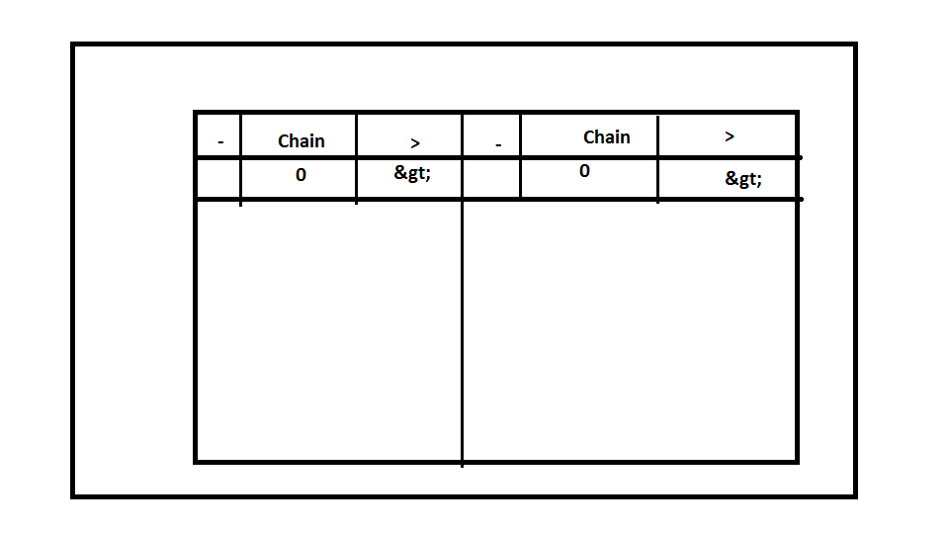
Fig4.1 Bug3 Before fixing the bug
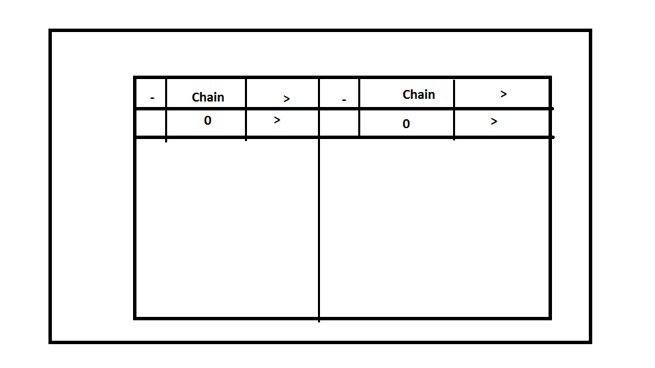
Fig4.2 Bug3 After fixing the bug

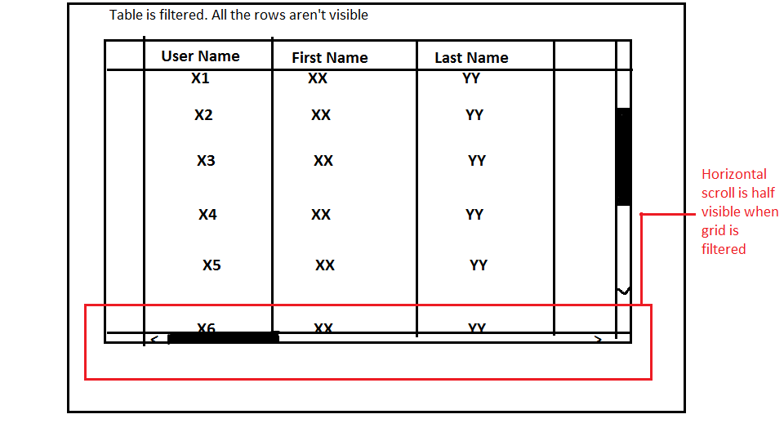
Fig4.3 Bug8

- USER MANAGEMENT: DUPLICATE ENTRIES IN REPLACE ROLE FROM USER DROP DOWN
Expected result: System should throw an error message 'Choose another user or something to that effect
Actual Result: System throws'Unable to perform request due to system error’ message. After clicking OK, system again displays the same error message

- USER MANAGEMENT: DELETION OF FILTER IN CUSTOMIZE TABLE SCREEN
Expected Result: System should throw a message saying `At least check one
filter or something to that effect
Actual Result: System does not throw any message

- BRPM: CHECK BOXES IN BUSINESS RULE HISTORY PAGE
Description:
On Business Rule History page only action available is Print or Export. Still
there are check boxes implying that only the selected records will be printed
or exported. So the check boxes should be removed
- BRPM: DATE FIELD IN BUSINESS RULE HISTORY PAGE
Description:
Dates in Business Rule History page should be a calendar function

4.2 DEVELOPMENT OF COE 14.0.5

4.2.1 Code Drop 1
In code drop 1, Weblogic 11g is replaced by Weblogic server 12c

Weblogic server

Oracle WebLogic Server is an enterprise-ready and scalable Java Platform, Enterprise Edition (Java EE) application server. Its infrastructure chains the deployment of many types of distributed applications and is a perfect base for building applications based on Service Oriented Architectures (SOA). SOA is a design methodology aimed at maximizing the reuse of application services.
The WebLogic Server complete implementation of the Java EE 7.0 specification delivers a standard set of APIs for building distributed Java applications that can access a wide variety of services, such as messaging services, databases and connections to external enterprise systems. End-user clients access these applications using Java or web browser clients. It allows enterprises to deploy mission-critical applications in a secure, highly available, robust and scalable environment.
These features allow enterprises to configure clusters of WebLogic Server instances to distribute load, and provide extra capacity in case of hardware or other failures. New diagnostic tools enable system administrators to view and tune the performance of deployed applications and the WebLogic Server environment itself. You can also configure WebLogic Server to monitor and tune application throughput automatically without human intervention. Extensive security features protect access to services, keep enterprise data secure, and prevent malicious attacks.
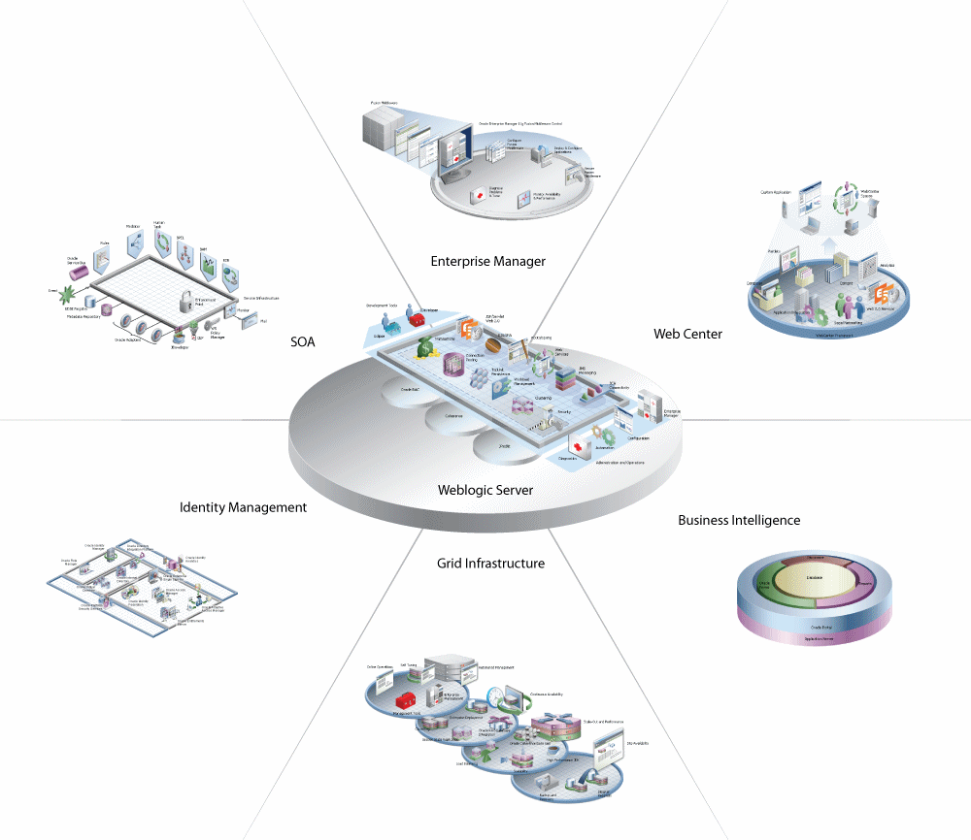
Fig 4.4 Oracle Fusion Middleware Overview

New Features in Weblogic 12c:

WebLogic Server 12c (12.2.1.2.0) includes features like multitenancy support, continuous availability, resource consumption management.

Multitenancy Support

Multitenancy in WebLogic Server offers a sharable framework which is utilized by different associations. These organizations are a conceptual assemblage of your own choosing, which you can consider as tenants. WebLogic Server Multitenant increases density and succeeds a more efficient use of resources while removing the hurdles typically present when trying to segment multiple applications.

Continuous Availability

Oracle WebLogic Server Continuous Availability delivers an integrated resolution for building maximum availability architectures (MAA) that extent data centers across distributed geographical locations. Integrated components include Oracle WebLogic Server, Oracle Coherence, Oracle Traffic Director, Oracle SiteGuard, and Oracle Database.
Java EE 7 Support

Oracle WebLogic Server 12.2.1.2.0 is a fully compatible implementation of the Java Platform, Enterprise Edition (Java EE) Version 7.0. Java EE 7 permits developers to make use of the newest innovations in the Java Enterprise APIs, which include new programming models, as well as combining, enhancing, and in some cases simplifying existing specifications.

4.2.2 Code Drop 2

In this code drop, the LUX Library is upgraded from 2.0 to 2.3
The coding changes were already explained in code inspection

4.2.3 Code Drop 3

This was entirely based on fixing the bugs which still exist in the latest version of COE

Table 4.2 List of bugs

NoNoNO | List of Bugs
1 | USER MANAGEMENT: SYSTEM ALLOWS CREATION OF 2 USERS WITH SAME LOGIN NAME
2 | BRPM: FILTERING BY HIERARCHY CAUSES AUTO EXPANSION OF COLLAPSED COLUMNS
3 | BRPM: AUTO EXPANSION OF COLLAPSED COLUMNS
4 | BRPM: BEHAVIOR OF > IN MERCHANDISE AND LOCATION SECTION
5 | USER MANAGEMENT: DUPLICATE ENTRIES IN REPLACE ROLE FROM USER DROP DOWN
6 | USER MANAGEMENT: CHOOSING SAME ROLE IN REPLACE ROLES FROM USERS DROPDOWN
7 | HELP: CONSISTENCY OF HELP ACROSS MULTIPLE FUNCTIONALITIES
8 | SEASONALITY MANAGER: SIZE OF THE SEASONALITY MANAGER
9 | SEASONALITY MANAGER: COLUMN FORMATTING IN NEW CURVES SECTION
10 | SEASONALITY MANAGER: ZOOM CHART WHEN MIN MAX DATES ARE VERY CLOSE
11 | SEASONALITY MANAGER: INVALID DATES IN ZOOM CHART STILL SHOWS RESULT
12 | SEASONALITY MANAGER: ZOOM CHART DOES NOT THROW AN ERROR WHEN NO DATES ARE GIVEN
13 | SEASONALITY MANAGER: MIN MAX DATE FORMAT
14 | BRPM: TRUNCATED TEXT IN REVERT CONFIRM POPUP
15 | PRICING GROUP MANAGER: HIERARCHY 4,5,6 DATA IS NOT VISIBLE
16 | BRPM: SCROLLBAR BEHAVIOR IN BUSINESS RULE HISTORY PAGE
17 | BRPM: TRUNCATED TEXT IN BUSINESS RULE HISTORY PAGE
18 | BRPM: CHECK BOXES IN BUSINESS RULE HISTORY PAGE
19 | BRPM: DATE FIELD IN BUSINESS RULE HISTORY PAGE
20 | BRPM: TRUNCATED TEXT UNDER SHOW RULES SECTION
21 | PRINT OR EXPORT: WRONG SAVE AS TYPE WHILE EXPORTING USER DATA TO EXCEL
22 | USER MANAGEMENT: DELETION OF FILTER IN CUSTOMIZE TABLE SCREEN
23 | BULKLOADER.SH IS FAILING
24 | USER MANAGEMENT: SCROLLING IN ROLE ASSIGNMENT SCREEN
25 | USER MANAGEMENT: INCORRECT POINTER IN ROLE ASSIGNMENT SCREEN
26 | USER MANAGEMENT: ROLE ASSIGNMENT WINDOW TOO NARROW FOR EFFECTIVE FUNCTIONING
27 | NEW GRID OR DUPLICATE GRID CREATION IS NOT HAPPENING SOMETIME
28 | GRID DESIGNER - SEARCH MESSAGE TITLE IS NOT WORKING
29 | GRID DESIGNER - HELP IS NOT WORKING
30 | GRID DESIGNER - ISSUE WITH VIEW ->SORT
31 | GRID DESIGNER - HIDDEN COLUMNS ARE NOT LISTED IN THE VIEW -> COLUMN
32 | GRID DESIGNER - VALIDATION LOG IS NOT FETCHING THE DATA
33 | GRID DESIGNER - GRID EDITOR IS SHOWS ERROR MESSAGES FOR SOME FIELDS
34 | GRID DESIGNER - ITEM DETAILS LAYOUT WORKS DIFFERENTLY IN CODE DROP 2
35 | GRID DESIGNER THROWS JAVA NULL POINTER EXCEPTION
36 | GRID DESIGNER IS THROWING SYSTEM EXCEPTION
37 | USER MANAGEMENT: CAN NOT MAXIMIZE MANAGE USERS WINDOW
38 | ABOUT SECTION: OK BUTTON IN ABOUT SECTION IS NOT COMPLETELY VISIBLE
39 | TIME OUT IS NOT HAPPENING IN PRICING GROUP MANAGER
40 | VERSION DISPLAYS AS 14.0.4
41 | BRPM - COLUMN UNDER > UNDER MERCHANDISE AND LOCATION DISPLAYS &GT;
42 | PRINT OR EXPORT -COLUMN COUNT DISPLAYING WRONG COUNTS
43 | PRINT-SINGLE SHEET IS PRINTING FOR THE PRINT OPTION
44 | HELP SECTION-VIEW TOPIC INTERFACE SEEMS DIFFERENT
45 | HELP-DOCUMENTATION ON THE OTN MOVED OR DELETED OR BROKEN
46 | HELP SECTION -CLICKING ON LEGAL NOTICES, JUST SCROLLS UP THE PAGE
47 | USER MANAGEMENT-SCROLL DOWN AND MOUSE OVER ON SCROLL GRID MOVING UP
48 | USER MANAGEMENT-VERTICAL SCROLL MISSING IN FILTER TABLE
49 | USER MANAGEMENT-FILTER TABLE VERTICAL SCROLL NOT WORKING
50 | USER MANAGEMENT-TWO HORIZONTAL SCROLLS FOUND IN USER MANAGEMENT GRID
51 | SEASONALITY MANAGER-COLLPASED COLUMNS IN SEASONALITY GRID
52 | HELP SECTION- FOR TOPIC NOT FOUND CASES UI AND LOGO HEADER SECTION DISAPPEARS
53 | EN AT THE END OF THE PAGE IN HELP AS A LINK
54 | HELP'S SECTION VIEW TOPIC INTERFACE LOOKS DIFFERENT
55 | PRICING GROUP MANAGER-ON MOUSE OVER ,MOUSE POINTER CHNAGES TO LINK SELECTOR.ODT
56 | BRPM-MOUSE POINTER CHANGING IN TO LINK SELECT POINTER ON THE EXPAND CONTROL
57 | BRPM-FILTER SECTION COMPLETELY NOT VISIBLE HAVE TO SCROLL EACH TIME
58 | EDIT PRICING GROUP-ADD ITEMS AND REMOVE ITEMS LAST CHECK BOX NOT ABLE TO UNCHECK
59 | PRICING GROUP VISIBLE LAST CHECK BOX-CHECK AND UNCHECK NOT ABLE TO PERFORM
60 | USER MANAGEMENT-ROLE ASSIGNMENT-NOT ABLE TO UNCHECK THE SELECTED LAST CHECKBOX
61 | USER MANAGEMENT-NOT ABLE TO UNCHECK THE SELECTED LAST VISIBLE CHECKBOX
62 | USER MANAGEMENT-ADD ROLE ASSIGNMENT MERCHANDISE SUCCEDING HIERARCHY CANT SELECT
63 | USER MANAGEMENT -HORIZONTAL SCROLL HALF VISIBLE
64 | MANAGE USERS-LAST VISIBLE USER ABOVE THE HORIZONTAL SCROLL NOT ABLE TO CLICK OFF
65 | USER MANAGEMENT-NOT ABLE TO SELECT THE LAST ROLE WHICH IS VISIBLE IN THE WINDOW
66 | PGM-HORIZONTAL SCROLL REPOSITIONING TO THE SCROLL START ON USING MOUSE
67 | PRICING GROUP MANAGER-SOME FILTER OPTIONS NOT FILTERING AS EXPECTED
68 | PRICING GROUP MANAGER-TABLE BODY IS NOT IN MOVEMENT WITH THE TABLE HEADER
69 | PRICING GROUP MANAGER-ITEM INFO'S EDIT BUSINESS RULE ALTERING THE WORKSHEET AREA
70 | BRPM-NAVIGATING TO UPPER LEVELS IS NOT POSSIBLE ONCE MOVED TO LOWER LEVELS
71 | COE-PRINT OR EXPORT WINDOW IS NOT TERMINATING WHEN CLICKING ON DESIRED BUTTONS
72 | BRPM-BUSINESS RULES COLUMNS WHOLE TEXT IS NOT VISIBLE WITH THE + AND – CONTROL
73 | PRICING GROUP MANAGER-COLUMN SORT(ASCENDING & DESCENDING) NOT SORTING THE TABLE
74 | USER MANAGEMENT-MOST OF THE SECONDARY WINDOWS NOT RESIZING WHEN DRAGGED
75 | SECONDARY WINDOW CONTENTS ARE NOT RESIZING ACCORDING TO THE WINDOW RESIZING

CHAPTER 5
CONCLUSION AND FUTURE SCOPE

A brief summary of the work done in the project including the problem statement and the work methodology adopted is discussed. The conclusions and significance of the results obtained and the future scope of work in this field are observed.

5.1 SUMMARY

The reliable and efficient code lines had been delivered to the customer with the help of Sustenance Engineering on COE(Oracle Retail Clearance Optimization Engine), and had made profits for Oracle Retail. Sustenance Engineering thus extends the life of a product. The project aims to develop the COE patch release 14.0.5. This includes three code drops. The first one is replacing weblogic server 11g with weblogic server 12c. The methodology used for fixing bugs is the customer raises a service request. The COE SE team will give the solution. And finally the solution is sent to the customer.

5.2 CONCLUSION

After the three code drops the COE patch release 14.0.5 is deployed. This is basically done for the customers who are using other oracle products which run on the latest versions of weblogic server and LUX. The past six months at Oracle India was an excellent opportunity for me to gain some hands on experience in the software engineering field.I have acquired many new skills and improved many existing ones, working in a team based environment, dealing with management and customers, and presentation and communication skills. It was nice experience of learning so many new technologies and the way it is implemented in such a huge organization like Oracle. Got opportunity to work in highly experienced team so learned a lot from them. Overall technical exposure in this tenure of internship was very knowledge gaining and helped me understanding way of work in a well settled organization.

5.3 FUTURE SCOPE OF WORK

Oracle Retail has so many products and supports around 23 different languages. It has huge investments on third party vendors for translation. So a translator can be designed to minimize this investment in terms of cost and effort to some extent. We can also include the audio system, to pronounce the generated sentences. We can also try to support the translation of Indian languages.
REFERENCES

[1] "Oracle Retail Clearance Optimization Engine Documentation Library".
Docs.oracle.com. N.p., 2017. Web. 6 Apr. 2017.
[2] "VPAT - GBU Lightweight UI Extensions (LUX) 1.1.1". Oracle.com. N.p., 2017.
Web. 6 Apr. 2017.
[3] "Understanding Administration Console Extensions". Docs.oracle.com. N.p., 2017.
Web. 6 Apr. 2017.
[4] "F12 Devtools Guide". Docs.microsoft.com. N.p., 2017. Web. 6 Apr. 2017.
[5] "Oracle JET 3.0.0". Docs.oracle.com. N.p., 2017. Web. 6 Apr. 2017.

PROJECT DETAILS

Student Details
Student Name | HEMA SAI AISHWARYA V
Register Number | 130905580 | Section / Roll No | B- 50
Email Address | aishwaryavhs07@gmail.com | Phone No (M) | 9980553970
Project Details
Project Title | DEVELOPMENT AND DEBUGGING OF COE
Project Duration | 6 months | Date of reporting | 04.01.2017
Organization Details
Organization Name | ORACLE Retail
Full postal address with pin code | Oracle India Pvt Ltd.  Prestige Technology Park -III, Valence Building,  Sy.No. 110/1,2&3  Amane Bellandur Khane Village,  Varthur Hobli,  Marathahalli Ring Road,  Bangalore 560103 Karnataka , India
Website address | https://www.oracle.com
External Guide Details
Name of the Guide | Mr. Sunil Chowdary
Designation | Senior Manager, Software Development,  RGBURD ISC Apps Sustaining Eng
Full contact address with pin code | Oracle India Pvt Ltd,  Prestige tech park-III, Valence block, Marathahalli ring road, Bangalore-560103
Email address | sunil.chowdary@oracle.com | Phone No (M) | +918066050782,  +919886353999
Internal Guide Details
Faculty Name | Mr. Prakash K Aithal
Full contact address with pin code | Dept of Computer Science & Engg, Manipal Institute of Technology, Manipal – 576 104 (Karnataka State), INDIA
Email address | prakash.aithal@manipal.edu

