An AIT Lab Project Report on

“SuperMarket Website”

Submitted by

Hema Sai Aishwarya V

Roll-50

130905580

7th sem B sec

Department of Computer Science & Engineering



**Summary**

The website is for the supermarket customers and employees.

**Admin or Employee Side:**

*Login Page:*

An employee or a manager can login by entering the username and password present in the employee database. If the details entered are correct, he/she can enter the employee profile.

Sessions are used for the state management here. The username of the employee gets saved into the session variable

*Employee Profile:*

Mainly consists of these functions:

* Adding a new product
* Displaying the inventory to the manager ( manager password should be entered)
* Bill generation by taking the serial number of the transaction as input
* Price of an item can be changed by the manager (password should be entered)
* The employee can logout from the profile when ever he/she wants.

Update and display Page:

Here, the employee can add new products to the inventory by entering details like product name, price, quantity, image etc. The data gets updated as soon as submitted.

A wizard is used to show both the update and display pages here. Displaying the inventory is done using the gridview control.

Bill Generation Page:

Gridview control and data access is used to retrieve information from database and display on the webpage.

Change Price Page:

Here, the details of the product along with a new price is entered into the form. This new price will get updated to the database. Along with this the profit obtained will also change accordingly. Here two dropdownlists are present. The products are displayed in the second dropdownlist according to the category selected in the first dropdownlist. QueryString is used for moving from one page to another.

**Customer Side:**

*Signup Page:*

A new user can create an account by entering his/her details into the signup form. Validations are used here. If the required forms are not entered, error is shown. If the fields do not match the required validations, error is shown. If the details are correctly entered, the user account is created.

*Login Page:*

Session variable ‘new’ is created for login session. Logout will destroy the variable immediately.

If the correct username and password are entered, the page is redirected to the customer’s profile page

*Profile Page:*

Here, the previous orders placed by the customer logged in will be displayed in the form of gridview. The data is retrieved from the database tables.

*Bill Generation Page:*

Here the serial number of transaction is given as input to obtain the bill. The bill contains details in the gridview. The total amount payable is also displayed here by using the suitable query.

MultiView control is used here.

**Main Website Pages:**

*Home Page:*

AdRotator control is used here to display banners of the webite. Xml file is created and added to the AdRotator as the XmlDataSource

*Product Pages:*

This includes electronics ,food, clothing pages.

All the three pages consists of AdRotator control to display pictures belonging to that category.

Here , a gridview containing the list of items and their prices are displayed.

Dropdownlists can be used to select the product and quantity, if enough amount is there in the inventory the request is accepted . Otherwise, ‘product out of stock’ is displayed in a label.

The user can further proceed towards billing process where the bill is generated.

**Pages:**

**Employee Side:**

**Login Page:**

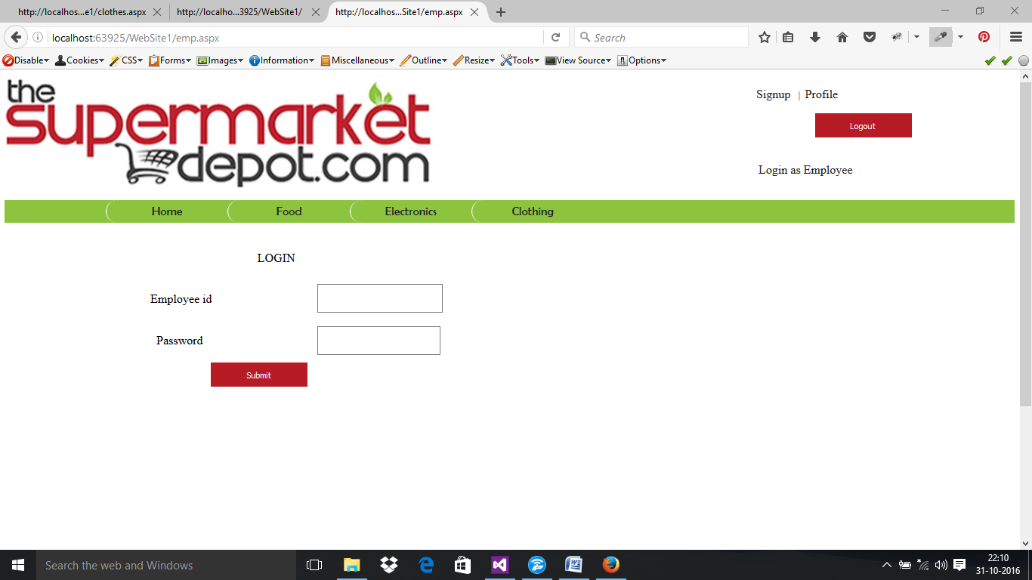

ASPX FILE:

<%@ Page Title="" Language="C#" MasterPageFile="~/MasterPage.master" Theme="Theme1" AutoEventWireup="true" CodeFile="emp.aspx.cs" Inherits="emp" %>

<asp:Content ID="Content1" ContentPlaceHolderID="head" Runat="Server">

<style type="text/css">

#Password1 {

width: 200px;

margin-left: 0px;

}

.auto-style1 {

height: 26px;

}

.auto-style2 {

height: 26px;

width: 266px;

}

.auto-style3 {

width: 266px;

}

.auto-style4 {

height: 26px;

width: 202px;

}

.auto-style5 {

width: 202px;

}

</style>

</asp:Content>

<asp:Content ID="Content2" ContentPlaceHolderID="ContentPlaceHolder1" Runat="Server">

<div class="left1">

<div class="form1">

<p>

&nbsp;&nbsp;&nbsp;&nbsp;&nbsp;&nbsp;&nbsp;&nbsp; </p>

<p>

LOGIN&nbsp;</p>

<p>

<table style="width:48%;">

<tr>

<td class="auto-style2">

<p>

&nbsp;Employee id&nbsp;&nbsp;&nbsp;&nbsp;&nbsp;&nbsp;&nbsp;&nbsp;&nbsp;&nbsp;&nbsp;

</p>

</td>

<td class="auto-style4">

<asp:TextBox ID="TextBox1" runat="server" style="margin-bottom: 2px" Width="200px"></asp:TextBox>

</td>

<td class="auto-style1"></td>

</tr>

<tr>

<td class="auto-style3">

<p style="width: 277px">

&nbsp;&nbsp;&nbsp;Password&nbsp;&nbsp;&nbsp;&nbsp;&nbsp;&nbsp;&nbsp;&nbsp;&nbsp;&nbsp;&nbsp;&nbsp;&nbsp; &nbsp;&nbsp;&nbsp;&nbsp;&nbsp;&nbsp; </p>

</td>

<td class="auto-style5">

<asp:TextBox ID="TextBox2" runat="server" TextMode="Password" Width="196px"></asp:TextBox>

</td>

<td>&nbsp;</td>

</tr>

<tr>

<td class="auto-style3"> &nbsp;&nbsp;&nbsp;&nbsp;&nbsp;&nbsp;&nbsp;&nbsp;&nbsp;&nbsp;&nbsp;&nbsp;&nbsp;&nbsp;&nbsp;&nbsp;&nbsp;&nbsp;&nbsp;&nbsp;

<asp:Button ID="Button1" runat="server" Text="Submit" class="b1" OnClick="Button1_Click" />

</td>

<td class="auto-style5">&nbsp;</td>

<td>&nbsp;</td>

</tr>

</table>

</p>

<p>

&nbsp;</p>

<p>

</div>

</div>

</asp:Content>

.CS FILE:

using System;

using System.Collections.Generic;

using System.Linq;

using System.Web;

using System.Web.UI;

using System.Web.UI.WebControls;

using System.Data;

using System.Data.SqlClient;

using System.Configuration;

public partial class emp : System.Web.UI.Page

{

SqlConnection con = new SqlConnection(ConfigurationManager.ConnectionStrings["supermarket"].ConnectionString);

protected void Page_Load(object sender, EventArgs e)

{

}

protected void Button1_Click(object sender, EventArgs e)

{

con.Open();

string checkuser = "select count(*) from employees where empid='" + TextBox1.Text + "'";

SqlCommand cmd = new SqlCommand(checkuser, con);

int temp = Convert.ToInt32(cmd.ExecuteScalar().ToString());

con.Close();

if (temp == 1)

{

con.Open();

string checkpass = "select pass from employees where empid='" + TextBox1.Text + "'";

SqlCommand passcmd = new SqlCommand(checkpass, con);

string password = passcmd.ExecuteScalar().ToString().Replace(" ", "");

if (password == TextBox2.Text)

{

Session["newemp"] = TextBox1.Text;

Response.Write("Login successful!");

Response.Redirect("~/admin/empprofile.aspx");

}

else

Response.Write("Login unsuccessful! Please try again" );

}

else

Response.Write("Login unsuccessful! Please try again" + temp);

}

}

**Employee Profile Page:**

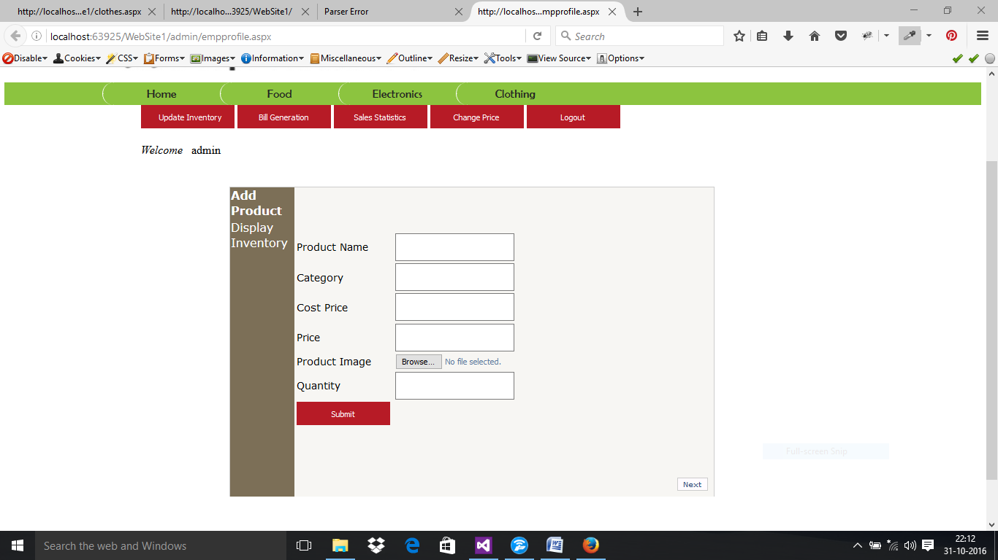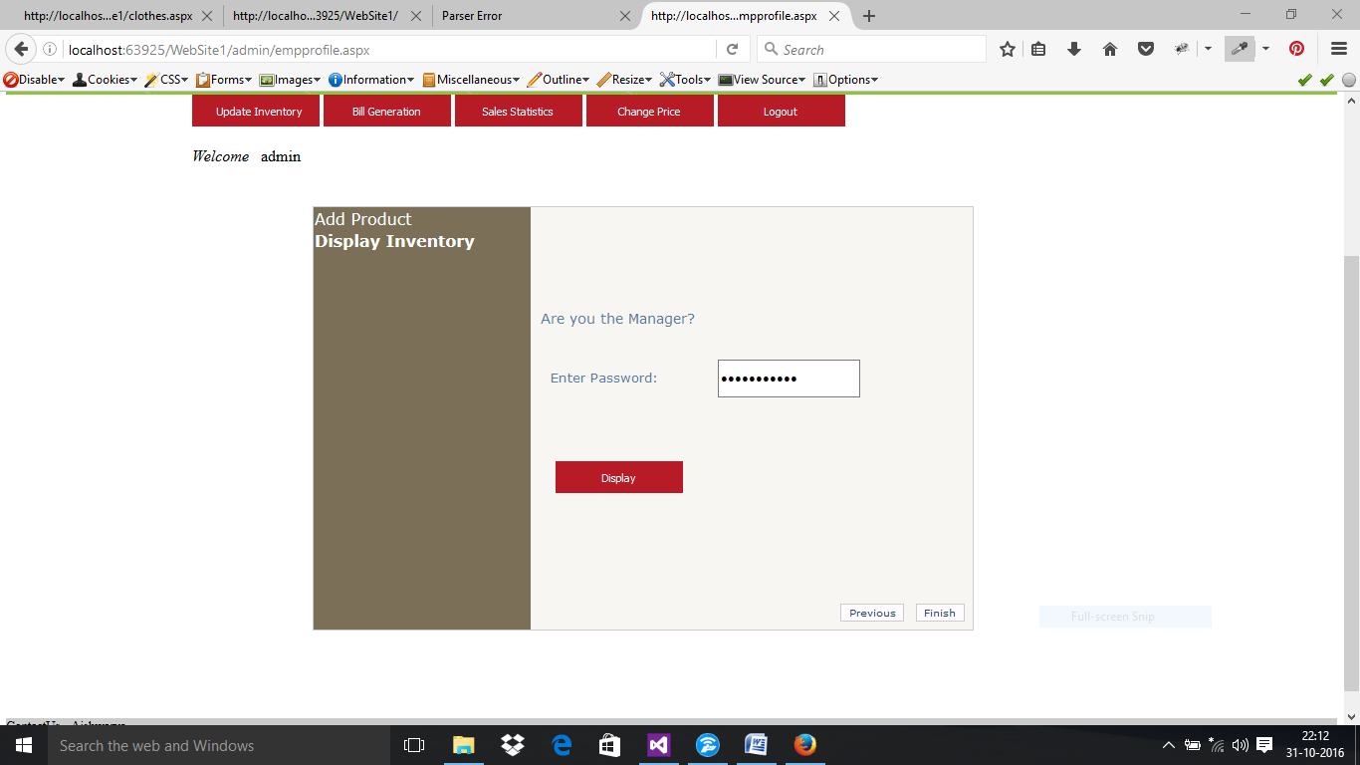

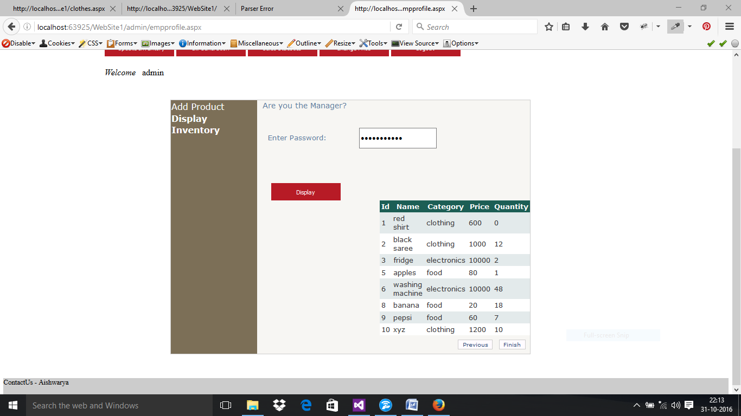

**.ASPX FILE:**

<%@ Page Title="" Language="C#" MasterPageFile="~/MasterPage.master" Theme="Theme1" AutoEventWireup="true" CodeFile="empprofile.aspx.cs" Inherits="admin_empprofile" %>

<asp:Content ID="Content1" ContentPlaceHolderID="head" Runat="Server">

</style>

</asp:Content>

<asp:Content ID="Content2" ContentPlaceHolderID="ContentPlaceHolder1" Runat="Server">

<div class="left1">

<div class="form1">

<asp:Button ID="Button3" class="b1" runat="server" OnClick="Button3_Click" Text="Update Inventory" Width="150px" />

<asp:Button ID="Button4" class="b1" runat="server" OnClick="Button4_Click" Text="Bill Generation" Width="150px" />

<asp:Button ID="Button5" class="b1" runat="server" OnClick="Button5_Click" Text="Sales Statistics" Width="150px" />

<asp:Button ID="Button6" class="b1" runat="server" OnClick="Button6_Click" Text="Change Price" Width="150px" />

<asp:Button ID="Button8" class="b1" runat="server" Text="Logout" Width="150px" OnClick="Button8_Click" />

<br />

<br />

<asp:Label ID="Label9" runat="server" Text="Welcome" Font-Italic="True"></asp:Label>

&nbsp;

<asp:Label ID="Label10" runat="server"></asp:Label>

<br />

<br />

<br />

<asp:Wizard ID="Wizard1" runat="server" BackColor="#F7F6F3" BorderColor="#CCCCCC" BorderStyle="Solid" BorderWidth="1px" Font-Names="Verdana" Font-Size="0.8em" Height="532px" ActiveStepIndex="0" Width="829px" style="margin-left: 152px" OnFinishButtonClick="Wizard1_FinishButtonClick">

<HeaderStyle BackColor="#5D7B9D" BorderStyle="Solid" Font-Bold="True" Font-Size="0.9em" ForeColor="White" HorizontalAlign="Left" />

<NavigationButtonStyle BackColor="#FFFBFF" BorderColor="#CCCCCC" BorderStyle="Solid" BorderWidth="1px" Font-Names="Verdana" Font-Size="0.8em" ForeColor="#284775" />

<SideBarButtonStyle BorderWidth="0px" Font-Names="Verdana" ForeColor="White" />

<SideBarStyle BackColor="#7C6F57" BorderWidth="0px" Font-Size="0.9em" VerticalAlign="Top" />

<StepStyle BorderWidth="0px" ForeColor="#5D7B9D" />

<WizardSteps>

<asp:WizardStep runat="server" title="Add Product">

<table style="width: 60%; height: 107px;">

<tr>

<td class="auto-style19">

<asp:Label ID="Label3" runat="server" Font-Size="18px" ForeColor="Black" Text="Product Name"></asp:Label>

</td>

<td class="auto-style20">

<asp:TextBox ID="TextBox1" runat="server" Width="196px"></asp:TextBox>

</td>

<td class="auto-style21"></td>

</tr>

<tr>

<td class="auto-style17">

<asp:Label ID="Label4" runat="server" Font-Size="18px" ForeColor="Black" Text="Category"></asp:Label>

</td>

<td class="auto-style15">

<asp:TextBox ID="TextBox2" runat="server" Width="196px"></asp:TextBox>

</td>

<td class="auto-style13"></td>

</tr>

<tr>

<td class="auto-style18">

<asp:Label ID="Label14" runat="server" Font-Size="18px" ForeColor="Black" Text="Cost Price"></asp:Label>

</td>

<td class="auto-style16">

<asp:TextBox ID="TextBox6" runat="server" Width="196px"></asp:TextBox>

</td>

<td class="auto-style14">

<br />

<br />

</td>

</tr>

<tr>

<td class="auto-style18">

<asp:Label ID="Label5" runat="server" Font-Size="18px" ForeColor="Black" Text="Price"></asp:Label>

</td>

<td class="auto-style16">

<asp:TextBox ID="TextBox3" runat="server" Width="196px"></asp:TextBox>

</td>

<td class="auto-style14">

<br />

<br />

</td>

</tr>

<tr>

<td class="auto-style4">

<asp:Label ID="Label6" runat="server" Font-Size="18px" ForeColor="Black" Text="Product Image"></asp:Label>

</td>

<td class="auto-style5">

<asp:FileUpload ID="FileUpload1" runat="server" />

</td>

<td>&nbsp;</td>

</tr>

<tr>

<td class="auto-style7">

<asp:Label ID="Label7" runat="server" Font-Size="18px" ForeColor="Black" Text="Quantity"></asp:Label>

</td>

<td class="auto-style8">

<asp:TextBox ID="TextBox4" runat="server" Width="196px"></asp:TextBox>

</td>

<td class="auto-style9"></td>

</tr>

<tr>

<td class="auto-style2">

<asp:Button ID="Button2" class="b1" runat="server" OnClick="Button2_Click" Text="Submit" />

</td>

<td class="auto-style6">

<asp:Label ID="Label8" runat="server" Font-Size="18px" ForeColor="Black"></asp:Label>

</td>

<td class="auto-style3">&nbsp;</td>

</tr>

</table>

</asp:WizardStep>

<asp:WizardStep runat="server" title="Display Inventory">

&nbsp; <asp:Label ID="Label11" runat="server" Text="Are you the Manager?" Font-Size="18px"></asp:Label>

<br />

<br />

<br />

&nbsp; &nbsp; <asp:Label ID="Label12" runat="server" Text="Enter Password:" Font-Size="16px"></asp:Label> &nbsp; &nbsp;&nbsp;&nbsp;&nbsp;&nbsp;&nbsp; &nbsp; <asp:TextBox ID="TextBox5" runat="server" OnTextChanged="TextBox5_TextChanged" TextMode="Password"></asp:TextBox>

<br />

<br />

&nbsp;&nbsp;&nbsp;

<asp:Label ID="Label13" runat="server" Font-Italic="True" Font-Size="16px"></asp:Label>

<br />

<br />

<br />

<asp:Button ID="Button7" runat="server" class="b1" OnClick="Button7_Click1" Text="Display" Width="100px" Height="27px" style="margin-left: 32px" />

<br />

<asp:GridView ID="GridView1" runat="server" BackColor="White" BorderColor="#DEDFDE" BorderStyle="None" BorderWidth="1px" CellPadding="4" ForeColor="Black" GridLines="Vertical" Visible="False" AutoGenerateColumns="False" style="margin-left: 27px">

<AlternatingRowStyle BackColor="White" />

<FooterStyle BackColor="#CCCC99" />

<HeaderStyle BackColor="#6B696B" Font-Bold="True" ForeColor="White" />

<PagerStyle BackColor="#F7F7DE" ForeColor="Black" HorizontalAlign="Right" />

<RowStyle BackColor="#F7F7DE" />

<SelectedRowStyle BackColor="#CE5D5A" Font-Bold="True" ForeColor="White" />

<SortedAscendingCellStyle BackColor="#FBFBF2" />

<SortedAscendingHeaderStyle BackColor="#848384" />

<SortedDescendingCellStyle BackColor="#EAEAD3" />

<SortedDescendingHeaderStyle BackColor="#575357" />

<Columns>

<asp:TemplateField HeaderText="Id">

<ItemTemplate>

<asp:Label ID="label1" runat="server" Text='<%#Eval("id") %>'></asp:Label>

</ItemTemplate>

</asp:TemplateField>

<asp:TemplateField HeaderText="Name">

<ItemTemplate>

<asp:Label ID="label2" runat="server" Text='<%#Eval("name") %>'></asp:Label>

</ItemTemplate>

</asp:TemplateField>

<asp:TemplateField HeaderText="Category">

<ItemTemplate>

<asp:Label ID="label3" runat="server" Text='<%#Eval("category") %>'></asp:Label>

</ItemTemplate>

</asp:TemplateField>

<asp:TemplateField HeaderText="Price">

<ItemTemplate>

<asp:Label ID="label4" runat="server" Text='<%#Eval("price") %>'></asp:Label>

</ItemTemplate>

</asp:TemplateField>

<asp:TemplateField HeaderText="Quantity">

<ItemTemplate>

<asp:Label ID="label5" runat="server" Text='<%#Eval("quantity") %>'></asp:Label>

</ItemTemplate>

</asp:TemplateField>

</Columns>

</asp:GridView>

</asp:WizardStep>

</WizardSteps>

</asp:Wizard>

</div>

</div>

</asp:Content>

**.CS FILE**

public partial class admin_empprofile : System.Web.UI.Page

{

SqlConnection con = new SqlConnection(ConfigurationManager.ConnectionStrings["supermarket"].ConnectionString);

protected void Page_Load(object sender, EventArgs e)

{

if (Session["newemp"] != null)

{

Label10.Text = Session["newemp"].ToString();

}

else

Response.Redirect("~/emp.aspx");

}

protected void Button3_Click(object sender, EventArgs e)

{

Response.Redirect("~/admin/empprofile.aspx");

}

protected void Button4_Click(object sender, EventArgs e)

{

Response.Redirect("~/admin/bill.aspx");

}

protected void Button5_Click(object sender, EventArgs e)

{

Response.Redirect("~/admin/salesstats.aspx");

}

protected void Button6_Click(object sender, EventArgs e)

{

Response.Redirect("~/admin/changeprice.aspx");

}

protected void Button2_Click(object sender, EventArgs e)

{

if (FileUpload1.HasFile)

{

//image upload

string str = FileUpload1.FileName;

FileUpload1.PostedFile.SaveAs(Server.MapPath(".")+"//uploads//"+str);

string path = "~//uploads//" + str.ToString();

int temp1 = Convert.ToInt32(TextBox3.Text);

int temp2 = Convert.ToInt32(TextBox6.Text);

int temp3 = temp1 - temp2; //calculate profit

con.Open();

SqlCommand cmd = new SqlCommand("insert into products values('" + TextBox1.Text + "','" + TextBox2.Text + "','" + TextBox3.Text + "','" + path + "','" + TextBox4.Text + "','" + TextBox6.Text + "','" + temp3 + "')", con);

cmd.ExecuteNonQuery();

con.Close();

Label8.Text="uploaded!!";

GridView1.Visible = true;

SqlDataAdapter da = new SqlDataAdapter("select * from products", con);

DataTable dt = new DataTable();

da.Fill(dt);

GridView1.DataSource = dt;

DataBind();

}

else

{

Label8.Text="Please upload an image!";

}

}

protected void Wizard1_FinishButtonClick(object sender, WizardNavigationEventArgs e)

{

GridView1.Visible = true;

SqlDataAdapter da = new SqlDataAdapter("select * from products", con);

DataTable dt = new DataTable();

da.Fill(dt);

GridView1.DataSource = dt;

DataBind();

}

protected void Button7_Click1(object sender, EventArgs e)

{

if (TextBox5.Text == "managerpass")

{

GridView1.Visible = true;

SqlDataAdapter da = new SqlDataAdapter("select * from products", con);

DataTable dt = new DataTable();

da.Fill(dt);

GridView1.DataSource = dt;

DataBind();

}

else

{

Label13.Text = "Wrong Password ! Please Enter Again! ";

}

}

protected void Button8_Click(object sender, EventArgs e)

{

Session.Remove("newemp");

}

protected void TextBox5_TextChanged(object sender, EventArgs e)

{

}

}

**BILL GENERATION PAGE:**

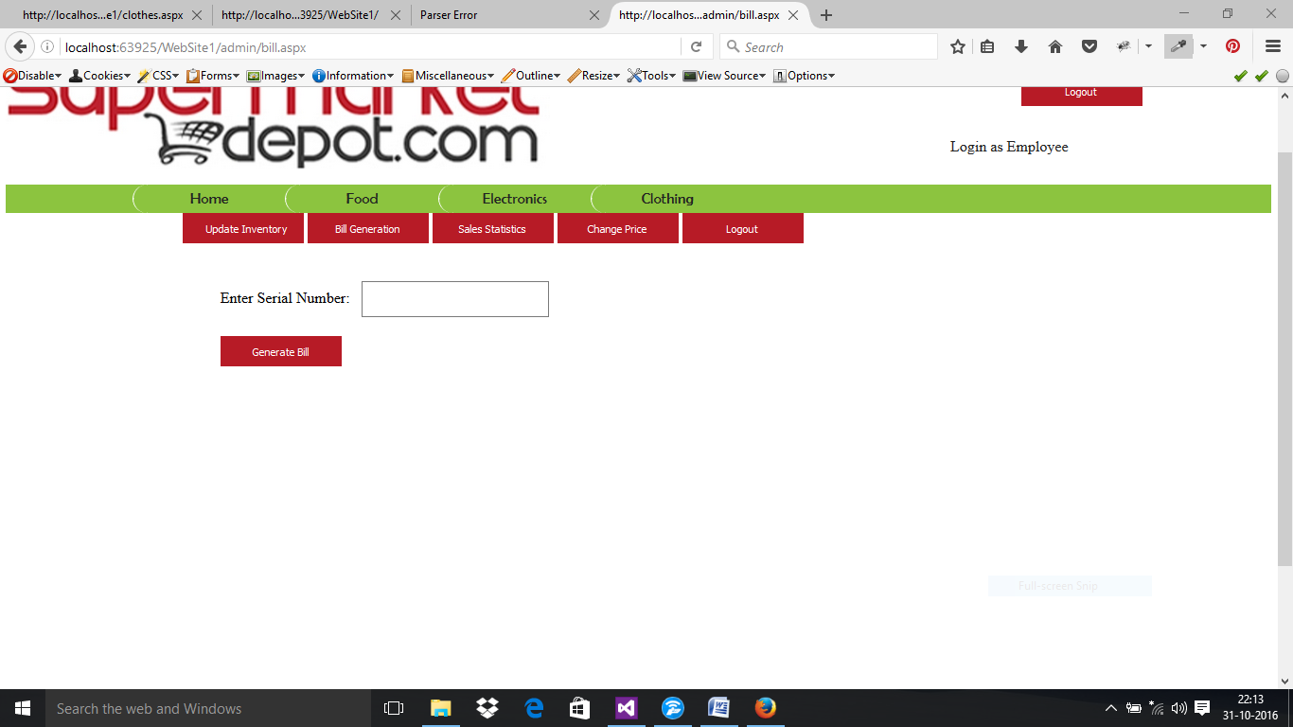

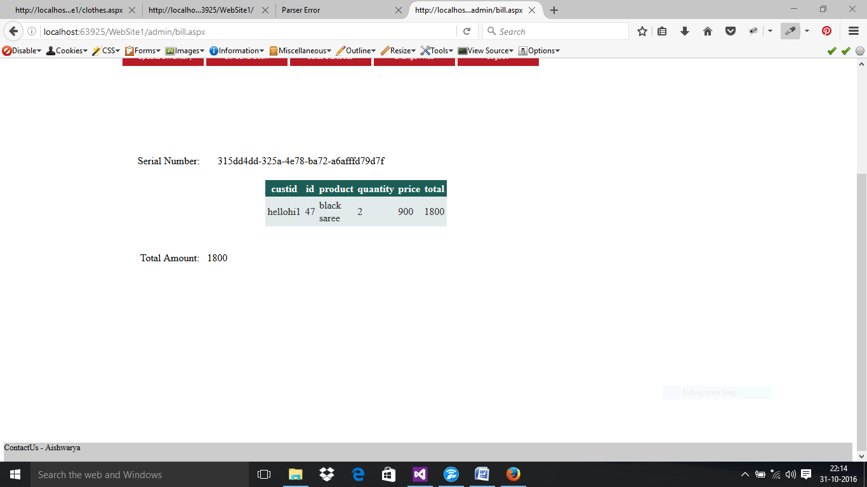

**.ASPX FILE**

<%@ Page Title="" Language="C#" MasterPageFile="~/MasterPage.master" AutoEventWireup="true" CodeFile="bill.aspx.cs" Theme="Theme1" Inherits="admin_bill" %>

<asp:Content ID="Content1" ContentPlaceHolderID="head" Runat="Server">

</asp:Content>

<asp:Content ID="Content2" ContentPlaceHolderID="ContentPlaceHolder1" Runat="Server">

<div class="left1">

<div class="form1">

<asp:Button ID="Button3" runat="server" OnClick="Button3_Click" class="b1" Text="Update Inventory" Width="150px" />

<asp:Button ID="Button4" runat="server" OnClick="Button4_Click" class="b1" Text="Bill Generation" />

<asp:Button ID="Button5" runat="server" OnClick="Button5_Click" class="b1" Text="Sales Statistics" />

<asp:Button ID="Button6" runat="server" OnClick="Button6_Click" class="b1" Text="Change Price" />

<asp:Button ID="Button8" runat="server" Text="Logout" class="b1" OnClick="Button8_Click" />

<br />

<br />

<br />

&nbsp;&nbsp;&nbsp;&nbsp;&nbsp;&nbsp;&nbsp;&nbsp;&nbsp;

<asp:Label ID="Label2" runat="server" Text="Enter Serial Number:"></asp:Label>

&nbsp;

<asp:TextBox ID="TextBox1" runat="server" Width="240px" TextMode="Password"></asp:TextBox>

<br />

<br />

&nbsp;&nbsp;&nbsp;&nbsp;&nbsp;&nbsp;&nbsp;&nbsp;&nbsp;

<asp:Button ID="Button7" class="b1" runat="server" OnClick="Button7_Click" Text="Generate Bill" Width="209px" />

<br />

<asp:Label ID="Label1" runat="server" Text="Serial Number:"></asp:Label>

&nbsp; &nbsp;&nbsp;&nbsp;

<asp:Label ID="Label8" runat="server"></asp:Label>

<br />

<br />

<asp:GridView ID="GridView1" runat="server" style="margin-left: 32px">

</asp:GridView>

<br /><br />

&nbsp;&nbsp;&nbsp;&nbsp;&nbsp;&nbsp; <asp:Label ID="Label4" runat="server" Text="Total Amount:"></asp:Label>

&nbsp;

<asp:Label ID="Label7" runat="server"></asp:Label>

<br />

&nbsp;

<br />

</div>

</div>

</asp:Content>

**.CS FILE**

public partial class admin_bill : System.Web.UI.Page

{

protected void Page_Load(object sender, EventArgs e)

{

Label4.Visible = false;

Label1.Visible=false;

}

protected void Button3_Click(object sender, EventArgs e)

{

Response.Redirect("~/admin/empprofile.aspx");

}

protected void Button4_Click(object sender, EventArgs e)

{

Response.Redirect("~/admin/bill.aspx");

}

protected void Button5_Click(object sender, EventArgs e)

{

Response.Redirect("~/admin/salesstats.aspx");

}

protected void Button6_Click(object sender, EventArgs e)

{

Response.Redirect("~/admin/changeprice.aspx");

}

protected void Button7_Click(object sender, EventArgs e)

{

SqlConnection con = new SqlConnection(ConfigurationManager.ConnectionStrings["supermarket"].ConnectionString);

Label4.Visible = true;

Label2.Visible = false;

TextBox1.Visible = false;

Button7.Visible = false;

Label1.Visible = true;

Label8.Text = TextBox1.Text;

GridView1.Visible = true;

SqlDataAdapter da = new SqlDataAdapter("select custid,id,product,quantity,price,total from custcart where code='" + TextBox1.Text + "'", con);

DataTable dt = new DataTable();

da.Fill(dt);

GridView1.DataSource = dt;

DataBind();

con.Open();

SqlCommand cmd = new SqlCommand("select sum(total) from custcart where code='" + TextBox1.Text + "'", con);

int temp1 = Convert.ToInt32(cmd.ExecuteScalar().ToString());

Label7.Text = temp1.ToString();

con.Close();

}

protected void Button8_Click(object sender, EventArgs e)

{

Response.Redirect("~/emp.aspx");

}

}

**CHANGE PRICE**

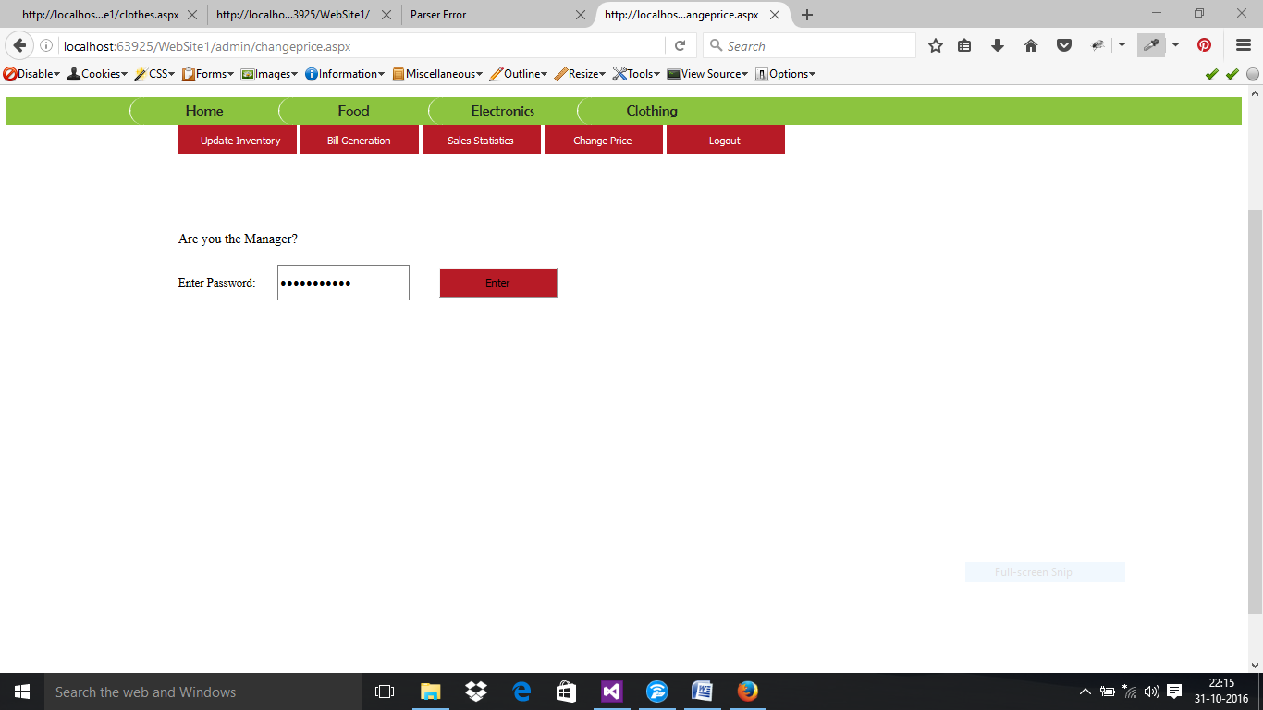

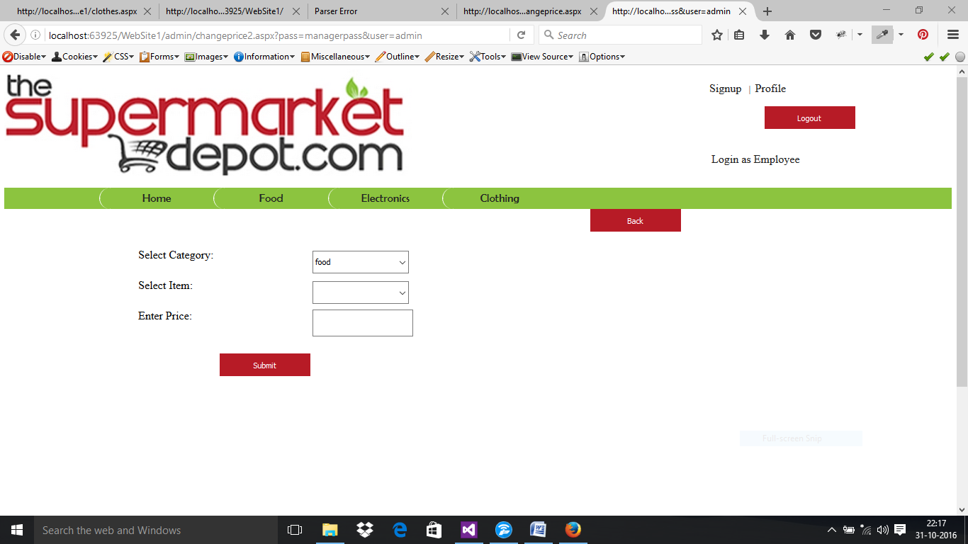

**.ASPX FILE**

<%@ Page Title="" Language="C#" MasterPageFile="~/MasterPage.master" AutoEventWireup="true" Theme="Theme1" CodeFile="changeprice.aspx.cs" Inherits="admin_changeprice" %>

<asp:Content ID="Content1" ContentPlaceHolderID="head" Runat="Server">

</asp:Content>

<asp:Content ID="Content2" ContentPlaceHolderID="ContentPlaceHolder1" Runat="Server">

<div class="left1">

<div class="form1">

<asp:Button ID="Button8" runat="server" Text="Update Inventory" class="b1" OnClick="Button8_Click"/>

<asp:Button ID="Button1" runat="server" Text="Bill Generation" class="b1" OnClick="Button1_Click" />

<asp:Button ID="Button5" runat="server" Text="Sales Statistics" class="b1" OnClick="Button5_Click" />

<asp:Button ID="Button6" runat="server" Text="Change Price" class="b1" OnClick="Button6_Click" />

<asp:Button ID="Button9" runat="server" Text="Logout" class="b1" OnClick="Button9_Click" />

<asp:Label runat="server" Text="Are you the Manager?" Font-Size="18px" ID="Label11"></asp:Label>

<br />

<br />

<asp:Label runat="server" Text="Enter Password:" Font-Size="16px" ID="Label12"></asp:Label>

&nbsp;&nbsp;&nbsp;&nbsp;

<asp:TextBox runat="server" TextMode="Password" ID="TextBox5" OnTextChanged="TextBox5_TextChanged"></asp:TextBox>

&nbsp;&nbsp;&nbsp;&nbsp;&nbsp;&nbsp;

<asp:Button ID="Button3" runat="server" OnClick="Button3_Click" class="b1" Text="Enter" />

<asp:Label ID="Label13" runat="server" Font-Size="14px" ForeColor="Red"></asp:Label>

<br />

<br />

<br />

</div>

</div>

</asp:Content>

<%@ Page Title="" Language="C#" MasterPageFile="~/MasterPage.master" AutoEventWireup="true" Theme="Theme1" CodeFile="changeprice2.aspx.cs" Inherits="admin_changeprice2" %>

<asp:Content ID="Content1" ContentPlaceHolderID="head" Runat="Server">

<style type="text/css">

.auto-style1 {

width: 299px;

}

</style>

</asp:Content>

<asp:Content ID="Content2" ContentPlaceHolderID="ContentPlaceHolder1" Runat="Server">

<div class="left1">

<div class="form1">

<br />

<br />

<asp:Button ID="Button3" class="b1" runat="server" OnClick="Button3_Click" style="margin-left: 800px" Text="Back" Width="73px" />

<br />

<br />

<table style="width:100%;">

<tr>

<td class="auto-style1">

<asp:Label ID="Label2" runat="server" Text="Select Category:"></asp:Label>

<br />

<br />

</td>

<td class="auto-style2">

<asp:DropDownList ID="DropDownList1" runat="server" Height="18px" Width="170px" OnSelectedIndexChanged="DropDownList1_SelectedIndexChanged" AutoPostBack="True" >

<asp:ListItem>food</asp:ListItem>

<asp:ListItem>electronics</asp:ListItem>

<asp:ListItem>clothing</asp:ListItem>

</asp:DropDownList>

</td>

<td>&nbsp;</td>

</tr>

<tr>

<td class="auto-style1">

<asp:Label ID="Label3" runat="server" Text="Select Item:"></asp:Label>

<br />

<br />

</td>

<td class="auto-style2">

<asp:DropDownList ID="DropDownList2" runat="server" Height="16px" Width="170px" AutoPostBack="True" OnSelectedIndexChanged="DropDownList2_SelectedIndexChanged">

</asp:DropDownList>

</td>

<td>&nbsp;</td>

</tr>

<tr>

<td class="auto-style1">

<asp:Label ID="Label5" runat="server" Text="Enter Price:"></asp:Label>

<br />

<br />

</td>

<td class="auto-style2">

<asp:TextBox ID="TextBox1" runat="server" Width="170px"></asp:TextBox>

</td>

<td>&nbsp;</td>

</tr>

<tr>

<td class="auto-style1">

<br />

<asp:Button ID="Button2" runat="server" Text="Submit" Width="112px" style="margin-left: 143px" class="b1" OnClick="Button2_Click" />

<br />

</td>

<td class="auto-style2">

<asp:Label ID="Label6" runat="server" ForeColor="#339933"></asp:Label>

</td>

<td>&nbsp;</td>

</tr>

</table>

<br />

</div>

</div>

</asp:Content>

**.CS FILE**

public partial class admin_changeprice : System.Web.UI.Page

{

SqlConnection con = new SqlConnection(ConfigurationManager.ConnectionStrings["supermarket"].ConnectionString);

protected void Page_Load(object sender, EventArgs e)

{

if (Session["newemp"] != null)

{

}

else

Response.Redirect("~/emp.aspx");

}

protected void TextBox5_TextChanged(object sender, EventArgs e)

{

}

protected void Button3_Click(object sender, EventArgs e)

{

if (TextBox5.Text == "managerpass")

{

string url = "changeprice2.aspx?";

url += "pass=" + Server.UrlEncode(TextBox5.Text) +"&";

url += "user=" + Session["newemp"].ToString();

Response.Redirect(url);

}

else

{

Label13.Text = "Wrong Password ! Please Enter Again! ";

}

}

protected void Button8_Click(object sender, EventArgs e)

{

Response.Redirect("~/admin/empprofile.aspx");

}

protected void Button1_Click(object sender, EventArgs e)

{

Response.Redirect("~/admin/bill.aspx");

}

protected void Button5_Click(object sender, EventArgs e)

{

Response.Redirect("~/admin/salesstats.aspx");

}

protected void Button6_Click(object sender, EventArgs e)

{

Response.Redirect("~/admin/changeprice.aspx");

}

protected void Button9_Click(object sender, EventArgs e)

{

Response.Redirect("~/emp.aspx");

}

}

public partial class admin_changeprice2 : System.Web.UI.Page

{

SqlConnection con = new SqlConnection(ConfigurationManager.ConnectionStrings["supermarket"].ConnectionString);

protected void Page_Load(object sender, EventArgs e)

{

}

protected void DropDownList1_SelectedIndexChanged(object sender, EventArgs e)

{

con.Open();

string q = "select name from products where category='" + DropDownList1.SelectedValue + "'";

SqlCommand cmd1 = new SqlCommand(q, con);

SqlDataReader dr = cmd1.ExecuteReader();

DropDownList2.DataSource = dr;

DropDownList2.Items.Clear();

DropDownList2.DataTextField = "name";

DropDownList2.DataValueField = "name";

DropDownList2.DataBind();

con.Close();

}

protected void DropDownList2_SelectedIndexChanged(object sender, EventArgs e)

{

}

protected void Button2_Click(object sender, EventArgs e)

{

SqlCommand cmd2 = new SqlCommand("update products set price='" + TextBox1.Text + "' where name='" + DropDownList2.SelectedValue + "' and category='" + DropDownList1.SelectedValue + "'", con);

con.Open();

cmd2.ExecuteNonQuery();

con.Close();

con.Open();

string p1 = "select cp from products where name ='" + DropDownList2.SelectedValue + "'and category='" + DropDownList1.SelectedValue + "'";

SqlCommand cmd3 = new SqlCommand(p1, con);

int temp1 = Convert.ToInt32(cmd3.ExecuteScalar().ToString());

con.Close();

//cost price found as temp1

int profit = Convert.ToInt32(TextBox1.Text) - temp1;

SqlCommand cmd4 = new SqlCommand("update products set profit='" +profit+ "' where name='" + DropDownList2.SelectedValue + "' and category='" + DropDownList1.SelectedValue + "'", con);

con.Open();

cmd4.ExecuteNonQuery();

con.Close();

Label6.Text = "Updated Price !";

}

protected void Button3_Click(object sender, EventArgs e)

{

Response.Redirect("~/admin/empprofile.aspx");

}

}

**CUSTOMER’S SIDE:**

**SIGNUP PAGE:**

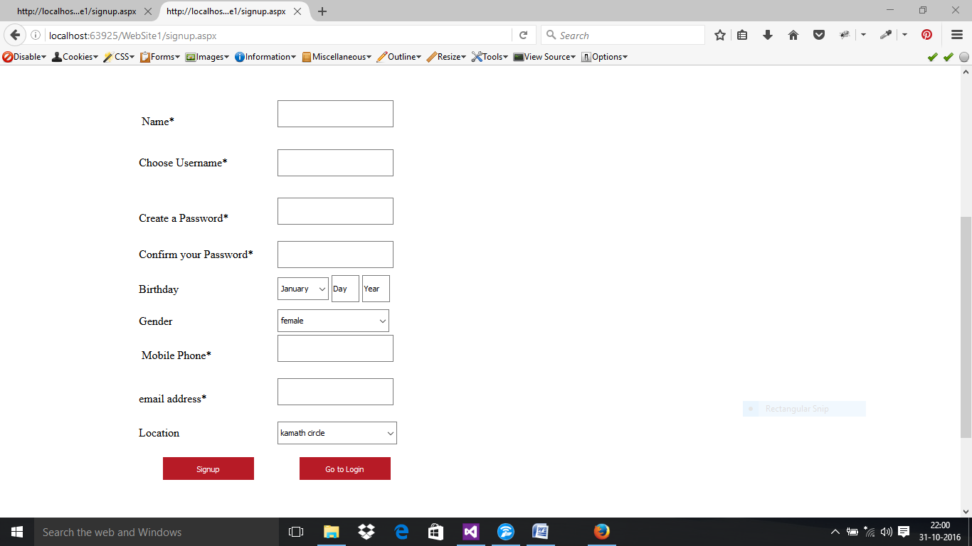

**.ASPX FILE**

<%@ Page Title="" Language="C#" MasterPageFile="~/MasterPage.master" AutoEventWireup="true" CodeFile="signup.aspx.cs" Inherits="_Default" Theme="Theme1" %>

<asp:Content ID="Content2" ContentPlaceHolderID="ContentPlaceHolder1" Runat="Server">

<div class="left1">

<div class="form1">

<p>

&nbsp;</p>

<p>

<asp:Label ID="Label1" runat="server"></asp:Label>

</p>

<p>

&nbsp;</p>

<p>

<table style="width: 100%; height: 105px;">

<tr>

<td class="auto-style1">&nbsp;Name*</td>

<td class="auto-style21">

<asp:TextBox ID="TextBox1" runat="server" OnTextChanged="TextBox1_TextChanged" Width="196px" style="margin-left: 0px"></asp:TextBox>

<br />

<asp:RequiredFieldValidator ID="RequiredFieldValidator1" runat="server" ErrorMessage="*required" ControlToValidate="TextBox1" ForeColor="Red" Font-Size="14px"></asp:RequiredFieldValidator>

</td>

<td>

&nbsp; <asp:RegularExpressionValidator ID="RegularExpressionValidator1" runat="server" ErrorMessage="enter a valid name" ControlToValidate="Textbox1" ForeColor="Red" ValidationExpression="^[a-zA-Z'.\s]{1,40}$" Font-Size="14px"></asp:RegularExpressionValidator>

<br />

</td>

</tr>

<tr>

<td class="auto-style1">

<p style="width: 240px">

Choose Username &nbsp;

&nbsp;</p>

</td>

<td class="auto-style21"> <asp:TextBox ID="TextBox2" runat="server" OnTextChanged="TextBox1_TextChanged" Width="196px" ></asp:TextBox>

<asp:RequiredFieldValidator ID="RequiredFieldValidator2" runat="server" ErrorMessage="*required" ControlToValidate="TextBox2" ForeColor="Red" Font-Size="14px"></asp:RequiredFieldValidator> </td>

<td>

&nbsp;<asp:RegularExpressionValidator ID="RegularExpressionValidator2" runat="server" ErrorMessage="enter a valid username" ValidationExpression="^[a-zA-Z0-9](_(?!(\.|_))|\.(?!(_|\.))|[a-zA-Z0-9]){6,18}[a-zA-Z0-9]$" ControlToValidate="TextBox2" ForeColor="Red" Font-Size="14px"></asp:RegularExpressionValidator>

</td>

</tr>

<tr>

<td class="auto-style1">Create a Password*&nbsp;&nbsp;&nbsp;&nbsp;</td>

<td class="auto-style21">

<asp:TextBox ID="Password2" runat="server" OnTextChanged="TextBox1_TextChanged" Width="196px" TextMode="Password" ></asp:TextBox>

<br />

<asp:RequiredFieldValidator ID="RequiredFieldValidator3" runat="server" ErrorMessage="*required" ForeColor="Red" ControlToValidate="Password2" Font-Size="14px"></asp:RequiredFieldValidator>

</td>

<td>

&nbsp;<asp:RegularExpressionValidator ID="RegularExpressionValidator3" runat="server" ErrorMessage="enter a valid password" ValidationExpression="^[a-zA-Z0-9\s]{7,10}$" ControlToValidate="Password2" ForeColor="Red" Font-Size="14px"></asp:RegularExpressionValidator>

<br />

</td>

</tr>

<tr>

<td class="auto-style1">Confirm your Password*</td>

<td class="auto-style21">

<asp:TextBox ID="Password1" runat="server" OnTextChanged="TextBox1_TextChanged" Width="196px" TextMode="Password" ></asp:TextBox>

</td>

<td><asp:CompareValidator ID="CompareValidator1" runat="server" ErrorMessage="the passwords donot match" ControlToValidate="Password1" ControlToCompare="Password2" ForeColor="Red" Font-Size="14px"></asp:CompareValidator>

<br />

</td>

</tr>

<tr>

<td class="auto-style5">

<p>

Birthday

</p>

</td>

<td class="auto-style22">

<asp:DropDownList ID="DropDownList1" runat="server" Height="21px" OnSelectedIndexChanged="DropDownList1_SelectedIndexChanged" Width="89px">

<asp:ListItem>January</asp:ListItem>

<asp:ListItem>February</asp:ListItem>

<asp:ListItem>March</asp:ListItem>

<asp:ListItem>April</asp:ListItem>

<asp:ListItem>May</asp:ListItem>

<asp:ListItem>June</asp:ListItem>

<asp:ListItem>July</asp:ListItem>

<asp:ListItem>August</asp:ListItem>

<asp:ListItem>September</asp:ListItem>

<asp:ListItem>October</asp:ListItem>

<asp:ListItem>November</asp:ListItem>

<asp:ListItem>December</asp:ListItem>

</asp:DropDownList>

<asp:TextBox ID="TextBox9" runat="server" OnTextChanged="TextBox1_TextChanged" Width="42px" >Day</asp:TextBox>

<asp:TextBox ID="TextBox10" runat="server" OnTextChanged="TextBox1_TextChanged" Width="41px" >Year</asp:TextBox>

</td>

<td class="auto-style3"></td>

</tr>

<tr>

<td class="auto-style1">Gender&nbsp;&nbsp;&nbsp;</td>

<td class="auto-style21">

<asp:DropDownList ID="DropDownList3" runat="server" Height="21px" Width="196px">

<asp:ListItem>female</asp:ListItem>

<asp:ListItem>male</asp:ListItem>

</asp:DropDownList>

</td>

<td>

<br />

</td>

</tr>

<tr>

<td class="auto-style18">

<p>

&nbsp;Mobile Phone*</p>

</td>

<td class="auto-style23">

<asp:TextBox ID="TextBox7" runat="server" OnTextChanged="TextBox1_TextChanged" Width="196px" ></asp:TextBox>

<asp:RequiredFieldValidator ID="RequiredFieldValidator4" runat="server" ErrorMessage="*required" ControlToValidate="TextBox7" ForeColor="Red" Font-Size="14px"></asp:RequiredFieldValidator> </td>

<td class="auto-style20">

&nbsp;<asp:RegularExpressionValidator ID="RegularExpressionValidator4" runat="server" ErrorMessage="enter a valid number" ValidationExpression="^[0-9]{10}$" ControlToValidate="TextBox7" ForeColor="Red" Font-Size="14px"></asp:RegularExpressionValidator>

<br />

</td>

</tr>

<tr>

<td class="auto-style1">email address*&nbsp;&nbsp;</td>

<td class="auto-style21">

<asp:TextBox ID="TextBox8" runat="server" OnTextChanged="TextBox1_TextChanged" Width="196px" ></asp:TextBox>

<br /

<asp:RequiredFieldValidator ID="RequiredFieldValidator5" runat="server" ErrorMessage="*required" ControlToValidate="TextBox8" ForeColor="Red" Font-Size="14px"></asp:RequiredFieldValidator> </td>

<td>

&nbsp; <asp:RegularExpressionValidator ID="RegularExpressionValidator5" runat="server" ErrorMessage="enter valid email id" ControlToValidate="TextBox8" ForeColor="Red" ValidationExpression="^\S+@\S+\.\S+$" Font-Size="14px"></asp:RegularExpressionValidator>

<br />

</td>

</tr>

<tr>

<td class="auto-style11">Location&nbsp;</td>

<td class="auto-style24">

<asp:DropDownList ID="DropDownList2" runat="server" Height="23px" Width="210px">

<asp:ListItem>kamath circle</asp:ListItem>

<asp:ListItem>tiger circle</asp:ListItem>

<asp:ListItem></asp:ListItem>

</asp:DropDownList>

</td>

<td class="auto-style13">

<br />

</td>

</tr>

</table>

</p>

<p>

&nbsp;&nbsp;&nbsp;&nbsp;&nbsp;&nbsp;&nbsp;

&nbsp;<asp:Button ID="Button2" runat="server" Text="Signup" class="b1" OnClick="Button2_Click" />

&nbsp;&nbsp;&nbsp;&nbsp;&nbsp;&nbsp;&nbsp;&nbsp;&nbsp;&nbsp;&nbsp;&nbsp;&nbsp;&nbsp; <asp:Button ID="Button3" runat="server" OnClick="Button3_Click" Text="Go to Login" class="b1" />

</p>

<p>

</div>

</div>

</asp:Content>

**.CS FILE**

public partial class _Default : System.Web.UI.Page

{

protected void Button2_Click(object sender, EventArgs e)

{

if (!Page.IsValid)

{

Label1.Text += "Registration unsuccessful !";

return;

}

else

{

SqlConnection con = new SqlConnection(ConfigurationManager.ConnectionStrings["supermarket"].ConnectionString);

SqlCommand cmd = new SqlCommand("insert into userdetails(name,username,pass,birth,gender,mobile,email,location) values('" + TextBox1.Text + "','" + TextBox2.Text + "','" + Password2.Text + "','" + DropDownList1.SelectedValue + TextBox9.Text + TextBox10.Text + "','" + DropDownList3.SelectedValue + "','" + TextBox7.Text + "','" + TextBox8.Text + "','" + DropDownList2.SelectedValue + "')", con);

con.Open();

cmd.ExecuteNonQuery();

con.Close();

Label1.Visible = true;

Label1.Text = "data stored successfully " + TextBox1.Text;

TextBox1.Text = " ";

TextBox2.Text = " ";

TextBox7.Text = " ";

TextBox8.Text = " ";

TextBox9.Text = " ";

TextBox10.Text = " ";

Password1.Text = " ";

Password2.Text = " ";

}

}

protected void Button3_Click(object sender, EventArgs e)

{

Response.Redirect("login.aspx");

}

}

**LOGIN PAGE**

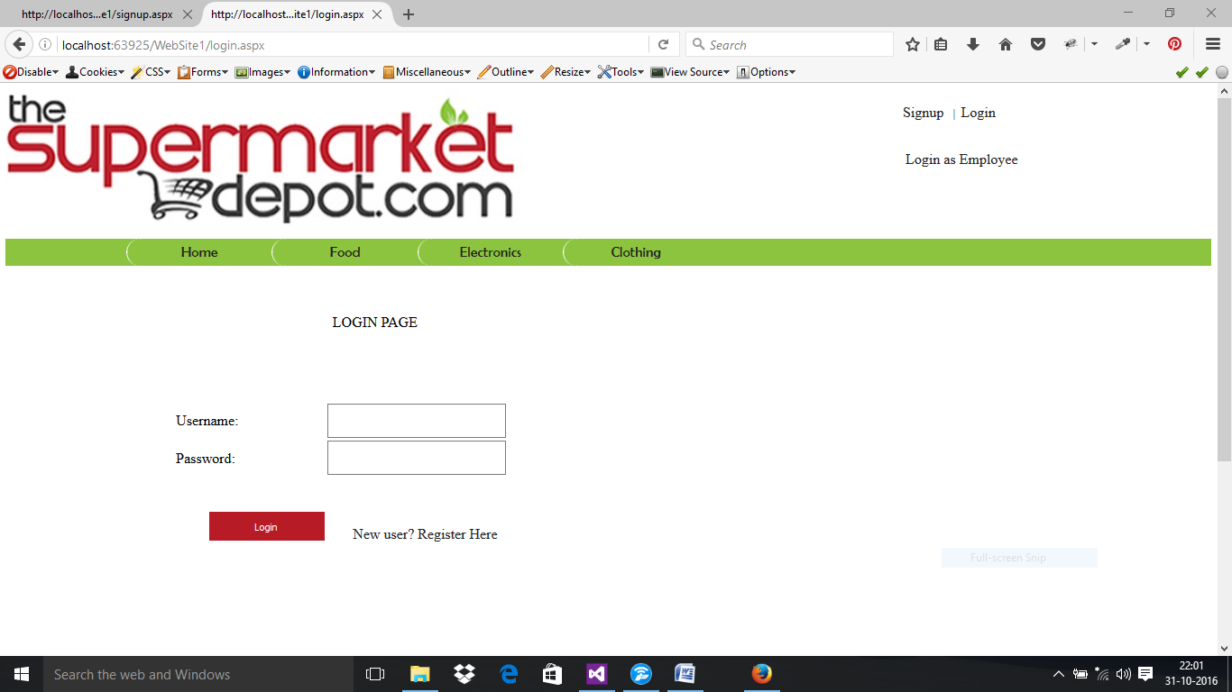

**.ASPX FILE**

<%@ Page Title="" Language="C#" MasterPageFile="~/MasterPage.master" AutoEventWireup="true" CodeFile="login.aspx.cs" Inherits="login" Theme="Theme1"%>

<asp:Content ID="Content1" ContentPlaceHolderID="head" Runat="Server">

</style>

</asp:Content>

<asp:Content ID="Content2" ContentPlaceHolderID="ContentPlaceHolder1" Runat="Server">

<div class="left1">

<div class="form1">

<p style="height: 32px">

<asp:Label ID="Label1" runat="server" ForeColor="Red" Font-Size="14px"></asp:Label>

<br />

<br />

<table style="width:100%;">

<tr>

<td class="auto-style1">Username:</td>

<td class="auto-style2"><asp:TextBox ID="TextBox1" runat="server" Width="240px"></asp:TextBox>

</td>

<td>&nbsp;</td>

</tr>

<tr>

<td class="auto-style1">Password:&nbsp;&nbsp;&nbsp;&nbsp;&nbsp;&nbsp;&nbsp;&nbsp;</td>

<td class="auto-style2"><asp:TextBox ID="TextBox2" runat="server" Width="240px" TextMode="Password"></asp:TextBox>

</td>

<td>&nbsp;</td>

</tr>

<tr>

<td class="auto-style1">

<br />

<asp:Button ID="Button1" runat="server" OnClick="Button1_Click" style="margin-left: 46px" Text="Login" class="b1" /> </td>

<p style="width: 326px">

&nbsp;&nbsp;&nbsp;&nbsp;&nbsp;&nbsp; <a href="signup.aspx">New user? Register Here</a></p>

</td>

<td>&nbsp;</td>

</tr>

</table>

</div>

</div>

</asp:Content>

**.CS FILE**

public partial class login : System.Web.UI.Page

{

protected void Button1_Click(object sender, EventArgs e)

{

SqlConnection con = new SqlConnection(ConfigurationManager.ConnectionStrings["supermarket"].ConnectionString);

con.Open();

string checkuser = "select count(*) from userdetails where username='" + TextBox1.Text + "'";

SqlCommand cmd= new SqlCommand(checkuser,con);

int temp = 0;

temp = Convert.ToInt32(cmd.ExecuteScalar().ToString());

con.Close();

if (temp == 1)

{

con.Open();

string checkpass = "select pass from userdetails where username='" + TextBox1.Text + "'";

SqlCommand passcmd = new SqlCommand(checkpass,con);

string password = passcmd.ExecuteScalar().ToString().Replace(" ","");

if (password == TextBox2.Text)

{

Session["new"] = TextBox1.Text;

Response.Write("Login successful!");

Response.Redirect("profile.aspx");

}

else

Response.Write("Login unsuccessful! Please try again"+password);

}

else

Response.Write("Login unsuccessful! Please try again"+temp);

}

}

**PROFILE PAGE**

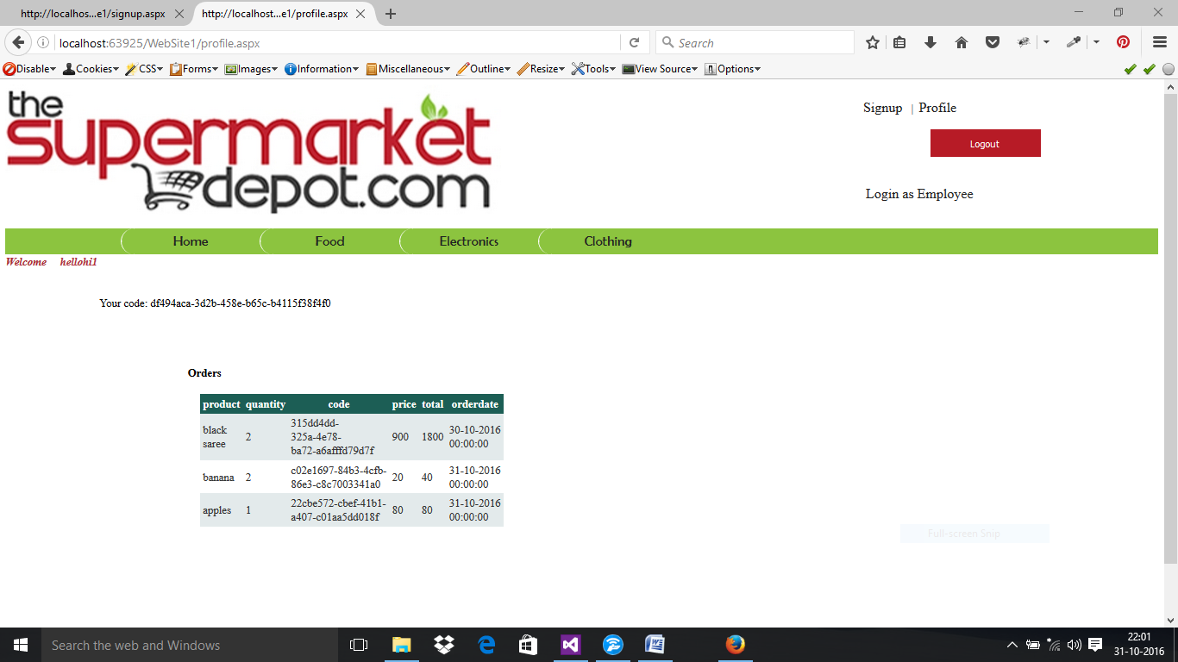

**.ASPX FILE**

<%@ Page Title="" Language="C#" MasterPageFile="~/MasterPage.master" Theme="Theme1" AutoEventWireup="true" CodeFile="profile.aspx.cs" Inherits="profile" %>

<asp:Content ID="Content1" ContentPlaceHolderID="head" Runat="Server">

</asp:Content>

<asp:Content ID="Content2" ContentPlaceHolderID="ContentPlaceHolder1" Runat="Server">

&nbsp; &nbsp; <asp:Label ID="Label1" runat="server" Text="Welcome" Font-Bold="True" Font-Italic="True" ForeColor="#AE2C36"></asp:Label>

&nbsp; &nbsp; <asp:Label ID="Label2" runat="server" Font-Bold="True" Font-Italic="True" ForeColor="#B3323E"></asp:Label>

&nbsp;&nbsp;&nbsp;&nbsp;&nbsp;&nbsp;

<br />

<asp:Label ID="Label3" runat="server" Text="Your code:"></asp:Label>

<asp:Label ID="Label4" runat="server"></asp:Label>

<br />

<br />

<br />

Orders</h4>

<asp:GridView ID="GridView1" runat="server" style="margin-left: 227px">

</asp:GridView>

</asp:Content

**.CS FILE**

public partial class profile : System.Web.UI.Page

{

SqlConnection con = new SqlConnection(ConfigurationManager.ConnectionStrings["supermarket"].ConnectionString);

protected void Page_Load(object sender, EventArgs e)

{

if (Session["new"] != null)

{

Label2.Text = Session["new"].ToString();

Label4.Text = Guid.NewGuid().ToString();

//grid view starts

GridView1.Visible = true;

SqlDataAdapter da = new SqlDataAdapter("select product,quantity,code,price,total,orderdate from custcart where custid='"+Label2.Text+"' ", con);

DataTable dt = new DataTable();

da.Fill(dt);

GridView1.DataSource = dt;

DataBind();

//grid view ends

//("select product,quantity,code,price,total,orderdate from custcart ", con);

}

else

Response.Redirect("~/login.aspx");

}

}

**SHOPPING CART PAGE**

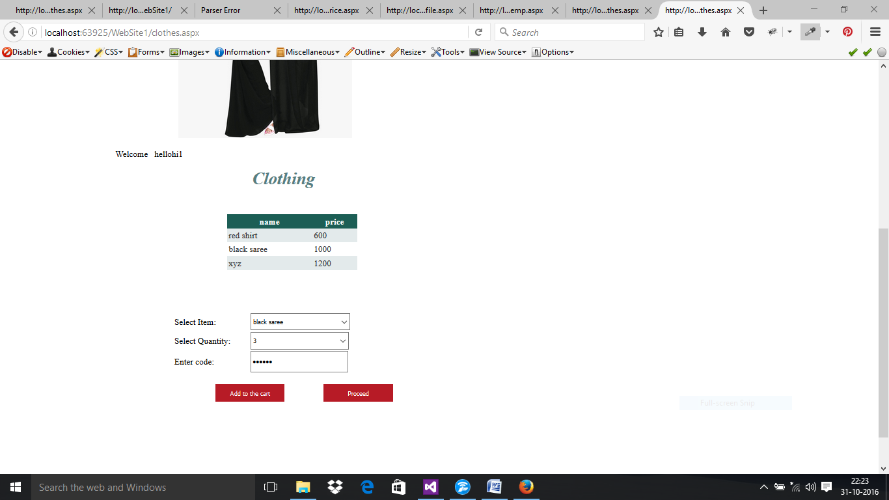

**BILL GENERATION PAGE**

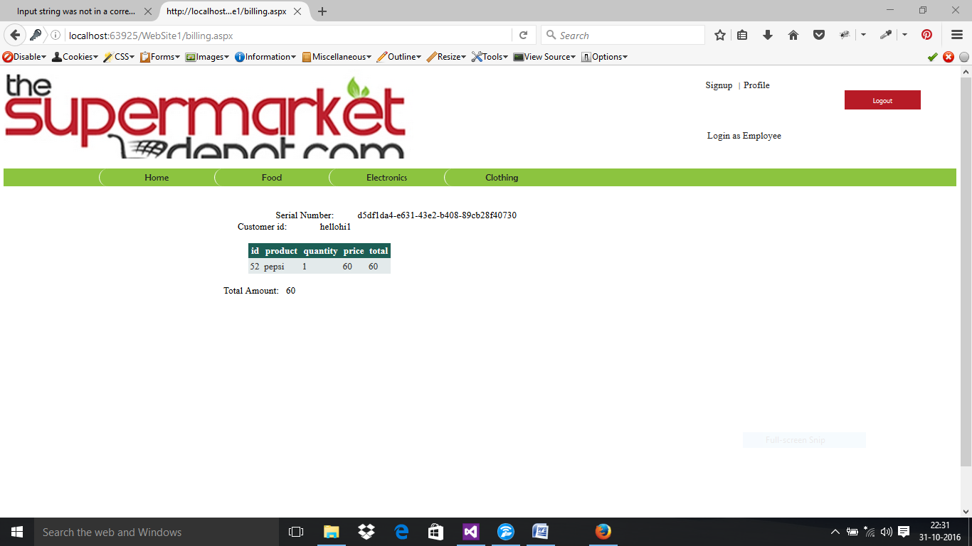

**MAIN WEBSITE**

**HOME PAGE**

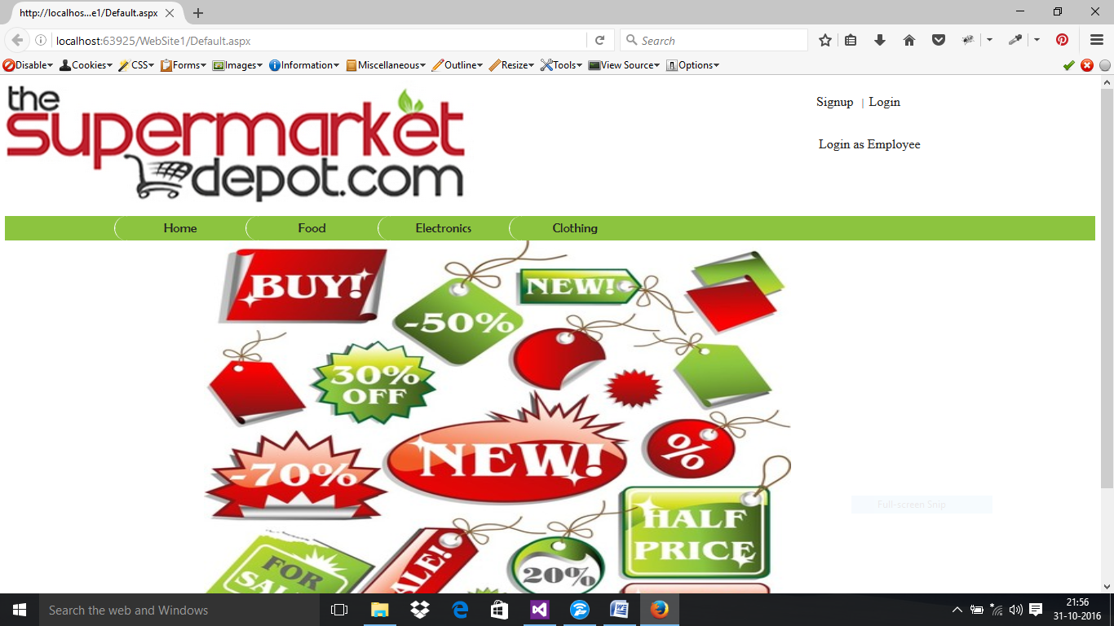

**.ASPX FILE**

<%@ Page Title="" Language="C#" MasterPageFile="~/MasterPage.master" Theme="Theme1" AutoEventWireup="true" CodeFile="Default.aspx.cs" Inherits="_Default" %>

<asp:Content ID="Content1" ContentPlaceHolderID="head" Runat="Server">

</asp:Content>

<asp:Content ID="Content2" ContentPlaceHolderID="ContentPlaceHolder1" Runat="Server">

<asp:AdRotator ID="AdRotator1" runat="server" Width="900px" Height="600px" DataSourceID="XmlDataSource1" />

<asp:XmlDataSource ID="XmlDataSource1" runat="server" DataFile="~/banners.xml"></asp:XmlDataSource>

&nbsp;

</asp:Content>

**FOOD PAGE**

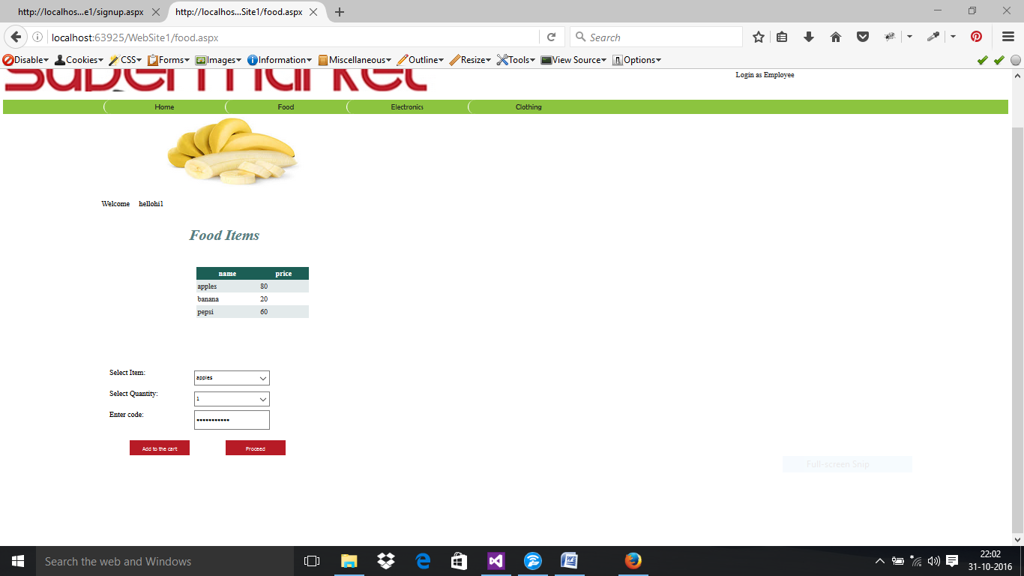

**.ASPX FILE**

<%@ Page Title="" Language="C#" MasterPageFile="~/MasterPage.master" Theme="Theme1" AutoEventWireup="true" CodeFile="food.aspx.cs" Inherits="food" %>

<asp:Content ID="Content1" ContentPlaceHolderID="head" Runat="Server">

<style type="text/css">

.auto-style1 {

width: 221px;

}

.auto-style2 {

width: 204px;

}

</style>

</asp:Content>

<asp:Content ID="Content2" ContentPlaceHolderID="ContentPlaceHolder1" Runat="Server">

<div class="left1">

<div class="form1">

<p>

<asp:AdRotator ID="AdRotator1" runat="server" DataSourceID="XmlDataSource2" Width="400px" Height="200px"/>

<asp:XmlDataSource ID="XmlDataSource2" runat="server" DataFile="~/foodxml.xml"></asp:XmlDataSource>

</p>

<p>

&nbsp;&nbsp;&nbsp;&nbsp;&nbsp;&nbsp;<asp:Label ID="Label6" runat="server" Text="Welcome"></asp:Label>

&nbsp;&nbsp;&nbsp;&nbsp;<asp:Label ID="Label7" runat="server"></asp:Label>

&nbsp;&nbsp;

</p>

<p>

<asp:Label ID="Label3" runat="server" Font-Bold="True" Font-Italic="True" Font-Size="40px" ForeColor="#567E81" Text="Food Items" Height="42px" style="margin-left: 263px"></asp:Label>

&nbsp;</p>

<p>

&nbsp;</p>

<asp:GridView ID="GridView1" runat="server" CellPadding="4" ForeColor="#333333" GridLines="None" style="margin-left: 180px" Height="116px" Width="394px">

<AlternatingRowStyle BackColor="White" />

<EditRowStyle BackColor="#7C6F57" />

<FooterStyle BackColor="#1C5E55" Font-Bold="True" ForeColor="White" />

<HeaderStyle BackColor="#1C5E55" Font-Bold="True" ForeColor="White" />

<PagerStyle BackColor="#666666" ForeColor="White" HorizontalAlign="Center" />

<RowStyle BackColor="#E3EAEB" />

<SelectedRowStyle BackColor="#C5BBAF" Font-Bold="True" ForeColor="#333333" />

<SortedAscendingCellStyle BackColor="#F8FAFA" />

<SortedAscendingHeaderStyle BackColor="#246B61" />

<SortedDescendingCellStyle BackColor="#D4DFE1" />

<SortedDescendingHeaderStyle BackColor="#15524A" />

</asp:GridView>

<table style="width: 76%; margin-left: 48px;">

<tr>

<td class="auto-style1">

<asp:Label ID="Label2" runat="server" Text="Select Item:"></asp:Label>

<br />

<br />

</td>

<td class="auto-style2"><asp:DropDownList ID="DropDownList2" runat="server" OnSelectedIndexChanged="DropDownList2_SelectedIndexChanged" style="margin-left: 0px" Height="53px" Width="203px">

</asp:DropDownList>

</td>

<td>&nbsp;</td>

</tr>

<tr>

<td class="auto-style1"> <asp:Label ID="Label4" runat="server" Text="Select Quantity:"></asp:Label>

</td>

<td class="auto-style2"> <asp:DropDownList ID="DropDownList1" runat="server" Height="54px" Width="203px">

<asp:ListItem Value="1"></asp:ListItem>

<asp:ListItem>2</asp:ListItem>

<asp:ListItem>3</asp:ListItem>

<asp:ListItem>4</asp:ListItem>

<asp:ListItem>5</asp:ListItem>

<asp:ListItem>6</asp:ListItem>

<asp:ListItem>7</asp:ListItem>

<asp:ListItem>8</asp:ListItem>

<asp:ListItem>9</asp:ListItem>

<asp:ListItem>10</asp:ListItem>

<asp:ListItem></asp:ListItem>

</asp:DropDownList>

</td>

<td>&nbsp;</td>

</tr>

<tr>

<td class="auto-style1"> <asp:Label ID="Label8" runat="server" Text="Enter code:"></asp:Label>

<br />

<br />

</td>

<td class="auto-style2"> <asp:TextBox ID="TextBox1" runat="server" TextMode="Password" Height="23px" Width="191px"></asp:TextBox>

</td>

<td>

<asp:Label ID="Label5" runat="server" ForeColor="#009933"></asp:Label>

</td>

</tr>

</table>

<br />

&nbsp;&nbsp;&nbsp;&nbsp;&nbsp;&nbsp;&nbsp;&nbsp;&nbsp;&nbsp;&nbsp;&nbsp;&nbsp;&nbsp;&nbsp;&nbsp;&nbsp;&nbsp;&nbsp;&nbsp;&nbsp;<asp:Button ID="Button3" runat="server" class="b1" Text="Add to the cart" OnClick="Button3_Click" />

&nbsp;&nbsp;&nbsp;&nbsp;&nbsp;&nbsp;&nbsp;&nbsp;&nbsp;&nbsp;&nbsp;&nbsp;&nbsp;&nbsp;&nbsp;&nbsp;&nbsp;&nbsp;<asp:Button ID="Button4" runat="server" class="b1" Text="Proceed" OnClick="Button4_Click" />

</p>

</div>

</div>

</asp:Content>

**.CS FILE**

public partial class food : System.Web.UI.Page

{

protected void Page_Load(object sender, EventArgs e)

{

SqlConnection con = new SqlConnection(ConfigurationManager.ConnectionStrings["supermarket"].ConnectionString);

if (Session["new"] != null)

{

Label7.Text = Session["new"].ToString();

GridView1.Visible = true;

SqlDataAdapter da = new SqlDataAdapter("select name,price from products where category='food'", con);

DataTable dt = new DataTable();

da.Fill(dt);

GridView1.DataSource = dt;

DataBind();

con.Open();

string q = "select name from products where category='food'";

SqlCommand cmd1 = new SqlCommand(q, con);

SqlDataReader dr = cmd1.ExecuteReader();

while (dr.Read())

{

DropDownList2.Items.Add(dr[0].ToString());

}

con.Close();

}

else

{

GridView1.Visible = true;

DropDownList2.Visible = false;

DropDownList1.Visible = false;

Label2.Visible = false;

Label4.Visible = false;

Label6.Visible = false;

Button3.Visible = false;

Button4.Visible = false;

Label8.Visible = false;

TextBox1.Visible = false;

SqlDataAdapter da = new SqlDataAdapter("select name,price from products where category='food'", con);

DataTable dt = new DataTable();

da.Fill(dt);

GridView1.DataSource = dt;

DataBind();

}

}

protected void Button4_Click(object sender, EventArgs e)

{

Response.Redirect("~/billing.aspx");

}

protected void Button3_Click(object sender, EventArgs e)

{

SqlConnection con = new SqlConnection(ConfigurationManager.ConnectionStrings["supermarket"].ConnectionString);

con.Open();

string check = "select count(*) from products where name ='" + DropDownList2.SelectedValue + "' and quantity >= '" + DropDownList1.SelectedValue + "' and category='food'";

SqlCommand cmd1 = new SqlCommand(check, con);

string p = "select price from products where name ='" + DropDownList2.SelectedValue + "'and category='food'";

SqlCommand cmd2 = new SqlCommand(p, con);

int temp1 = Convert.ToInt32(cmd2.ExecuteScalar().ToString());

int temp2 = Convert.ToInt32(DropDownList1.SelectedValue);

string p1 = "select quantity from products where name ='" + DropDownList2.SelectedValue + "'and category='food'";

SqlCommand cmd3 = new SqlCommand(p1, con);

int temp3 = Convert.ToInt32(cmd3.ExecuteScalar().ToString());

int temp4 = temp3 - temp2; //changed quantity

int total = temp1 * temp2;

int temp = Convert.ToInt32(cmd1.ExecuteScalar().ToString());

con.Close();

if (temp == 1)

{

SqlCommand cmd = new SqlCommand("insert into custcart(custid,product,quantity,code,price,total,orderdate) values('" + Session["new"].ToString() + "','" + DropDownList2.SelectedValue + "' ,'" + DropDownList1.SelectedValue + "','" + TextBox1.Text + "','" + temp1 + "','" + total + "', @orderdate )", con);

con.Open();

//add parameter for current date

cmd.Parameters.Add("@orderdate", SqlDbType.DateTime);

cmd.Parameters["@orderdate"].Value = DateTime.Now;

cmd.ExecuteNonQuery();

con.Close();

SqlCommand com = new SqlCommand("update products set quantity='" + temp4 + "' where name='" + DropDownList2.SelectedItem.Text + "' and category='food' ", con);

con.Open();

com.ExecuteNonQuery();

con.Close();

Label5.Text = "Added item:" + DropDownList2.SelectedItem.Text + DropDownList1.SelectedValue;

}

else

{

Label5.Text = "Product out of stock";

}

}

protected void DropDownList2_SelectedIndexChanged(object sender, EventArgs e)

{

}

}

**CLOTHING PAGE**

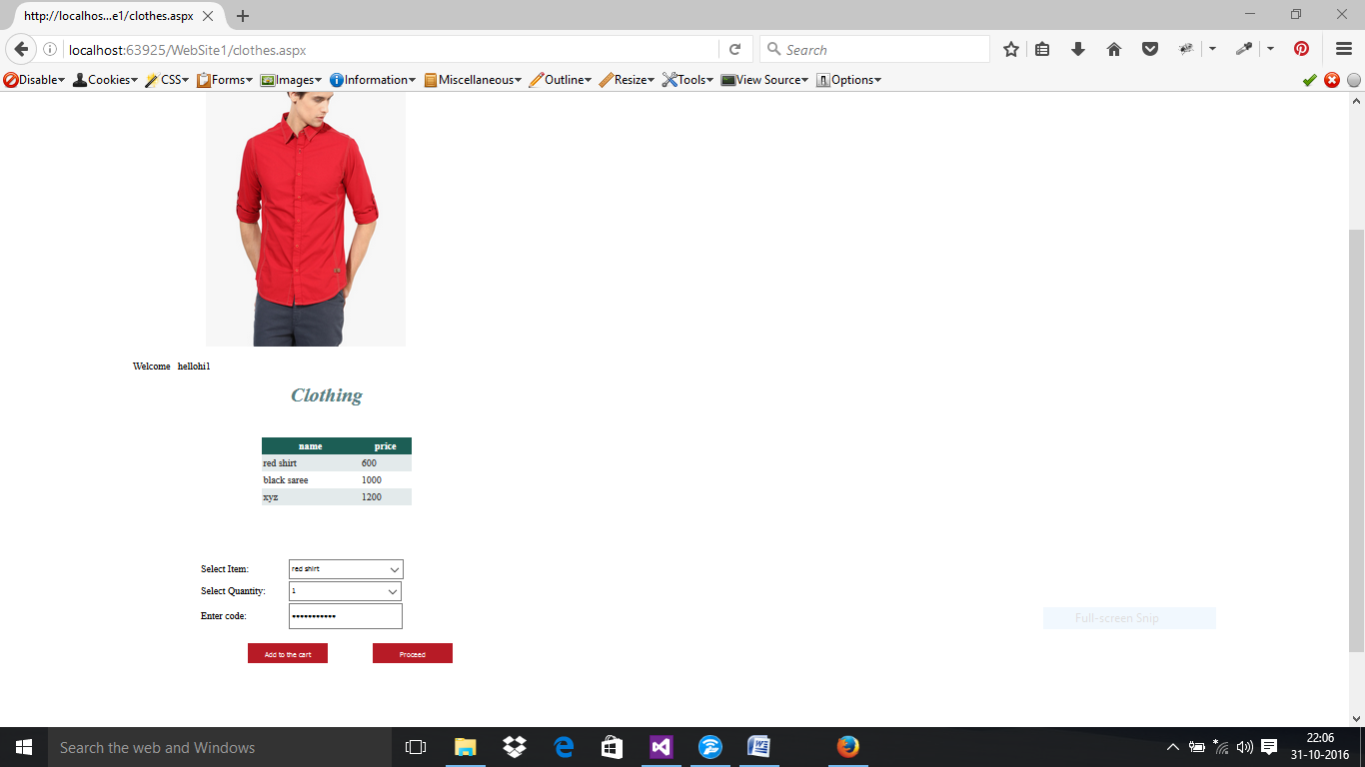

**.**

**ELECTRONICS PAGE:**

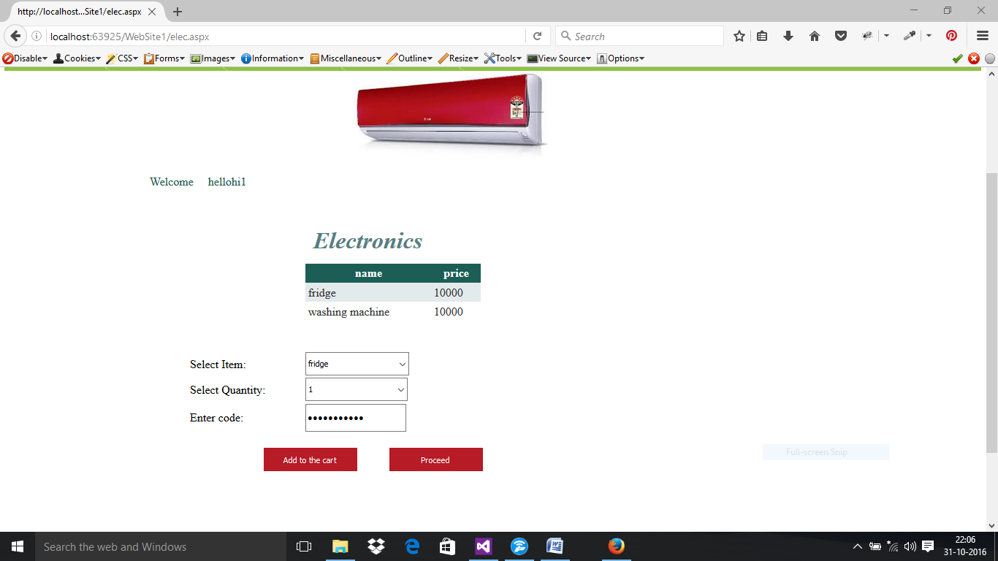

Clothing, food, electronics have similar .cs and .aspx files.