ShopNest Power BI Dashboard Report

This report includes visual analysis and key insights for the Power BI Capstone Project on ShopNest Store.

# 1. Top Categories by Total Price

Identify and visually represent the top 10 product categories by total sales.

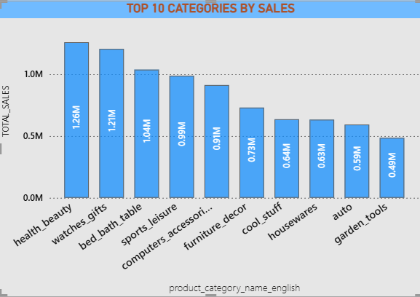

* ** Health and beauty** tops all category by gaining **1.26M**, this indicates high demand, different products variety and emerged as highly trusted brand.
* Following that, **watches and gifts (1.21M),** bed bath tables (1.04M) adds their portion for overall revenue. And coming out as competitors.
* **Sports_leisure (0.99M), Computer accessories (0.91M), Furniture decor (0.73)** are mid- tier categories performing well and showing lifestyle and personal Customer intersts.
* Categories in the bottom half are maintaining their average and concentrate on Marketing, product expansion and Strategies to boost their performance.
* Overall Shop nest Store shows various diversity of categories and their products.

# 2. Delayed Orders Analysis

Determine the number of delayed orders in each category. An order is considered delayed if the actual delivery date is later than the estimated delivery date.

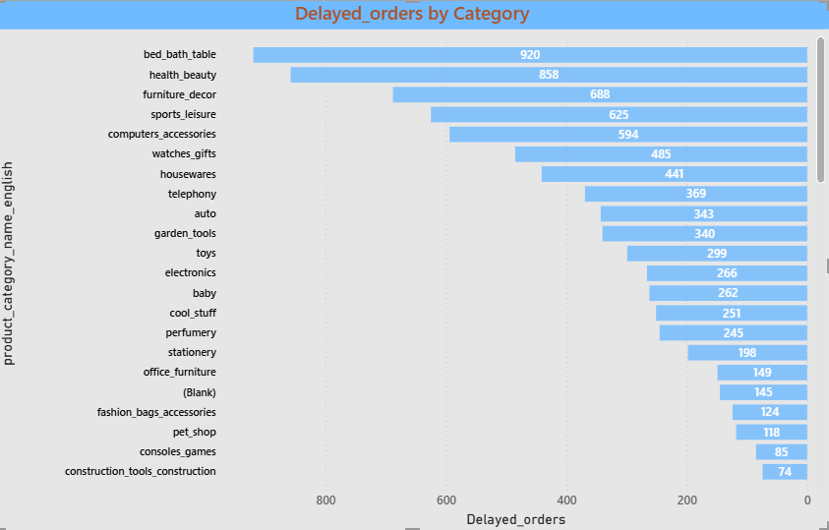

* **Bed-bath-table** being top in top 2 has most delayed orders, indicating any supply chain or inventory issues.
* TOP 1 category **health and beauty** has 2nd highest delays. suggesting due to high order volumes it may have failed to meet delivery deadlines.
* **Furniture** and **sports** categories have highest delays, probably due to new designs and that may take longer to ship.
* **Computers, accessories** and **telephony** may have supplier chain and logistics issue.
* Moderate delay Categories like **Watches & Gifts, Housewares, Auto, and Garden Tools** show delays ranging between **340–485**, still worth monitoring but less critical than the top 5.
* Focus needed on High-selling categories (like **Bed, Bath & Table** and **Health & Beauty**) having high delays suggests a **performance bottleneck** — these areas may benefit from improved warehouse or delivery coordination.

# 3. Monthly Comparison of Delayed and On-Time Orders

Create a dynamic visual that compares the number of delayed orders to the number of orders received earlier for each month. Utilize the drillthrough cross-report feature to provide a detailed analysis of late and on-time deliveries.

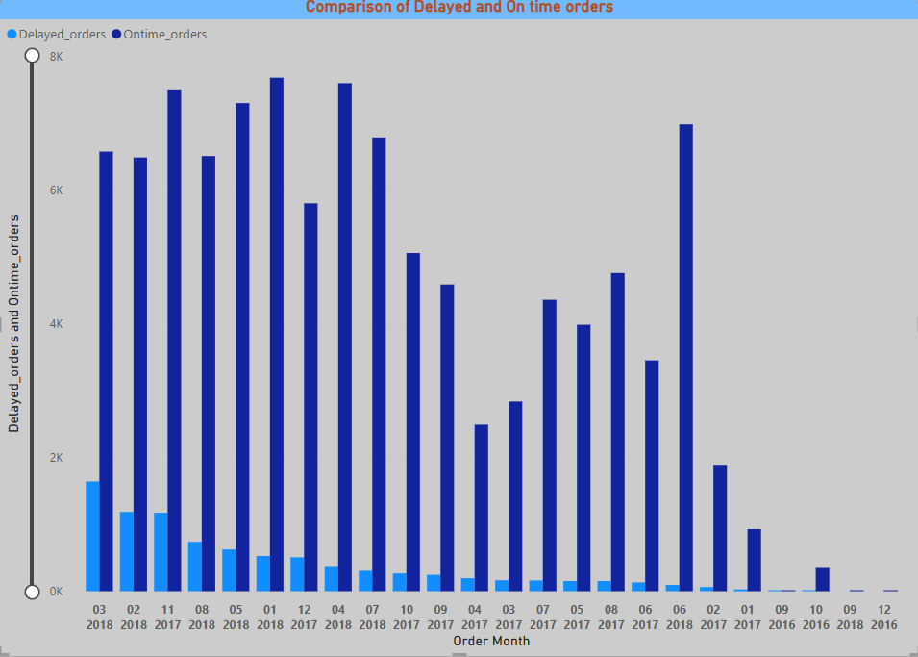

* Ontime order **dominant** in every month over delayed order.
* The ratio over online versus delayed is **healthy across** observed period.
* The **highest volume of total orders** (especially on-time) occurred in **early to mid-2018** — particularly in **March, April, and May**.
* The **minimal activity was shown in 2016** states that the operation was just starting or data is incomplete for that period.
* After mid-2018, there's a **noticeable decline** in both on-time and delayed orders.
* This might be due to a change in operations, reduced customer activity, or data availability limitation.
* Despite changes in order volume, **delayed orders remain fairly consistent** in their count and do not show major spikes — a positive indicator for logistics performance.

# 4. Payment Method Analysis

Analyze the most frequently used payment methods by customers using a visually appealing representation, such as a pie chart or other suitable visuals.

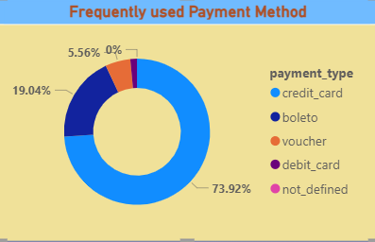

* **Credit card is the most preferred payment method** used with 73.92% for transactions.
* **Bolento is a local payment** methos in Brazil, which is still popular with 19.04%.
* **Minor usage of Voucher and debit card** with 5.56% and ~0%, These may be used occasionally for promotional discounts or by a smaller customer segment.
* A very small portion was defined as not defined. This may suggest inconsistent data or data is not available.
* **Business implementation** can be done by using following steps:

-Marketing strategies like EMI offers or loyalty programs should focus on **credit card users**.

-Enhancing Boleto support and promotions could cater to the non-credit audience segment.

-Investigate the “not_defined” portion to ensure no revenue data is lost or misclassified.

# 5. Product Rating Analysis

Determine the top 10 highest-rated products and the bottom 10 lowest-rated products using a bar or column chart.

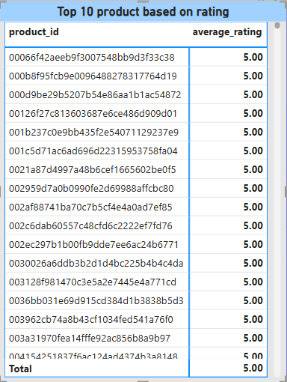 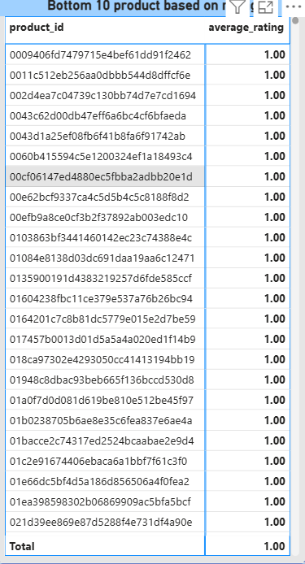

* All top 10 products have received a **perfect average rating of 5.00**.

This indicates:

* **High customer satisfaction**, likely due to product quality, accurate descriptions, or good delivery experience.
* These products might have **low but consistent review counts**, so further checking number of reviews could validate reliability.
* These could be promoted in marketing campaigns as **"Top Rated Products"** to drive trust and conversions.
* **All bottom 10 products are rated** **1.00**, the lowest possible score.

This reflects **poor customer experience**, possibly due to:

* Product defects
* Mismatched expectations
* Late delivery
* Incorrect item sent

Many of these products may require:

* **Further investigation**
* **Customer feedback analysis**
* **Vendor or quality audits**

If the ratings come from very few reviews, consider **review normalization** or **minimum review thresholds** before taking action.

# 6. State-wise Sales Analysis

Identify and visually represent states with high and low sales, providing a clear understanding of regional sales performance.

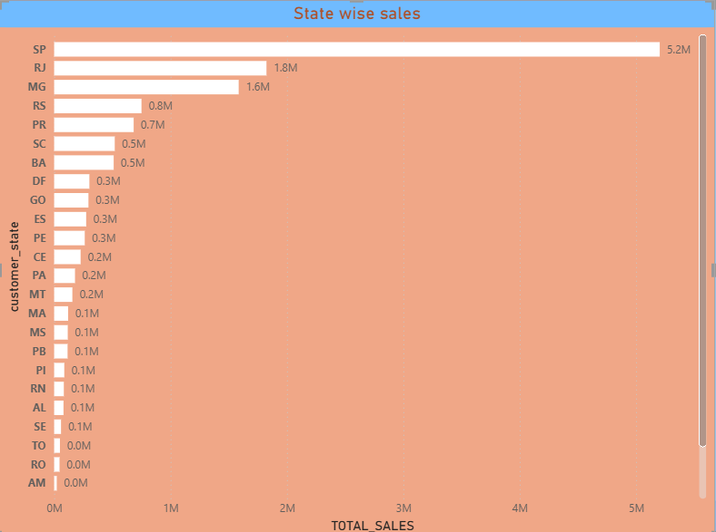

**TOP performing states**

* **São Paulo (SP)** dominates the sales chart with **5.2 million**, contributing a **huge share of total sales**.
* Followed by:
  + **Rio de Janeiro (RJ)** – 1.8M
  + **Minas Gerais (MG)** – 1.6M
* These top 3 states account for the **majority of national sales**, indicating:
  + High population density
  + Strong purchasing behavior
  + Possible regional promotions or supply chain strength

**Mid-Range States:**

* **RS, PR, SC, BA** each contribute between **0.5M to 0.8M**, showing decent engagement.
* These are important secondary markets with **growth potential** through targeted campaigns or improved logistics.

**🔻 Low-Contribution States:**

* States like **RO, TO, AM** have **negligible or zero sales**.
* Others like **SE, AL, RN, PI** contribute just around **0.1M**, possibly due to:
  + Less marketing reach
  + Poor infrastructure/logistics

**Opportunities for Growth:**

* The business can focus on **expansion strategies** in underperforming states through:
  + Localized marketing
  + Influencer or partner collaborations
  + Supply chain improvements

# 7. Seasonal Sales Patterns

Investigate and visualize any seasonal patterns (Quarterly) or trends in sales data over the course of the year.

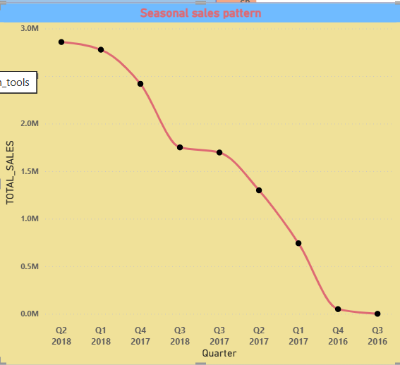

**Overall Trend:**

* There is a **clear upward trend** in sales from **Q3 2016 to Q2 2018**.
* Total sales have grown from **almost zero to ~3 million** during this period.
* This consistent rise reflects:
  + Increasing customer base
  + Improved brand visibility
  + Possibly better seasonal offerings or logistics over time

**Quarterly Growth Highlights:**

* **Major spike observed** between **Q4 2017 and Q1 2018** — indicating a strong Q1 performance.
* **Sharpest rise** seen from **Q4 2017 to Q2 2018** — suggests effective strategy deployment or high seasonal demand (likely due to promotions/festive season).

**Early Quarters (2016 - Early 2017):**

* Sales were **very low or negligible** until **Q4 2016**, indicating:
  + Initial phase of business operations
  + Market testing or limited operations
  + Lack of customer awareness

**Seasonality:**

* While the trend is generally upward, there’s a **steady seasonal climb**, with **no major drop in any quarter**.
* This shows strong retention and consistent growth, rather than heavy dependency on a single festive season or event.

# 8. Revenue Analysis

Determine the total revenue generated by ShopNest Store and analyze how it changes over time (Yearly). Represent this information through suitable visuals to highlight trends and patterns.

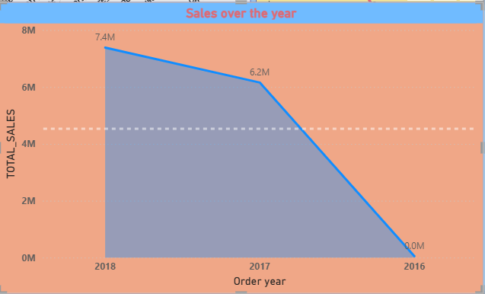

**Trend Overview:**

* **Consistent Year-on-Year Growth** from **2016 to 2018**:
  + **2016**: Near zero sales — indicates launch or very early-stage operations.
  + **2017**: Sharp jump to **6.2M**, showing rapid expansion.
  + **2018**: Further increase to **7.4M**, signaling strong performance and market traction.

**Key Takeaways:**

* The **growth rate** from **2016 to 2017** is the highest (a massive jump from zero).
* **2018 shows growth**, but at a **slower pace than 2017**, which may suggest:
  + Market saturation starting
  + Operational bottlenecks
  + External challenges (competition, policy, etc.)

**Strategic Insight:**

* Continued upward trajectory shows a **scalable business model**.
* Important to **analyze what worked in 2017**, as it was the breakout year.
* From 2018 onward, focus may need to shift to **customer retention** and **new verticals** to maintain momentum.