Executive Summary & Overview

Exploratory Data Analysis (EDA) Report
Titanic Passenger Dataset Evaluation & Key Finding Deliverable

This report outlines a formal statistical and visual exploratory data analysis (EDA) conducted on the Titanic passenger survival dataset. The primary objective is to evaluate data health, isolate anomalies, track key attribute distributions, and establish multi-variable patterns to define strong survival predictors.

Statistical Exploration & Structural Integrity

A baseline structural inspection confirms that the matrix contains 891 primary entries across major numeric and non-numeric analytical columns. A look into data counts exposes minor integrity variances:

Metric / Column | PassengerId | Survived | Pclass | Age | Sex Summary | Fare
Total Counts | 891.00 | 891.00 | 891.00 | 718.00 | Male: 577 | 891.00
Mean (Average) | 446.00 | 0.3838 | 2.3086 | 29.5630 | Female: 314 | 32.8461
Max Value | 891.00 | 1.0000 | 3.0000 | 80.0000 | Total: 891 | 512.3200

Key Structural Observations:
Missing Value Anomalies: The Age data stream contains clear null-value gaps (fewer than the baseline 891 items), making value imputation necessary before modeling.
Global Survival Baseline: The dataset shows an overall baseline survival rate of 38.38%.
Gender Disparity: The absolute volume of passengers skew heavily male (577 individuals vs 314 females).

Univariate Analysis (Distribution Profiles)

Examining columns individually surfaces underlying shape profiles and flags extreme mathematical anomalies.
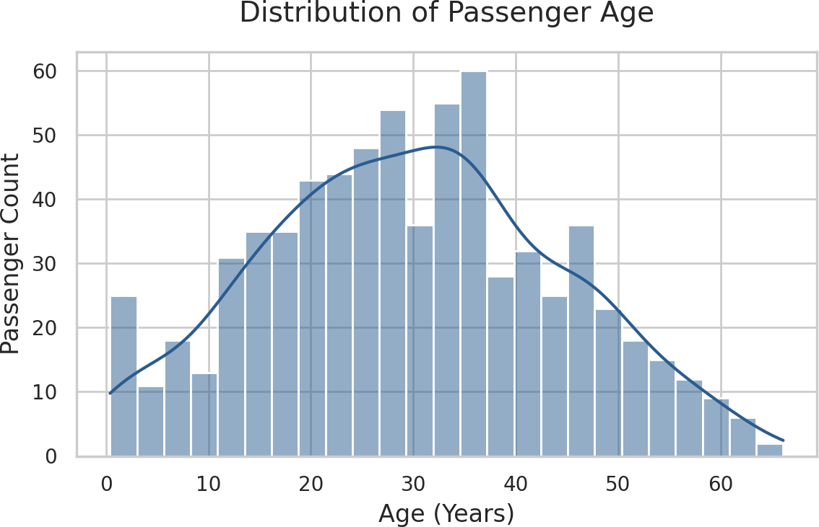

Figure 1: Passenger Age Distribution Profile

The age distribution shows a realistic profile with a slight right-side skew. The densest cluster represents active young adults ranging between 20 and 32 years of age, alongside a minor baseline uptick for young children.

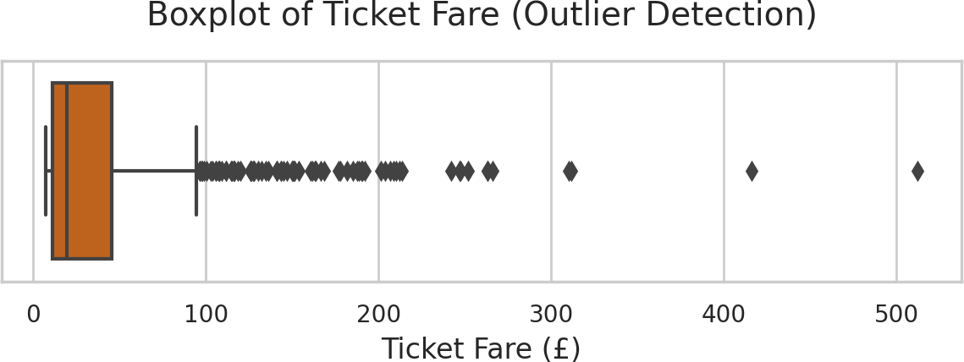

Figure 2: Boxplot for Fare Outlier Identification

Outlier Assessment: The Ticket Fare data shows extreme right-skewed anomalies. The standard baseline population spent under £40, whereas premium accounts paid upwards of £250 to £512, creating distinct economic outlier gaps.

Bivariate & Multivariate Analysis

Intersecting distinct groupings uncovers operational rules and demographic survival patterns.
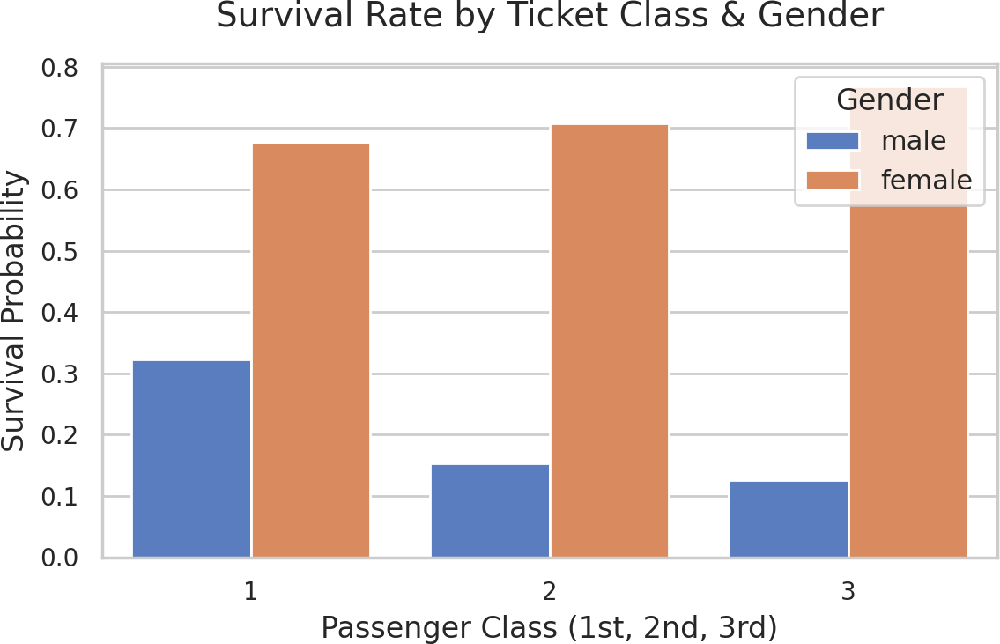

Figure 3: Survival Probability via Ticket Class and Gender Grouping

Survival Impact Conclusions:
The Crucial Impact of Gender: Female passengers achieved significantly superior survival probabilities compared to male cohorts across every category tier.
Socio-Economic Tier Multipliers: Independent of gender, 1st Class designations scaled survival probability dramatically compared to 3rd Class ticket holders, highlighting an explicit class privilege trend.

Correlation Matrix Map

Evaluating linear Pearson relationship indices establishes global interaction behaviors among numeric parameters.
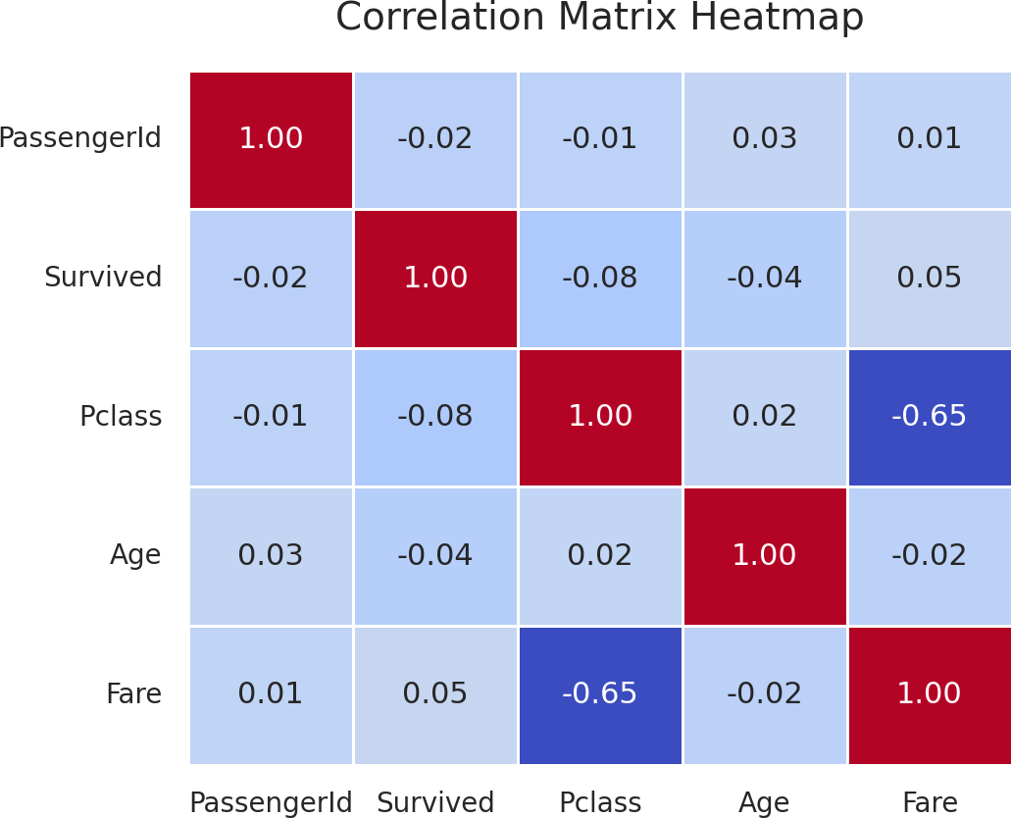

Figure 4: Pearson Correlation Matrix Heatmap Grid

The heatmap surfaces a clear negative correlation coefficient between Ticket Fare and Passenger Class (Pclass). This maps cleanly to economic structures where premium class levels (1st Class) demand heavily expanded fare outlays. Higher survival metrics visually align with expanded pricing dimensions, validating that premium economic status provided functional safety benefits.

Consolidated Conclusions

  - Social & Gender Stratification: Demographics tell the complete story of the disaster. Gender stood as the absolute strongest baseline classifier for survival outcomes, augmented directly by socio-economic class positioning.
  - Data Prep Matrix: Future engineering pipelines must actively account for the extreme Fare variance outliers and address missing entries in the Age data stream.

