1. Object Class
2. Inheritance is carrying over properties from parent class to child class
3. Method Overloading is two or more methods having same name with different parameter list.

Ex : public void display() {

// method body }

public void display(String names) {

// method body }

public void display(String names, int id) {

// method body }

1. Constructor is a special method in java which has same name as class name and no return type. Constructor overloading is a technique in which more than one constructor is initialized with different list of parameters.

Ex :

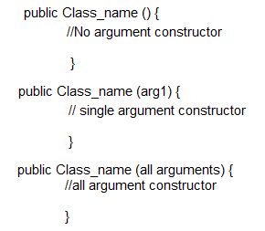

1. Constructor chaining is a technique in which one constructor is called inside another constructor. This is done with the use of **“this ();”** method.
2. Keywords:
3. Extends: this keyword is used to achieve inheritance of one class into another.
4. Package: package keyword is used to determine the classes, interfaces and enums to which the current class belongs to.
5. Import: Import keyword is used to access a parent class instance into a child class when they are present in different packages.
6. Return: When a return type is used to initialize a method, return keyword is used to return the same type of data after executing that method. No statements are executed after return statement, as it returns the control back to the main method.
7. **“this”** is a keyword which is used to map the instance variable to the local variable to help in reading the values sent to the local variable.

**“this ( )”** is a special method used in order to achieve constructor overloading.

1. Object oriented programming considers everything is an object. An object is mandatorily needed to call any class. OOPs concept implements real world objects into programming language.

|  |  |
| --- | --- |
| 1. Polymorphism | 1. Abstraction |
| 1. Encapsulation | 1. Inheritance |

1. Class is a blueprint description of an object, which has statements related to the functionalities of that object. Object is a real-world runtime entity, which has a state, behaviour, and identity.
2. Constructor is a Special method in java which is called by default when a class is invoked. It creates an instance of a class. Since in OOPs everything is considered to be an object, constructor creates an instance of a class which behaves as an object for that class.
3. .

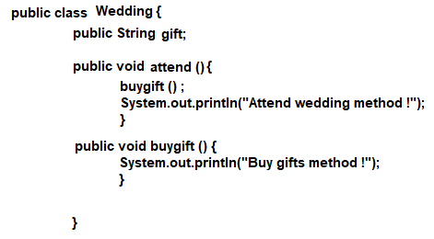

1. We can execute any method before main method, it does not give any error. The static properties are loaded into the memory with the help of class loader. But to perform certain functions in a particular order, a main method is necessary.
2. Access Modifiers / Access Specifiers are the keywords which are used to determine the cope of the property (references or methods)
3. Access Modifiers :
4. Private: Entities declared as private can be accessed only within the method in which they are initialized in. If instance variables are made private, they can be accessed with the help of getters and setters.
5. Package default: when no access specifier is specified, whatever is the default access specifier for that package, the same will be applied.
6. Public: Entities declared as public can be accessed by anyone from anywhere.