1. This is an example of Type Casting (converting one datatype to another). The output here will be false, as in boolean datatype, “1” is considered as false.
2. 10, 110
3. Compile time error : In “if” clause, there is no comparison operator
4. A static entity is allocated memory during the compile time itself. The main method is made static so that, during the runtime itself the JVM can call the class even without the instance of the class being created.
5. .

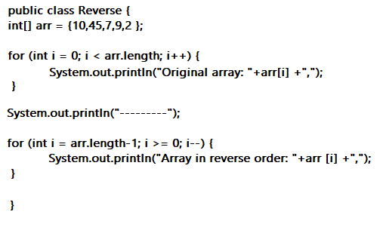

1. .

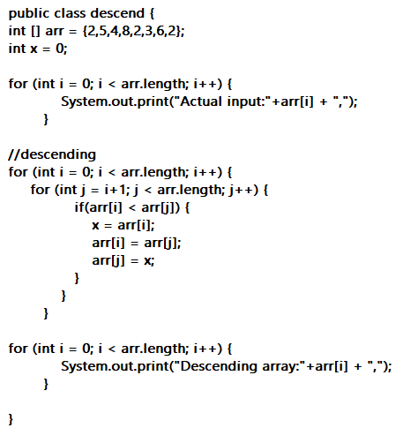

1. Fail
2. **“this”** keyword: Points to the current object. It is used to pass the reference values to the instance variable.

**“this()”** method: It is used to achieve constructor overloading.

1. .

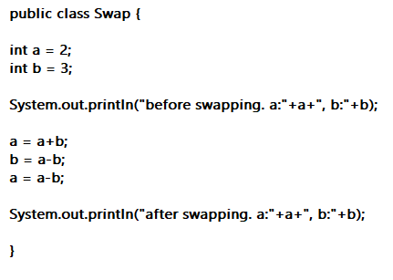

1. 1.

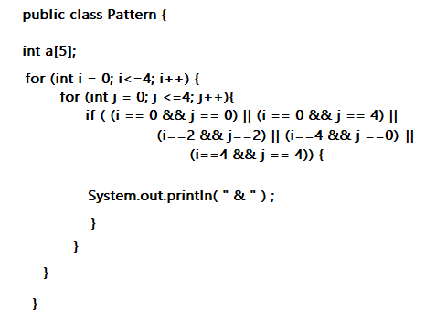

2.

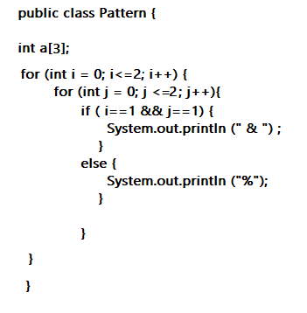

3.

