**WORKSHEET-1**

**DEEP LEARNING**

**Q1 to Q8 are MCQs with only one correct answer. Choose the correct option.**

1. Which of the following can approximate any function universally (i.e. universal approximators)?

D) All of the above

1. In which of the following domains we cannot use neural networks?

D) None of the above

1. Rearrange the following steps of a gradient descent algorithm in correct order of their occurrence?

i. Initialize random weight and bias

ii. Repeat the process until you find the best weights of network

iii. Change weights and biases for each neuron to reduce the error

iv. Calculate error distances between the actual and the predicted value v. Pass an input through the network and get values from output layer

C) i – v – iv – iii – ii

1. What is the full form of RNN?
   1. Recurrent Neural Network
2. What is plasticity in neural networks?

C) output pattern keeps on changing

1. What is stability plasticity dilemma?
   1. static inputs & categorization can’t be handled
2. Read the following statements:

**Statement 1**: It is possible to train a network well by initializing all the weights as 0 **Statement 2**: It is possible to train a network well by initializing biases as 0 Which of the statements given above is true, Choose the correct option?

B) Statement 2 is true while statement 1 is false

Which of the following architecture has feedback connections?

* 1. Recurrent Neural network

**Q9 and Q10 are MCQs with one or more correct answers. Choose all the correct options.**

1. In training a neural network, you notice that the loss does not decrease in the few starting epochs. The reason behind it could be
   1. Learning Rate is low B) Regularisation parameter is high

D) Stuck at local minima

1. Which of the following function(s) can be used to impart non – linearity in a neural network?
   1. Stochastic Gradient Descent

C) Convolution Function D) Sigmoid Function

**Q11 to Q15 are subjective answer type question. Answer them briefly.**

1. **What is Deep Learning?**

**Deep learning** (also known as **deep structured learning**) is part of a broader family of [machine learning](https://en.wikipedia.org/wiki/Machine_learning) methods based on [artificial neural networks](https://en.wikipedia.org/wiki/Artificial_neural_networks) with [representation learning](https://en.wikipedia.org/wiki/Representation_learning). Learning can be [supervised](https://en.wikipedia.org/wiki/Supervised_learning), [semi-supervised](https://en.wikipedia.org/wiki/Semi-supervised_learning) or [unsupervised](https://en.wikipedia.org/wiki/Unsupervised_learning).

Deep learning architectures such as [deep neural networks](https://en.wikipedia.org/wiki/Deep_learning#Deep_neural_networks), [deep belief networks](https://en.wikipedia.org/wiki/Deep_belief_network), [recurrent neural networks](https://en.wikipedia.org/wiki/Recurrent_neural_networks) and [convolutional neural networks](https://en.wikipedia.org/wiki/Convolutional_neural_networks) have been applied to fields including [computer vision](https://en.wikipedia.org/wiki/Computer_vision), [machine vision](https://en.wikipedia.org/wiki/Machine_vision), [speech recognition](https://en.wikipedia.org/wiki/Automatic_speech_recognition), [natural language processing](https://en.wikipedia.org/wiki/Natural_language_processing), [audio recognition](https://en.wikipedia.org/wiki/Audio_recognition), social network filtering, [machine translation](https://en.wikipedia.org/wiki/Machine_translation), [bioinformatics](https://en.wikipedia.org/wiki/Bioinformatics), [drug design](https://en.wikipedia.org/wiki/Drug_design), medical image analysis, material inspection and [board game](https://en.wikipedia.org/wiki/Board_game) programs, where they have produced results comparable to and in some cases surpassing human expert performance.

[Artificial neural networks](https://en.wikipedia.org/wiki/Artificial_neural_network) (ANNs) were inspired by information processing and distributed communication nodes in biological systems. ANNs have various differences from biological [brains](https://en.wikipedia.org/wiki/Brain). Specifically, neural networks tend to be static and symbolic, while the biological brain of most living organisms is dynamic (plastic) and analog.

The adjective "deep" in deep learning comes from the use of multiple layers in the network. Early work showed that a linear [perceptron](https://en.wikipedia.org/wiki/Perceptron) cannot be a universal classifier, and then that a network with a nonpolynomial activation function with one hidden layer of unbounded width can on the other hand so be. Deep learning is a modern variation which is concerned with an unbounded number of layers of bounded size, which permits practical application and optimized implementation, while retaining theoretical universality under mild conditions. In deep learning the layers are also permitted to be heterogeneous and to deviate widely from biologically informed [connectionist](https://en.wikipedia.org/wiki/Connectionism) models, for the sake of efficiency, trainability and understandability, whence the "structured" part.

1. **What is reinforcement learning?**

Reinforcement learning is a type of machine learning frameworks which addresses such learning machinery. It aims to find an optimal policy to achieve the goal by interacting with the environment through rewarding or penalizing the decisions made by the machine.

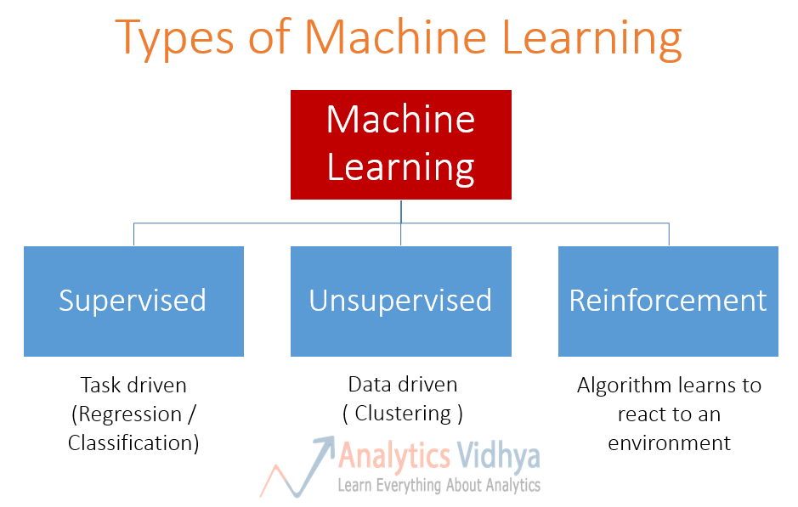

1. **What Are the Differences Between Machine Learning and Deep Learning?**

**Comparison of Machine Learning and Deep Learning**

Now that you have understood an overview of Machine Learning and Deep Learning, we will take a few important points and compare the two techniques.

**Data dependencies**

The most important difference between deep learning and traditional machine learning is its performance as the scale of data increases. When the data is small, deep learning algorithms don’t perform that well. This is because deep learning algorithms need a large amount of data to understand it perfectly. On the other hand, traditional machine learning algorithms with their handcrafted rules prevail in this scenario. Below image summarizes this fact.

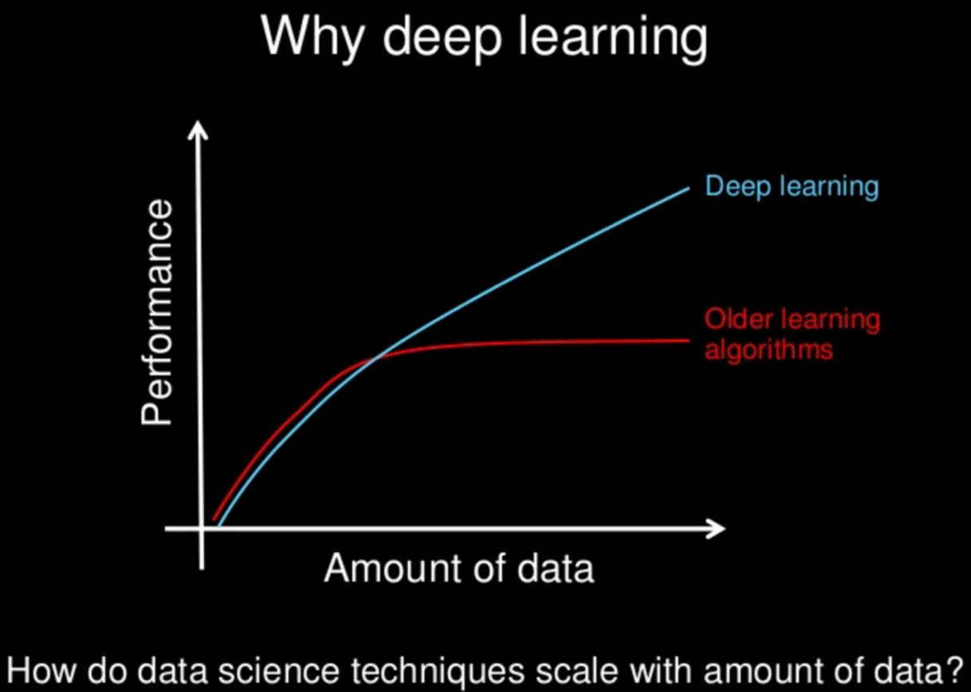

**Hardware dependencies**

Deep learning algorithms heavily depend on high-end machines, contrary to traditional machine learning algorithms, which can work on low-end machines. This is because the requirements of deep learning algorithm include GPUs which are an integral part of its working. Deep learning algorithms inherently do a large amount of matrix multiplication operations. These operations can be efficiently optimized using a GPU because GPU is built for this purpose.

**Feature engineering**

Feature engineering is a process of putting domain knowledge into the creation of feature extractors to reduce the complexity of the data and make patterns more visible to learning algorithms to work. This process is difficult and expensive in terms of time and expertise.

In Machine learning, most of the applied features need to be identified by an expert and then hand-coded as per the domain and data type.

For example, features can be pixel values, shape, textures, position and orientation. The performance of most of the Machine Learning algorithm depends on how accurately the features are identified and extracted.

Deep learning algorithms try to learn high-level features from data. This is a very distinctive part of Deep Learning and a major step ahead of traditional Machine Learning. Therefore, deep learning reduces the task of developing new feature extractor for every problem. Like, Convolutional NN will try to learn low-level features such as edges and lines in early layers then parts of faces of people and then high-level representation of a face.

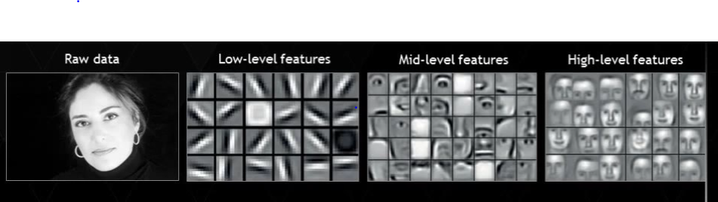

**Problem Solving approach**

When solving a problem using traditional machine learning algorithm, it is generally recommended to break the problem down into different parts, solve them individually and combine them to get the result. Deep learning in contrast advocates to solve the problem end-to-end.

Let’s take an example to understand this.

Suppose you have a task of multiple object detection. The task is to identify what is the object and where is it present in the image.

In a typical machine learning approach, you would divide the problem into two steps, object detection and object recognition. First, you would use a bounding box detection algorithm like grabcut, to skim through the image and find all the possible objects. Then of all the recognized objects, you would then use object recognition algorithm like SVM with HOG to recognize relevant objects.

On the contrary, in deep learning approach, you would do the process end-to-end. For example, in a [YOLO net](https://pjreddie.com/darknet/yolo/) (which is a type of deep learning algorithm), you would pass in an image, and it would give out the location along with the name of object.

**Execution time**

Usually, a deep learning algorithm takes a long time to train. This is because there are so many parameters in a deep learning algorithm that training them takes longer than usual. State of the art deep learning algorithm ResNet takes about two weeks to train completely from scratch. Whereas machine learning comparatively takes much less time to train, ranging from a few seconds to a few hours.

This is turn is completely reversed on testing time. At test time, deep learning algorithm takes much less time to run. Whereas, if you compare it with k-nearest neighbors (a type of machine learning algorithm), test time increases on increasing the size of data. Although this is not applicable on all machine learning algorithms, as some of them have small testing times too.

**Interpretability**

Last but not the least, we have interpretability as a factor for comparison of machine learning and deep learning. This factor is the main reason deep learning is still thought 10 times before its use in industry.

Let’s take an example. Suppose we use deep learning to give automated scoring to essays. The performance it gives in scoring is quite excellent and is near human performance. But there’s is an issue. It does not reveal why it has given that score. Indeed mathematically you can find out which nodes of a deep neural network were activated, but we don’t know what there neurons were supposed to model and what these layers of neurons were doing collectively. So we fail to interpret the results.

On the other hand, machine learning algorithms like decision trees give us crisp rules as to why it chose what it chose, so it is particularly easy to interpret the reasoning behind it. Therefore, algorithms like decision trees and linear/logistic regression are primarily used in industry for interpretability.

1. **What is a perceptron?**

A neural network is an interconnected system of perceptrons, so it is safe to say perceptrons are the foundation of any neural network. Perceptrons can be viewed as building blocks in a single layer in a neural network, made up of four different parts:

1. Input Values or One Input Layer
2. Weights and Bias
3. Net sum
4. Activation function

A neural network, which is made up of perceptrons, can be perceived as a complex logical statement (neural network) made up of very simple logical statements (perceptrons); of “AND” and “OR” statements. A statement can only be true or false, but never both at the same time. The goal of a perceptron is to determine from the input whether the feature it is recognizing is true, in other words whether the output is going to be a 0 or 1. A complex statement is still a statement, and its output can only be either a 0 or 1.

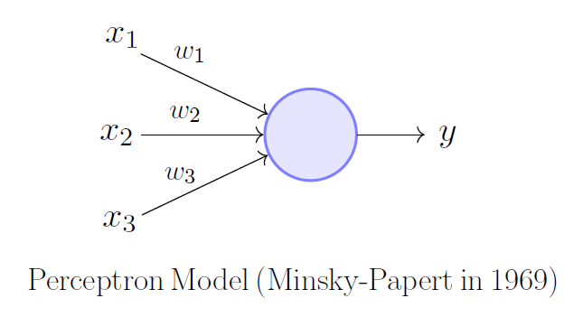

Following the map of how a perceptron functions is not very difficult: summing up the weighted inputs (product of each input from the previous layer multiplied by their weight), and adding a bias (value hidden in the circle), will produce a weighted net sum. The inputs can either come from the input layer or perceptrons in a previous layer. The weighted net sum is then applied to an activation function which then standardizes the value, producing an output of 0 or 1. This decision made by the perceptron is then passed onto the next layer for the next perceptron to use in their decision.

Together, these pieces make up a single perceptron in a layer of a neural network. These perceptrons work together to classify or predict inputs successfully, by passing on whether the feature it sees is present (1) or is not (0). The perceptrons are essentially messengers, passing on the ratio of features that correlate with the classification vs the total number of features that the classification has. For example, if 90% of those features exist then it is probably true that the input is the classification, rather than another input that only has 20% of the features of the classification. It’s just as Helen Keller once said, “Alone we can do so little; together we can do so much.” and this is very true for perceptrons all around.

1. **What’s the difference between AI and ML?**

## AI:

Artificial intelligence as an academic discipline was founded in 1956. The goal then, as now, was to get computers to perform tasks regarded as uniquely human: things that required intelligence. Initially, researchers worked on problems like playing checkers and solving logic problems.

If you looked at the output of one of those checkers playing programs you could see some form of “artificial intelligence” behind those moves, particularly when the computer beat you. Early successes caused the first researchers to exhibit almost boundless enthusiasm for the possibilities of AI, matched only by the extent to which they misjudged just how hard some problems were.

Artificial intelligence, then, refers to the output of a computer. The computer is doing something intelligent, so it’s exhibiting intelligence that is artificial.

The term AI doesn’t say anything about how those problems are solved.  There are many different techniques including rule-based or expert systems. And one category of techniques started becoming more widely used in the 1980s: machine learning.

## Machine Learning:

The reason that those early researchers found some problems to be much harder is that those problems simply weren't amenable to the early techniques used for AI. Hard-coded algorithms or fixed, rule-based systems just didn’t work very well for things like image recognition or extracting meaning from text.

**The solution turned out to be not just mimicking human behavior (AI) but mimicking how humans learn.**

Think about how you learned to read. You didn’t sit down and learn spelling and grammar before picking up your first book. You read simple books, graduating to more complex ones over time. You actually learned the rules (and exceptions) of spelling and grammar from your reading. Put another way, you processed a lot of data and learned from it.

That’s exactly the idea with machine learning. Feed an algorithm (as opposed to your brain) a lot of data and let it figure things out. Feed an algorithm a lot of data on financial transactions, tell it which ones are fraudulent, and let it work out what indicates fraud so it can predict fraud in the future. Or feed it information about your customer base and let it figure out how best to segment them. Find out more about [machine learning techniques here](https://blogs.oracle.com/bigdata/machine-learning-techniques).

As these algorithms developed, they could tackle many problems. But some things that humans found easy (like speech or handwriting recognition) were still hard for machines. However, if machine learning is about mimicking how humans learn, why not go all the way and try to mimic the human brain? That’s the idea behind [neural networks](https://blogs.oracle.com/bigdata/3-more-machine-learning-techniques-to-know" \t "_blank).

The idea of using artificial neurons (neurons, connected by synapses, are the major elements in your brain) had been around for a while. And neural networks simulated in software started being used for certain problems. They showed a lot of promise and could solve some complex problems that other algorithms couldn’t tackle.

But machine learning still got stuck on many things that elementary school children tackled with ease: how many dogs are in this picture or are they really wolves? Walk over there and bring me the ripe banana. What made this character in the book cry so much?

It turned out that the problem was not with the concept of machine learning. Or even with the idea of mimicking the human brain. It was just that simple neural networks with 100s or even 1000s of neurons, connected in a relatively simple manner, just couldn’t duplicate what the human brain could do. It shouldn't be a surprise if you think about it; human brains have around 86 billion neurons and very complex interconnectivity.