**LAB#06**

# Fundamentals of Flask Framework

**OBJECTIVE:**

Introduction to Flask framework including basic concept of backend along with syntax, folder structure including routes management and control structures.

**Task:**

Create a basic Gym Management System website using **Flask, HTML**, and **CSS**. The website will include:

* A **Home** page displaying a welcome message and gym highlights.
* An **About Us** page sharing details about the gym's mission, team, and facilities.
* A **Membership** page showcasing membership plans and services.

Use **Flask** to manage routes for these pages, serve dynamic content using templates, and style the website with CSS. Place **HTML** files in the templates folder and **CSS** files in the static folder.

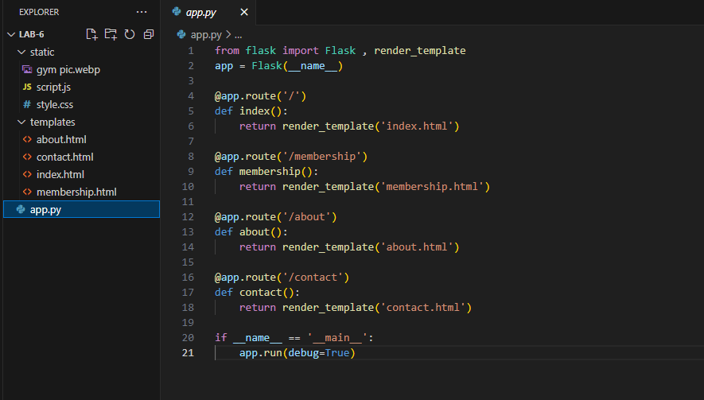

**ROUTING:**

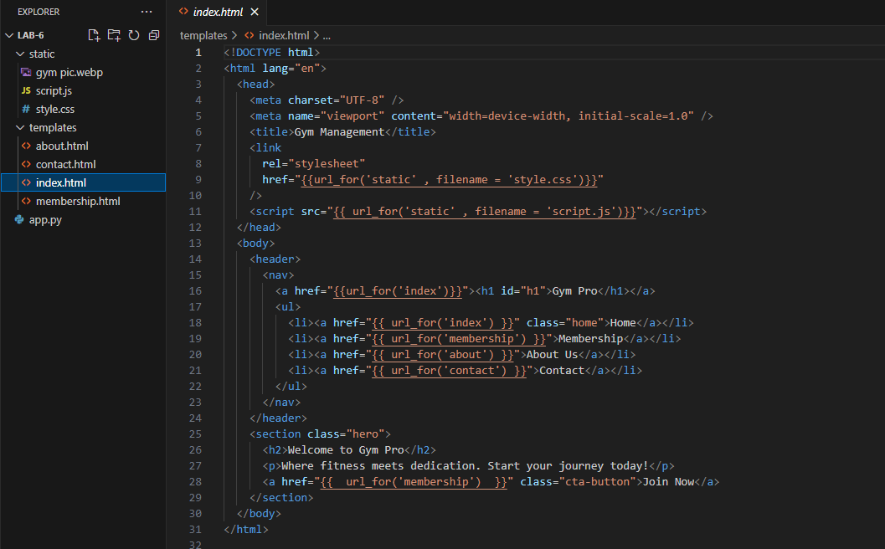

**ABOUT PAGE:**

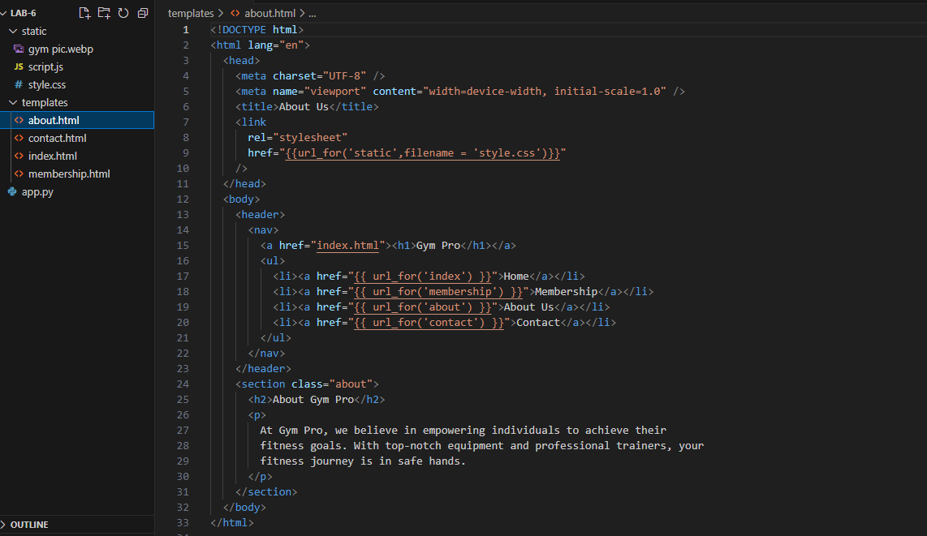

**MEMBERSHIP PAGE:**

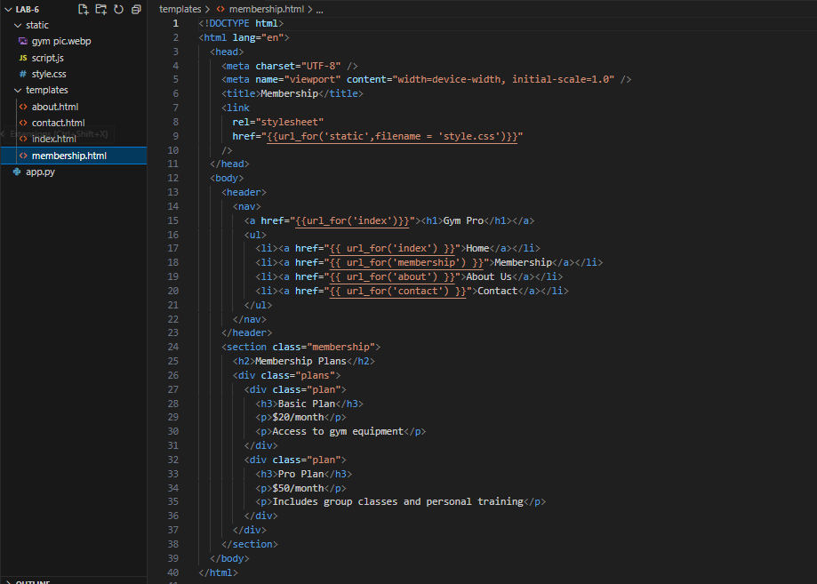

**CONTACT PAGE:**

