Exploratory Data Analysis
The Diamonds Dataset
Statistical Summary · Correlation Analysis · Key Influencing Factors
53,940 diamonds · 10 variables · price range $326 – $18,823

1. Introduction & Objective
This report presents an exploratory data analysis (EDA) of the classic Diamonds dataset, which records the price and physical/quality attributes of 53,940 round-cut diamonds. The goal is to understand the shape of the data, identify data-quality issues, quantify relationships between variables, and determine which factors most strongly influence price — while surfacing any misleading patterns along the way.
The dataset contains 10 variables: carat (weight), cut, color, clarity, depth %, table %, price (USD), and the physical dimensions x/y/z (mm).

2. Dataset Overview & Data Quality

2.1 Structure
Metric | Value
Rows | 53,940
Columns | 10 (7 numeric, 3 categorical)
Missing values | 0
Exact duplicate rows | 146 (0.27%)
Rows with a zero dimension (x/y/z) | 20 (likely data-entry errors)

The data is essentially complete — no missing values — but is not perfectly clean: 146 exact duplicate rows and 20 rows with an impossible zero dimension (e.g. z = 0mm) were found. These were excluded from the visual analysis below to avoid distorting scale and correlation estimates, though they represent a negligible fraction (<0.4%) of the data.

2.2 Categorical Variables
- Cut: 5 levels — Ideal (40%) is the most common, followed by Premium (26%), Very Good (22%), Good (9%), and Fair (3%).
- Color: 7 levels (D = colorless/best, J = most tinted). G is most common; the distribution is fairly balanced across grades.
- Clarity: 8 levels from I1 (worst) to IF (flawless). SI1 and VS2 are the most common grades; flawless (IF) stones are rare (3.3%).

3. Statistical Summary
Variable | Mean / Notes
Carat | 0.80 (median 0.70), right-skewed, max 5.01
Price | $3,933 (median $2,401), heavily right-skewed
Depth % | 61.7% (tight distribution, std 1.4)
Table % | 57.5% (tight distribution, std 2.2)

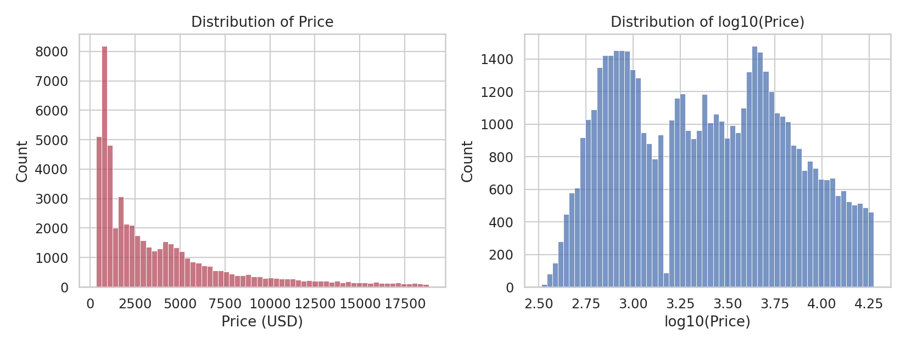
Figure 1 — Price is heavily right-skewed (many affordable stones, a long tail of expensive ones). On a log10 scale, the distribution becomes far more symmetric, indicating price grows multiplicatively with quality/size.

4. Correlation Analysis
To identify what drives price, we computed pairwise Pearson correlations between all numeric variables.
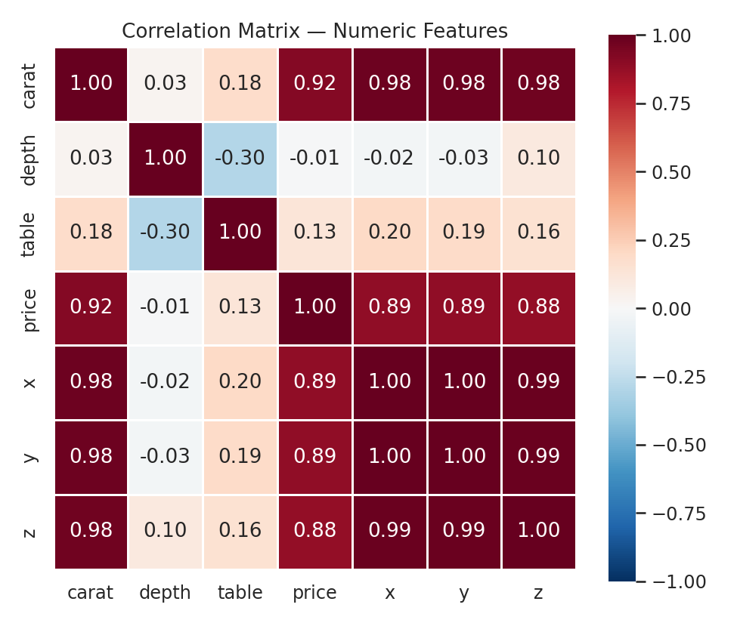
Figure 2 — Correlation matrix of numeric features.

4.1 Key Findings
- Carat (weight) is by far the strongest predictor of price (r = 0.92).
- The physical dimensions x, y, z are highly correlated with carat and each other (r > 0.95) — they are largely redundant measures of size, and also correlate strongly with price (r ≈ 0.86–0.88) purely because they encode size.
- Table % and depth % have very weak correlation with price (r = 0.13 and r = -0.01), suggesting these proportion metrics affect visual quality more than market price directly.
- Depth % and table % are mildly negatively correlated (r = -0.30), reflecting a geometric trade-off in how a stone is cut.
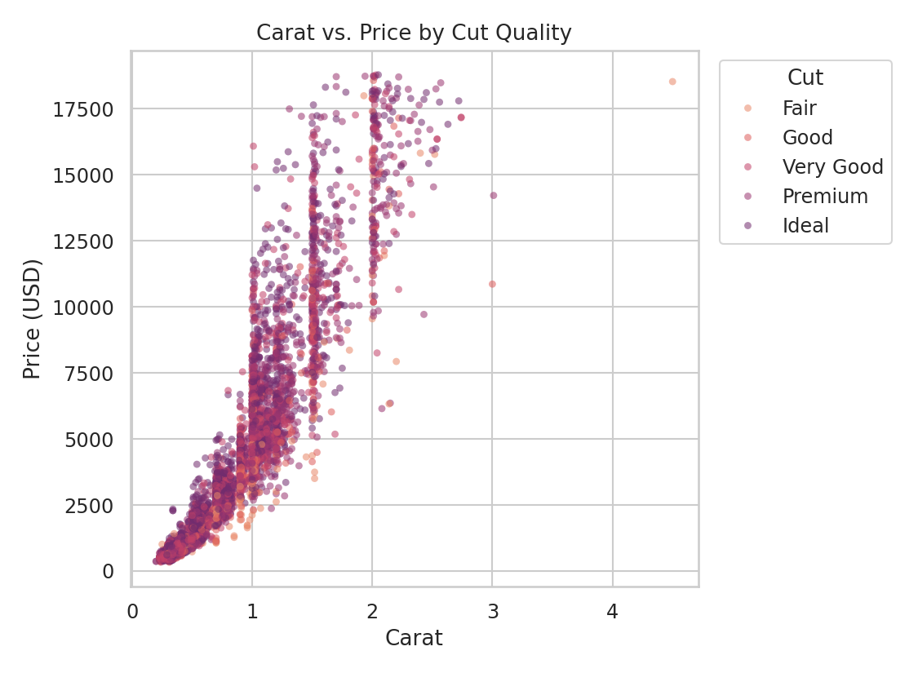
Figure 3 — Carat vs. price, colored by cut. Price rises non-linearly with carat, and the relationship is not a single clean curve — cut quality shifts the curve, and variance in price grows with carat size.

5. Category Effects: Cut, Color, Clarity
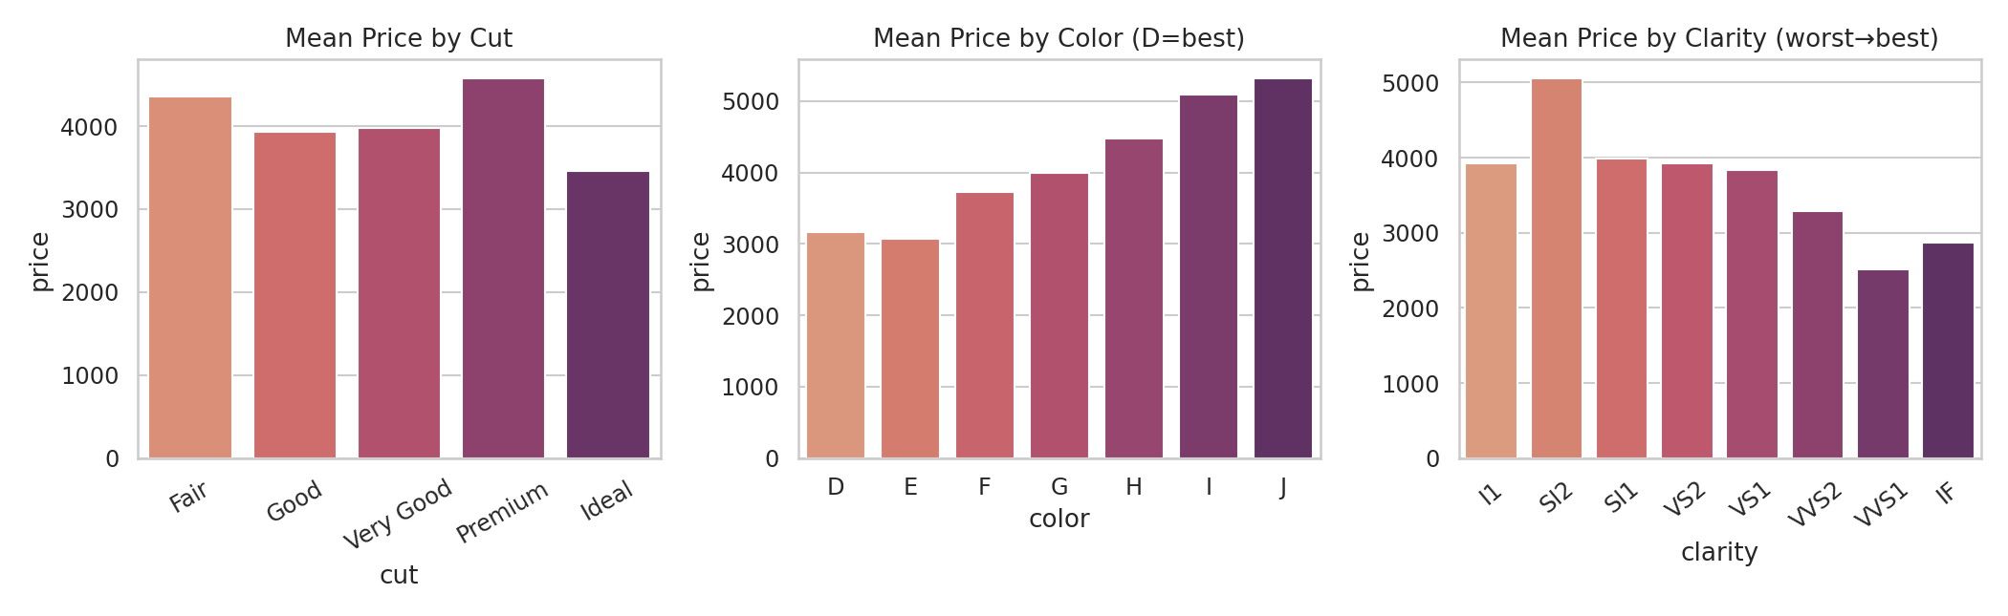
Figure 4 — Mean price by cut, color, and clarity.
At first glance, the cut chart is counter-intuitive: Ideal-cut diamonds have the lowest average price, and Premium/Fair cuts appear the most expensive. Similarly, better color/clarity grades (D, IF) show lower average prices than worse grades (J, SI2). This runs opposite to what "quality" should imply — this is investigated in Section 6.

6. A Closer Look: Simpson's Paradox
The pattern in Section 5 is a textbook case of Simpson's Paradox — a confounding variable (carat) reverses the apparent relationship. Ideal-cut diamonds are disproportionately smaller (mean 0.70 carat) than Fair-cut diamonds (mean 1.05 carat), because cutters are more willing to sacrifice a larger rough stone for a lower cut grade. Since carat dominates price, low-cut-but-large stones can out-price high-cut-but-small stones on average.
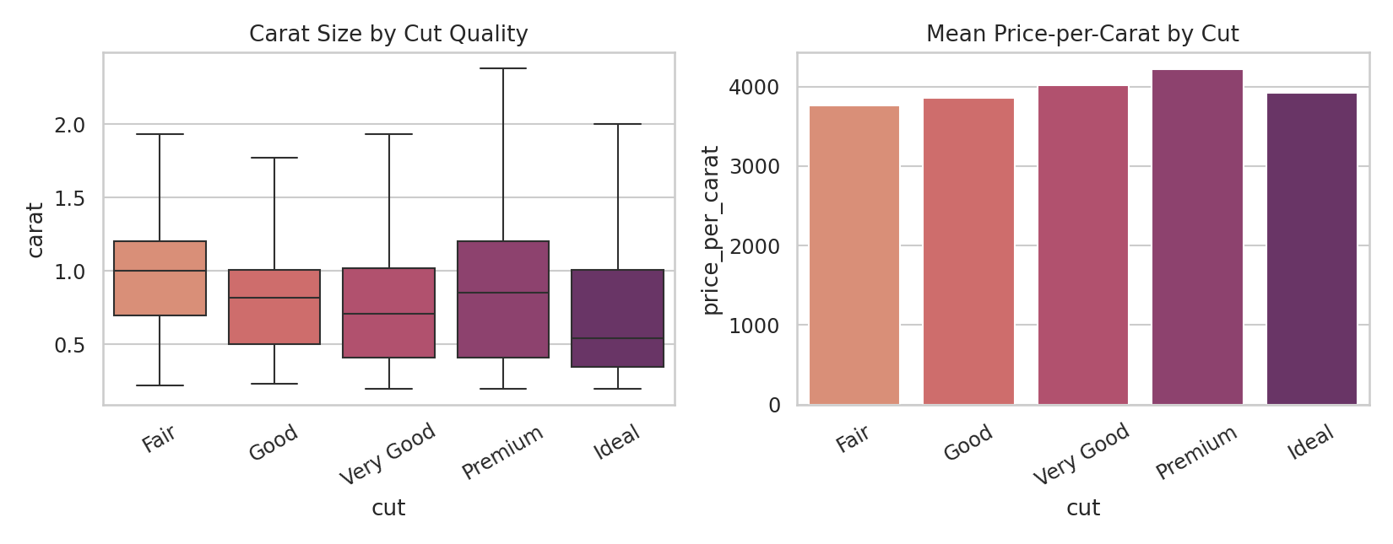
Figure 5 — Left: Fair-cut diamonds are on average nearly 50% larger than Ideal-cut diamonds. Right: once price is normalized per carat, the ranking flips — Premium cut actually commands the highest $/carat, and Fair the lowest, which matches quality intuition.
Takeaway: never interpret a category's raw average price without checking whether group sizes/carats differ. Price-per-carat is the fairer lens for comparing cut, color, and clarity quality, and under that lens quality grades behave as expected: better clarity and better color modestly increase price-per-carat, and Premium/Ideal cuts out-earn Fair cuts.

7. Secondary Features: Depth & Table
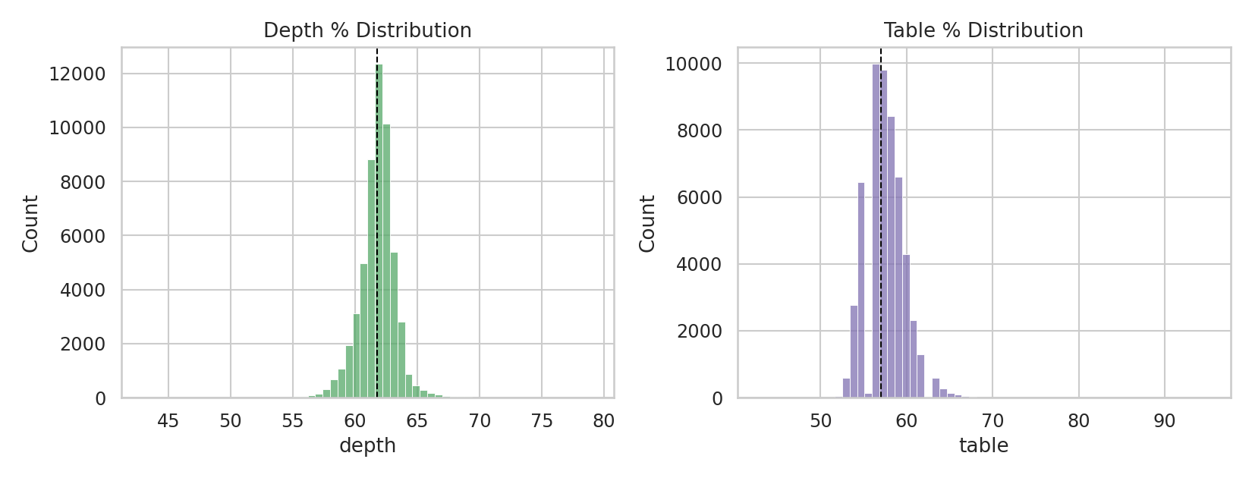
Figure 6 — Depth % and table % are tightly clustered around ~61.7% and ~57.5% respectively (dashed line = median), consistent with cutters converging on proportions known to maximize brilliance. Outliers outside this narrow band likely indicate poorly-cut stones.

8. Summary of Key Insights
- Carat is the dominant driver of price (r = 0.92); dimensions x/y/z are redundant proxies for the same signal.
- Table % and depth % barely correlate with price directly — they matter for visual brilliance, not raw market value.
- Raw average price by cut/color/clarity is misleading due to a strong confound with carat (Simpson's Paradox); price-per-carat is the correct metric for judging quality effects.
- Once normalized for size, quality grades behave intuitively: Premium and Ideal cuts, better color, and better clarity all command a price-per-carat premium.
- The dataset is largely clean (~0% missing) but contains 146 duplicate rows and 20 physically impossible records that should be removed before modeling.
- Price is heavily right-skewed; a log-price transform is recommended before any regression or ML modeling on this data.

9. Suggested Next Steps
- Fit a multiple regression or gradient-boosted model using carat, cut, color, and clarity to predict log(price), then examine feature importance directly.
- Engineer a volume feature (x × y × z) to test whether it out-performs carat alone.
- Investigate the 20 zero-dimension and 146 duplicate rows to decide whether to correct or drop them before modeling.
- Segment analysis by carat bucket (e.g. <0.5, 0.5–1, 1–2, 2+) to see if quality effects on price-per-carat change at different size tiers.

