
Mini project report on

TITLE
Submitted in partial fulfilment of the requirements for the award of degree of

Bachelor of Technology
in
Computer Science & Engineering
UE23CS351A – DBMS Project
Submitted by:
AISIRI SHETTY  SHLOKA SHETTY | PES2UG24CS623  PES2UG24CS659
under the guidance of

Dr. Shilpa S
Assistant Professor
PES University

AUG - DEC 2026
DEPARTMENT OF COMPUTER SCIENCE AND ENGINEERING
FACULTY OF ENGINEERING
PES UNIVERSITY
(Established under Karnataka Act No. 16 of 2013)
Electronic City, Hosur Road, Bengaluru – 560 100, Karnataka, India

PES UNIVERSITY

(Established under Karnataka Act No. 16 of 2013)
Electronic City, Hosur Road, Bengaluru – 560 100, Karnataka, India

CERTIFICATE

This is to certify that the mini project entitled

Citizen Complaint Management System
is a bonafide work carried out by

AISIRI SHETTY  SHLOKA SHETTY | PES2UG24CS623  PES2UG24CS659

In partial fulfilment for the completion of fifth semester DBMS Project (UE24CSS351A) in the Program of Study -Bachelor of Technology in Computer Science and Engineering under rules and regulations of PES University, Bengaluru during the period AUG. 2026 – DEC. 2026. It is certified that all corrections / suggestions indicated for internal assessment have been incorporated in the report. The project has been approved as it satisfies the 5th semester academic requirements in respect of project work.

Signature
Dr. Shilpa S
Assistant Professor

DECLARATION

We hereby declare that the DBMS Project entitled Disasters Data Management System has been carried out by us under the guidance of Dr. Shilpa S, Assistant Professor and submitted in partial fulfilment of the course requirements for the award of degree of Bachelor of Technology in Computer Science and Engineering of PES University, Bengaluru during the academic semester AUG – DEC 2026.

AISIRI SHETTY  SHLOKA SHETTY | PES2UG24CS623  PES2UG24CS659

ACKNOWLEDGEMENT

I would like to express my gratitude to Dr. Shilpa S, Department of Computer Science and Engineering, PES University, for her continuous guidance, assistance, and encouragement throughout the development of this UE23CS351A - DBMS Project.
I take this opportunity to thank Dr. Sandesh B J, C, Professor, ChairPerson, Department of Computer Science and Engineering, PES University, for all the knowledge and support I have received from the department.
I am deeply grateful to Prof. Jawahar Doreswamy, Chancellor – PES University, Dr. Suryaprasad J, Vice-Chancellor, PES University for providing to me various opportunities and enlightenment every step of the way. Finally, this DBMS Project could not have been completed without the continual support and encouragement I have received from my family and friends.

ABSTRACT
The Citizen Complaint Management System is a database-driven application designed to organize the registration, tracking and resolution of civic complaints. Complaints are stored with details such as description, category, priority, filing date, current status and responsible department. The database also maintains citizen, department, worker, civic asset, worker assignment, resolution and status-audit information.
The system uses MySQL 8.0 for relational data storage and Python Streamlit for the user interface. Python connects to MySQL using mysql-connector-python, while environment variables are used to configure database connection details. The application provides a dashboard and workflows for registering complaints, viewing and tracking complaints, updating status and priority, assigning workers and recording resolutions.
The database demonstrates primary and foreign keys, associative relations, SQL joins and aggregate queries, a view, a stored procedure, a user-defined function, a trigger and transaction rollback. During verification, the database contained 20 citizens, 30 complaints, 10 departments, 18 workers, 19 resolutions and 6 status-audit records. The view, procedure, function and trigger were executed and verified.

TABLE OF CONTENTS

Chapter No. | Title | Page No.
 | INTRODUCTION | 11
 | PROBLEM DEFINITION | 12
 | ER MODEL | 13
 | ER TO RELATIONAL MAPPING | 14
 | DDL STATEMENTS | 15
 | DML STATEMENTS | 20
 | QUERIES (SIMPLE QUERY AND UPDATE AND DELETE OPERATION, CORRELATED QUERY AND NESTED QUERY) | 23
 | STORED PROCEDURE, FUNCTIONS AND TRIGGERS | 30
 | FRONT END DEVELOPMENT | 40
REFERENCES/BIBLIOGRAPHY |  | 41
APPENDIX A DEFINITIONS, ACRONYMS AND ABBREVIATIONS |  | 42

LIST OF TABLES
Table No. | Title | Page No.
4.1 | Relational Schema of the System | TBD
5.1 | Database Table Structures | TBD
6.1 | Verification of Records in Relational Tables | TBD
7.1 | SQL Query Results | TBD

LIST OF FIGURES
Figure No. | Title | Page No.
3.1 | ER Diagram of Citizen Complaint Management System | TBD
4.1 | Relational Schema Diagram | TBD
5.1 | MySQL Table Creation and Structure | TBD
6.1 | Inserted Records in Relational Tables | TBD
9.1 | Dashboard | TBD
9.2 | Register Complaint Page | TBD
9.3 | View and Track Complaints Page | TBD
9.4 | Manage Complaints Page | TBD
9.5 | Assign Workers Page | TBD
9.6 | Record Complaint Resolution Page | TBD

1. INTRODUCTION

The Citizen Complaint Management System is a database-driven application developed to manage civic complaints in an organized and efficient manner. Citizens may face several public service issues related to roads, streetlights, water supply, sanitation and other municipal facilities. Handling these complaints manually can make it difficult to maintain records, assign responsibilities and monitor the progress of complaint resolution.
The proposed system provides a centralized platform to register, store, view and manage citizen complaints. Each complaint is associated with the citizen who reported it and the department responsible for handling it. The system also maintains information about workers, public assets, worker assignments and complaint resolutions.
The application uses MySQL as its relational database management system and Python Streamlit for its front-end interface. The database stores information in multiple related tables and uses SQL operations to retrieve and manage records. A dashboard provides an overview of complaint information, while the application allows users to register complaints, update their status and priority, assign workers and record resolutions.
The system demonstrates important DBMS concepts such as relational schema design, primary keys, foreign keys, joins, aggregate queries, views, stored procedures, user-defined functions, triggers and transaction management.
1.1 OBJECTIVES
The main objectives of the project are:
- To develop a centralized database for managing citizen complaints.
- To maintain citizen, department, worker and public asset information.
- To provide a facility for registering and tracking complaints.
- To classify complaints based on category and priority.
- To assign workers to complaints for resolution.
- To update complaint status and maintain resolution details.
- To maintain an audit record of complaint status changes.
- To demonstrate SQL queries and advanced DBMS concepts.
- To develop a user-friendly interface using Python Streamlit.
1.2 SCOPE OF THE PROJECT
The project focuses on managing civic complaints through a relational database and a web-based interface. It supports complaint registration, complaint tracking, department association, worker assignment, priority management and resolution recording.
The system is intended as an academic DBMS project demonstrating the practical application of database concepts. It can be extended in the future with features such as user authentication, automated notifications and online deployment.

2. PROBLEM DEFINITION

Managing citizen complaints is an important responsibility of civic and municipal departments. Complaints related to roads, water supply, sanitation, streetlights and other public facilities need to be recorded, assigned and resolved systematically.

When complaint records are maintained manually or in separate systems, it becomes difficult to track complaint status, identify the responsible department, assign workers and maintain resolution history. There is also a possibility of duplicate records and delays in addressing complaints.

The Citizen Complaint Management System addresses these problems by providing a centralized database that stores complaint information and connects it with citizens, departments, workers and public assets. It allows complaint details to be registered, viewed and updated through a simple application interface.

2.1 EXISTING SYSTEM

In a manual complaint management process, complaints may be recorded using paper forms or separate registers. Tracking the progress of complaints requires checking multiple records, and maintaining historical information can be difficult.

Some limitations of the existing approach include:

Difficulty in maintaining centralized complaint records.

Time-consuming complaint tracking.

Difficulty in identifying the responsible department.

Challenges in assigning workers and monitoring their work.

Lack of an organized status-change history.

Difficulty in generating complaint summaries and reports.

2.2 PROPOSED SYSTEM

The proposed Citizen Complaint Management System uses a relational database to organize complaint-related information. MySQL stores the records, while a Python Streamlit application provides the interface for interacting with the database.

The system provides the following features:

Registration of citizen complaints.

Storage of citizen and department details.

Classification of complaints based on category and priority.

Viewing and tracking of registered complaints.

Updating complaint status and priority.

Assigning workers to complaints.

Recording complaint resolution details.

Maintaining status-change records using a database trigger.

Displaying complaint summaries through a dashboard.

2.3 FUNCTIONAL REQUIREMENTS

The system shall store citizen information.

The system shall maintain department and worker details.

The system shall allow complaints to be registered.

The system shall associate complaints with citizens and departments.

The system shall allow complaints to be viewed and tracked.

The system shall support priority and status updates.

The system shall allow workers to be assigned to complaints.

The system shall store complaint resolution details.

The system shall maintain an audit history of status changes.

The system shall display complaint information through a dashboard.

2.4 NON-FUNCTIONAL REQUIREMENTS

Data Integrity: Primary keys, foreign keys and other defined constraints help maintain valid database records.

Usability: The Streamlit interface provides a simple way to interact with the system.

Maintainability: The application separates database connection logic from interface code.

Security: Database credentials are stored in an environment configuration file rather than directly in the application source code.

Reliability: The database maintains complaint and resolution records in a structured manner.

3. ER MODEL
3.1 Introduction
The Entity Relationship (ER) Model represents the database structure of the Citizen Complaint Management System. It identifies the main entities, their attributes, and the relationships between them.
The system is designed to manage citizen complaints related to public infrastructure, assign complaints to appropriate departments and workers, associate complaints with affected assets, and maintain resolution records.
The ER model helps represent the relationships between different entities and provides the foundation for converting the database design into relational tables.

3.2 Entities and Their Attributes
The database consists of nine main relational tables. Each table represents an entity or an associative entity used to maintain relationships between records.
1. Citizen
Stores the personal and contact information of citizens who register complaints.
Attributes:
- Citizen_ID (Primary Key)
- Name
- Phone
- Address
- Email
2. Department
Stores information about the departments responsible for handling complaints.
Attributes:
- Dept_ID (Primary Key)
- Dname
- Location
- Phone
3. Complaint
Stores details of complaints submitted by citizens.
Attributes:
- Complaint_ID (Primary Key)
- Description
- Priority
- Status
- Date_filed
- Category
- Citizen_ID (Foreign Key)
- Dept_ID (Foreign Key)
4. Worker
Stores information about workers assigned to handle complaints.
Attributes:
- Worker_ID (Primary Key)
- Fname
- Lname
- Phone
- Role
- Skills
- Dept_ID (Foreign Key)
5. Asset
Stores information about public infrastructure assets associated with complaints.
Attributes:
- Asset_ID (Primary Key)
- Install_date
- Asset_type
- Location
6. Complaint_Asset
An associative entity that connects complaints with the infrastructure assets affected by them.
Attributes:
- Complaint_ID (Composite Primary Key and Foreign Key)
- Asset_ID (Composite Primary Key and Foreign Key)
7. Complaint_Worker
An associative entity that records the workers assigned to complaints.
Attributes:
- Complaint_ID (Composite Primary Key and Foreign Key)
- Worker_ID (Composite Primary Key and Foreign Key)
- Assigned_date
8. Resolution
Stores information about the resolution of complaints.
Attributes:
- Resolution_ID (Primary Key)
- Resolution_date
- Notes
- SLA_status
- Complaint_ID (Unique Foreign Key)
9. Complaint_Status_Audit
- Audit_ID (Primary Key)
- Complaint_ID
- Old_Status
- New_Status
- Changed_At

3.3 Relationships Between Entities
The following relationships are represented in the ER model:
- Citizen – Complaint: One citizen can file multiple complaints, while each complaint is filed by one citizen. This represents a one-to-many relationship.
- Department – Complaint: One department can handle multiple complaints, while each complaint is assigned to one department. This represents a one-to-many relationship.
- Department – Worker: One department can employ multiple workers, while each worker belongs to one department. This represents a one-to-many relationship.
- Complaint – Asset: A complaint can involve multiple assets, and an asset can be associated with multiple complaints. This represents a many-to-many relationship implemented through the Complaint_Asset table.
- Complaint – Worker: A complaint can be assigned to multiple workers, and a worker can handle multiple complaints. This represents a many-to-many relationship implemented through the Complaint_Worker table.
- Complaint – Resolution: A complaint may have zero or one resolution, and each resolution belongs to exactly one complaint. This relationship is implemented using the unique Complaint_ID foreign key in the Resolution table.

3.4 ER Diagram
The ER diagram illustrates the entities, their attributes, primary keys, and relationships in the Citizen Complaint Management System. It provides a visual representation of the database structure and shows how information is connected across the different entities.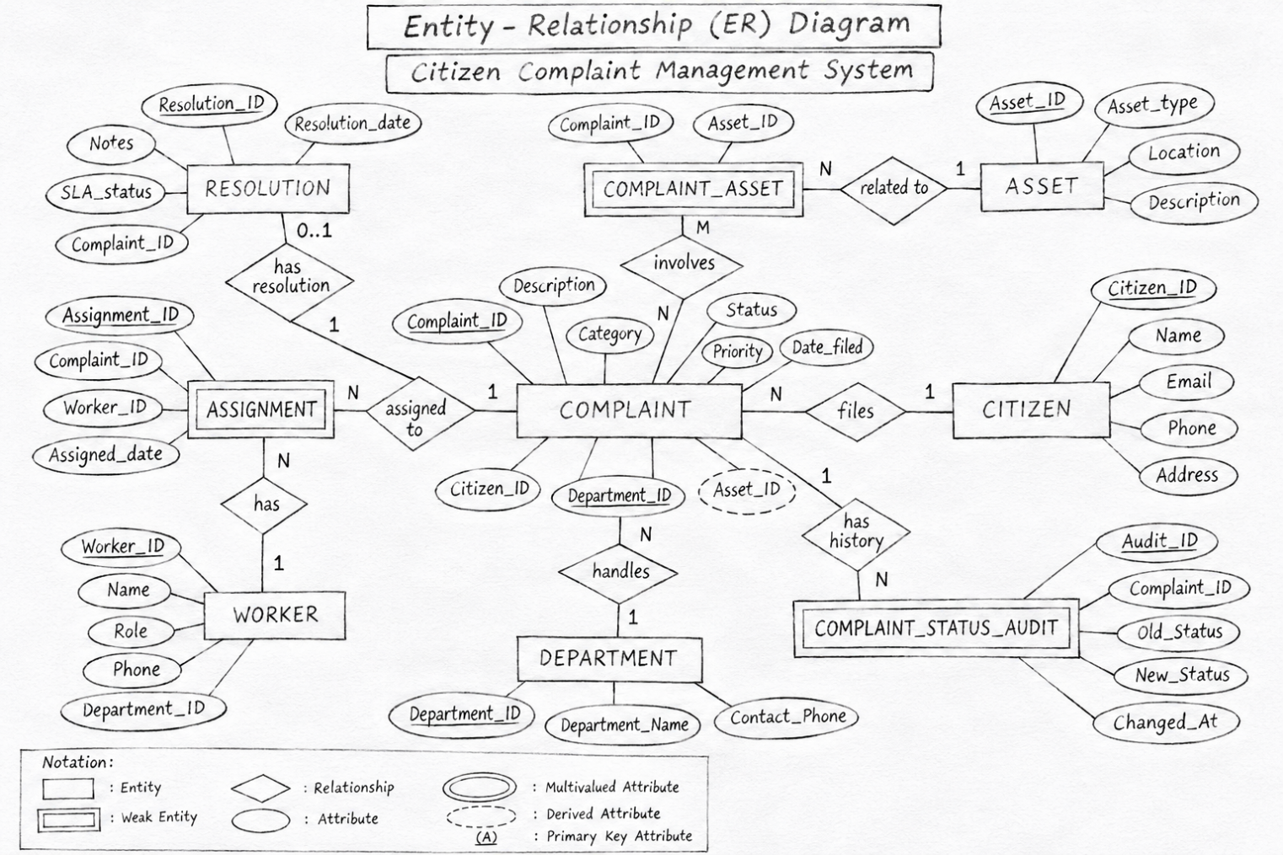

4. ER TO RELATIONAL MAPPING

4.1 STEPS OF ALGORITHM FOR CHOOSEN PROBLEM
The Entity Relationship model of the Citizen Complaint Management System is converted into a relational database schema using the ER-to-relational mapping process.
The following steps are used:
- Mapping Strong Entities: Each strong entity is converted into a separate relation. Its primary key is selected as the unique identifier.
- Mapping One-to-Many Relationships: The primary key of the entity on the one side is added as a foreign key to the relation on the many side.
- Mapping Many-to-Many Relationships: A separate relation is created for each many-to-many relationship. The primary keys of the participating entities are included as foreign keys and together form a composite primary key.
- Mapping One-to-One Relationships: The relationship between Complaint and Resolution is implemented by including Complaint_ID as a unique foreign key in the Resolution relation.
- Mapping Attributes: All entity attributes are included in their corresponding relations.

4.2 COMPLETE DIAGRAM OF RELATIONAL MAPPING
The relational schema represents the database structure in the form of relations (tables). Each relation contains attributes, primary keys and foreign keys to maintain data integrity and establish relationships between tables.
The relational schema of the Citizen Complaint Management System is as follows:
1. DEPARTMENT
DEPARTMENT (Dept_ID, Dname, Location, Phone)
Primary Key: Dept_ID
2. CITIZEN
CITIZEN (Citizen_ID, Name, Phone, Address, Email)
Primary Key: Citizen_ID
3. ASSET
ASSET (Asset_ID, Install_date, Asset_type, Location)
Primary Key: Asset_ID
4. WORKER
WORKER (Worker_ID, Fname, Lname, Phone, Role, Skills, Dept_ID)
Primary Key: Worker_ID
Foreign Key: Dept_ID references DEPARTMENT(Dept_ID)
5. COMPLAINT
COMPLAINT (Complaint_ID, Description, Priority, Status, Date_filed, Category, Citizen_ID, Dept_ID)
Primary Key: Complaint_ID
Foreign Keys:
- Citizen_ID references CITIZEN(Citizen_ID)
- Dept_ID references DEPARTMENT(Dept_ID)
6. COMPLAINT_ASSET
COMPLAINT_ASSET (Complaint_ID, Asset_ID)
Composite Primary Key: (Complaint_ID, Asset_ID)
Foreign Keys:
- Complaint_ID references COMPLAINT(Complaint_ID)
- Asset_ID references ASSET(Asset_ID)
7. COMPLAINT_WORKER
COMPLAINT_WORKER (Complaint_ID, Worker_ID, Assigned_date)
Composite Primary Key: (Complaint_ID, Worker_ID)
Foreign Keys:
- Complaint_ID references COMPLAINT(Complaint_ID)
- Worker_ID references WORKER(Worker_ID)
8. RESOLUTION
RESOLUTION (Resolution_ID, Resolution_date, Notes, SLA_status, Complaint_ID)
Primary Key: Resolution_ID
Foreign Key: Complaint_ID references COMPLAINT(Complaint_ID)
Constraint: Complaint_ID is UNIQUE.
9. COMPLAINT_STATUS_AUDIT
COMPLAINT_STATUS_AUDIT (Audit_ID, Complaint_ID, Old_Status, New_Status, Changed_At)
Primary Key: Audit_ID

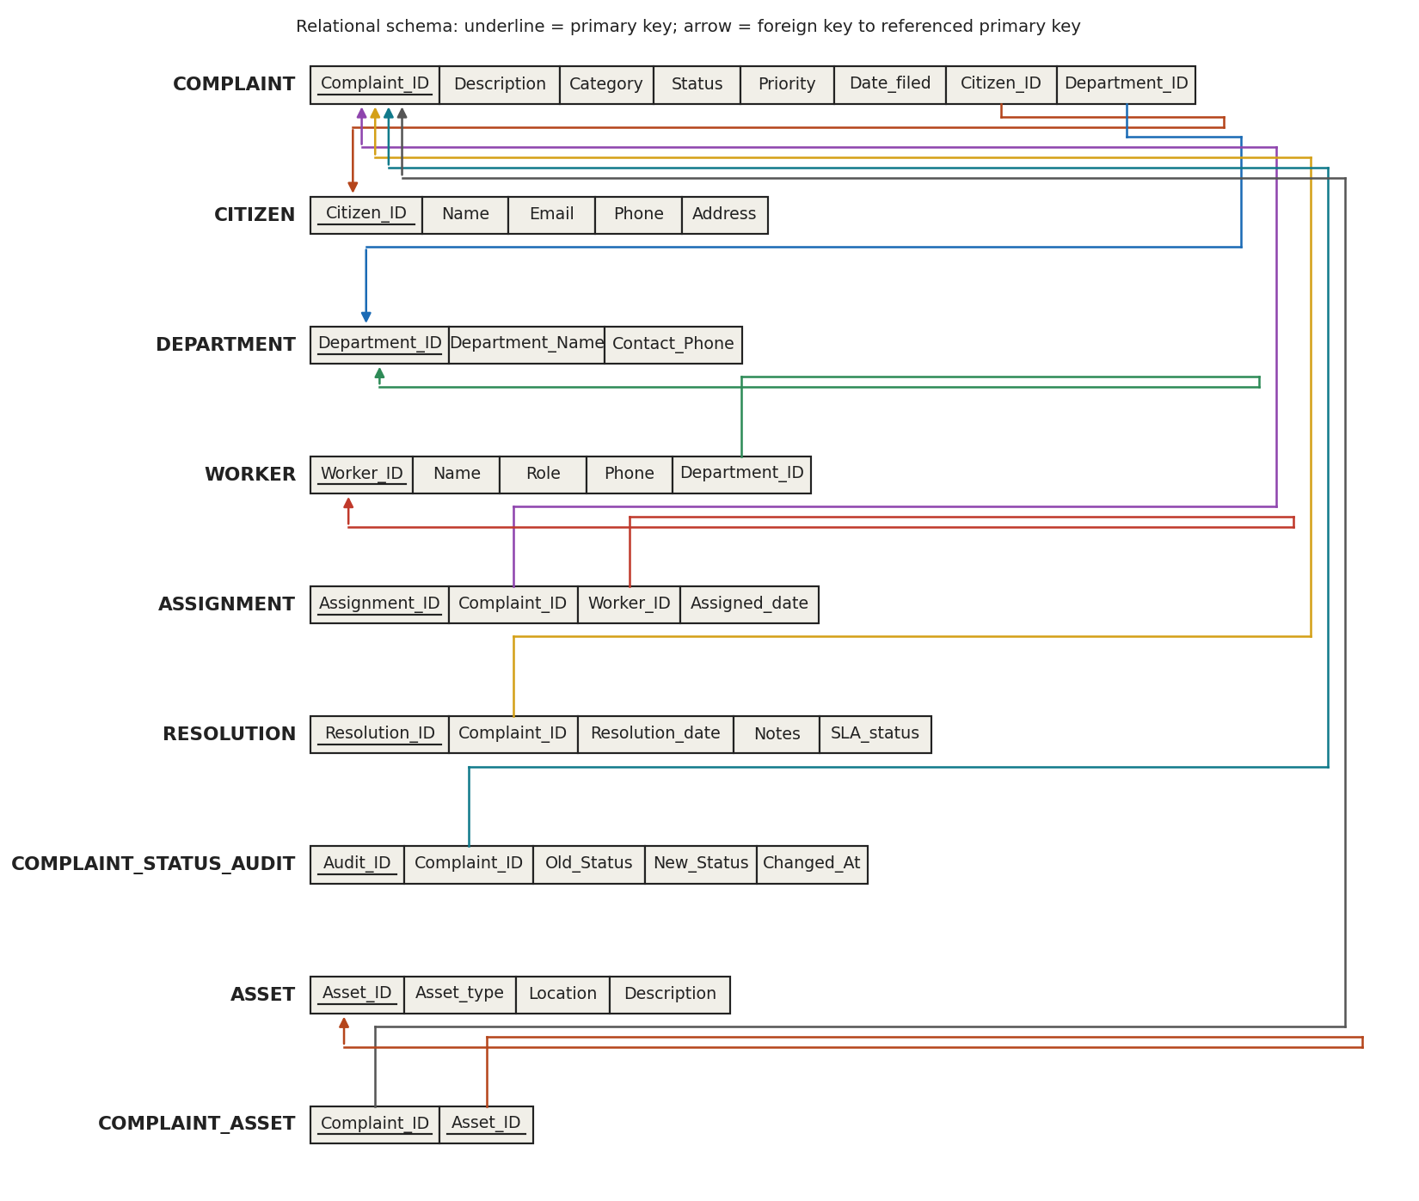

5. DDL STATEMENTS

5.1 Introduction
Data Definition Language (DDL) consists of SQL commands used to define and modify the structure of a database. In the Citizen Complaint Management System, DDL commands are used to create the database, define tables, specify attributes, establish primary and foreign keys, and apply constraints.
The main DDL commands used in this project are CREATE, ALTER and DROP.
5.2 Database Creation
The database named complaintmanagement was created using the CREATE DATABASE command. The USE command was then executed to select the database for further operations.
5.3 Table Creation
nine main relational tables were created for the Citizen Complaint Management System:
- Department
- Citizen
- Asset
- Worker
- Complaint
- Complaint_Asset
- Complaint_Worker
- Resolution
- Complaint status audit
Each table contains attributes appropriate to its purpose. Primary keys are used to uniquely identify records, while foreign keys establish relationships between related tables.
5.4 Constraints Used
The following constraints were implemented in the database:
- PRIMARY KEY: Uniquely identifies each record in a table.
- FOREIGN KEY: Establishes relationships between tables and maintains referential integrity.
- NOT NULL: Ensures that mandatory attributes cannot contain NULL values.
- UNIQUE: Ensures that a value does not occur more than once in a column.
- CHECK: Restricts values to specified conditions, such as valid complaint priorities and statuses.
5.5 Altering Table Structure
The ALTER TABLE command was used to modify the existing Citizen table by adding an Email attribute. This allows the system to store email contact information for registered citizens.
5.6 Dropping a Table
The DROP TABLE command was demonstrated using a temporary test table. After verifying its creation, the temporary table was dropped without affecting the main project tables.

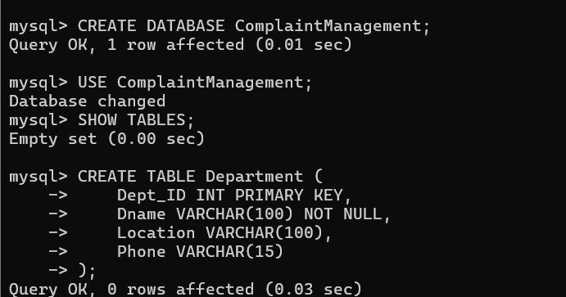

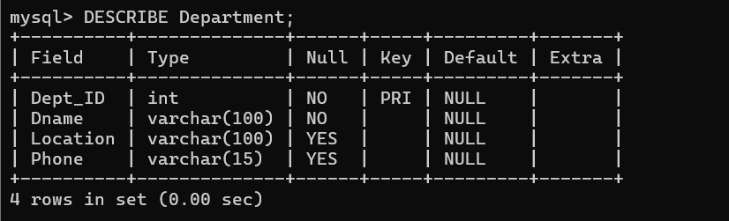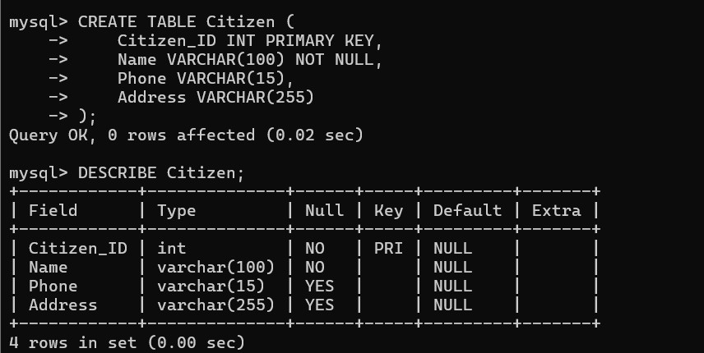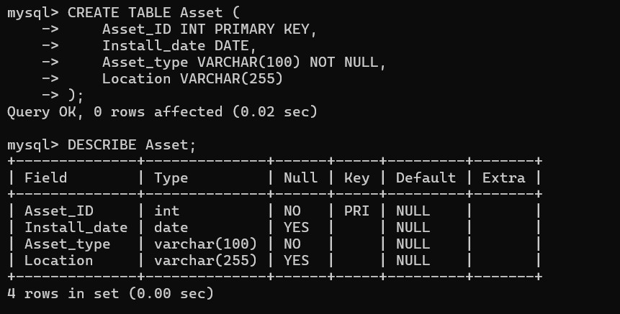

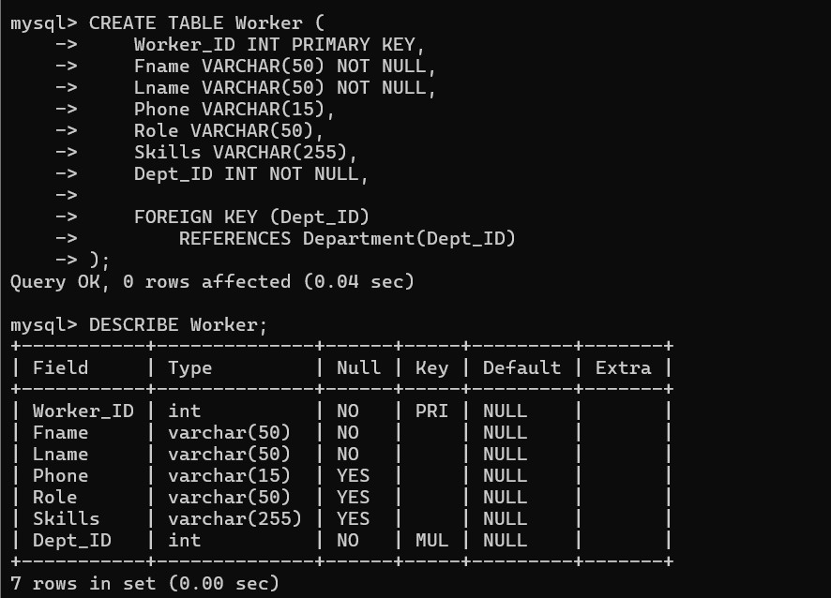
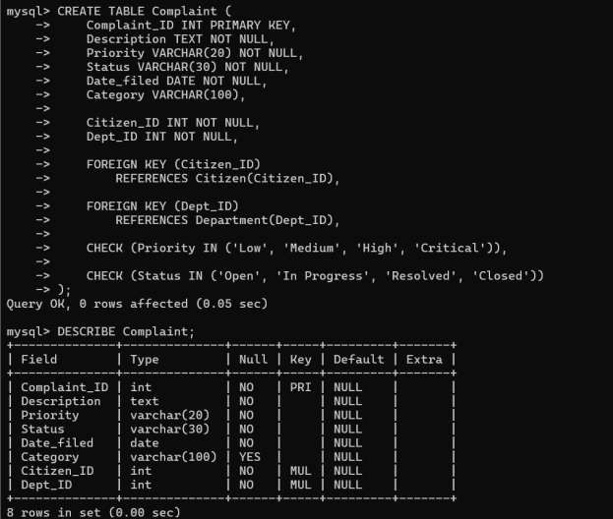

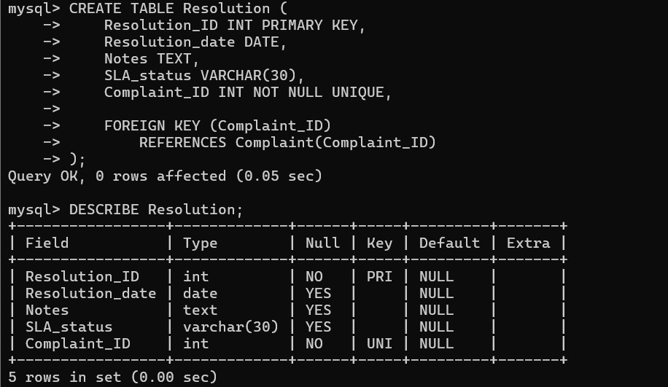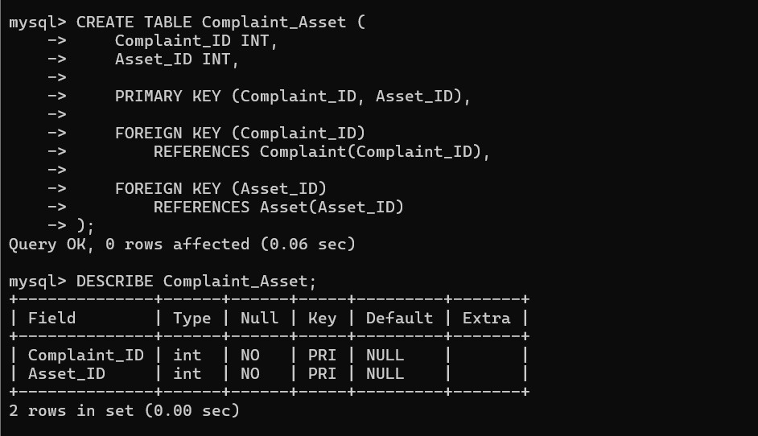

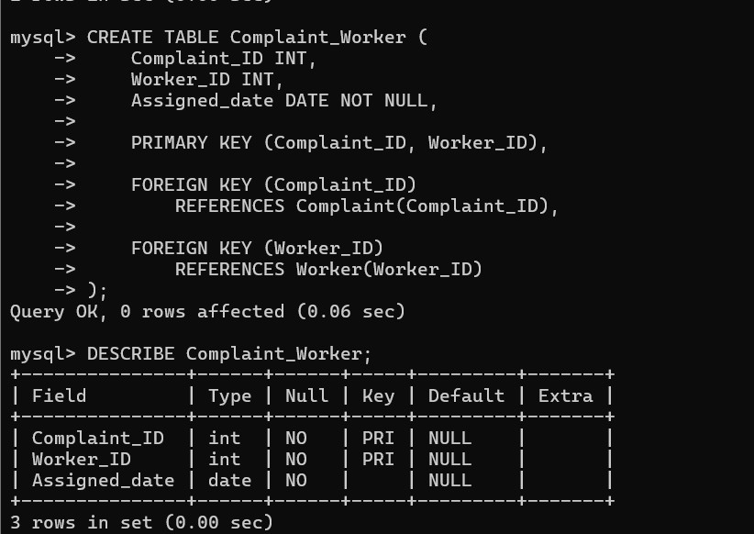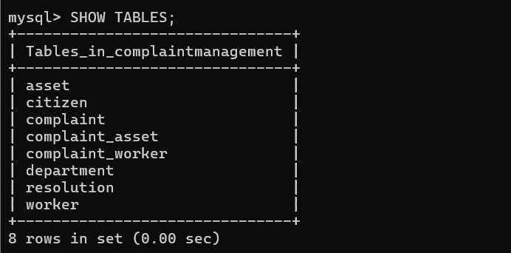

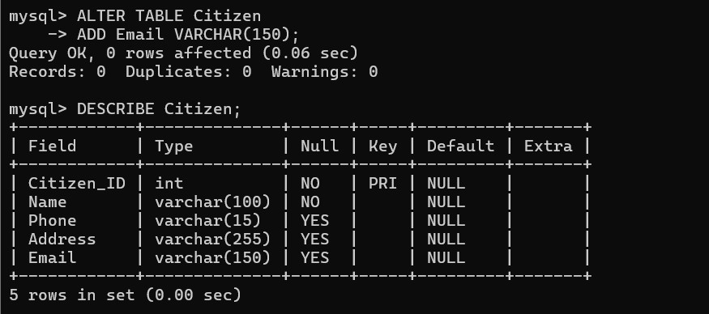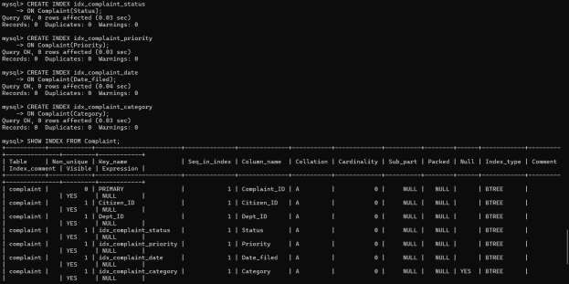

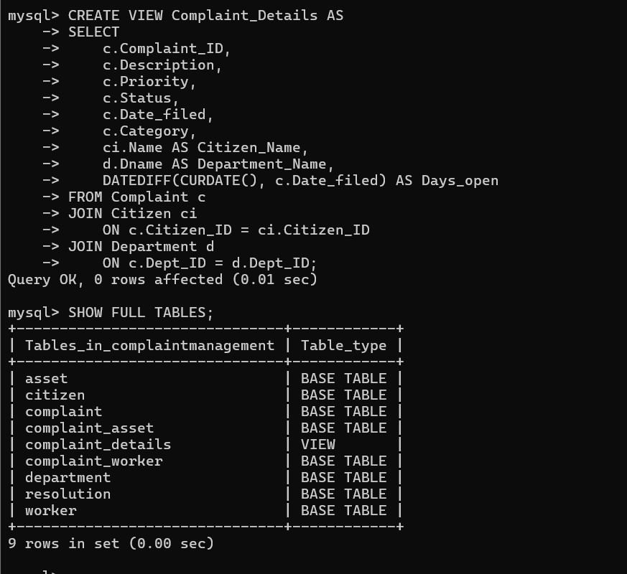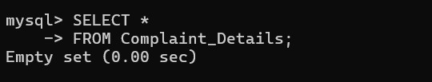

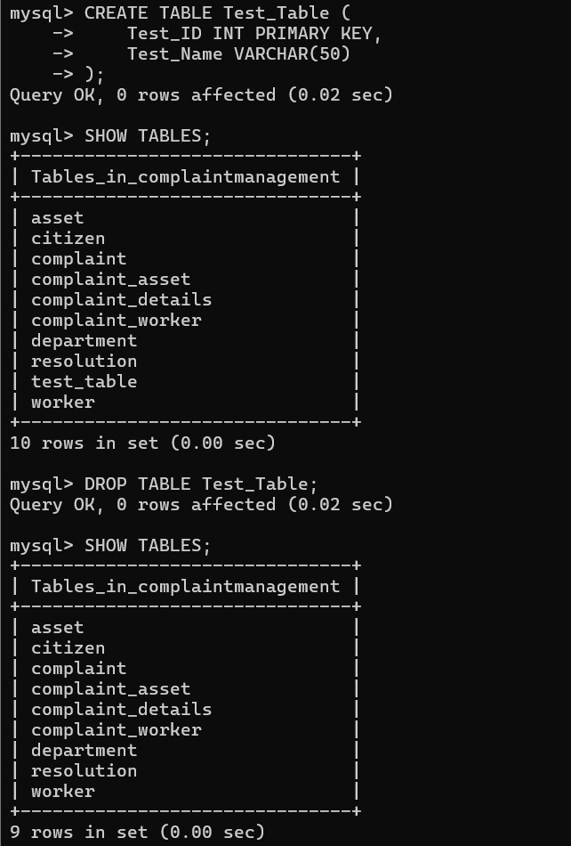

6. DML STATEMENTS

6.1 Introduction
Data Manipulation Language (DML) consists of SQL commands used to insert, retrieve, modify and delete records stored in database tables.
In the Citizen Complaint Management System, DML commands are used to manage citizen details, department information, infrastructure assets, workers, complaints, assignments and resolution records.
The main DML operations performed in this project are INSERT, UPDATE, DELETE and SELECT.

6.2 INSERT Operation
The INSERT command is used to add new records into database tables.
In this project, records were inserted into all nine main relational tables. The database contains information about departments, citizens, assets, workers, complaints, complaint-asset associations, complaint-worker assignments and resolutions.
A total of 10 department records, 20 citizen records, 18 asset records, 18 worker records, 30 complaint records, 30 complaint-asset records, 35 complaint-worker records and 19 resolution records were included in the DML implementation.

6.3 UPDATE Operation
The UPDATE command is used to modify existing records in a table.
The following modifications were performed:
- Updated the status of complaint 419 to Resolved.
- Changed the priority of complaint 420 to Critical.
- Updated the address of citizen 101 to BTM Layout, Bangalore.
- Updated the skills of worker 301 to Advanced Electrical Maintenance.
These operations demonstrate how existing records can be modified using conditional UPDATE statements.

6.4 DELETE Operation
The DELETE command is used to remove records from database tables.
In this project, complaint 430 was deleted along with its associated records from the Complaint_Worker and Complaint_Asset tables. The child records were deleted first to maintain referential integrity.

6.5 SELECT Operation
The SELECT command is used to retrieve records from database tables.
Different SELECT queries were executed to display complaint information, filter complaints based on their status and priority, and retrieve records based on specified conditions.

6.6 Summary
The DML operations demonstrate the insertion, retrieval, modification and deletion of records in the Citizen Complaint Management System. These operations help maintain and manage the information stored in the database.

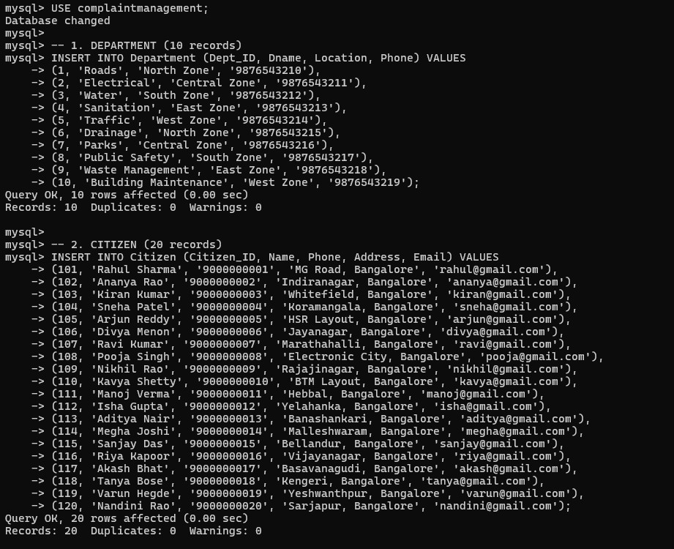
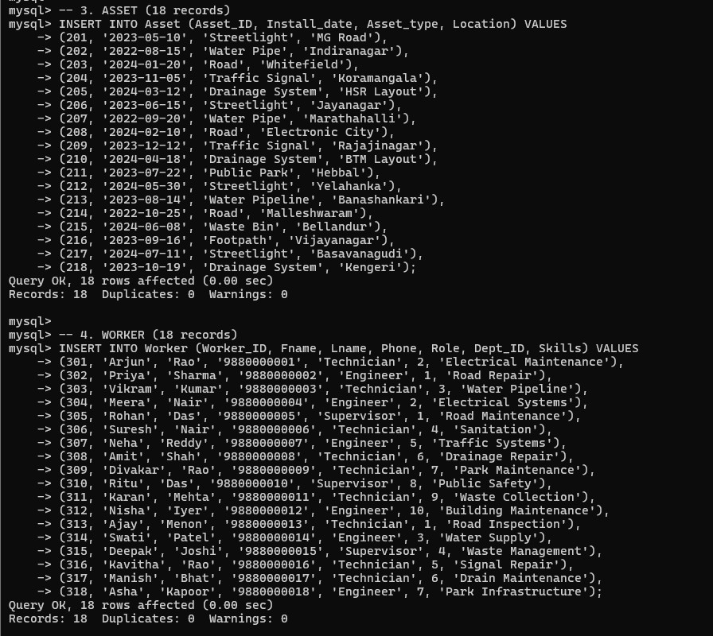
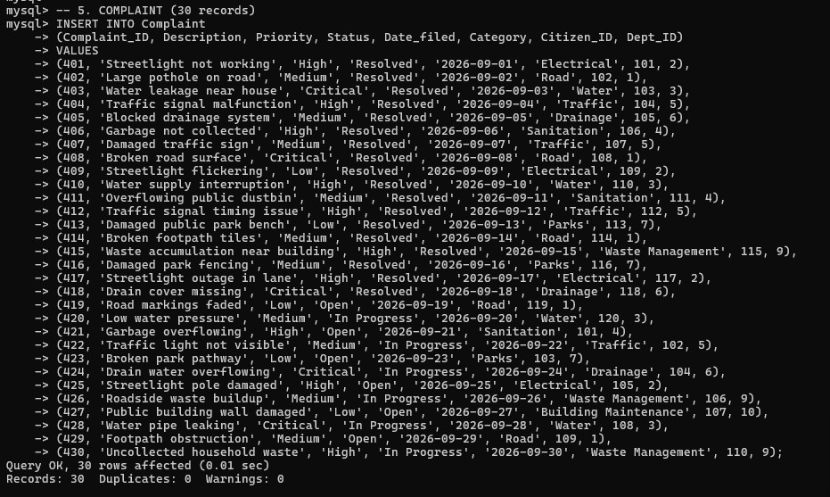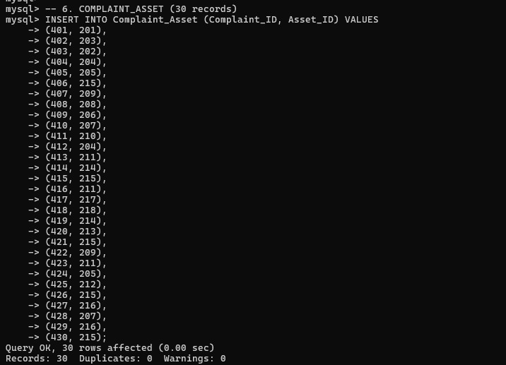

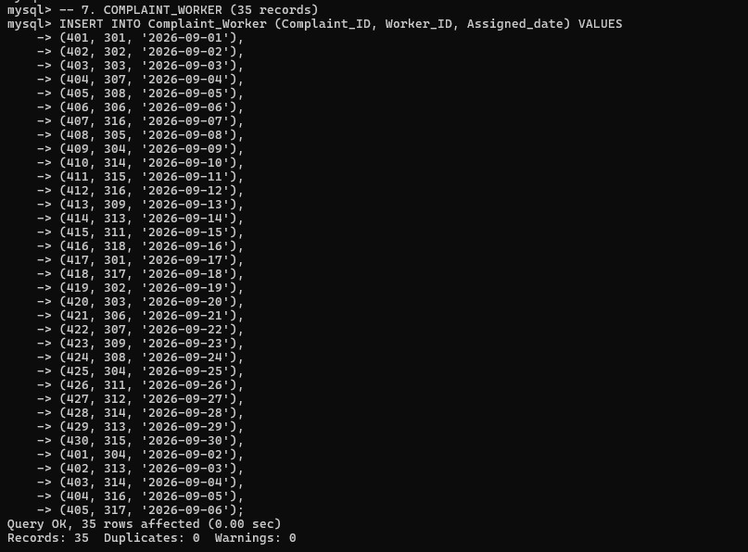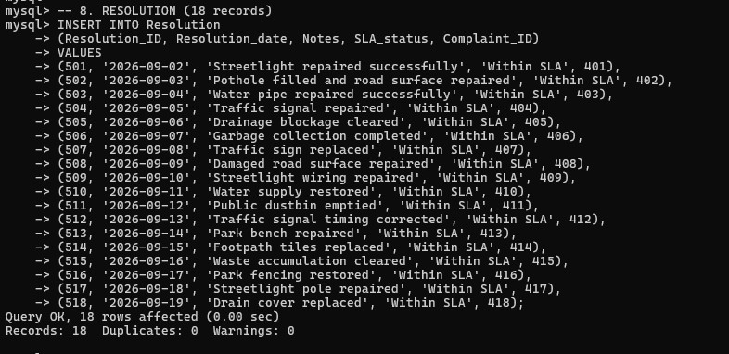
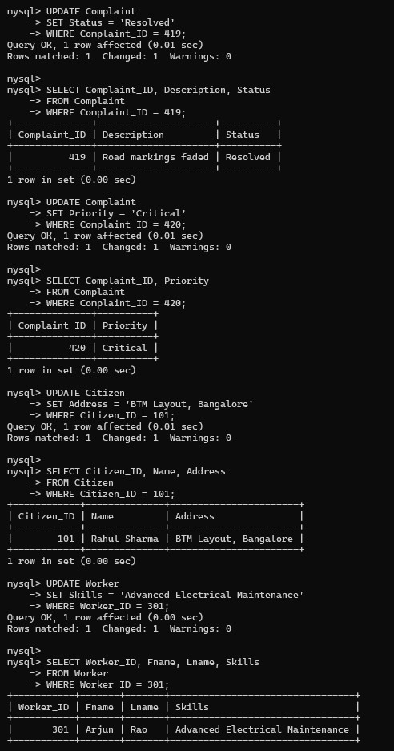
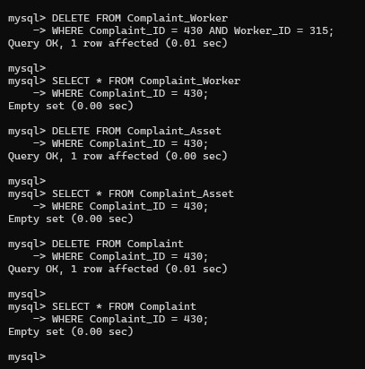
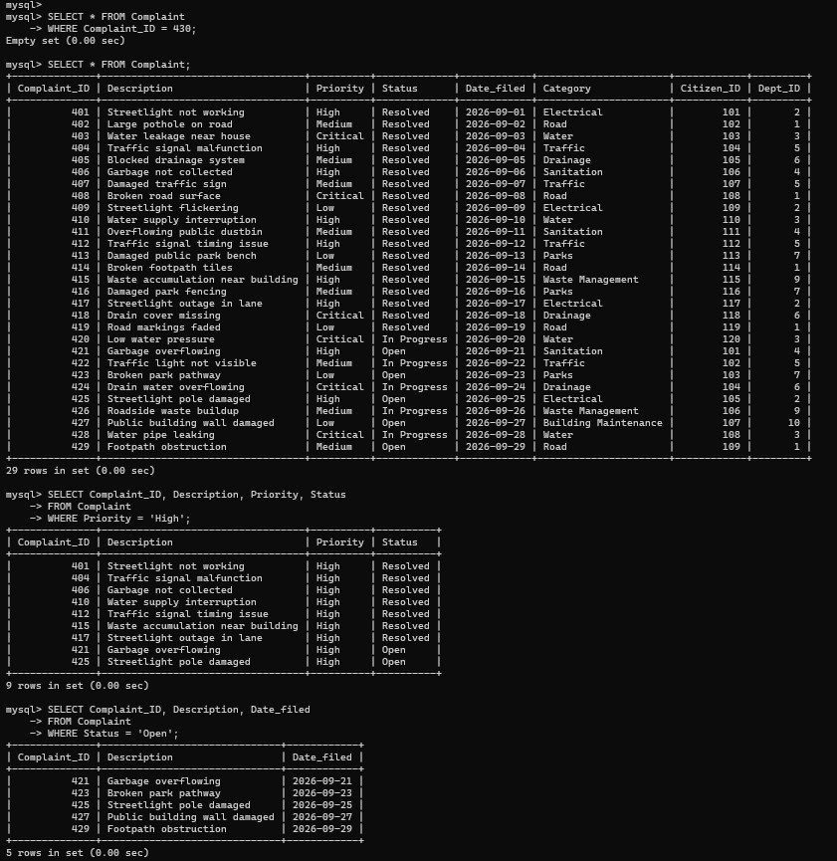

7. QUERIES
7.1 Introduction
SQL queries are used to retrieve, filter, organize and analyse information stored in the database. Various SQL queries were executed in the Citizen Complaint Management System to retrieve complaint details, analyse complaint distribution and establish relationships between different tables.

7.2 Simple SELECT Queries
Simple SELECT queries are used to retrieve records from individual tables. The WHERE clause is used to filter records based on specific conditions.
In this project, SELECT queries were used to display complaints, retrieve complaints based on their status and priority, and view records filed on specific dates.

7.3 ORDER BY Clause
The ORDER BY clause is used to arrange query results in ascending or descending order.
In this project, complaint records were displayed according to their filing dates in descending order to show the most recently filed complaints first.

7.4 GROUP BY Clause
The GROUP BY clause is used to group records that have the same values in a specified column.
In this project, complaints were grouped according to their status and priority to analyse the distribution of complaints across different categories.

7.5 Aggregate Functions
Aggregate functions perform calculations on a set of records and return a single result.
The following aggregate functions were used:
- COUNT(): Counts the total number of complaints.
- MIN(): Finds the earliest complaint filing date.
- MAX(): Finds the latest complaint filing date.
These functions help analyse complaint records and understand the overall database information.

7.6 JOIN Operations
JOIN operations are used to retrieve related information from multiple tables.
In this project, joins were performed between Complaint, Citizen and Department to display complaint details along with the citizen's name and department name.
Joins were also performed between Worker, Department, Complaint_Worker and Complaint to retrieve worker assignments and related complaint information.
7.7 HAVING Clause
The HAVING clause is used to filter grouped records based on aggregate conditions.
In this project, the HAVING clause was used to display departments that handled more than one complaint.

7.8 Subqueries
A subquery is a query written inside another SQL query. It is used when the result of one query is required by another query.
In this project, a subquery was used to retrieve citizens who had submitted complaints with Critical priority.

7.9 Views
A view is a virtual table created using the result of an SQL query. It allows data from multiple tables to be displayed in a simplified format.
In this project, a view named Complaint_Details was created by joining the Complaint, Citizen and Department tables. It displays complaint details along with the citizen's name and department name.
The view simplifies the retrieval of related complaint information without requiring the same JOIN operations to be written repeatedly.

7.10 Transaction Management
Transactions are used to execute a group of database operations as a single logical unit. The COMMIT command permanently saves changes, while the ROLLBACK command cancels uncommitted changes.
In this project, transaction management was demonstrated by updating the priority of complaint 420.
First, the priority was changed to High and committed. A second transaction changed the priority to Low, but the ROLLBACK command was executed. The final SELECT query confirmed that the priority remained High.

7.11 Summary
The SQL queries demonstrate how the database can be used to retrieve meaningful information, analyse complaint distribution, combine related records and filter results based on specific conditions.
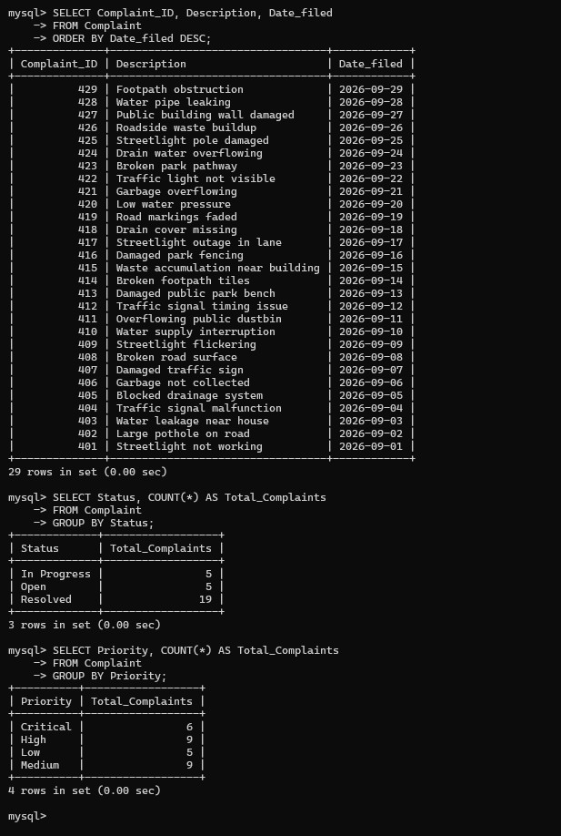
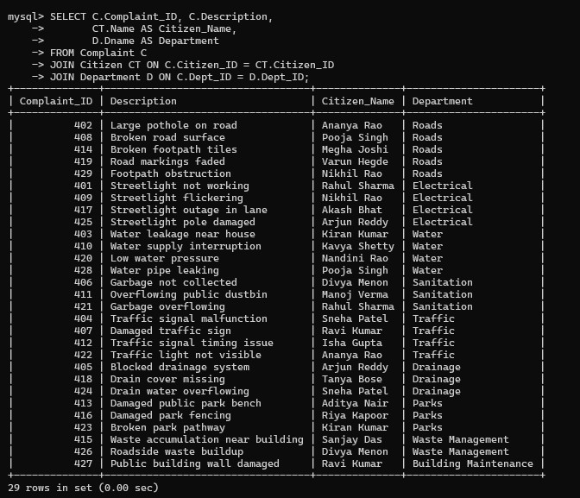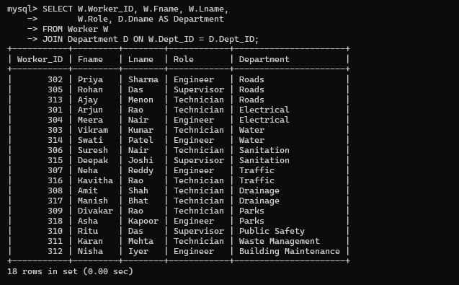

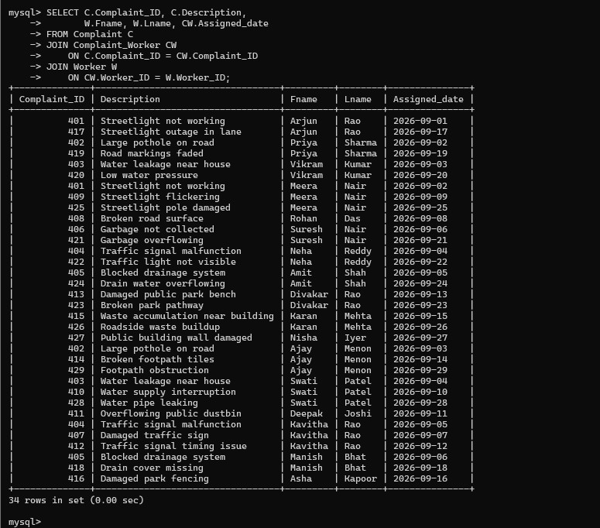
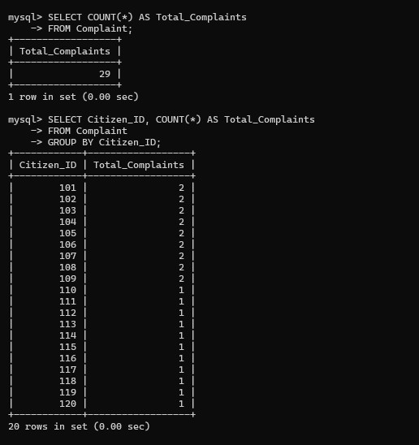
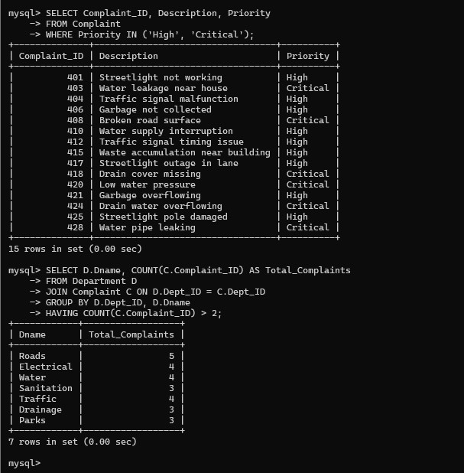
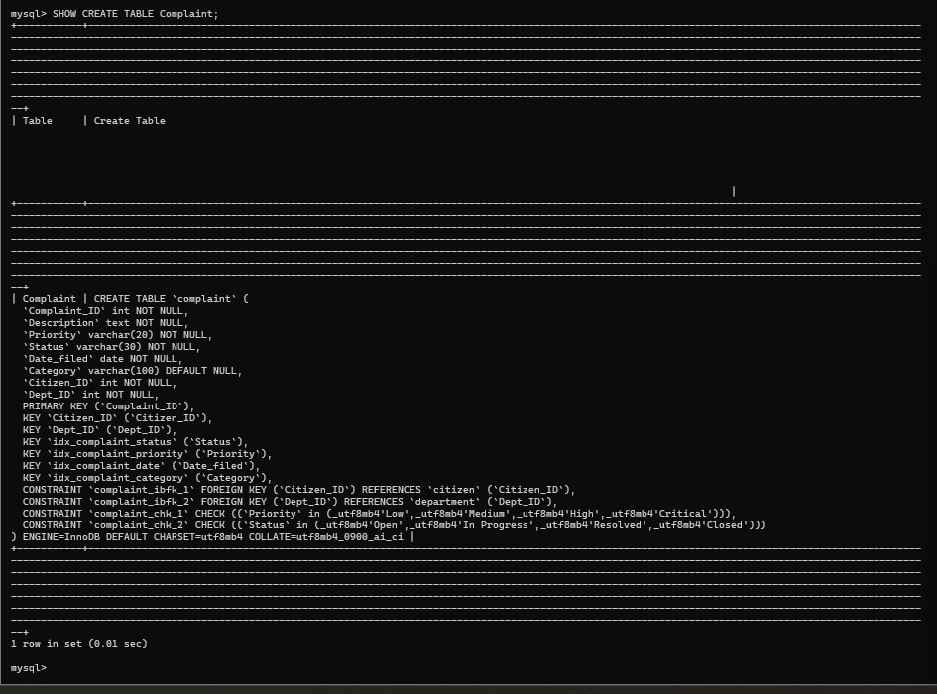
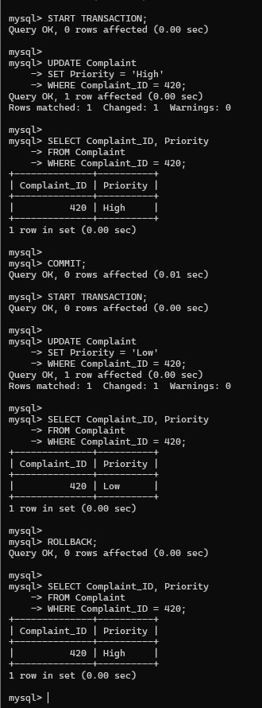
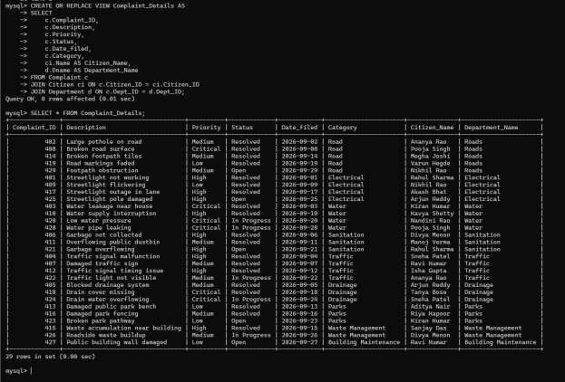

8.STORED PROCEDURES, FUCNTIONS AND TRIGGERS
8.1 Introduction
Stored procedures, functions and triggers are database programming features used to perform operations and automate tasks within a database.
In the Citizen Complaint Management System, these features are used to retrieve complaints based on their status, calculate complaint-related information and maintain a record of complaint status changes.

8.2 Stored Procedure
A stored procedure is a group of SQL statements stored in the database and executed whenever required.
In this project, a stored procedure named GetComplaintsByStatus was created. It accepts a complaint status as an input parameter and retrieves the Complaint_ID, Description, Priority, Status and Date_filed of complaints matching the specified status.
The procedure was tested using the CALL command with 'Open' as the input status. It successfully retrieved the open complaints from the database.

8.3 Function
A stored function is a database object that accepts input parameters, performs an operation and returns a value.
In this project, the function GetCitizenComplaintCount was implemented to calculate the total number of complaints submitted by a particular citizen.
The function accepts a Citizen_ID as input and returns the corresponding complaint count. It was tested using Citizen_ID 101, which returned a count of 2.

8.4 Trigger
A trigger is a database object that automatically executes when a specified event occurs on a table.
In this project, a trigger named After_Complaint_Status_Update was created on the Complaint table.
The trigger executes after an UPDATE operation. It checks whether the complaint status has changed. If a change is detected, the previous status, new status and complaint ID are inserted into the Complaint_Status_Audit table.
This helps maintain a history of complaint status changes and supports tracking of complaint progress.

8.5 Summary
The stored procedure, function and trigger demonstrate the use of database programming features in the Citizen Complaint Management System. They simplify complaint retrieval, calculate useful information and automatically maintain an audit record whenever a complaint status changes.
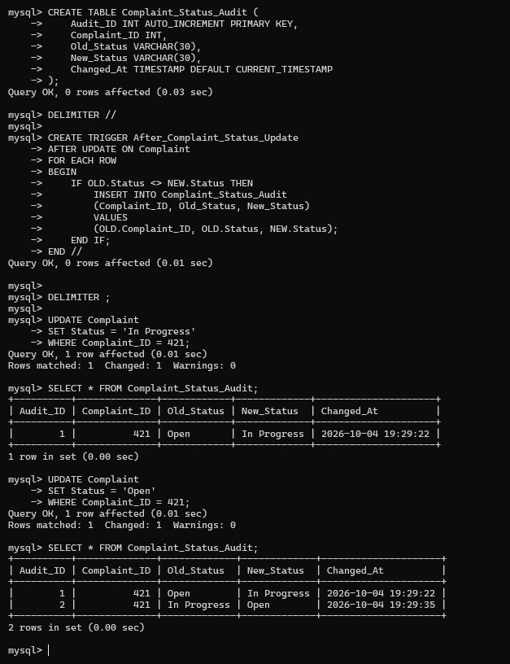
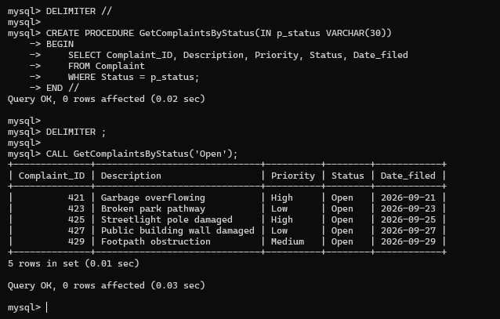

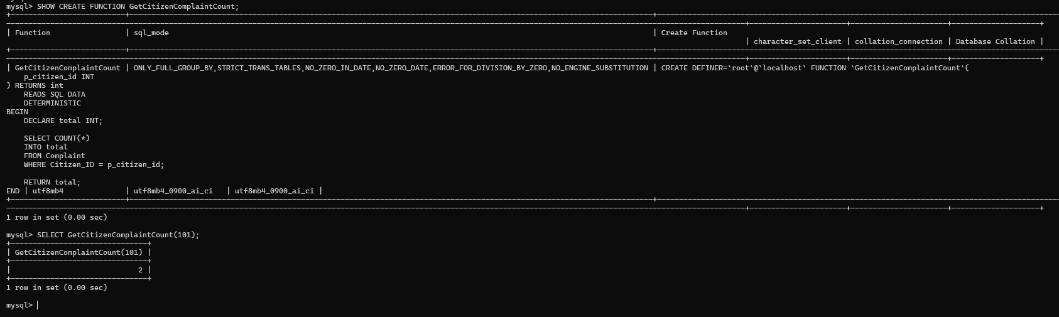

9. FRONT END DEVELOPEMNT
9.1 Introduction
The front end of the Citizen Complaint Management System was developed using Streamlit, a Python-based framework used to create interactive web applications.
The application provides a user-friendly interface for managing citizen information, registering complaints, viewing complaint records, assigning workers and recording complaint resolutions.
The front end is connected to the MySQL database using the mysql-connector-python library. This allows the application to perform database operations through the interface.

9.2 Technologies Used
The following technologies were used for front-end development:
- Python: Used to develop the application logic.
- Streamlit: Used to create the interactive web interface.
- MySQL: Used to store and manage application data.
- mysql-connector-python: Used to establish connectivity between Python and MySQL.
- python-dotenv: Used to load database configuration from environment variables.

9.3 Application Modules
The application consists of the following modules:
1. Dashboard
Displays an overview of the complaint management system and provides access to its main functionalities.
2. Register Complaint
Allows users to enter complaint details such as description, priority, category, citizen information and department.
3. View Complaints
Displays the available complaint records stored in the database.
4. Manage Complaints
Allows existing complaint records to be managed and their status or other details to be updated.
5. Assign Workers
Provides functionality to assign workers to complaints.
6. Record Resolution
Allows resolution details, including resolution date, notes and SLA status, to be recorded.

9.4 Database Connectivity
The application connects to the MySQL database using the mysql-connector-python library. Database configuration is maintained using environment variables loaded through python-dotenv.
This connection enables the application to insert, retrieve and update records in the Citizen Complaint Management System.

9.5 Summary
The Streamlit front end provides an interactive interface for accessing the database functionalities. It simplifies complaint registration, complaint tracking, worker assignment and resolution management through a web-based application.
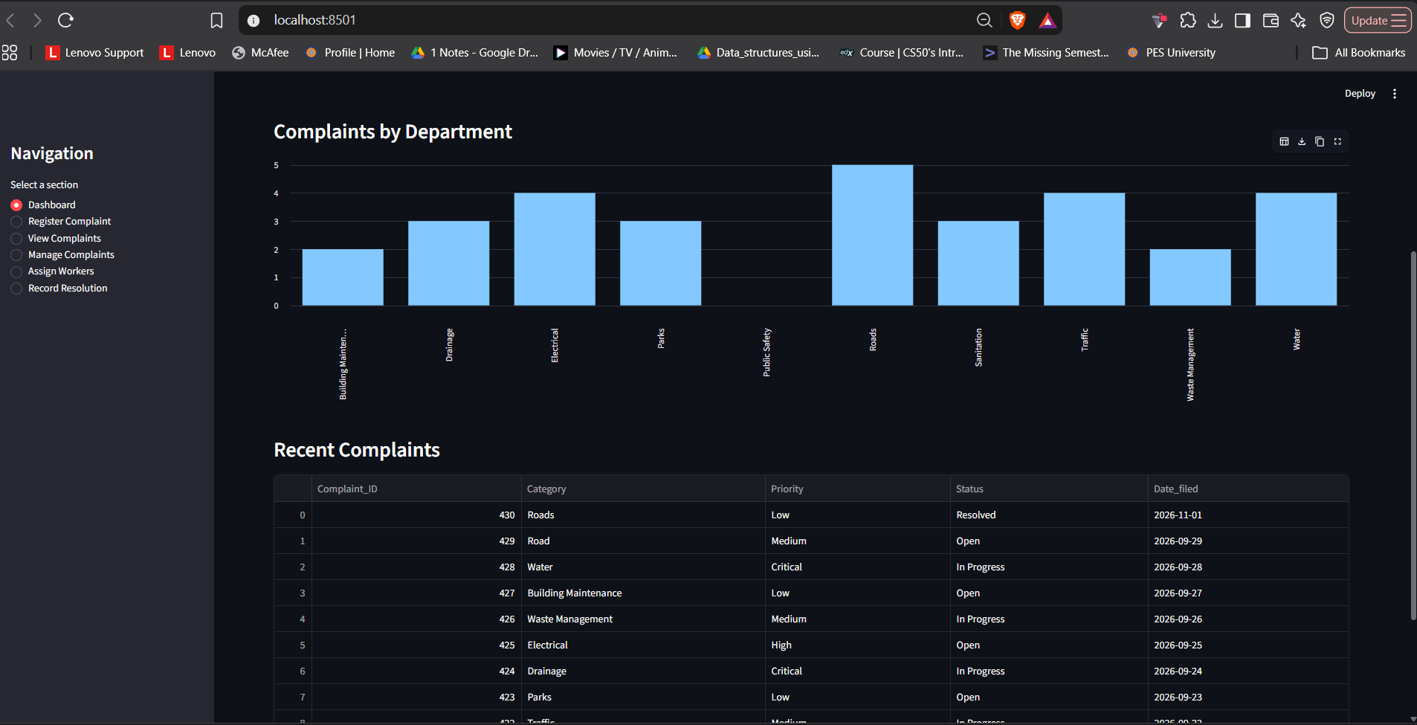

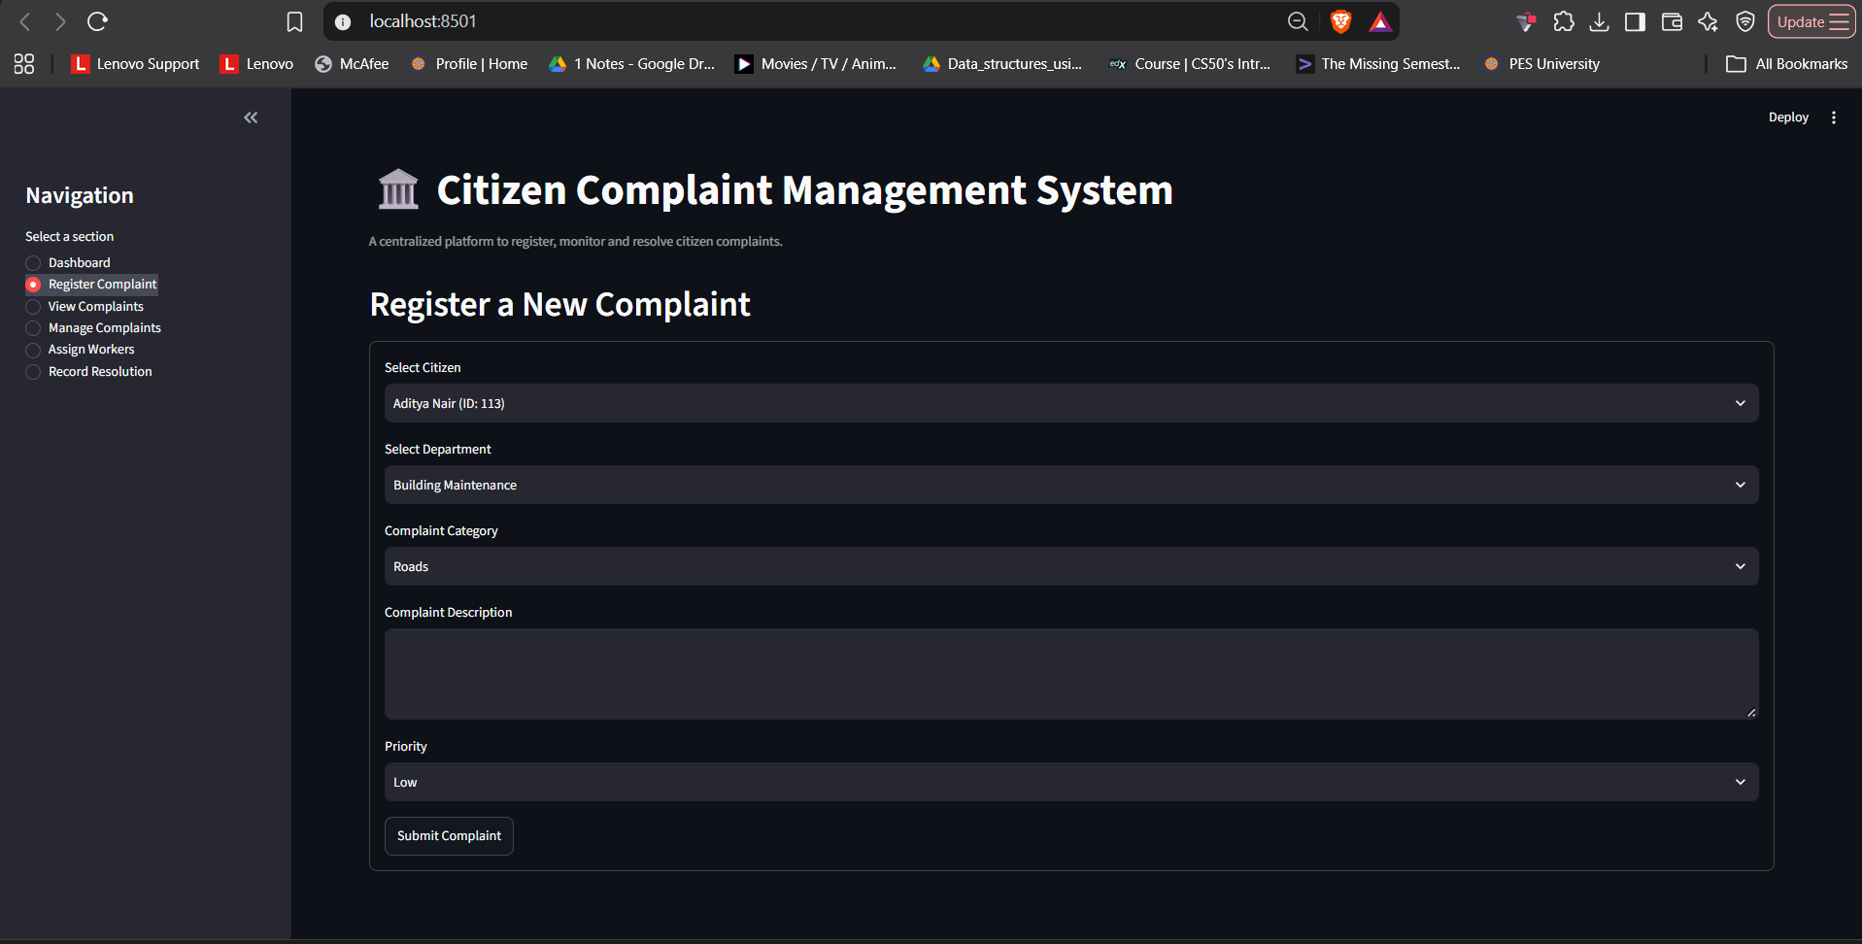
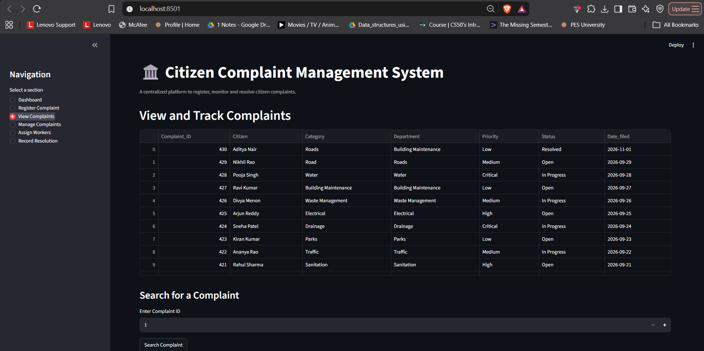

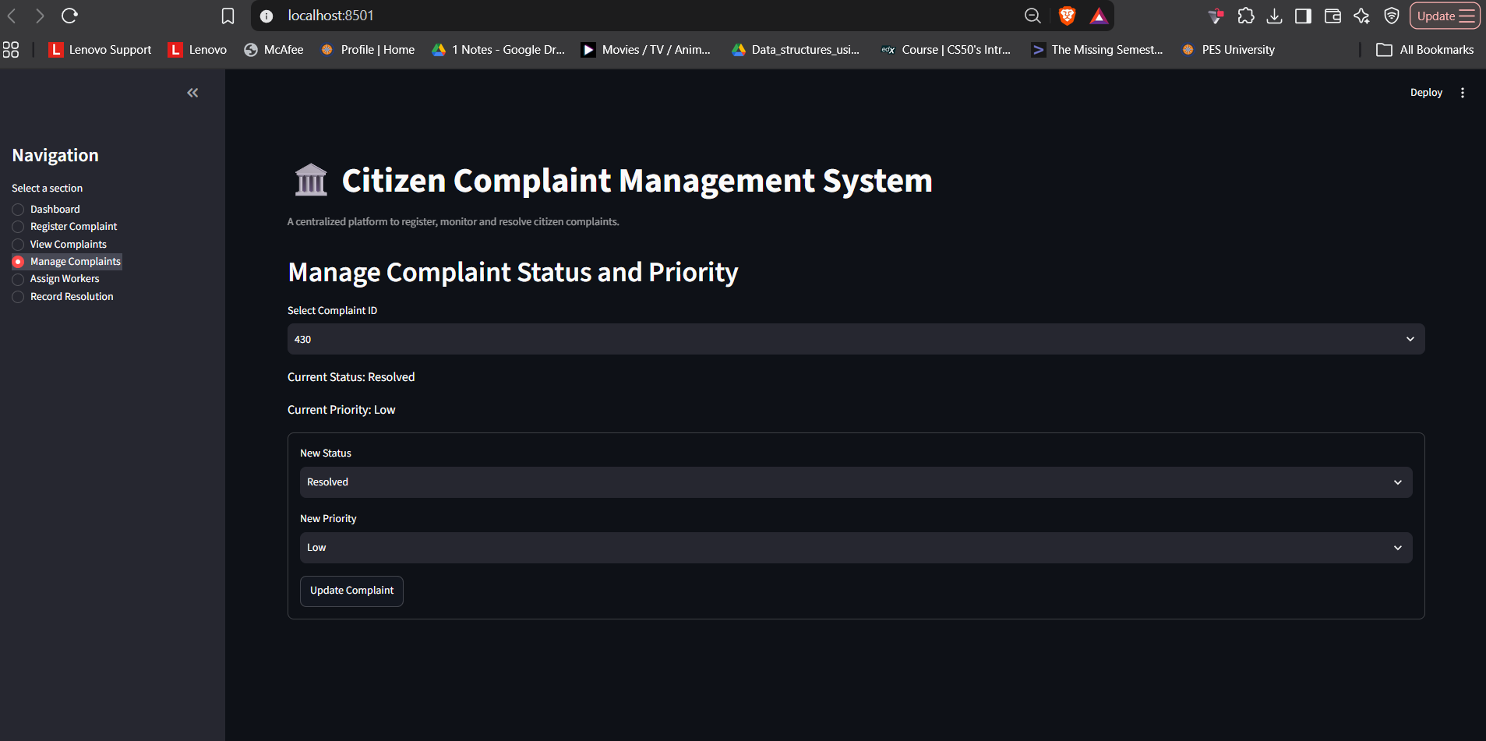
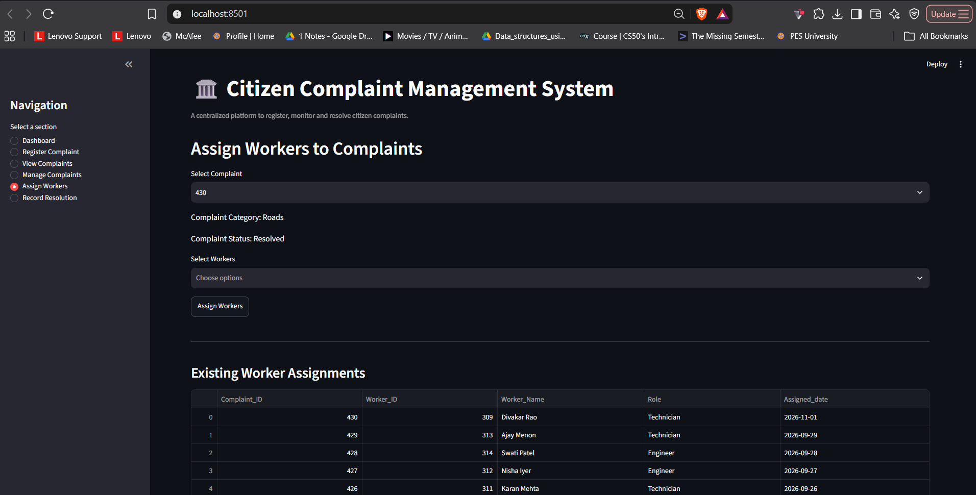

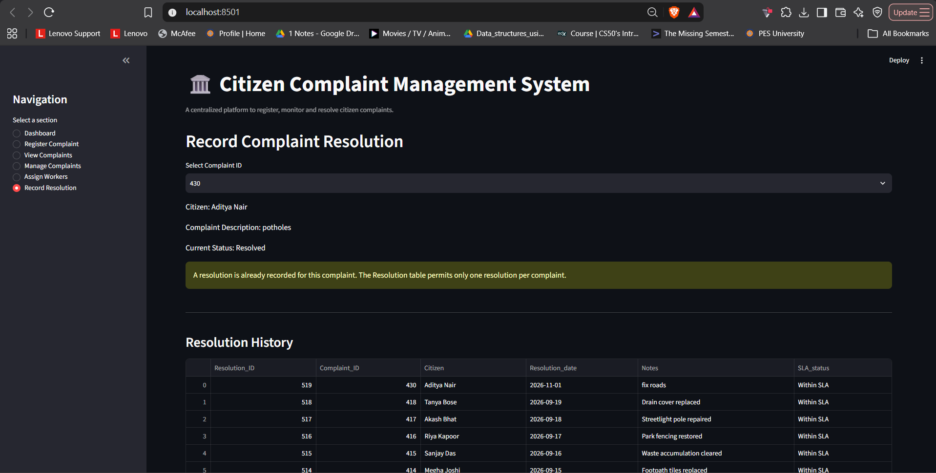

REFERENCES
- MySQL Documentation, MySQL 8.0 Reference Manual. https://dev.mysql.com/doc/refman/8.0/en/
- Streamlit Documentation, Streamlit API Reference. https://docs.streamlit.io/
- Python Documentation, Python 3 Documentation. https://docs.python.org/3/
- MySQL Connector/Python Documentation. https://dev.mysql.com/doc/connector-python/en/
- Project Source Code, Citizen Complaint Management System. GitHub Repository: https://github.com/aisiriii/Citizen-Complaint-Management-System

