# 九宫格配置

* 1. /getSudokuConfigList
  2. Get
  3. 无参数
  4. 
  5. 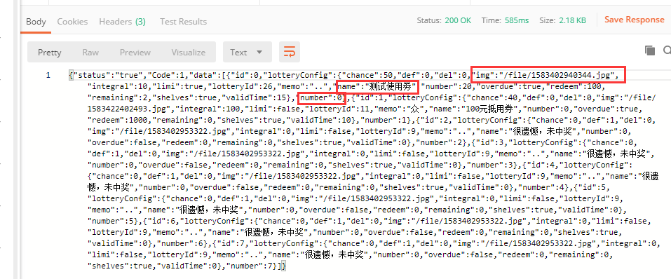

# **抽奖**

* 1. /luckyDraw
  2. Get
  3. Openid
  4. 如:http://localhost:8080/jxd/luckyDraw?openid=oImAa1KK6sWiJmFMVsYMqrX9uF5c
  5. 
  6. 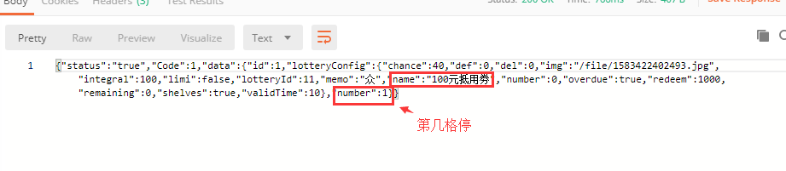
  7. 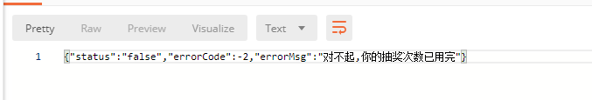

# **剩余抽奖次数**

* 1. /getUser
  2. Get
  3. 参数：openid
  4. 如：[http://localhost:8080/jxd/getUser?openid=oImAa1KK6sWiJmFMVsYMqrX9uF5c](http://localhost:8080/jxd/getLotteryNumber?openid=oImAa1KK6sWiJmFMVsYMqrX9uF5c)
  5. 
  6. 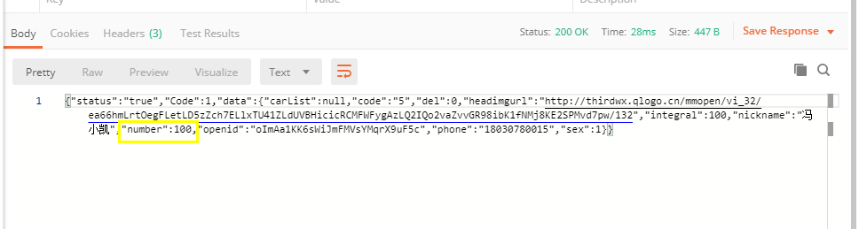

# **奖劵列表**

* 1. /getLotteryListByOpenid
  2. Get
  3. 参数：openid
  4. 如：<http://localhost:8080/jxd/getLotteryListByOpenid?openid=oImAa1KK6sWiJmFMVsYMqrX9uF5c>
  5. 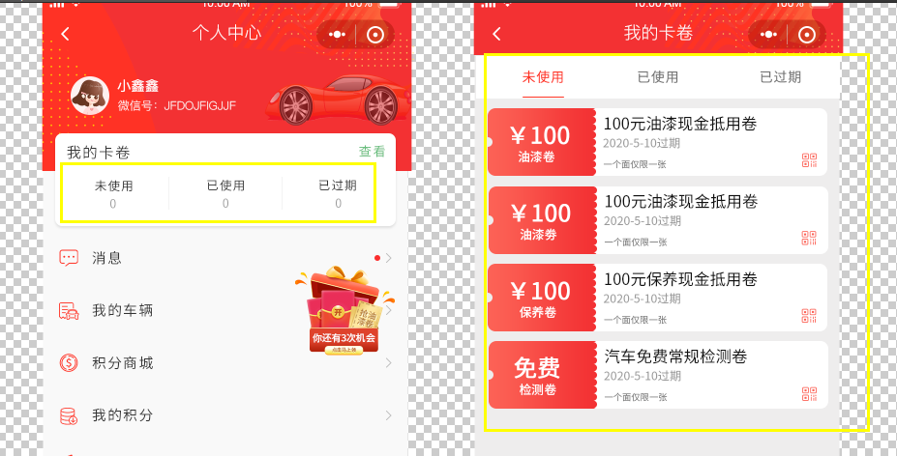
  6. 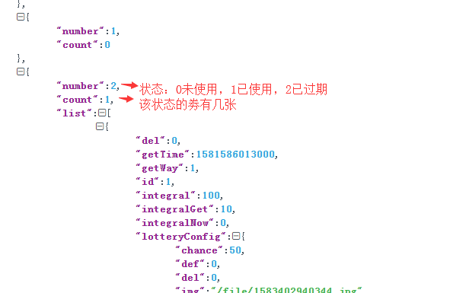

# **是否有未读消息**

* 1. /haveNewMessage
  2. Get
  3. 参数 openid
  4. 如：<http://localhost:8080/jxd/haveNewMessage?openid=oImAa1KK6sWiJmFMVsYMqrX9uF5c>
  5. 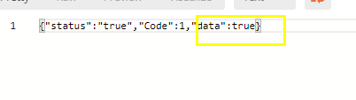
  6. 

# **剩余积分**

* 1. /getUser
  2. Get
  3. 参数：openid
  4. 如：[http://localhost:8080/jxd/getUser?openid=oImAa1KK6sWiJmFMVsYMqrX9uF5c](http://localhost:8080/jxd/getLotteryNumber?openid=oImAa1KK6sWiJmFMVsYMqrX9uF5c)
  5. 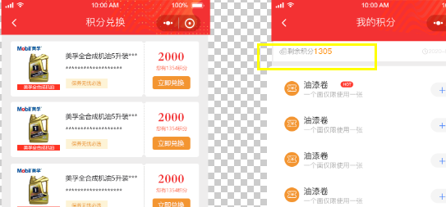
  6. 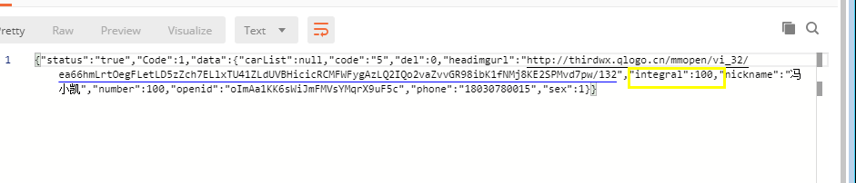

# **上传文件**

* 1. /uploadFile
  2. Post
  3. 参数：file

# **添加车辆**

* 1. /addCar
  2. Post
  3. 参数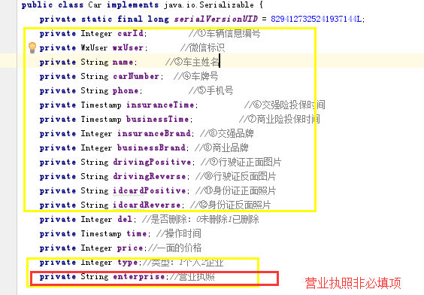

# **更改车辆**

* 1. /updateCar
  2. Post
  3. 参数

# **积分商城商品列表**

* 1. /getGoodsList
  2. Get
  3. 参数 无
  4. 如：<http://localhost:8080/jxd/getGoodsList>
  5. 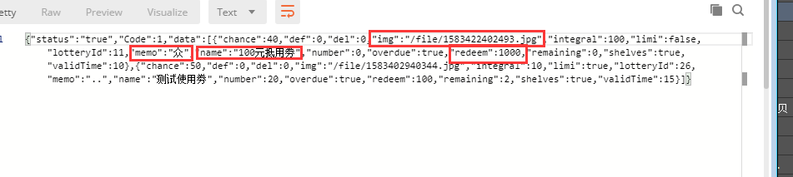
  6. 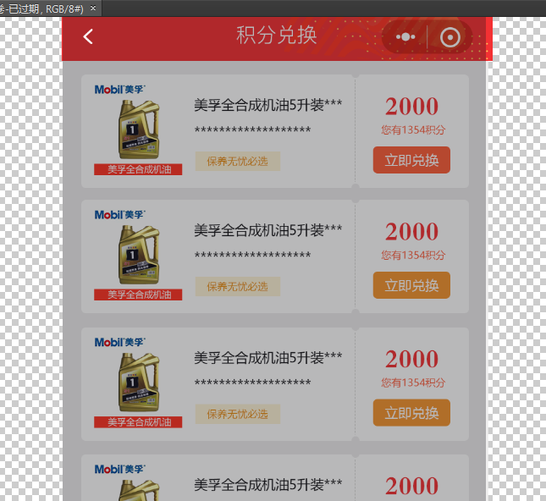

# **商品兑换**

* 1. /creditsExchange
  2. Get
  3. 参数 lotteryId size openid
  4. 如：<http://localhost:8080/jxd/creditsExchange?lotteryId=26&size=3&openid=oImAa1KK6sWiJmFMVsYMqrX9uF5c>
  5. 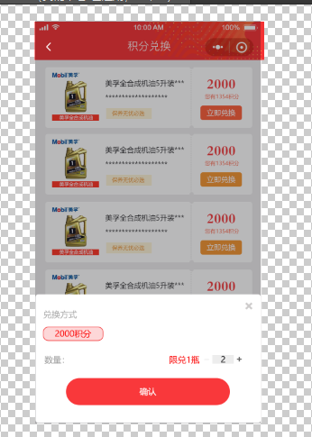
  6. 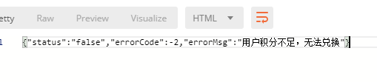
  7. 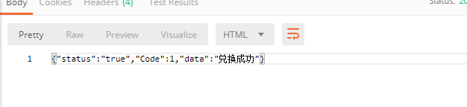

# **车辆列表**

* 1. /getCarList
  2. Get
  3. 参数 openid
  4. 如 <http://localhost:8080/jxd/getCarList?openid=oImAa1KK6sWiJmFMVsYMqrX9uF5c>
  5. 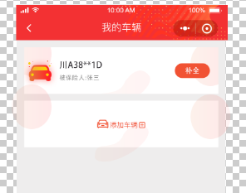
  6. 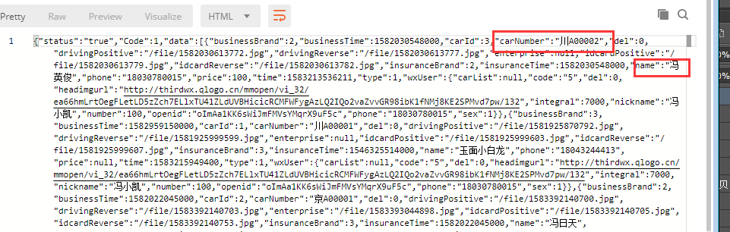

# **消息列表**

* 1. /getMessageList
  2. Get
  3. 参数 openid
  4. 如 <http://localhost:8080/jxd/getMessageList?openid=oImAa1KK6sWiJmFMVsYMqrX9uF5c>
  5. 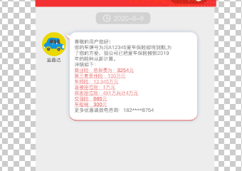
  6. 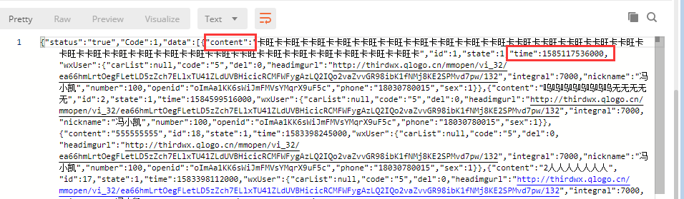

# **奖劵详情**

* 1. /getLotteryById
  2. Get
  3. 参数 id
  4. 如 <http://localhost:8080/jxd/getLotteryById?id=1>
  5. 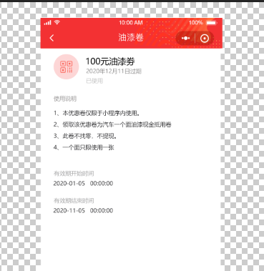
  6. 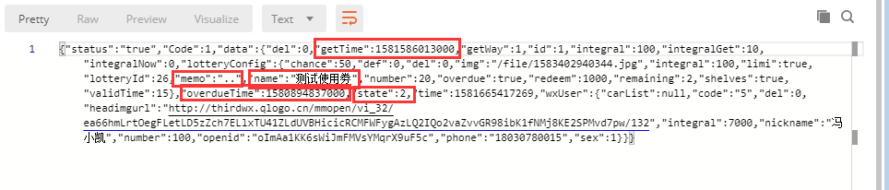
  7. 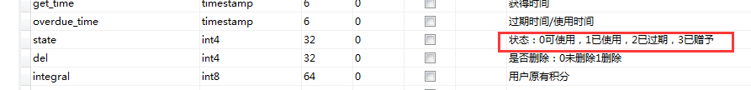

# **获得二维码**

* 1. /getQrCode
  2. Get
  3. 参数 carId lotteryHistoryId
  4. 如 <http://localhost:8080/jxd/getQrCode?carId=3&lotteryHistoryId=1>
  5. 
  6. 

# **添加新用户**

* 1. /addUser
  2. Post
  3. 参数 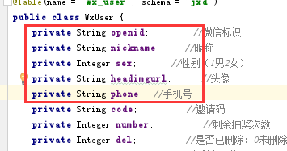
  4. 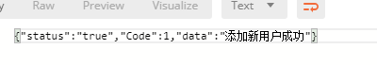
  5. 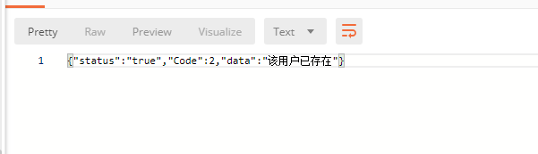

# **剩余发送次数**

* 1. /getUser
  2. Get
  3. 参数：openid
  4. 如：[http://localhost:8080/jxd/getUser?openid=oImAa1KK6sWiJmFMVsYMqrX9uF5c](http://localhost:8080/jxd/getLotteryNumber?openid=oImAa1KK6sWiJmFMVsYMqrX9uF5c)
  5. 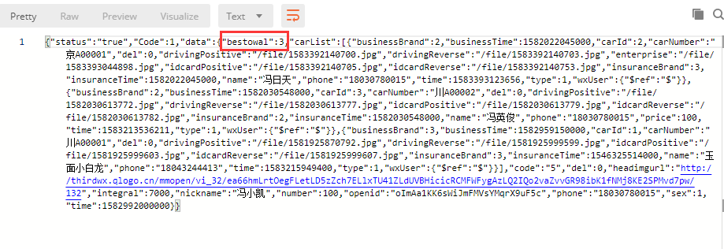
  6. 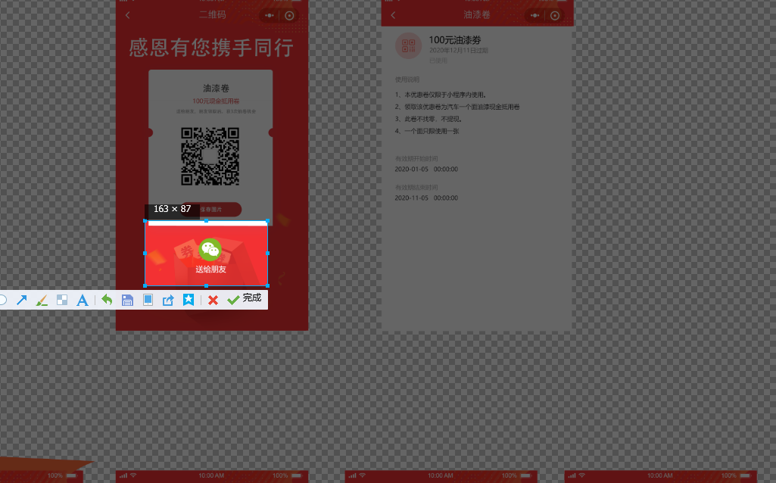

# **积分历史**

* 1. /getHistoryList
  2. Get
  3. 参数 openid
  4. 如：<http://localhost:8080/jxd/getHistoryList?openid=oImAa1KK6sWiJmFMVsYMqrX9uF5c>
  5. 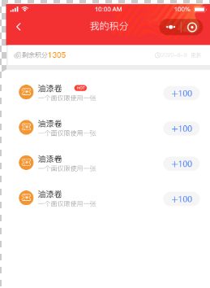
  6. 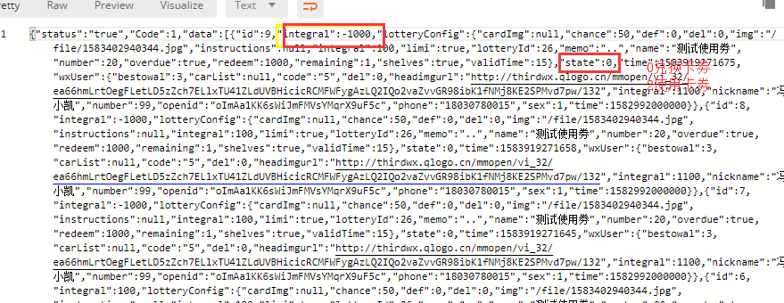

# **管理员消卷**

* 1. /useLottery
  2. Get
  3. 参数 carId lotteryHistoryId
  4. 如 172.81.208.22:8080/jxd/useLottery?carId=2&lotteryHistoryId=69
  5. 
  6. 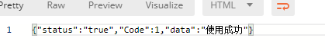
  7. 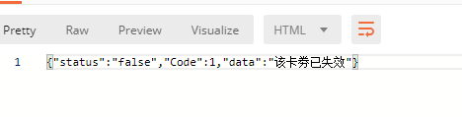

# **发送卡劵给朋友 做抽奖次数增加**

* 1. /giveLottery
  2. Get
  3. 参数 openid
  4. 如：<http://localhost:8080/jxd/giveLottery?openid=oImAa1KK6sWiJmFMVsYMqrX9uF5c>
  5. 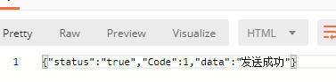
  6. 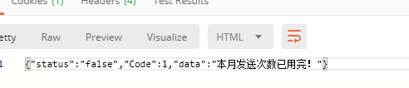
  7. 

# **朋友领劵**

* 1. /getLottery
  2. Get
  3. 参数 lotteryHistoryId openid
  4. 如：<http://localhost:8080/jxd/getLottery?lotteryHistoryId=77&openid=oImAa1CoJESEiEHXvW6LW0s_cVU4>
  5. 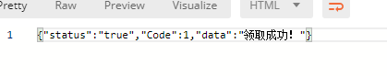
  6. 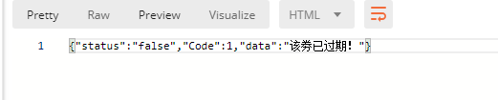

# 22.查询保险

* 1. /getInsuranceBrandList
  2. Get
  3. 参数 无
  4. 如：<http://localhost:8080/jxd/getInsuranceBrandList>
  5. 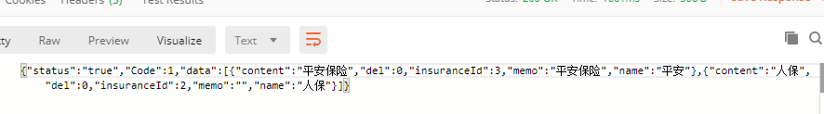

# 23.查看卷信息

* 1. /checkLottery
  2. Get
  3. 参数 carId lotteryHistoryId
  4. 如：<http://localhost:8080/jxd/checkLottery?carId=2&lotteryHistoryId=80>
  5. 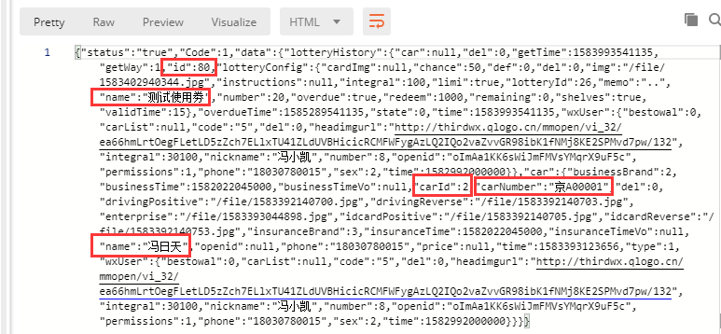
  6. 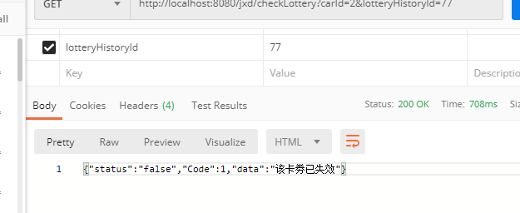

# 24.向用户发送验证码，并获取验证码

* 1. /verificationCode
  2. Get
  3. 参数 phone
  4. 如：localhost:8080/jxd/verificationCode?phone=18030780015
  5. 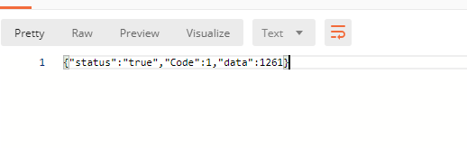

1. 33
2. 33
3. 33
4. 33