SV AUTO TRUCK REPAIR CC
Windhoek · Namibia
SAMS Test Report
Software Test Execution Report
Shop Automated Management System
Version 1.0 | 30 September 2026
Prepared in accordance with IEEE 829 test documentation practice

Document Control
Field | Value
Document title | SAMS Test Report — Software Test Execution Report
Version | 1.0
Date of issue | 30 September 2026
System under test | SAMS — Shop Automated Management System
Build tested | Commit 638dd6b (branch main)
Test branch | test/sams-e2e-suite, commit 78a1f8f
Status | Final
Distribution | Development team, project stakeholders

Related documents
Reference | Document | Version
[1] | SAMS Documentation | 1.0 — 28 Sep 2026
[2] | SAMS Test Cases (manual QA checklist) | 1.0 — 28 Sep 2026
[3] | tests/e2e/README.md — suite setup and execution guide | Current
[4] | tests/e2e/TEST-REPORT.md — machine-readable form of this report | Current

Revision history
Version | Date | Description
1.0 | 30 Sep 2026 | First issue. Full execution of the automated suite against commit 638dd6b.

Table of Contents

This field updates on open. In Word, press Ctrl+A then F9 to refresh page numbers.

1. Introduction

1.1 Purpose
This report records the outcome of an automated test execution against the SAMS web application. It states what was tested, how, what passed, what failed, and what each failure means for the product. It is intended to be actionable by the development team without reference to the test code.

1.2 Scope
The test basis is the manual QA checklist in SAMS Test Cases [2], which defines 89 cases across ten sections covering authentication, role-based redirection and access control, the client portal, the admin and manager modules, cross-cutting security, and the notification and contact-form features.
Of those 89 cases, 64 automated tests were implemented and executed. The remainder either require a live third-party service, or are blocked by defects recorded in this report (notably the absence of three role dashboards, which leaves nothing for the technician, finance and HR sections to exercise).
No application code was modified. All findings describe the system as committed at 638dd6b.

1.3 Severity definitions
Severity | Definition
Critical | Exploitable by an untrusted or low-privilege party; permits data loss, unauthorised modification, or privilege escalation. Fix before any deployment.
High | A core feature is unusable, or a security control is absent where the design assumes one. Fix before release.
Medium | Feature works but incorrectly or incompletely; or a defence-in-depth control is missing. Fix in the current cycle.
Low | Cosmetic, dead code, or documentation drift. Fix opportunistically.

2. Test Environment
The environment was built specifically for this execution. Nothing was installed system-wide; the whole stack is portable and removable by deleting a single directory.

2.1 Platform
Component | Version | Notes
PHP | 8.2.34 NTS (x64) | pdo_mysql, mbstring, gd, openssl, curl, zip, intl
MariaDB | 11.4.9 | Port 3307, matching backend/config/config.php line 36
dompdf | 3.1.5 | Installed via composer install
PHPMailer | 7.0.2 | Installed via composer install
Playwright | 1.49 | Test runner
Chromium | 153.0.8010.12 | Playwright build; headless for the run, headed for evidence
Web server | PHP built-in server | See deviation 2.2
Host OS | Windows 11 Pro (26100)

2.2 Deviation from the documented environment
SAMS Documentation [1] specifies Apache via XAMPP. XAMPP was not present on the test machine and its installer could not complete unattended, so an equivalent portable stack was assembled with the same PHP and MySQL-compatible versions, served by PHP's built-in web server.
Consequence: the .htaccess rewrite rules were not exercised. Those rules only redirect pre-split legacy paths (/Admin/*, /Config/*, /Public/*) and no checklist case covers them, so coverage is unaffected. Every finding in this report was confirmed against application code and database state, not against web-server configuration.

2.3 Test data
A dedicated seeding script (backend/setup/seed_test_data.php) creates a deterministic fixture set: one account per staff role, one account with an unrecognised role, and four client accounts covering every status value. Two approved clients each own a vehicle, job card, quotation and invoice, which gives the suite two distinct tenants for cross-tenant access testing.
The script is idempotent and writes a manifest of the record identifiers it created, so the tests reference real primary keys rather than guessing them. The database is re-seeded before every run.

3. Test Approach

3.1 Method
Tests drive a real Chromium browser against a running instance of the application. There is no mocking: each test authenticates through the login form, navigates as a user would, and asserts on rendered output, HTTP status codes and redirect targets. Where a case concerns state changed outside the browser — an administrator blocking an account mid-session — the test alters the database directly and then continues browsing, which is what the checklist case actually describes.

3.2 Traceability
Every test is named for the checklist case it implements, so a failure identifies its row in SAMS Test Cases [2] without cross-referencing. Five tests carry names not in the checklist; they cover gaps found during execution and are marked as extensions in section 6.3.

3.3 Verification of findings
Every failure in this report was reproduced by hand, outside the test runner, before being recorded. Assertions that proved incorrect were corrected rather than reported: three initial failures turned out to be defects in the tests, and one was an environmental flake caused by the host machine suspending mid-run. None of those appear as findings.
This matters for the numbers below: the 36 failures are 36 genuine defects in the application, not an unfiltered runner output.

3.4 Corrections made during execution
Two defects in the test suite itself were found and fixed before this report was finalised. They are recorded here because they changed the reported figures.
- Six ADMIN cases were passing against 404 pages. The PHP Not Found page echoes the requested path, so Admin/Employee/Employee/employees.php contains the word "employee" and an assertion on page text alone succeeded. Those tests now check the HTTP status and reject the 404 body. The defects were always present; the tests were not catching them.
- One case asserted nothing. AUTH-04 logged in as an administrator and checked that the dashboard returned 200, which cannot fail for the reason the case describes. It is now an explicit skip, because the users table has no column by which an account could be disabled.

4. Execution Summary

4.1 Overall result
Metric | Result
Checklist cases in scope [2] | 89
Checklist cases with automated coverage | 75
Automated tests implemented | 86
Passed | 49
Failed | 36
Skipped (no feature to test) | 1
Distinct defects confirmed | 23
Cases requiring manual execution | 2 (Google consent flow)

4.2 Results by checklist section
Section | Cases [2] | Tests run | Passed | Failed
1. Authentication (AUTH) | 14 | 13 | 11 | 1
1a. Google OAuth (OAUTH) | — | 6 | 6 | 0
2. Role redirect (ROLE) | 7 | 8 | 3 | 5
3. Client portal (CLIENT) | 11 | 12 | 8 | 4
4. Admin (ADMIN) | 26 | 17 | 7 | 10
5. Manager (MGR) | 7 | 7 | 5 | 2
6. Technician (TECH) | 4 | 2 | 0 | 2
7. Finance (FIN) | 4 | 4 | 0 | 4
8. HR (HR) | 4 | 4 | 0 | 4
9. Security (SEC) | 7 | 8 | 5 | 3
10. Notifications / contact | 5 | 3 | 2 | 1
Total | 89 | 86 | 49 | 36
Sections 6 to 8 are thin because the technician, finance and HR dashboards do not exist (finding H7). With no dashboard to reach, only the access-control case in each section could be executed; the remainder are blocked until those pages are built.

4.3 Assessment
The application builds, deploys and runs. Its core workflows — staff authentication, the admin dashboard, quotations, invoices, job cards and the client portal — are present and function. Authentication is the strongest area: all eleven tests pass.
Client tenant isolation holds. No test was able to read another client's quotation or invoice. The database queries behind those views are correctly scoped by client identifier.
Against that, two critical access-control defects are exploitable today — one by an unauthenticated visitor, one by the lowest-privilege account in the system. Four further findings block ordinary use of the product as shipped:
- No self-registered client can ever use the portal, even after an administrator approves them (H3).
- Nine of fifteen admin modules are dead — employees, inventory, reports, expenses, statutory documents, purchase orders, HR requests, user roles and services (H6).
- Every statutory document upload is unretrievable — files are written to one directory and linked from another (H9).
- The committed database schema cannot be installed by following the documented steps (M1–M3).

5. Defect Register
Findings are ordered by severity. The Case column gives the checklist reference where one exists.
ID | Finding | Severity | Case [2]
C1 | Any authenticated user, including a self-registered client, can permanently delete records | Critical | SEC-05
C2 | Unauthenticated visitors can execute schema-altering setup scripts | Critical | SEC-07
H1 | Role boundaries are not enforced on pages that render | High | MGR-06, TECH-04, FIN-04, HR-04
H2 | No CSRF protection on state-changing endpoints | High | SEC-05
H3 | Self-registered clients can never access the portal, even once approved | High | CLIENT-05
H4 | Every client invoice fails with a fatal error and leaks filesystem paths | High | CLIENT-09, SEC-06
H5 | The admin quotations module is entirely non-functional | High | ADMIN-06
H6 | Nine of fifteen admin modules are dead redirect stubs | High | ADMIN-12/13/15/17/18/20/21
H7 | Three of six role dashboards do not exist | High | ROLE-03/04/05
H8 | Blocking a client mid-session has no effect | High | CLIENT-11
H9 | Uploaded statutory documents are written where nothing can retrieve them | High | ADMIN-20
H10 | The OAuth callback never checks Google's verified-email claim | High | AUTH-09
H11 | Password reset is broken in production by a path-casing mismatch | High | AUTH-10
M1 | database.sql cannot be executed from top to bottom | Medium | —
M2 | The client-table migrations cannot apply | Medium | —
M3 | A required setup step is absent from the documentation | Medium | —
M4 | No rate limiting on the public contact form | Medium | CONTACT-03
M5 | Cross-tenant requests are not denied cleanly | Medium | CLIENT-07
M6 | Google sign-in only ever creates client accounts | Medium | AUTH-09
M7 | The login page ignores its own force parameter | Medium | —
L1 | Dead code: the payment-notification handler can never fire | Low | —
L2 | Contact enquiries are written to a different directory than documented | Low | ADMIN-26
L3 | Seeded user accounts carry placeholder password hashes | Low | —
L4 | Password-reset response differs by account existence when mail fails | Low | AUTH-11

6. Detailed Findings

6.1 Critical

C1 — Any authenticated user can permanently delete records
frontend/Admin/recycle-bin/permanent_delete_all.php executes an unconditional DELETE against the expenses table. Its only access check is whether a session exists:
if (!isset($_SESSION['user_id'])) { // line 5 — the only gate
header('Location: ../Auth/login.php');
exit;
}
A self-registered client — the lowest-privilege account in the system, obtainable by anyone through the public registration form — executed this endpoint successfully and received the success redirect shown below. permanent_delete_selected.php carries the identical gate.
Because the operation is a GET request with no CSRF token, it will also fire from any third-party page that an authenticated user happens to visit.
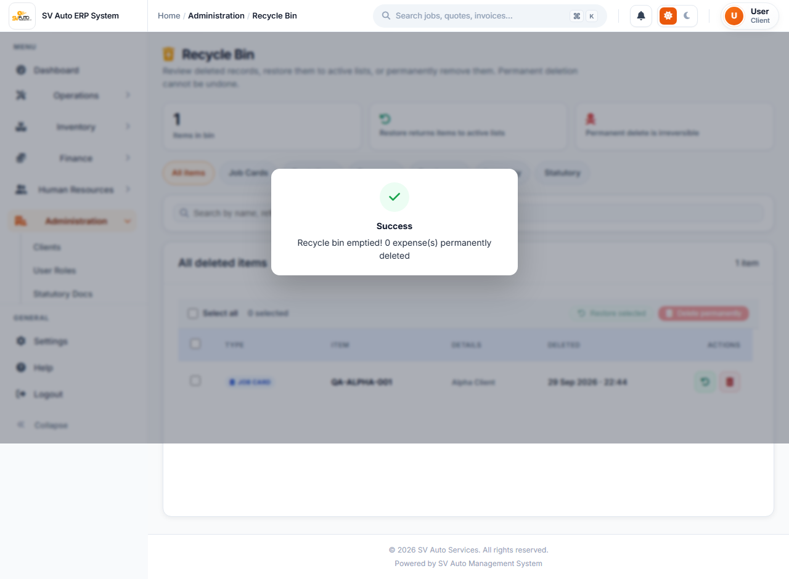
Figure 1 — C1 — a logged-in client receives "Recycle bin emptied!" after calling permanent_delete_all.php
Recommended fix: add require_admin(), convert the endpoint to POST, and require a CSRF token.

C2 — Unauthenticated visitors can execute schema-altering scripts
With no session established, all three of the following return HTTP 200 and perform their work:
Endpoint | Effect
Admin/recycle-bin/setup_recycle_bin_all.php | ALTER TABLE across eight tables
Admin/Statutory/add_deleted_column_statutory.php | ALTER TABLE statutory_docs
backend/migrations/run_all_migrations.php | Executes the entire migration file
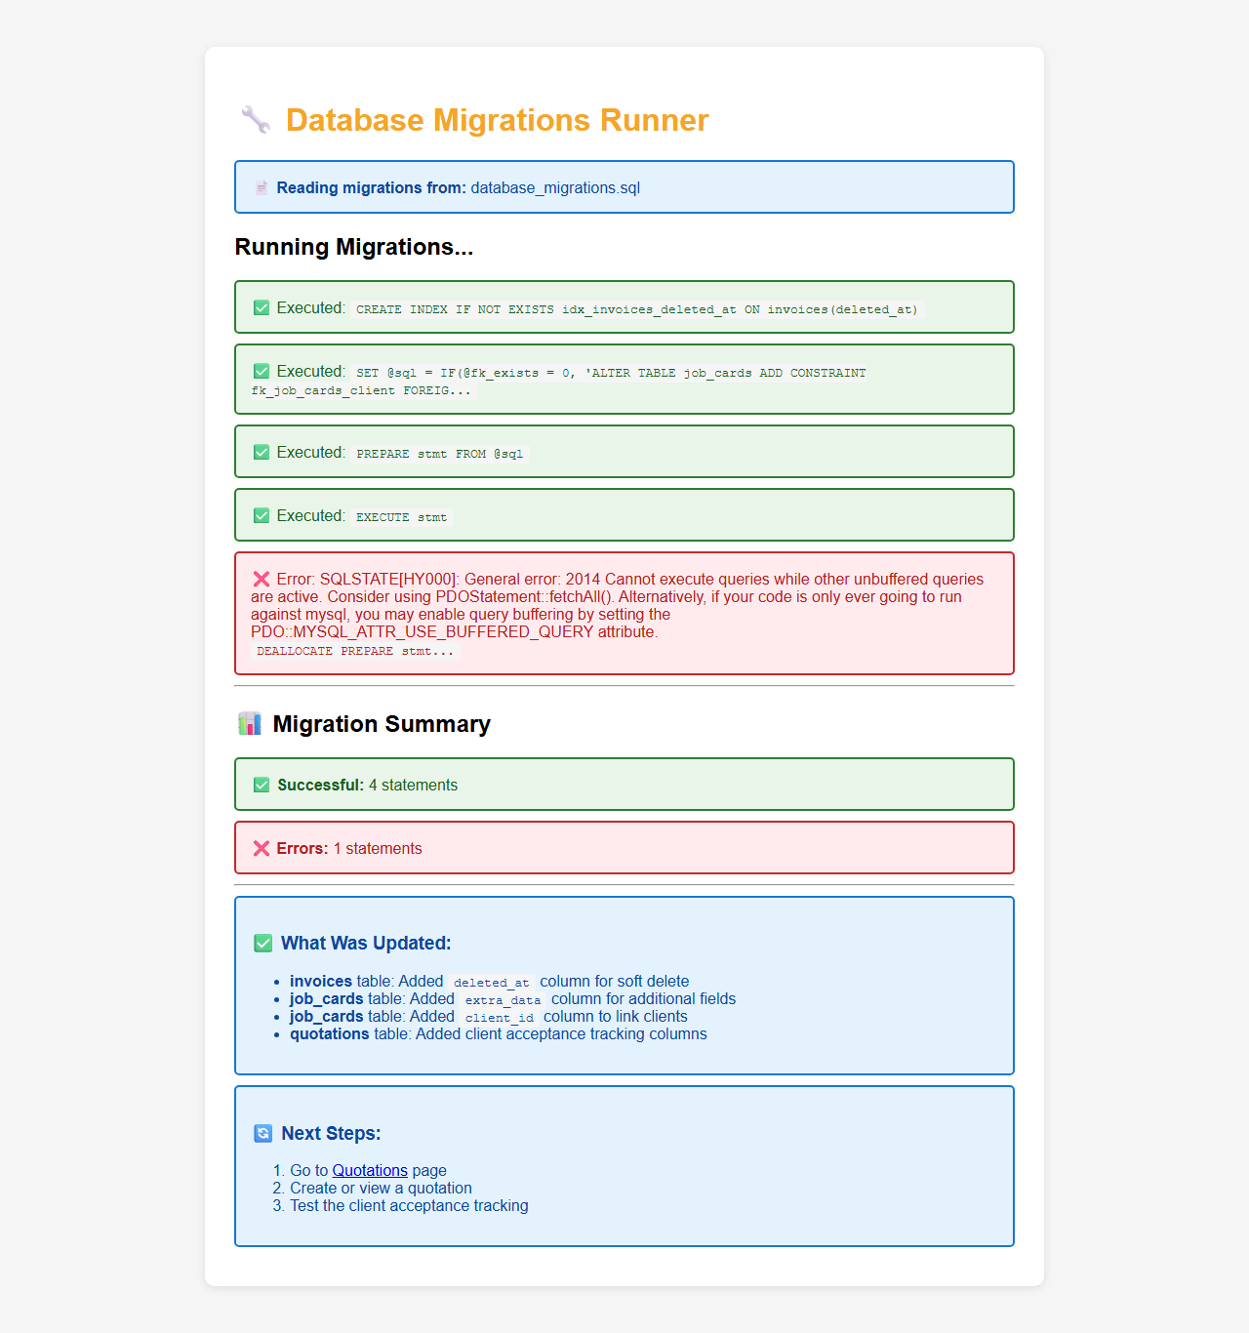
Figure 2 — C2 — run_all_migrations.php executing for a visitor with no session
Recommended fix: these are one-off setup utilities. Remove them from the deployed tree, or gate them behind require_admin() together with an environment check.

6.2 High

H1 — Role boundaries are not enforced on pages that render
Each staff role was authenticated in turn and pointed at five admin pages. The pages that guard themselves with require_admin() correctly refuse; those that check only for the presence of a session admit every role.
Page | Technician | Finance | HR | Manager
Admin/dashboard.php | served | served | served | served
Admin/recycle-bin/recycle_bin.php | served | served | served | served
Admin/Client/clients.php | blocked | blocked | blocked | blocked
Admin/Invoice/invoices.php | blocked | blocked | blocked | blocked
Admin/JobCard/job_card.php | blocked | blocked | blocked | blocked
The guard exists but is barely applied. Across 145 admin PHP files, 16 include Auth/auth.php and only 9 call require_admin(). Note also that auth.php diverts managers away from /Admin/ URLs, but dashboard.php never includes auth.php, so a manager reaches it regardless.
The recycle bin is the most consequential of these: it is the entry point to the permanent-delete operations described in C1.
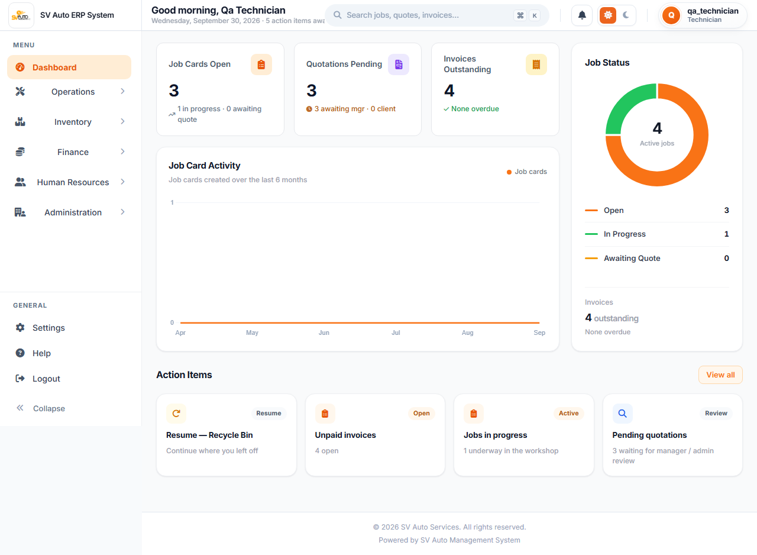
Figure 3 — H1 — the full admin dashboard rendered for a technician account

H3 — Self-registered clients can never access the portal
Registration writes a row to users and a row to clients. The two tables have independent auto-increment sequences, so the identifiers diverge:
Account | users.id | clients.id
qa.reg…@test.local | 17 | 11
login.php checks the users table first, so the session carries users.id. Client/includes/header.php then refreshes the account status using that value against the clients table:
$stmt = $pdo->prepare("SELECT status FROM clients WHERE id = ?");
$stmt->execute([$userId]); // users.id, not clients.id
$_SESSION['status'] = $currentStatus ?: 'pending';
The lookup misses, the status defaults to pending, and the client is redirected away from the dashboard on every request. This was reproduced end to end: a registration was approved at the database level, the account logged in successfully, and was still returned to the pending-approval page.

Figure 4 — H3 — an approved client is still held at pending-approval.php
This finding also has a security dimension. Once the clients table grows past the relevant users.id, the query begins returning a different client's status row.
Note on detection: CLIENT-01 passes. Registration genuinely works and correctly creates the account as pending. The defect appears only at the next step, so a checklist run that stops at CLIENT-01 would not find it.

H4 — Every client invoice fails and leaks filesystem paths
Client/view_invoice.php line 54 selects i.issue_date. The column created by add_invoices_table.sql is issued_date. The remaining nine files in the codebase that reference this column all spell it correctly; this is a single-file typo, and it breaks the client invoice view for every client on every request.
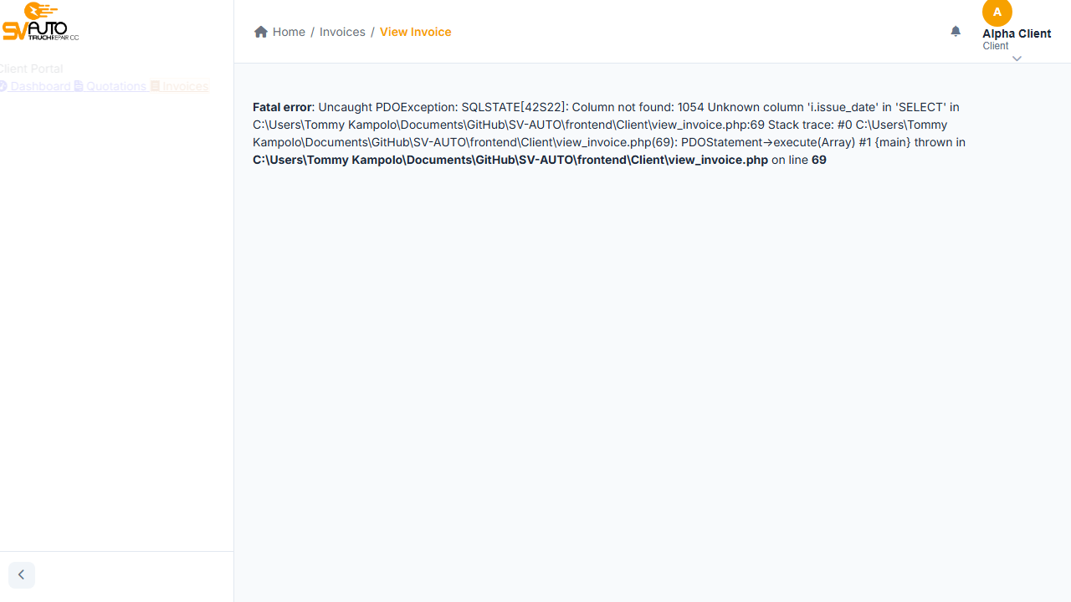
Figure 5 — H4 — a client opening their own invoice receives a PDO stack trace with absolute server paths
The same screenshot also evidences SEC-06: a full stack trace, including absolute filesystem paths, is displayed to the end user.
Recommended fix: rename issue_date to issued_date at lines 54 and 366.

H5 — The admin quotations module is non-functional
Admin/Quotation/quotations.php line 166 queries a created_at column on the quotations table. No such column exists — the table carries submitted_at instead. The page returns 516 bytes consisting only of the fatal error. The comment on the preceding line reads "use submitted_at, fall back to created_at", so the fallback was written against a column that was never added.
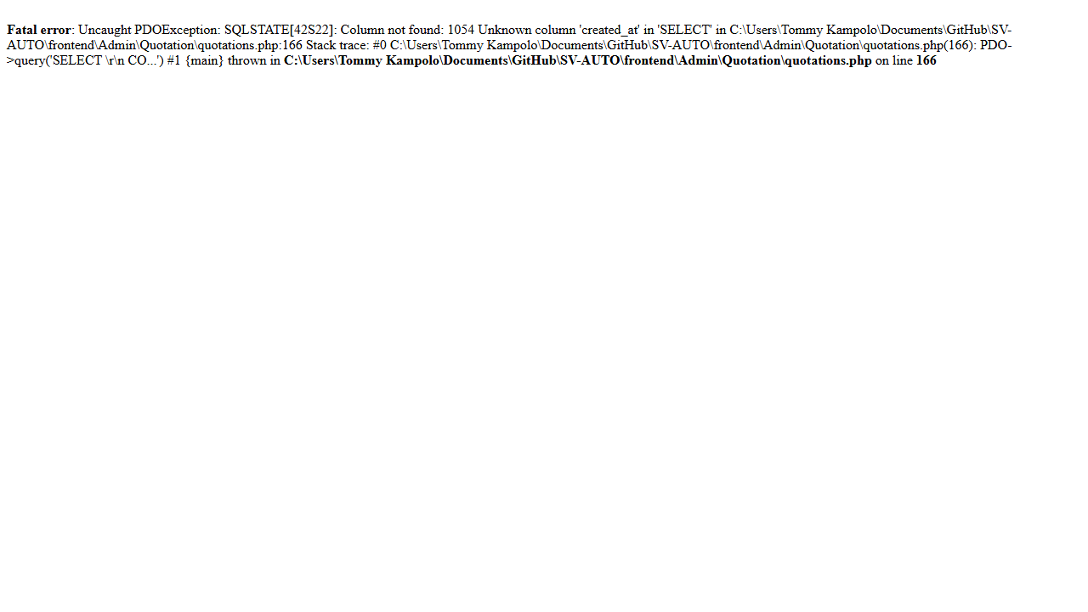
Figure 6 — H5 — the quotations module returns only a fatal error

H6 — Nine of fifteen admin modules are dead redirect stubs
Each of these sidebar destinations is a file of roughly 190 bytes that redirects to its own path relative to itself. The result is a doubled path that does not exist.
Sidebar link | Size | Resolves to
Employee/employees.php | 193 B | /Admin/Employee/Employee/… → 404
Expense/expenses.php | 191 B | /Admin/Expense/Expense/… → 404
Inventory/inventory.php | 194 B | /Admin/Inventory/Inventory/… → 404
Report/reports.php | 189 B | /Admin/Report/Report/… → 404
Service/services_update.php | 198 B | /Admin/Service/Service/… → 404
Statutory/statutory.php | 194 B | /Admin/Statutory/Statutory/… → 404
hr-request/hr_requests.php | 197 B | /Admin/hr-request/hr-request/… → 404
purchase-order/purchase_orders.php | 205 B | /Admin/purchase-order/purchase-order/… → 404
user-role/user_roles.php | 195 B | /Admin/user-role/user-role/… → 404
The real page content is not present elsewhere in the repository; version history shows these files were committed as stubs. For comparison, the working modules (clients, invoices, job cards, quotations, recycle bin) are files of 34 KB to 86 KB.
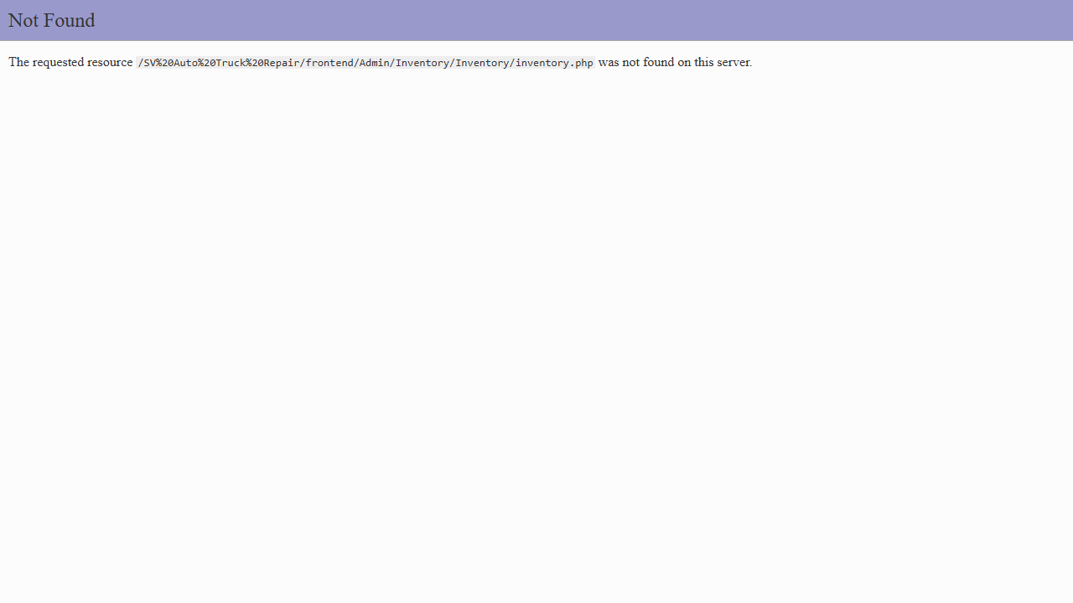
Figure 7 — H6 — the doubled path is visible in the address bar after following the Inventory link

H7 — Three of six role dashboards do not exist
getRoleRedirect() in frontend/login.php routes to six destinations. Three are absent from the filesystem, so those users authenticate successfully and arrive at a 404.
Role | Redirect target | Exists
admin | Admin/dashboard.php | Yes
manager | Manager/manager_dashboard.php | Yes
technician | Technician/technician_dashboard.php | No
finance | Admin/finance_dashboard.php | No
hr | Hr/hr_dashboard.php | No
client | Client/dashboard.php | Yes
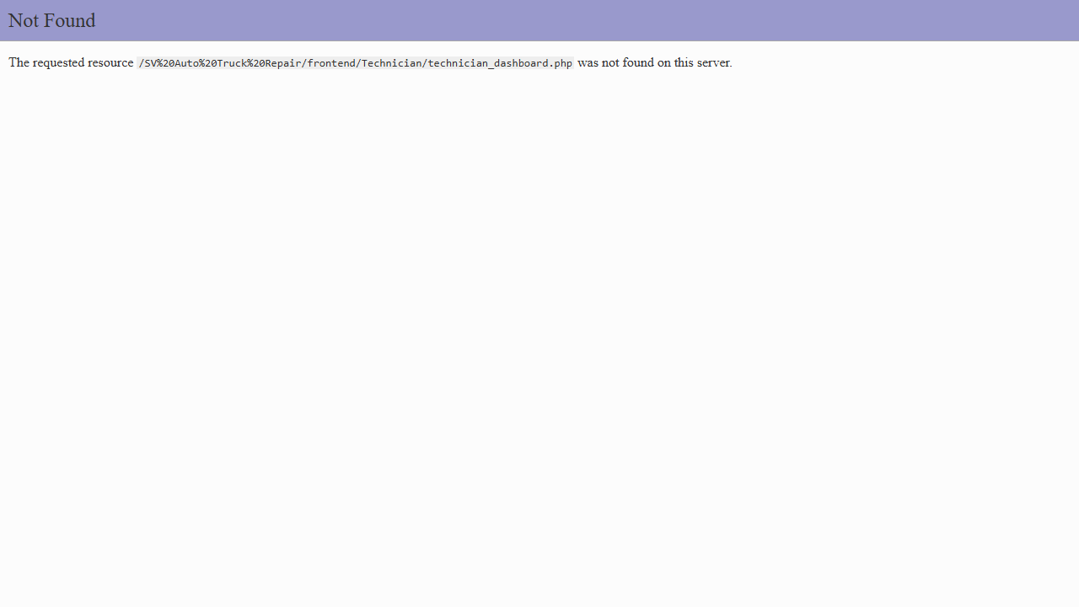
Figure 8 — H7 — a technician lands on a 404 immediately after a successful login
This finding blocks checklist sections 6, 7 and 8 almost entirely, which is why those rows in table 4.2 show a single test each.

H8 — Blocking a client mid-session has no effect
Client/includes/header.php refreshes the account status on every page load, then acts on it — but branches on one value only:
if ($_SESSION['role_name'] === 'client' && ($_SESSION['status'] ?? 'pending') === 'pending') {
The blocked state is never handled, so a client blocked by an administrator during an active session retains full access until they log out. Blocking at login time works correctly; only mid-session enforcement is missing.

H9 — Uploaded statutory documents cannot be retrieved
upload_statutory.php builds its destination as __DIR__ . '/../uploads/statutory/'. Because __DIR__ is already frontend/Admin/Statutory, files land in frontend/Admin/uploads/statutory/. The database, however, records the URL as uploads/statutory/<name>, which resolves from the frontend root to frontend/uploads/statutory/.
Verified by uploading two files: both were written to a directory that did not previously exist and is not part of the repository, while the database rows pointed elsewhere. Requesting the recorded URL returns 404. Every statutory document uploaded through the application is therefore unretrievable.
Recommended fix: change the path to __DIR__ . '/../../uploads/statutory/'.

H10 — The OAuth callback does not check the verified-email claim
google-callback.php links a Google identity to an existing account on WHERE email = ? OR google_id = ?, and nothing in the file reads Google's email_verified claim. Matching on an unverified address is the standard account-takeover path in OAuth integrations: an identity whose email is attacker-controlled and unverified would be linked directly into the matching client account. The callback also compares the state parameter with !== rather than hash_equals().
Basis: this finding is from code review, not a reproduced exploit. OAuth is unconfigured on the test machine — google.local.php is correctly absent and gitignored — so google-auth.php fails closed with a clear message and leaks nothing.
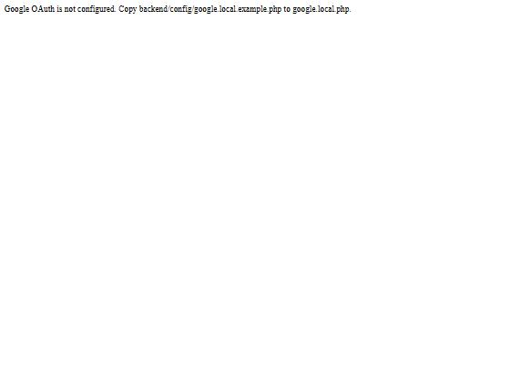
Figure 9 — The OAuth entry point failing closed when no credentials are present (OAUTH-06)

H11 — Password reset is broken in production by a path-casing mismatch
backend/config/functions.php builds two paths with the wrong case: it asks for backend/Config/mail.php when the directory is backend/config, and backend/Libraries/PHPMailer/src when the directory is backend/libraries.
Windows is case-insensitive, so local testing passes and the defect is invisible there. Linux is not, and the documented production host is Hostinger. On that host mail.php never loads and PHPMailer is never found, so erp_send_password_reset_email() returns "PHPMailer is not installed" and password reset cannot work at all.
It also promotes L4 from theoretical to live. With mail failing, the reset response differs depending on whether the account exists, which is an account-enumeration oracle.
Recommended fix: four strings in functions.php — /Config/ to /config/, and /Libraries/ to /libraries/.

6.3 Medium and Low
The findings below are described in full in TEST-REPORT.md [4]; they are summarised here with the detail needed to act on them.

M1–M3 — The committed schema cannot be installed as documented
- M1: database.sql declares users at line 11 with a foreign key to clients, which is not created until line 24. On a clean server this forward reference causes 10 of 18 CREATE TABLE statements to fail. Fix: move the clients definition above users, or load with FOREIGN_KEY_CHECKS disabled.
- M2: update_clients_table.sql fails on three statements because its multi-clause ALTER references AFTER last_name on a table that has no last_name column, so the whole statement aborts. add_client_status.sql and fix_google_oauth.sql then fail in turn. The net effect is that clients never gains password_hash, role or status — the columns login.php depends on, making client login impossible on a by-the-book install.
- M3: the deleted_at columns that the admin dashboard queries are added only by Admin/recycle-bin/setup_recycle_bin_all.php. No migration creates them and the four documented installation steps never mention running it.

M4 — No rate limiting on the public contact form
Six rapid submissions were all accepted and all persisted. A CSRF token and a honeypot field are present, but there is no throttle and no captcha. The checklist asks for this to be flagged if absent (CONTACT-03).

M5 — Cross-tenant requests are not denied cleanly
Client/view_quotation.php and view_invoice.php correctly detect the ownership mismatch and call header('Location: …'), but includes/header.php has already emitted HTML, so the redirect cannot be sent. The page renders an empty shell instead. No data is disclosed — the queries are properly scoped — so the security property holds; only the handling is incorrect.

M6 — Google sign-in only ever creates client accounts
google-callback.php touches the clients table exclusively and never queries users. A staff member signing in with Google therefore does not reach their staff account; they receive a new client account in pending status. The behaviour fails safe, but it means Google sign-in is a client-only feature despite appearing on the staff login page.

M7 — The login page ignores its own force parameter
login.php line 10 consults ?force when deciding whether to redirect an already-authenticated visitor, but the template at line 199 branches on $alreadyLoggedIn alone. A signed-in user sent to login.php?force=1 is shown "Continue to dashboard / Sign out" and never the login form, so they cannot switch accounts without logging out first.

Low-severity findings
ID | Finding
L1 | Client/view_invoice.php line 11 tests isset($inv) roughly 60 lines before $inv is assigned, so the payment-notification handler can never fire. Dead code.
L2 | contact_send.php writes enquiry files to frontend/storage/, while the documentation and the existing committed files use backend/storage/. Checklist case ADMIN-26 inspects the wrong directory.
L3 | database.sql seeds six users with literal placeholder strings in place of bcrypt hashes, so no seeded account can log in.
L4 | When mail delivery fails, the password-reset response differs depending on whether the account exists. On localhost this is the harmless developer-link branch, but on a production server with broken SMTP it becomes an account-enumeration oracle.

7. Items Verified as Working
The following were confirmed by passing tests and are recorded so that a future regression is visible as a change rather than a discovery.

7.1 Authentication
All eleven authentication tests pass — the only section with no failures.
- Valid staff credentials reach the correct role dashboard (AUTH-01).
- A wrong password and an unknown username return byte-identical messages, so the login form does not enumerate accounts (AUTH-02, AUTH-03).
- Logout destroys the session; protected pages are unreachable afterwards and the back button does not restore access (AUTH-05).
- Unauthenticated requests to protected URLs are redirected to the login page (AUTH-06).
- SQL injection attempts in the login fields are rejected with no error leakage (AUTH-13).
- Empty credentials are rejected server-side (AUTH-14).
- A login POST without a valid CSRF token is refused, and a session-based throttle locks the form after eight failed attempts.

7.2 Password reset
The full reset cycle was exercised: a reset link sets a new password, the previous password stops working immediately, and the link is rejected on reuse. An unregistered address receives the generic response with no link offered.
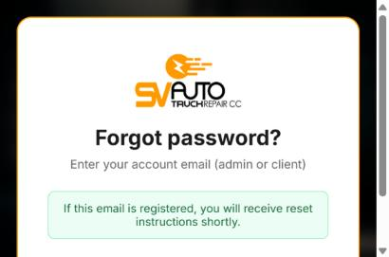
Figure 10 — AUTH-11 — an unregistered address receives the generic response
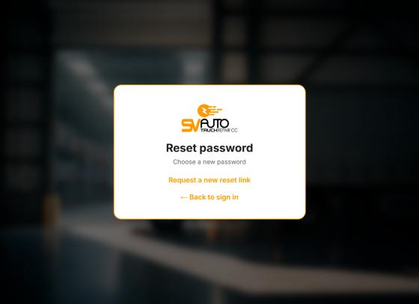
Figure 11 — AUTH-12 — a consumed reset link is rejected and the form is withdrawn

7.3 Client data isolation
Requesting another client's quotation or invoice by identifier disclosed nothing. Both underlying queries are correctly scoped by client identifier. This is the single most important security property in a multi-tenant portal and it holds.

7.4 File upload
A bare .php upload is refused by the extension whitelist. A .php file renamed .jpg is accepted — content is never inspected — but the stored file retains its .jpg extension and is served as inert image data, so it does not execute. The checklist requirement ("rejected, or not executable when served") is met on the second clause.
Caveat. This passes only because the whitelist happens to leave a safe extension on disk. There is no defence in depth behind it: file content is never inspected, and neither upload directory carries a deny rule. On a server that maps additional extensions to PHP, or if any code ever includes an uploaded path, this becomes remote code execution. It is worth hardening even though it passes today.

7.5 Session and application behaviour
- The session cookie is HttpOnly, and the session identifier is regenerated on login.
- Client status is enforced correctly at login: pending accounts reach the approval page, approved accounts reach the dashboard, and blocked accounts are refused with a suspension message.
- The contact form enforces a CSRF token, a honeypot field and server-side validation; empty submissions are rejected and not stored.
- The admin dashboard, clients, invoices, job cards and recycle bin all render correctly with no SQL errors.
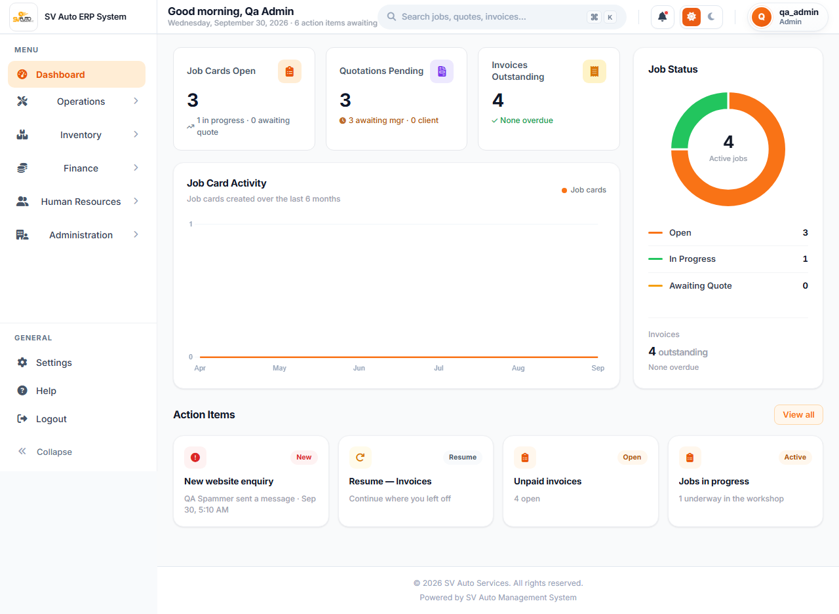
Figure 12 — The admin dashboard rendering correctly, for contrast with the failures above

8. Coverage and Exclusions

8.1 Requiring manual execution
Case | Reason
AUTH-08, AUTH-09 | Google OAuth — requires live Google Cloud credentials and a consent flow through Google's own sign-in, which cannot be automated against a third-party identity provider.

8.2 Cases reclassified during execution
Four cases were initially assessed as manual-only and proved otherwise. They are now automated:
- AUTH-10, AUTH-11, AUTH-12 — the reset flow needs no SMTP. When mail is unconfigured and the request originates locally, forgot-password.php prints the reset URL directly on the page, so the entire cycle is drivable.
- SEC-01 — both the upload and the subsequent fetch of the stored file can be driven directly, making the execution question decidable without manual inspection.

8.3 Blocked by defects
Checklist sections 6 (Technician), 7 (Finance) and 8 (HR) cannot be meaningfully executed until finding H7 is resolved, since the dashboards those sections exercise do not exist. Several ADMIN cases are likewise blocked by H6. These are recorded as blocked rather than failed, except for the single access-control case in each section, which was executable and failed.

8.4 Extensions beyond the checklist
Five tests cover gaps identified during execution and are named to distinguish them from checklist cases:
Test | Rationale
AUTH-CSRF | The checklist tests CSRF on state-changing forms but not on the login POST itself.
ROLE-DASH | Asserts the redirect targets exist. A redirect to a 404 is not a passing redirect.
ADMIN-NAV | Walks every sidebar link and follows redirects, which is how H6 was found.
CLIENT-07b | Separates "no data disclosed" from "denied cleanly" — the first holds, the second does not.
SEC-DEL | Directly targets the permanent-delete endpoint behind finding C1.

9. Conclusions and Recommendations

9.1 Conclusion
SAMS is a working application with a solid authentication layer and correct tenant data isolation. Its problems are concentrated in two areas: authorisation, which is designed but almost never applied, and deployment integrity, where the committed schema and several file paths do not match what the code expects.
The system is not fit for deployment in its current state. Findings C1 and C2 are exploitable by untrusted parties today and must be resolved first. Beyond those, four defects prevent ordinary use of features the product advertises.
Encouragingly, a substantial share of the high-severity findings are small fixes. H4, H5 and H9 are each a single incorrect identifier — a column name, a column name, and a relative path — and between them they restore the client invoice view, the admin quotations module and statutory document retrieval.

9.2 Recommended order of work
- C1, C2 — remove or gate the delete and setup endpoints. Both are reachable by untrusted parties today.
- H1, H2 — apply require_admin() across the admin tree and add CSRF tokens to state-changing routes.
- H4, H5, H9 — three one-line identifier fixes restoring three broken features.
- H3, H8 — correct the client status lookup and handle the blocked state.
- H10 — require the verified-email claim before linking by email, before OAuth is enabled in production.
- H6, H7 — restore the nine missing module pages and three missing dashboards, or remove their navigation entries.
- M1–M3 — make the schema installable from the committed files and bring the documentation into line.
- M4–M7, L1–L4 — correctness and hygiene fixes.

9.3 Recommendations for the test process
- Run the suite in continuous integration. It completes in under five minutes and requires only PHP, a MySQL-compatible database and Node.
- Treat the 19 failures as the regression baseline. Each failing test should flip to passing as its defect is fixed, which gives an objective measure of remediation progress.
- Revise the checklist where execution exposed gaps. CLIENT-01 passes while the account it creates is permanently unusable, because the case stops at "status = pending" and never asks what happens after approval. Extending cases to their next state would have caught H3 manually.
- Reassess the manual-only classification. Four of the six cases marked as requiring external services were automatable once the application's actual behaviour was examined.

Appendix A — Test Accounts
Created by backend/setup/seed_test_data.php. All accounts share the password Test@1234. These are local fixtures and carry no production significance.
Account | Role or status
qa.admin@test.local | Admin
qa.manager@test.local | Manager
qa.technician@test.local | Technician
qa.finance@test.local | Finance User
qa.hr@test.local | HR User
qa.cleaner@test.local | Unrecognised role, for the ROLE-07 fallback case
qa.client.approved@test.local | Client — approved
qa.client.other@test.local | Client — approved; second tenant for cross-tenant cases
qa.client.pending@test.local | Client — pending
qa.client.blocked@test.local | Client — blocked

Appendix B — Reproducing This Run
Prerequisites: PHP 8.2 or later with pdo_mysql, mbstring and gd; a MySQL-compatible database reachable at 127.0.0.1:3307 as root with no password; Node 18 or later.
1. Install PHP dependencies:
composer install
2. Build the schema. Note findings M1 to M3: load database.sql with FOREIGN_KEY_CHECKS disabled, apply the migrations in date order, then run Admin/recycle-bin/setup_recycle_bin_all.php to add the deleted_at columns.
3. Seed the test data:
php backend/setup/seed_test_data.php
4. Install and run the suite:
cd tests/e2e
npm install && npx playwright install chromium
npm test
Additional commands: npm run test:headed runs the suite in a visible browser, npm run report opens the HTML report, and npm run evidence regenerates the screenshots reproduced in this document.
The database is re-seeded automatically before every run. This matters because several cases mutate shared rows — CLIENT-11 blocks an account and restores it — so an interrupted run would otherwise leave state that causes the next run to fail for the wrong reason.

Appendix C — Evidence Index
All screenshots are committed under tests/e2e/evidence/ and can be regenerated with npm run evidence. Figures reproduced in this document are listed below; the directory holds 25 images in total.
File | Supports
EV-01-client-invoice-fatal-error.png | H4, SEC-06
EV-02-admin-quotations-fatal-error.png | H5, ADMIN-06
EV-03-inventory-404-doubled-path.png | H6, ADMIN-NAV
EV-04-technician-admin-dashboard.png | H1, TECH-04
EV-05-technician-recycle-bin.png | H1
EV-06-client-permanent-delete.png | C1, SEC-DEL
EV-07a / EV-07b | C2, SEC-07
EV-08 / EV-09 / EV-10 | H7, ROLE-03/04/05
EV-11-cross-tenant-quotation.png | M5, CLIENT-07
EV-12a / EV-12b | Correctly rendering pages, for contrast
EV-13-approved-client-still-pending.png | H3, CLIENT-05
EV-14 to EV-17 | AUTH-10, AUTH-11, AUTH-12
EV-18-oauth-entry-fails-closed.jpg | OAUTH-06
End of report

