Task 3 : Exploratory Data Analysis
Analyzing Tech Job Postings Across the US, India, and the UK

Prepared by Aisshwarya. A

1. Introduction
This report explores a dataset of 2,959 technology job postings collected from the Adzuna API across three countries — the United States, India, and the United Kingdom — as part of the SkillScope project. The goal of this exploratory analysis is to understand the shape of the dataset (its distributions, gaps, and quirks), and to surface early patterns in how required skills relate to posting salary, building on the skill-extraction work done in Task 1 and the classification work done in Task 2.
Three guiding questions shaped this analysis:
- How is the dataset distributed across countries and job categories?
- What does the spread of required skills and salaries look like, and are there data quality issues to account for?
- Which skills, if any, correlate with higher salary?

2. Methodology
The analysis was performed in Python using pandas, matplotlib, and seaborn on the cleaned dataset (adzuna_jobs_with_skills.csv) produced in Task 1. Statistical summaries and missing-value checks were run first, followed by distribution plots for postings and salary, and a correlation analysis between the ten most frequent skills, total skill count, and salary.
One data quality issue was identified and corrected during this process: the salary_max field contains raw values in each posting's local currency (USD, GBP, or INR) without conversion. Comparing salaries across countries directly would therefore be misleading — an Indian salary in INR looks numerically much larger than a comparable US salary in USD, despite representing similar real purchasing power. To address this, salary comparisons in this report are made within each country separately (e.g. via per-country medians and boxplots), rather than pooling raw salary values across countries. This is the same fix applied in the Task 2 predictive modeling work.

3. Dataset Overview
The dataset contains 2,959 postings, fairly evenly split across the three countries collected: 999 from the US, 990 from India, and 970 from the UK (per the search collection in Task 1). Of these, 480 postings (16.2%) are missing a salary_max value and were excluded from salary-based analysis.
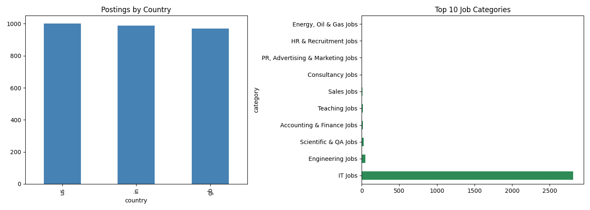
Figure 1. Left: posting counts by country, showing a roughly even three-way split. Right: postings by job category, showing an overwhelming concentration in "IT Jobs."
A notable finding here: the dataset is almost entirely composed of IT-category postings (roughly 2,800 of 2,959). This is expected, since the Task 1 collection used tech-focused search keywords (e.g. "Python Developer", "DevOps Engineer"), but it's an important scope limitation — the findings in this report describe the tech job market specifically, not the broader job market in these countries.

4. Salary Distribution by Country
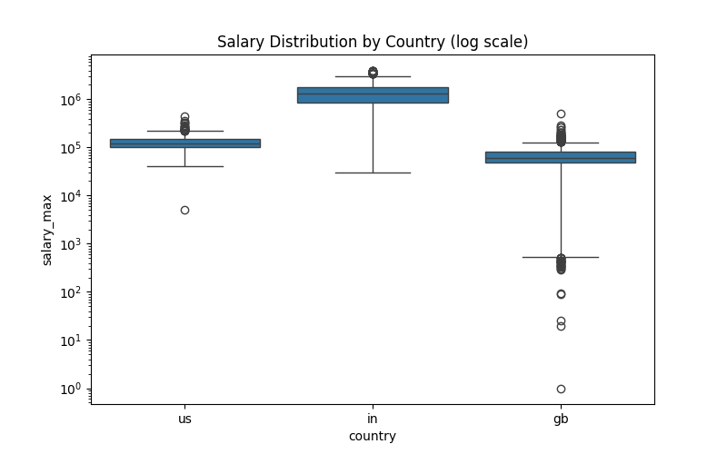
Figure 2. Salary distribution (log scale) by country, plotted separately due to differing local currencies.
Plotting salaries on a log scale and separated by country makes the currency issue visible directly: India's typical posted salary sits far higher in raw numerical terms (median roughly ₹1.3 million) than the US (~$123,000) or the UK (~£61,000), which reflects the INR/USD/GBP exchange gap rather than India actually paying more. Each country also shows a number of low-value outliers near the bottom of its range, which likely represent malformed or placeholder salary entries in the source data (e.g. a small number of postings list salary_max as low as 1) rather than genuine offers, and are worth flagging as noise for any future modeling on this field.

5. Skill Count per Posting
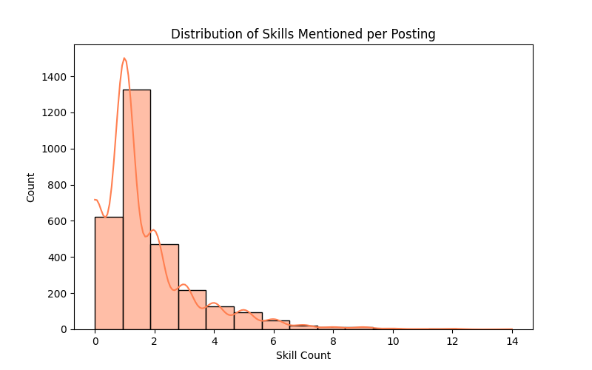
Figure 3. Distribution of the number of whitelisted skills detected per posting.
Most postings mention relatively few of the whitelisted technical skills — the distribution is right-skewed, peaking at 1 skill per posting, with a long tail extending out to 14. The average posting mentions 1.6 skills. This is consistent with how job postings are often written: a short list of core requirements rather than an exhaustive skill inventory, and it means skill_count itself is a fairly coarse signal — most of its predictive value likely comes from distinguishing postings with 0–1 skills from those with several, rather than fine differences further out in the tail.

6. Correlation Analysis: Skills and Salary
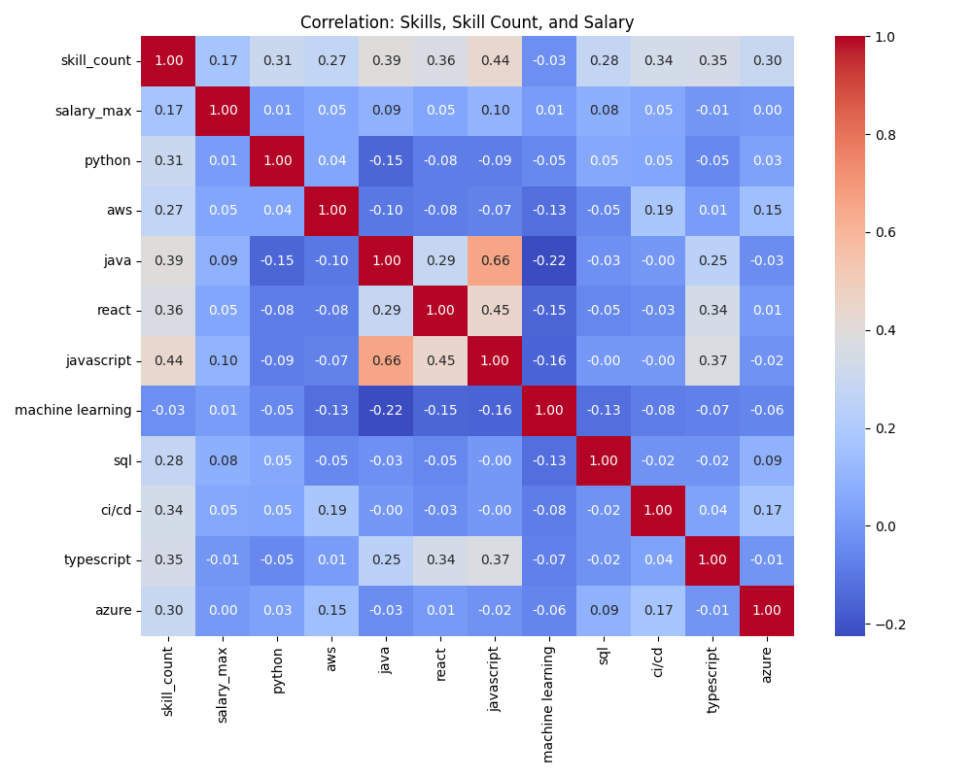
Figure 4. Correlation matrix between skill_count, salary_max, and the ten most frequent individual skills.
The strongest relationship with salary in this matrix is skill_count itself (r = 0.17) — postings that list more required skills tend to pay somewhat more, though the relationship is modest, not strong. Among individual skills, none show a strong standalone correlation with salary; the highest is JavaScript (r = 0.10), and the lowest is TypeScript (r ≈ -0.01, effectively no relationship).
The matrix also reveals expected co-occurrence patterns unrelated to salary directly: Java and JavaScript are correlated at r = 0.66, and React with JavaScript at r = 0.45 — reflecting that postings requiring one often require the other, which is a useful sanity check that the skill extraction from Task 1 is capturing real, coherent patterns rather than noise.

7. Key Insights
- The dataset skews heavily toward IT-category roles, so conclusions here apply to the tech job market specifically, not employment broadly.
- Raw salary figures cannot be compared across countries without normalization — the dataset mixes USD, GBP, and INR without conversion.
- Breadth of required skills (skill_count) is a more consistent signal for salary than any single specific skill — this is consistent with the modest classification accuracy (59–61%) found in the Task 2 modeling work.
- JavaScript shows the strongest individual-skill correlation with salary among the top 10 skills, though the effect is weak in absolute terms.
- Skill co-occurrence patterns (e.g. Java/JavaScript, React/JavaScript) are strong and expected, confirming the extraction pipeline is reliable.

8. Limitations
- 16.2% of postings have no salary data and were excluded from salary-related analysis, which may bias findings if missingness isn't random.
- The IT-heavy category skew means these findings should not be generalized to non-tech roles.
- Correlations reported here are linear and pairwise; they don't capture more complex interactions between skills, seniority, or company size, none of which are present in this dataset.
- A small number of extreme salary outliers (e.g. salary_max = 1) suggest some noise in the source data that a future pass could filter out.

9. Conclusion
This exploratory analysis confirms that the SkillScope dataset is usable but has real quirks worth accounting for: a strong IT-category skew from the original search terms, missing salary data in about one in six postings, and a currency-mixing issue that must be corrected before any cross-country salary comparison. Substantively, the clearest pattern is that breadth of required skills relates to salary more consistently than any single skill in isolation — a finding that lines up with and helps explain the moderate (59-65%) predictive performance seen in the Task 2 classification models.

