THE ASSOCIATION OF SCIENCE TEACHERS
Master Content & Website / Android App Blueprint
Institutional Profile • Activities • Conference Legacy • Publications • Gallery • Membership

Current name: The Association of Science Teachers
This master document consolidates the material shared so far and is intended to serve as the content foundation for the organisation's website and Android application.

1. About the Association
The Association of Science Teachers is an organisation dedicated to strengthening science education, promoting scientific temper, encouraging innovation, supporting teachers and connecting science education with the needs of society. Through conferences, teacher-development programmes, science celebrations, student activities, publications, awareness programmes and educational outreach, the Association provides a platform for teachers, students, scientists, educationists and other stakeholders to exchange ideas and contribute towards a scientifically informed and sustainable society.

Vision
To foster a scientifically aware, innovative and responsible society by empowering science teachers, inspiring learners and promoting meaningful engagement with science and technology.

Mission
- Strengthen the professional capacity of science teachers.
- Promote scientific temper, curiosity, critical thinking and evidence-based understanding.
- Encourage innovative, activity-based and technology-enabled science education.
- Provide platforms for interaction among teachers, scientists, educationists and students.
- Promote science communication and public understanding of science.
- Encourage environmental responsibility and sustainable development.
- Support student participation in science competitions, exhibitions, projects and related activities.
- Preserve and continue the Association's long tradition of conferences, publications and educational initiatives.

Objectives
- Advance the quality and reach of science education.
- Encourage professional exchange and collaboration among science teachers.
- Promote contemporary scientific knowledge and emerging technologies.
- Develop scientific attitude, creativity, problem-solving and research orientation among students.
- Create awareness of environmental and sustainability challenges.
- Encourage ethical and socially responsible use of science and technology.
- Recognise and celebrate contributions to science education.
- Build a national network for sharing educational experiences and resources.

2. Activities & Initiatives

National & Annual Science Teachers' Conferences
The Association's conference tradition brings together science teachers, scientists, educationists, administrators and invited guests. Conferences provide opportunities for professional exchange, expert lectures, discussions on science education, recognition of contributions and dialogue on contemporary scientific and social issues.

Science Education & Teacher Development
Programmes may include innovative pedagogy, experiential learning, STEM education, digital learning, classroom innovation, assessment practices, science communication and professional development.

Science Day & Science Awareness
Science Day celebrations and related programmes encourage students and communities to understand the relevance of science in everyday life through lectures, competitions, demonstrations, exhibitions and interactions.

Student Science Activities
The Association encourages curiosity and hands-on learning through science competitions, model making, projects, exhibitions, quizzes, experiments and innovation-oriented activities.

Science, Technology & Sustainable Development
Activities and publications address renewable energy, water management, sustainable agriculture, circular economy, climate change, pollution control, biodiversity and responsible use of technology.

Science Communication & Public Awareness
The Association promotes accessible, evidence-based communication of scientific ideas through lectures, articles, discussions, awareness programmes and interaction between experts, teachers and communities.

Environmental Awareness & Conservation
The Association encourages awareness and action concerning air pollution, water conservation, forests, biodiversity, climate change, waste management and sustainable development.

Science Teachers' Forums & Knowledge Exchange
Forums provide teachers with opportunities to exchange classroom experiences, discuss challenges, share teaching resources and explore emerging developments in science education.

Publications & Knowledge Resources
The Association's publication activity provides a platform for science education articles, editorials, contemporary scientific themes, environmental discussions, conference reports and educational resources.

Recognition & Felicitation
The Association brings together educators, scientists and distinguished guests and recognises contributions to science education through felicitation, awards, certificates and appreciation.

Conferences, Seminars & Expert Lectures
Expert interactions and seminars create opportunities for teachers and students to engage directly with experienced educators, scientists and subject specialists.

Educational & Community Outreach
Outreach programmes extend science education beyond formal classrooms through school visits, awareness programmes, community interactions and educational campaigns.

Youth & Future Scientists
The Association encourages students to develop scientific curiosity, creativity, problem-solving, innovation, research orientation and responsible use of technology.

Science for Society
A unifying theme for the Association's activities is the constructive role of science in addressing societal challenges in education, environment, health awareness, agriculture, water, energy, technology, climate change and sustainable development.

3. Conference History
The following chronology has been transcribed from the historical conference record shared for this project. It documents the Association's conference tradition from the First Conference in 1956 through the Fifty-third Conference in 2025. Spelling and place names are retained as closely as possible to the supplied record. This should be treated as the current archival dataset for the website until the Association provides any later or corrected records.
Conference | Year | Place
First | 1956 | Gwalior
Second | 1957 | Madras
Third | 1958 | Delhi
Fourth | 1959 | Jabalpur
Fifth | 1960 | Kanpur
Sixth | 1961 | Udaipur
Seventh | 1962 | Hyderabad
Eighth | 1963 | Ahmedabad
Ninth | 1964 | Nagpur
Tenth | 1965 | Patna
Eleventh | 1966 | Poona
Twelfth | 1967 | Guwahati
Thirteenth | 1968 | Ambala Cantt.
Fourteenth | 1969 | Bangalore
Fifteenth | 1970 | New Delhi
Sixteenth | 1972 | Bhubaneswar
Seventeenth | 1973 | Madras
Eighteenth | 1974 | Amritsar
Nineteenth | 1975 | Calcutta
Twentieth | 1976 | Agra
Twenty-first | 1977 | Srinagar
Twenty-second | 1978 | Trivandrum
Twenty-third | 1979 | Patna
Twenty-fourth | 1980 | Jabalpur
Twenty-fifth | 1981 | New Delhi
Twenty-sixth | 1982 | Hyderabad
Twenty-seventh | 1983 | Baroda
Twenty-eighth | 1985 | Jaipur
Twenty-ninth | 1986 | Madras
Thirtieth | 1987 | Bharwari, U.P.
Thirty-first | 1988 | New Delhi
Thirty-second | 1989 | Mysore
Thirty-third | 1991 | Jaipur
Thirty-fourth | 1993 | Dehara Dun
Thirty-fifth | 1998 | Ajmer
Thirty-sixth | 1999 | Calcutta
Thirty-seventh | 2000 | Patiala
Thirty-eighth | 2002 | Nagpur
Thirty-ninth | 2004 | Patna
Fortieth | 2005 | Kolkata
Forty-first | 2006 | Nagpur
Forty-second | 2008 | Bhandara, Maharashtra
Forty-third | 2009 | Kunigal, Tumkur, Karnataka
Forty-fourth | 2010 | Trivandrum, Kerala
Forty-fifth | 2014 | Nagpur, Maharashtra
Forty-sixth | 2015 | Patna, Bihar
Forty-seventh | 2016 | New Delhi
Forty-eighth | 2017 | Ranchi, Jharkhand
Forty-ninth | 2018 | B.H.U., Varanasi, U.P.
Fiftieth | 2019 | Bhuwaneshwar, Odisha
Fifty-first | Jan. 2024 | Simultala, Jamui, Bihar
Fifty-second | 2024 | Kushinagar, U.P.
Fifty-third | 2025 | Chakrapani Residential School, Rajgir, Nalanda, Bihar

Archival note: the supplied list contains gaps between some conference years; these gaps have not been filled with assumptions. The website should preserve the historical record as supplied and allow future corrections or additions through an administrator.

4. Publications & Knowledge Resources
The Association's publication material demonstrates a continuing interest in science education, scientific temperament, sustainability, teacher development and contemporary scientific issues.

Vigyan Shikshak
A core publication/resource for sharing science education perspectives, activities, editorials, articles and reports.

Science Education
Articles and discussions on the role of teachers, innovative pedagogy, student skills, scientific temperament and technology-enabled learning.

Science & Sustainable Future
Material covering renewable energy, water conservation, sustainable agriculture, circular economy, climate mitigation and adaptation.

Activities & Reports
Reports documenting Science Day celebrations, conferences, forums, lectures, school programmes and educational initiatives.

5. Photo Gallery & Activity Documentation
The photographs supplied for this project document conference-stage activities, felicitation ceremonies, expert interactions, group photographs and participation by teachers and guests. The website should organise these images by event rather than presenting them as an undifferentiated gallery.
- National Conferences
- Science Day Celebrations
- Teacher Development
- Expert Lectures
- Awards & Felicitations
- Student Activities
- Environmental Initiatives
- Community Outreach
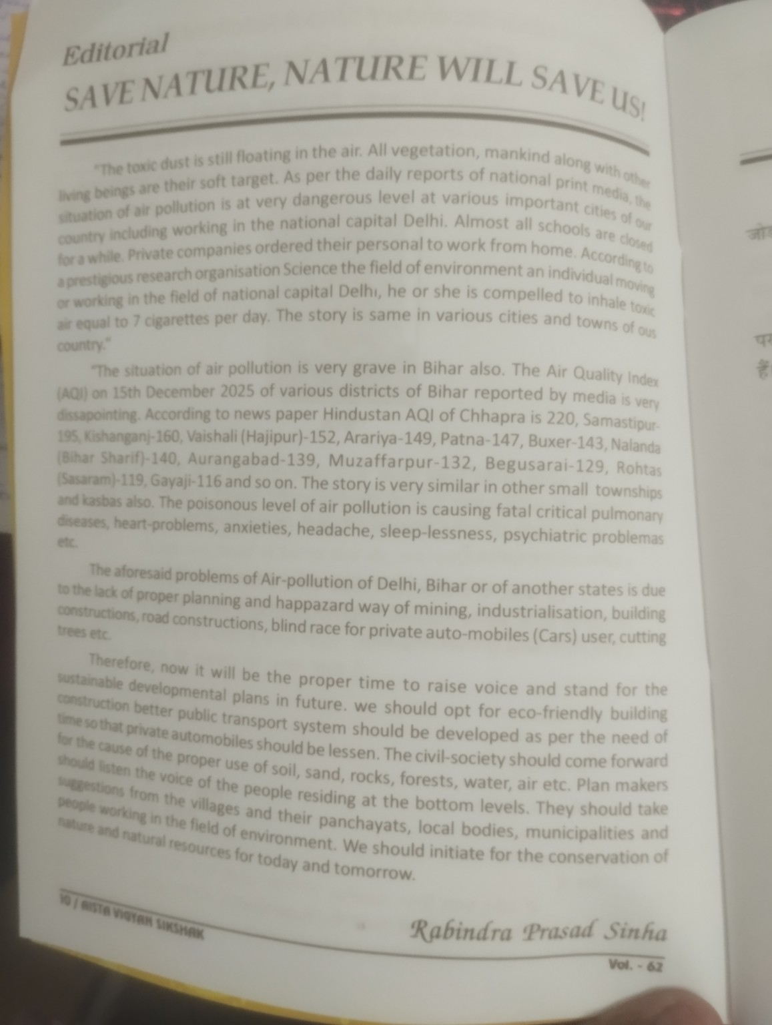
Conference felicitation / presentation
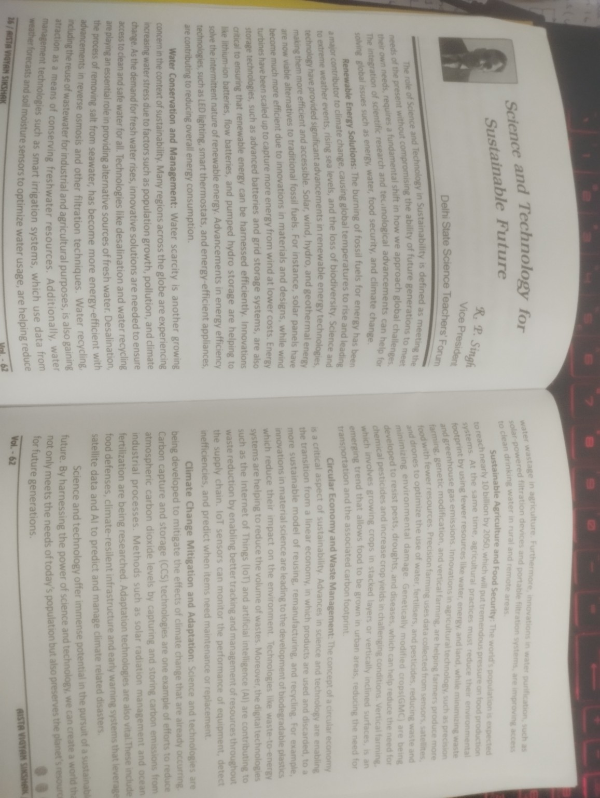
Conference audience and participating teachers
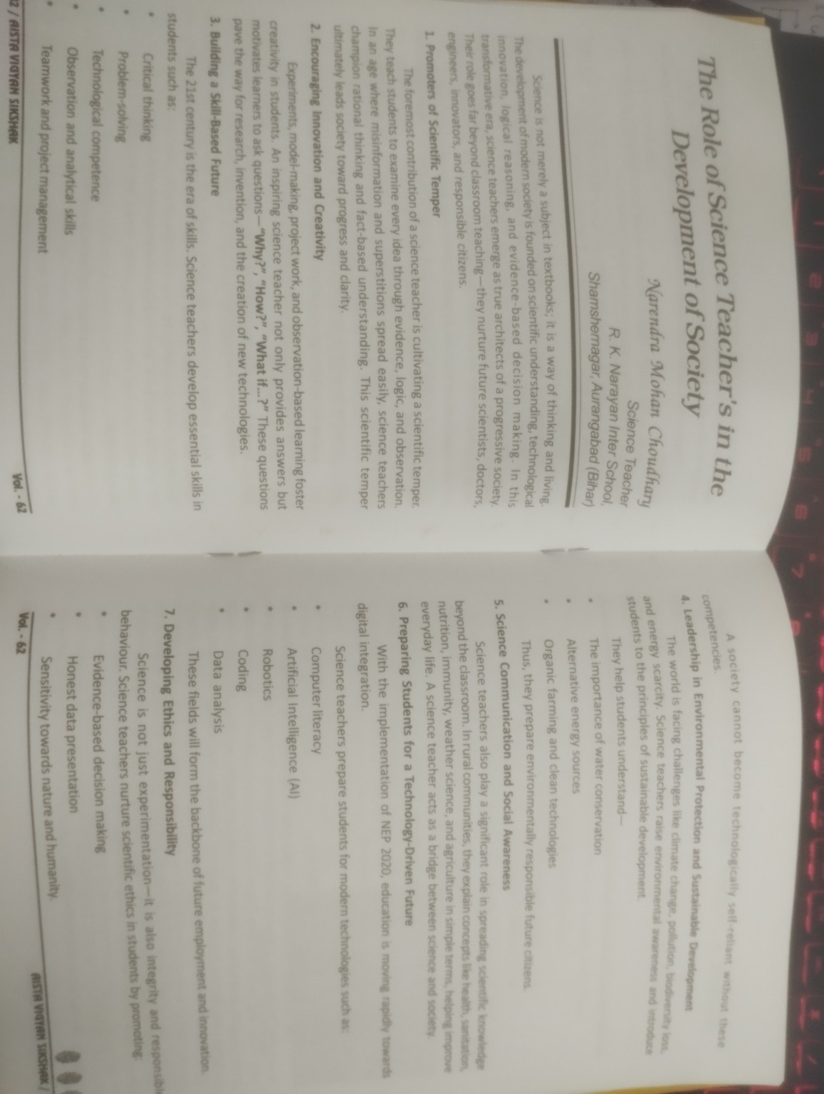
Group photograph of invited guests and participants
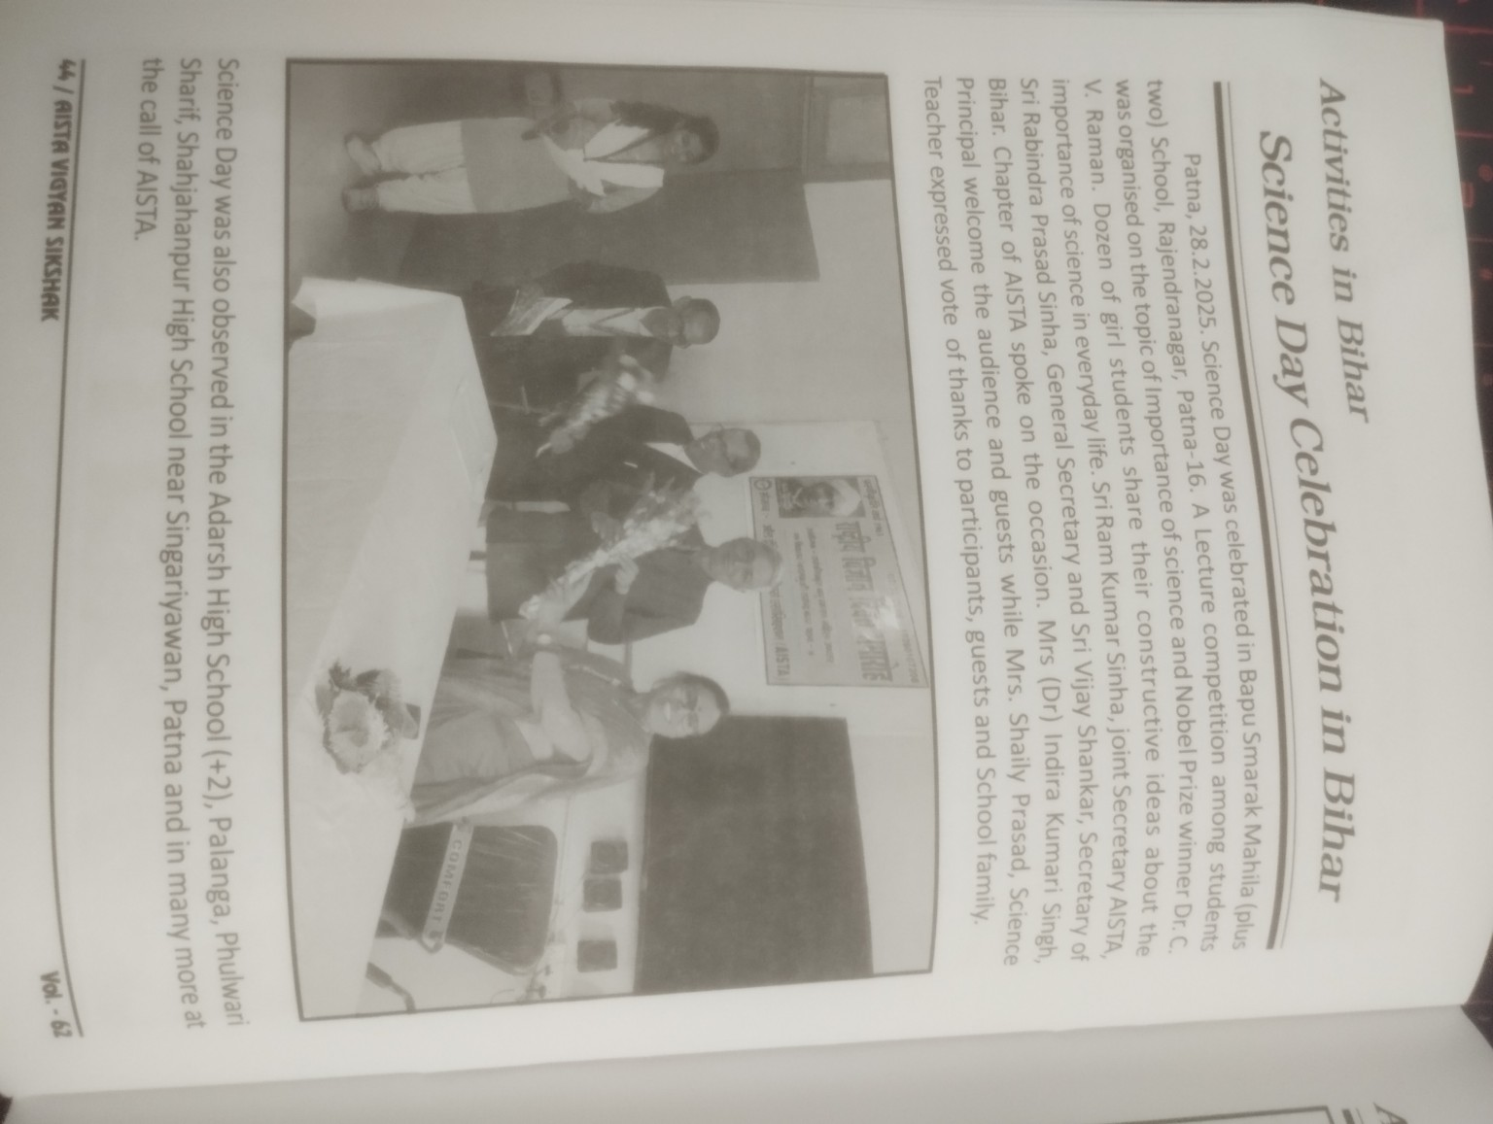
Expert interaction / address during conference
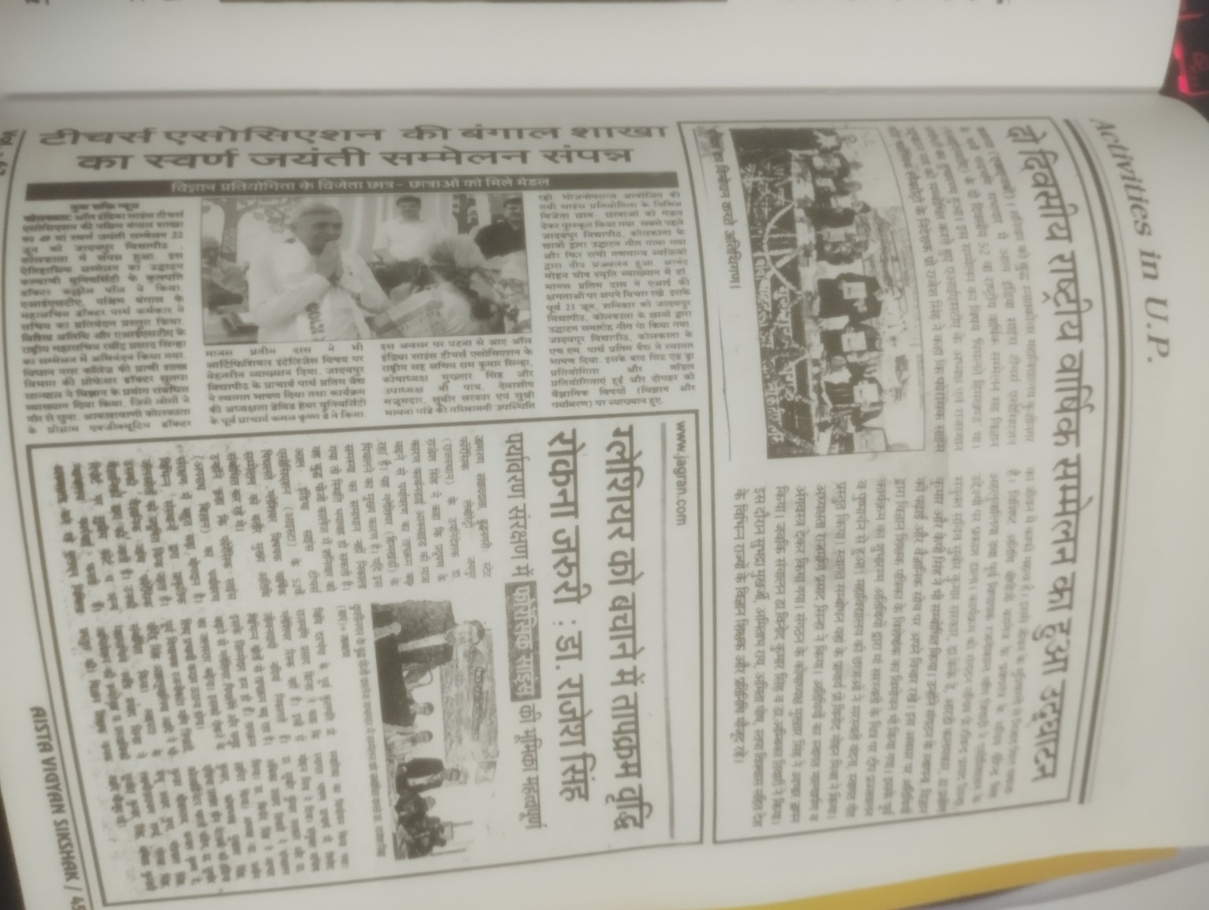
Science Day / educational activity documentation
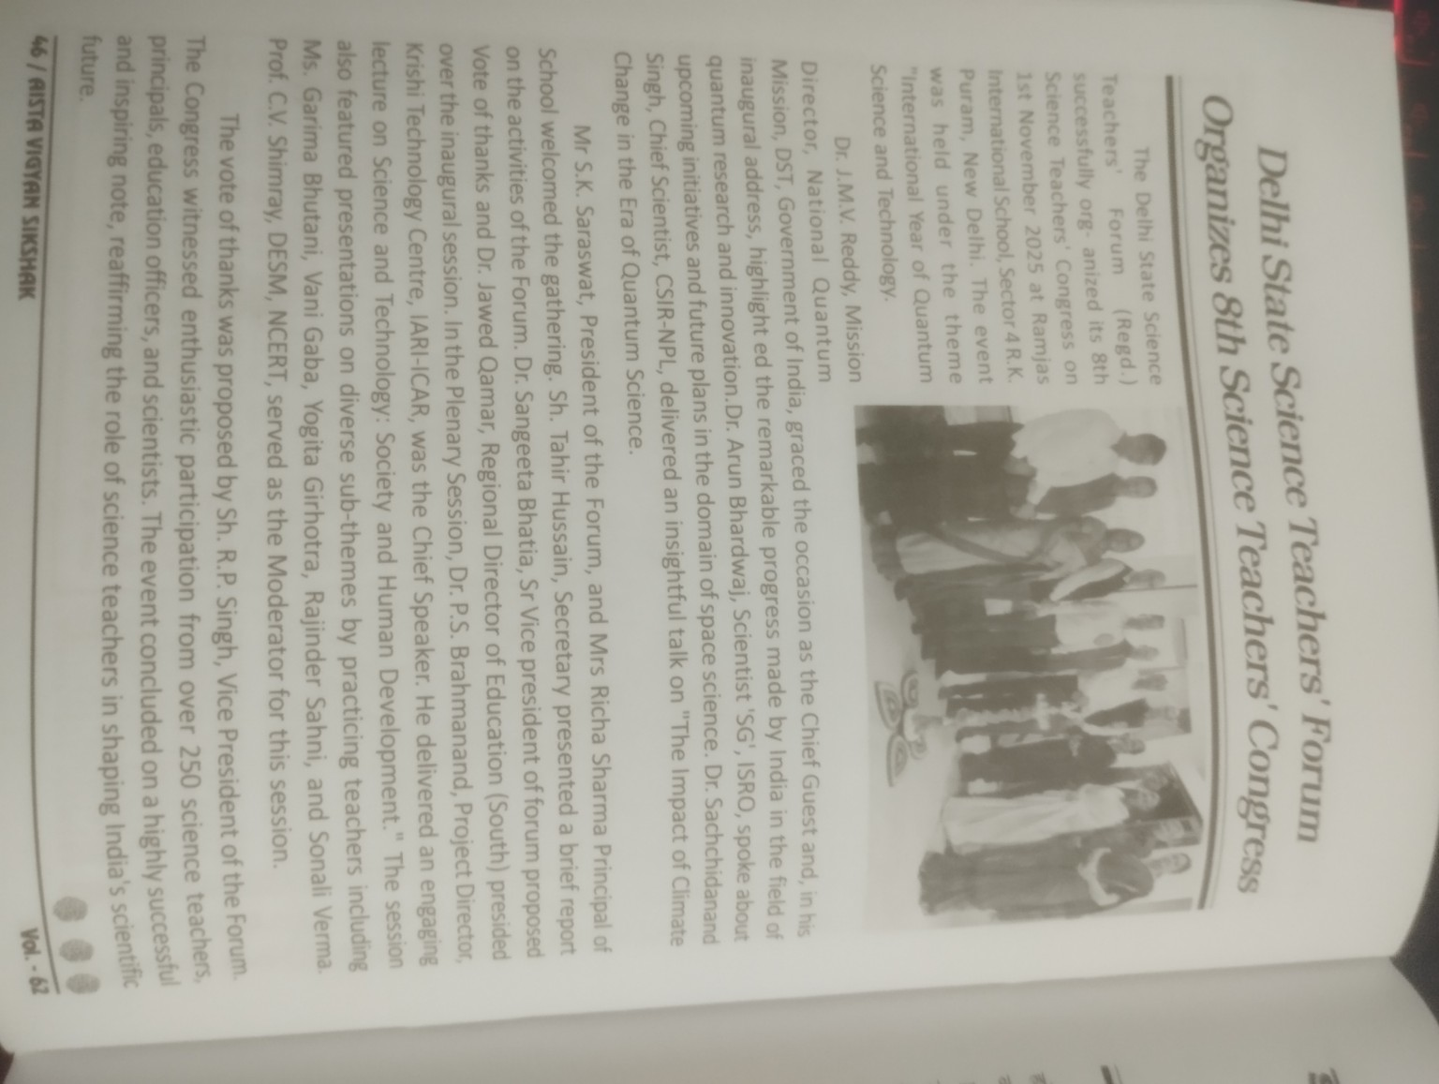
Science Teachers' Forum / institutional activity documentation

6. News & Events
Recommended categories for the website/app:
- Upcoming conferences and programmes
- Recent conference reports
- Science Day activities
- Teacher training and workshops
- Student competitions and exhibitions
- Awards and recognitions
- Publication releases
- Important notices and circulars

7. Membership
The Membership section should provide clear information on eligibility, membership categories, application, renewal, benefits and contact details. Actual fee amounts, categories and eligibility rules should be entered only after the Association confirms the current official rules.
- Membership information
- Membership categories
- New member registration
- Renewal
- Member profile / membership number
- Membership certificate (if applicable)
- Member directory (subject to privacy/consent rules)

8. Website / Android App Information Architecture
Section | Primary content
Home | Association introduction, latest news, upcoming events, featured activities, conference highlights and membership call-to-action.
About Us | About, history, vision, mission, objectives, leadership and organisation structure.
Activities | Conferences, teacher development, Science Day, student activities, science communication, environment, outreach and recognition.
Conferences | Conference history, individual conference pages, reports, photographs and proceedings.
Publications | Vigyan Shikshak, articles, editorials, reports and knowledge resources.
News & Events | Latest news, upcoming events, past events and announcements.
Gallery | Photos and videos organised by event/activity.
Membership | Membership information, registration, renewal and member services.
Notice Board | Official notices, circulars, conference announcements and important communications.
Contact | Office details, branches/chapters, contact form, email and other official channels.

9. Proposed Home Page Copy
Welcome to The Association of Science Teachers — a platform dedicated to science education, scientific temperament, teacher development, student engagement and the responsible use of science and technology for society.

Our Focus
- Science Education
- Teacher Development
- Student Innovation
- Scientific Temperament
- Science Communication
- Environment & Sustainability

10. Brand & Identity Direction
The current organisational identity should use the name 'The Association of Science Teachers' consistently. The latest supplied logo is the red circular emblem featuring the words 'THE ASSOCIATION OF SCIENCE TEACHERS', an outline map of India and an atom symbol. The final production website/app should use the original high-resolution logo asset supplied by the Association.
Where historical material refers to the earlier name/acronym, the historical reference can be retained in archival documents, while current navigation, headers and official communication should use the current name.

11. Content Governance & Data Entry
- Historical records should be entered from official Association archives and approved before publication.
- Conference place names and years should be preserved exactly where archival accuracy is important.
- Current office addresses, phone numbers, emails, membership fees and leadership details should be confirmed by the Association before launch.
- Photographs should carry event/year captions wherever known.
- Personal information of members and participants should not be publicly displayed without appropriate consent.
- The admin panel should allow authorised users to add/edit conferences, events, publications, notices, photos and membership information.

12. Recommended Build Sequence
1. Finalise official name, logo and visual identity.
2. Confirm About Us, Vision, Mission and Objectives.
3. Digitise and verify the complete conference archive.
4. Create the Activities and Publications content repository.
5. Create the News, Notice Board and Events modules.
6. Create Gallery categories and upload approved photographs.
7. Create Membership workflow.
8. Build the public website.
9. Build the Android application with the same content/API.
10. Add an administrator dashboard for content management.
11. Test, obtain Association approval and publish.

Prepared as a working master content document for The Association of Science Teachers

