**Sagarmatha College of Science and Technology**

**Sanepa, Lalitpur**

(Affiliated to Tribhuvan University)



**PROJECT REPORT ON**

**“IT eService”**

**SUBJECT CODE: CSC370**

**Program: BscCSIT**

**Faculty: Science and Technology**

**Semester: Sixth**

**Submitted by: Submitted to:**

**Bijay Shrestha (15749/074) Ganesh Khatri**

**Date of Submission: 2078/01/16**

# ACKNOWLEDGEMENT

I might want to communicate my most profound appreciation to every one of the individuals who gave us the likelihood to finish this report. An uncommon appreciation I provide for my Sixth Semester course teacher, Mr. Ganesh Khatri, whose commitment in animating ideas and consolation, assisted me with organizing my undertaking particularly recorded as a hard copy this report. Besides, I might likewise want to recognize with much appreciation the essential job of the staff of Sagarmatha College of Science and Technology, who gave the authorization to utilize all necessary gear and the vital materials to finish the job. I am appreciative and lucky enough to get consistent help from our seniors and each showing staff of BscCSIT department, which assisted me with effectively finishing my undertaking. I might likewise want to stretch out my respects to all the non-showing staff of BscCSIT department for their convenient help. I like the direction given by other boss just as the boards particularly in my venture record that has worked on my norm of report. My thanks and appreciations go to every one of our associates for their consolation and backing in fostering the venture.

With respect,

Bijay Shrestha (15749/074)

# ABSTRACT

Ecommerce plays incredible significance in the innovative business climate. IT eService has opened the entryway of chance and benefit to the organizations. This report broke down the various issues of online stages. The exploration expects to give a hypothetical commitment in understanding the status of online internet business. The Study Discuss the buyers' mobile-based managing practices. The report likewise distinguishes the issues looked by customers when they need to acknowledge through mobile. The current paper is an expressive examination dependent on the definite survey of prior relevant investigations identified with the different ideas of internet shopping to find the idea of mobile based shopping. Isolation and danger arise routinely as a justification being mindful about internet providers. Online Services comfort, data chasing, social contact, and variety influences the shopper mentality towards online arrangements.

Contents

ACKNOWLEDGEMENT i

ABSTRACT ii

CHAPTER 1 1

INTRODUCTION 1

**1.1. Introduction** 1

**1.2. Problem Statement** 1

**1.3. Objectives** 1

**1.4. Limitations** 2

**1.5. Brief History of E-Commerce** 2

**1.6. Status of Ecommerce in Nepal** 3

CHAPTER 2 4

REQUIREMENT ANALYSIS AND FEASIBILITY ANALYSIS 4

**2.1. Requirement Specification** 4

2.1.1 Functional Requirements 4

2.1.2 Non-Functional Requirements 6

**2.2 Feasibility Analysis** 7

2.2.1 Economical Feasibility 7

2.2.2 Operational Feasibility 7

2.2.3 Technical Feasibility 7

2.2.4 Schedule Feasibility 8

CHAPTER 3 9

DESIGN 9

**3.1. Process Modelling** 9

**3.2. Input Specification** 10

**3.3. Cart Specification** 15

**3.3. Home Page** 16

**3.4. Firebase:** 20

CHAPTER 4 22

IMPLEMENTATION 22

**4.1. Implementation** 22

4.1.1. Flutter 22

4.1.2. Dart 22

4.1.3. Firebase 22

**4.2. Software Used** 22

CHAPTER 5 23

CONCLUSION AND RECOMMENDATION 23

**5.1. Conclusion** 23

**5.2 Recommendation** 23

Reference 24

# List of Figures

Figure 1Use case diagram for User 5

Figure 2Use case diagram for admin 5

Figure 3 Level-0 DFD 9

Figure 4Level-1 DFD 9

Figure 5 Customer login 10

Figure 6 Customer sign up 11

Figure 7 Admin login 12

Figure 8 Admin dashboard 13

Figure 9 Admin dashboard Orders 14

Figure 10 Cart 15

Figure 11 Home page/ Product Catalog 16

Figure 12 Menu/Drawer 17

Figure 13 Orders 18

Figure 14 Chat with owner/admin 19

# List of Table

Table 1 Gantt chart 8

# CHAPTER 1

# INTRODUCTION

## **1.1. Introduction**

IT eService will be an e-commerce Mobile application built by using modern technologies and frameworks. The core application is made with Flutter with firebase. This application gives a core overview of services, their prices. This application is service oriented for IT works. To give the customers not only the advantage of taking services anytime, but also the advantage of taking services anywhere, using a mobile device for E-commerce has become an alternative. Users have to register an account and verify its identity. It uses email verification as account verification. After verification, users can choose for services and add to the cart.

## **1.2. Problem Statement**

E-commerce provides an easy way to sell products to a large customer base. However, there is a lot of competition among multiple e-commerce sites. The user seek for the best services that is offered to him/her. There are various IT company that provides the IT services but because they serve the customer physically, it is not applicable to get those services at anytime and anywhere. So due to this, the customer or user from various locations cannot reach the services offered by the IT companies. The user are mostly mobile user nowadays, such that they search the services through mobile.

## **1.3. Objectives**

It has become more than essential for B2B as well as other businesses to make the right use of e-commerce. Now, e-commerce is evolving or better say evolved into digital commerce that implies the entire business journey from buying to delivery with an online experience. Below are the few objectives of e-commerce:

* To develop business relations.
* To provide a unique customer experience.
* To increase the number of loyal customers.
* To Boosting the efficiency of services.
* To develop relevant targets.
* To make a responsive e-commerce system

## **1.4. Limitations**

The Limitations of this project can be listed out as follows:

* Internet connection is needed.
* Not so suitable for emergency cases

## **1.5. Brief History of E-Commerce**

The history of E-commerce is a history of how Information Technology has transformed business processes. Some authors will track back the history of E-commerce to the invention of the telephone at the end of last century. The Internet was conceived in 1969, when the Advanced Research Projects Agency (a Department of Defence organization) funded research of computer networking. The Internet could end up like EDI (Electronic Data Interchange) without the emergence of the World Wide Web in the 1990s. EDI (Electronic Data Interchange) is widely viewed as the beginning of E-commerce if we consider E-Commerce as the networking of business communities and digitalization of business information.

EDI, which expanded from financial transactions to other transaction processing and enlarged the participating companies from financial institutions to manufacturers, retailers, services, and so on. Many other applications followed, ranging from stock trading to travel reservation systems. Such systems were described as telecommunication applications and their strategic value was widely recognized. With the commercialization of the Internet in the early 1990s and its rapid growth to millions of potential customers, the term electronic commerce was coined, and EC applications expanded rapidly. One reason for the rapid expansion of the technology was the development of networks, protocols, software, and specifications. The other reason was the increase in competition and other business pressures. From 1995 to 1999, we have witnessed many innovative applications ranging from advertisement to auctions and virtual reality experiences. Almost every medium- and large-sized organization in the United States already has a Web site; many are very extensive; for example, in 1999 General Motors Corporation offered 18,000 pages of information that included 98,000 links to its products, services, and dealers.

## **1.6. Status of Ecommerce in Nepal**

The growth and expansion of information and communication technology to rural areas have created fertile grounds for e-commerce. According to Nepal Telecom Authority, mobile phone penetration has reached 130 percent, meaning there are more mobile connections than the population itself, and 62 percent of the population is connected to the internet. Social media platforms such as Facebook and Viber are now widely used for socialization. Despite the potential, Nepal is already lagging behind in localizing e-commerce as a business tool compared to many Asian countries, including our immediate neighbors. However, there are private-sector providers that have been pushing digital development. Ride-sharing applications such as Tootle and Pathao; payment platforms such as eSewa, IMEpay, and Khalti; or online shopping apps and websites such as Daraz and Muncha.com have already shown that e-commerce can become an alternative for transforming domestic business.

# CHAPTER 2

# REQUIREMENT ANALYSIS AND FEASIBILITY ANALYSIS

## **2.1. Requirement Specification**

### 2.1.1 Functional Requirements

* Register

The user of the application must be able to create an account. While creating his account, he must provide personal info: Name, address, email address, phone number. He will have to confirm his email address.

* Login

The mobile application must have login activity with a field for a username and a password.

The user will be able to login if he confirmed his email address. After logging in, the user will be able to:

-view latest services.

-add services to a cart.

-remove services from a cart.

-view the cart.

-confirm an order.

* User Authentication

The system shall authenticate the user and then display the panel based on the particular identified user.

* Keyword matches for efficient search

The system shall provide an efficient search feature based on keywords.

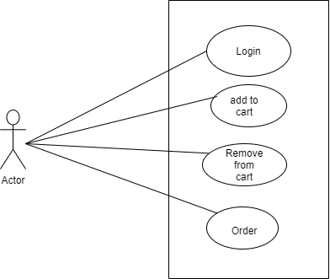

Figure Use case diagram for User

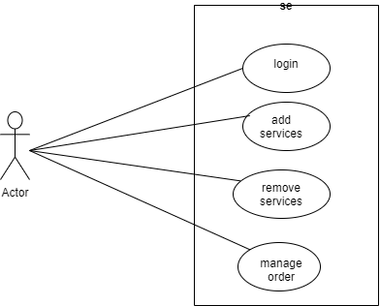

Figure Use case diagram for admin

### 2.1.2 Non-Functional Requirements

* Availability Requirements:

The system must be always available for use.

* Usability requirements:

The final mobile application will be entirely in English, because it is targeting the UK market. It will be user-friendly and very easy to use.

* Performance requirements:

The mobile application will be developed using flutter, which will, thanks to the good algorithms that will be used, guarantee a high execution speed and a minimized response time.

* Scalability requirements:

The expected number of users of the mobile application is very big. It is expected that the number of users grow on within the next few years. Therefore, the application must be highly scalable.

* Maintainability requirements:

The application should be maintainable in order to allow upgrades (through the Google Play Store) in the future.

* Extensibility requirements:

The mobile application should be extensible. It should allow updating it and adding new features in the future.

* Security requirements:

The application must be very secure because it deals with the private information of the users. This should be performed using the right encryption of data only accessed by the administrator. More than that, the system must follow these main security rules:

- Confidentiality: Only the admin has access to user personal info and orders.

- Integrity: Only the users can modify their personal info.

- Authenticity: No one can access, modify or delete other accounts’ information.

## **2.2 Feasibility Analysis**

A feasibility study is the study of the project at its initial stage and it shows if the proposed project can be practically implemented in real-time or not. It is judged based on finance, manpower, management, time, and whether it is worth the investment. All these factors are analyzed and studied to check if the system can be built efficiently with the available resources.

### 2.2.1 Economical Feasibility

Economic feasibility quantifies the project’s costs and revenue to determine whether it is possible to complete or not. Although no extra equipment was bought for our project, a good web hosting service is necessary for a working application. As the proposed project requires no extra equipment to be bought and the required needs are already present, so the system is economically feasible. Additionally, it would require marketing and advertising costs through the comparatively cost-effective internet.

### 2.2.2 Operational Feasibility

Operational feasibility quantifies whether the proposed project satisfies the requirement or can solve the defined problem that has been proposed during the analysis. This application is a website and users with any knowledge regarding the basic website can easily use it through any platform with ease. The GUI design is very simple to navigate through and is very user-friendly and hence this system is operationally feasible.

### 2.2.3 Technical Feasibility

The technical feasibility study focuses on gaining an understanding of the present technical resources, required technical expertise, their applicability to the expected needs of the proposed system, and the tools and software required for the overall implementation of the project. It requires a web server in which it can operate and it should be easily affordable. The tools and software required for this project are easily available on the internet since most of the software and tools are open source. However, the implementation of the algorithm and the calculations may seem complex.

### 2.2.4 Schedule Feasibility



Table Gantt chart

The above diagram represents the time taken for the completion of the project and the time consumed by each activity in the following weeks respectively. It shows that the requirement gathering and design took about 3 weeks. Similarly, coding took 5 weeks, testing took 4 weeks, and Implementation took 3 weeks. In addition, documentation is shown in the above Gantt chart. The documentation part has consumed more time as compared to others.

# CHAPTER 3

# DESIGN

## **3.1. Process Modelling**

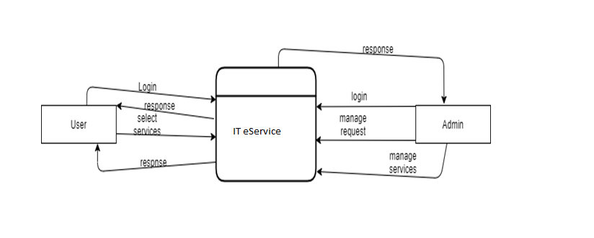

Figure Level-0 DFD

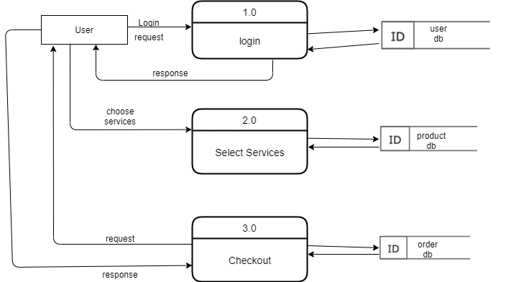

Figure Level-1 DFD

## **3.2. Input Specification**

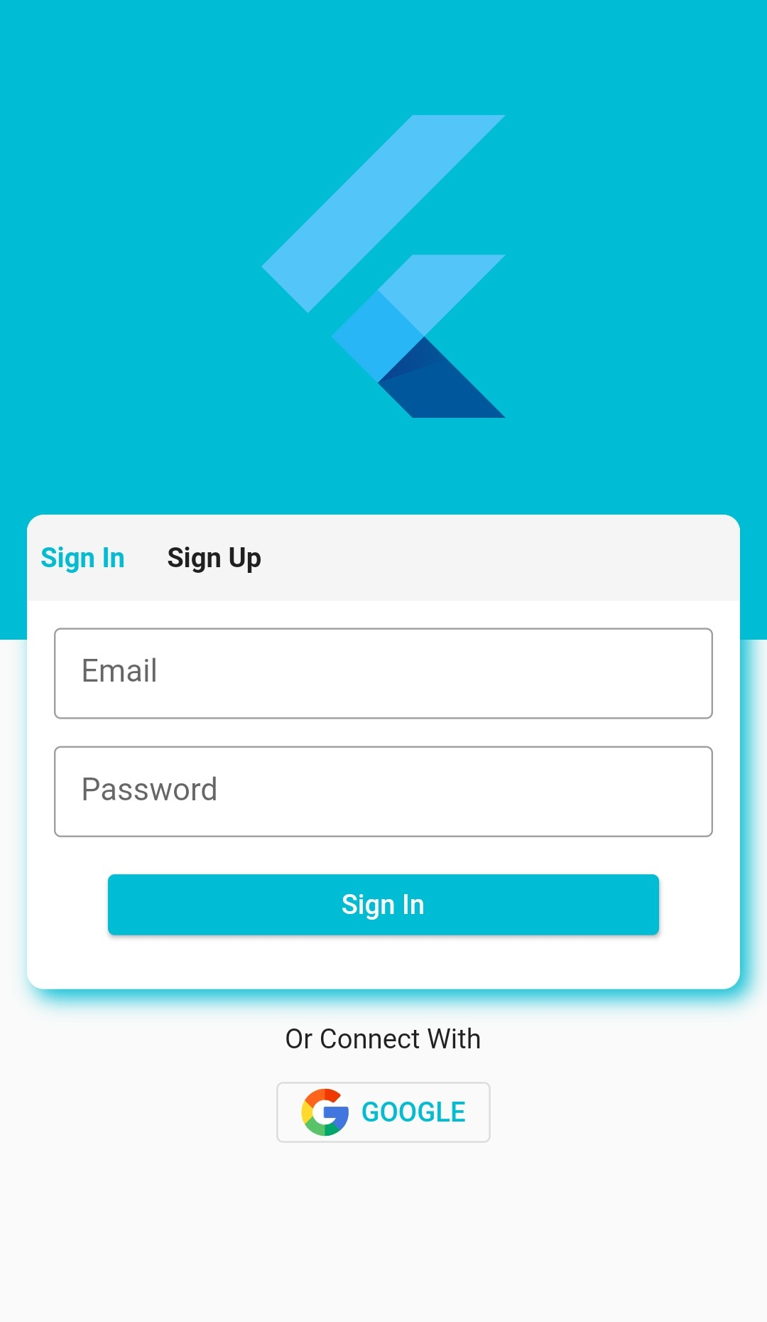

Figure Customer login

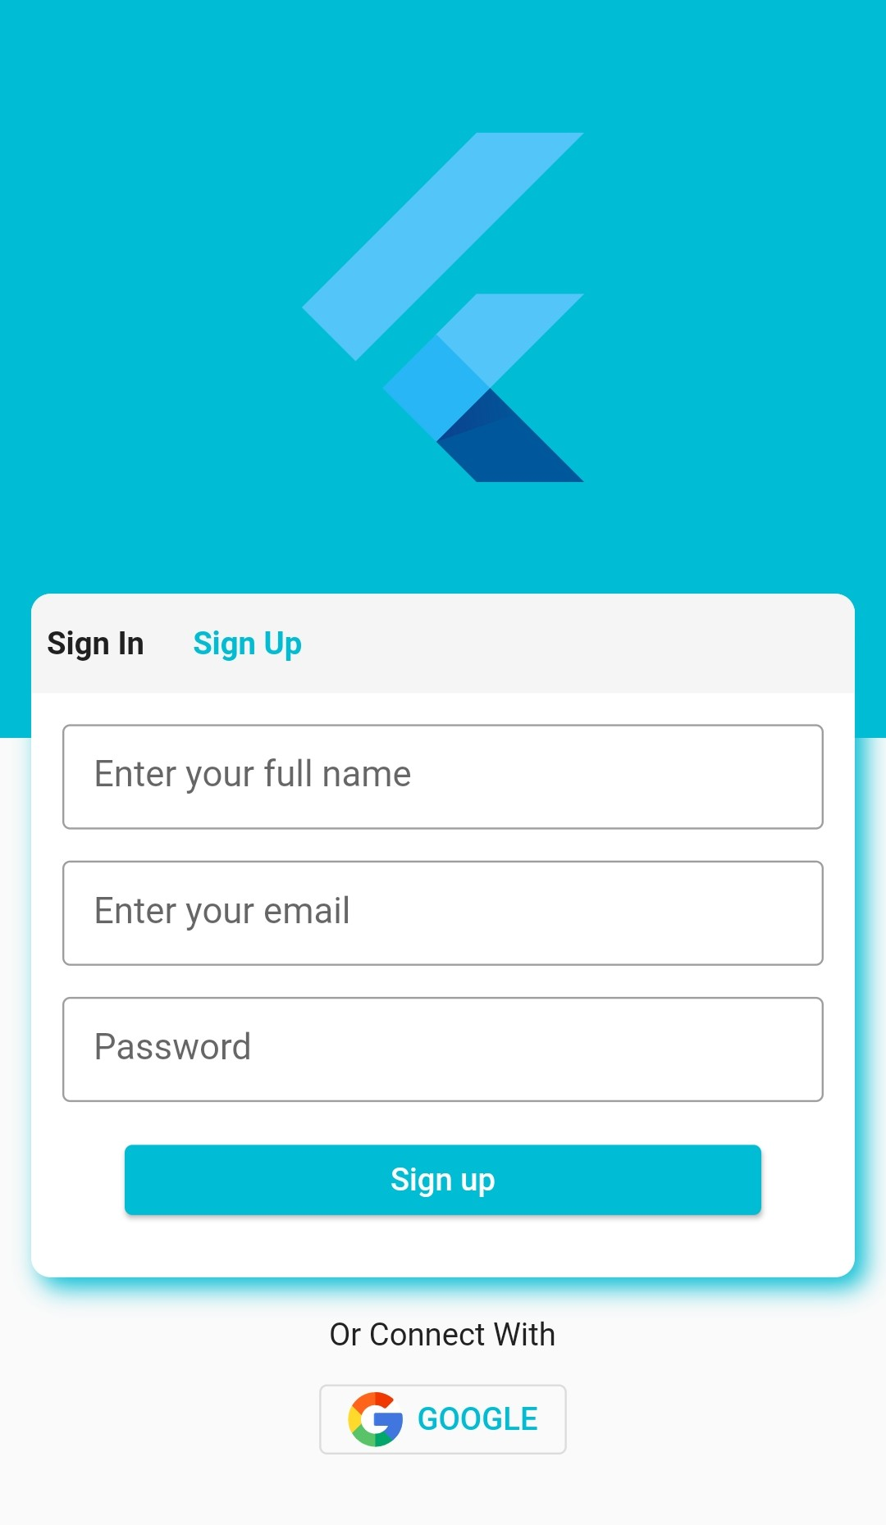

Figure Customer sign up

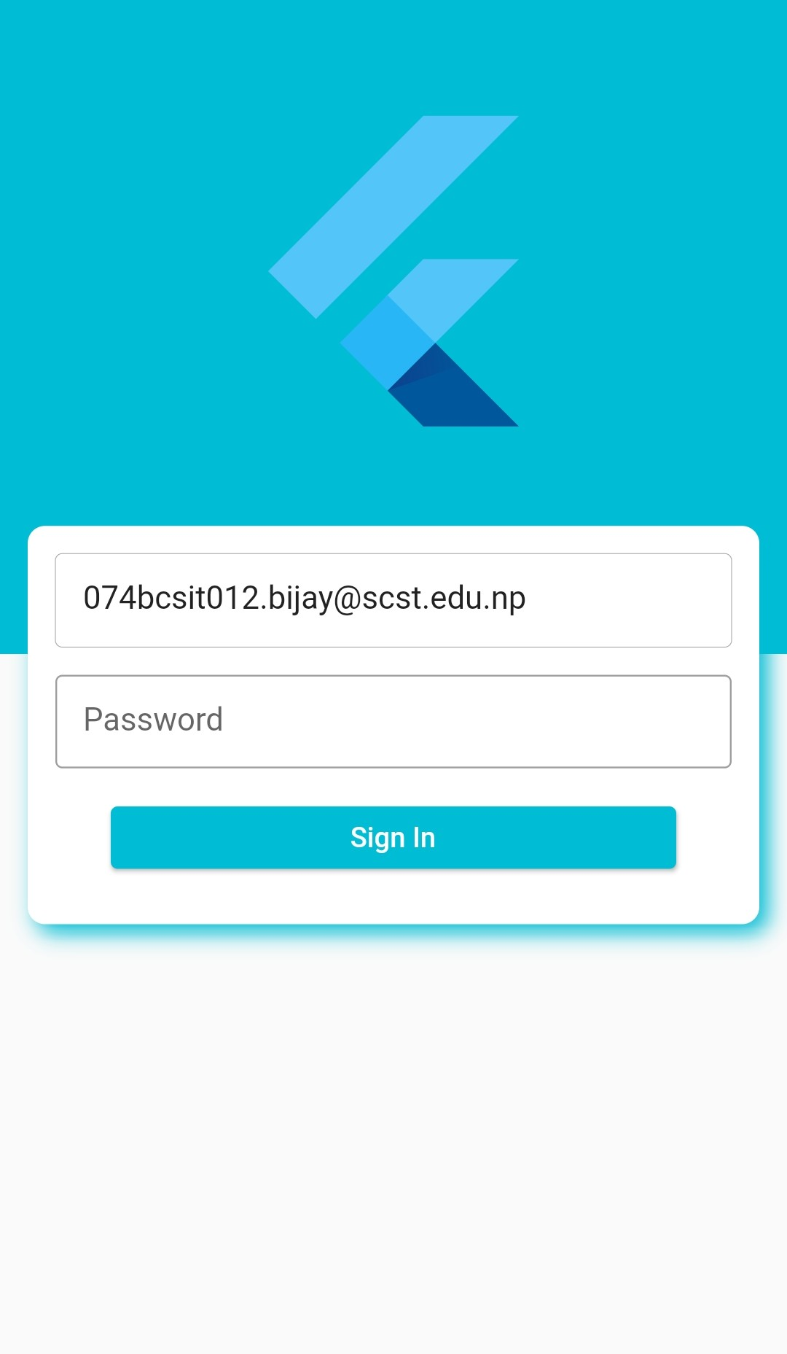

Figure Admin login

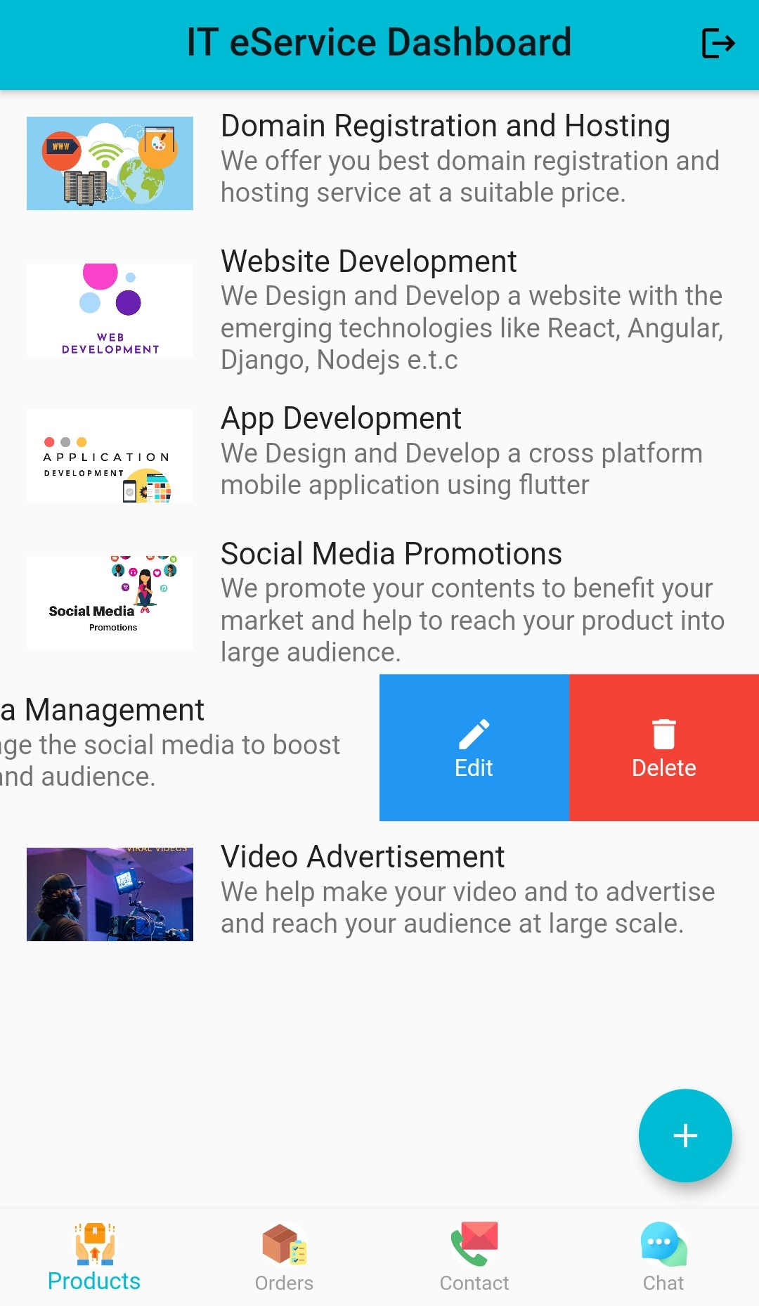

Figure Admin dashboard

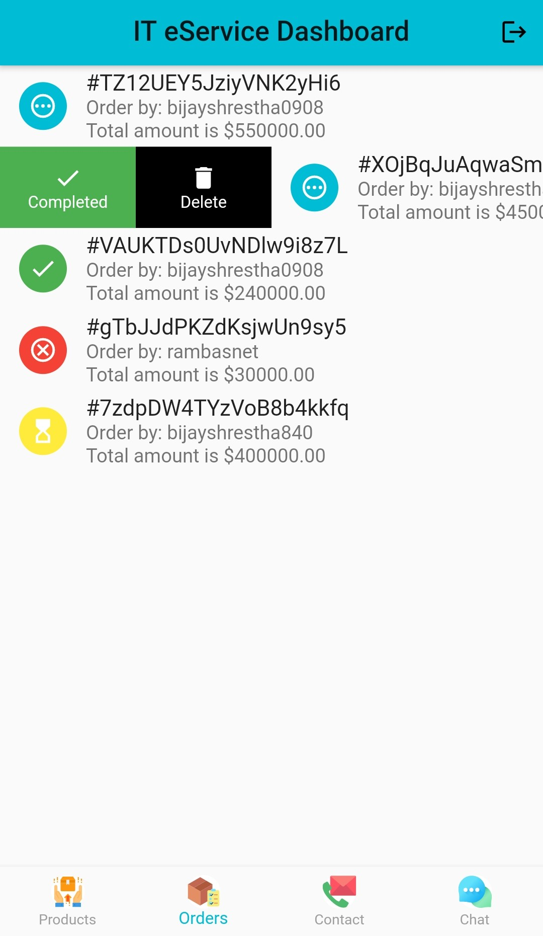

Figure Admin dashboard Orders

## **3.3. Cart Specification**

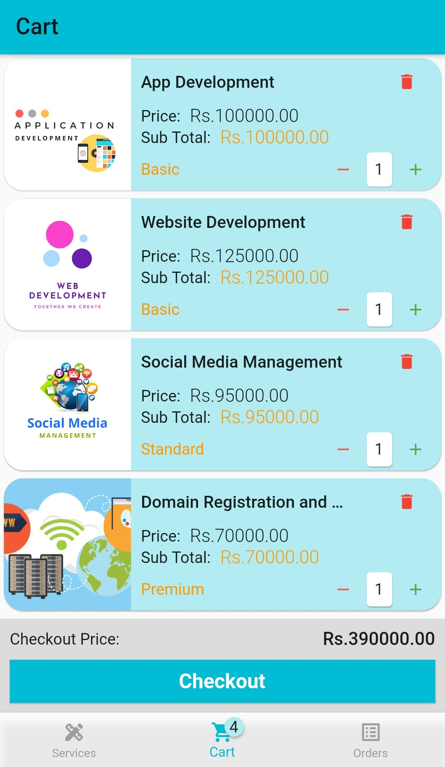

Figure Cart

## **3.3. Home Page**

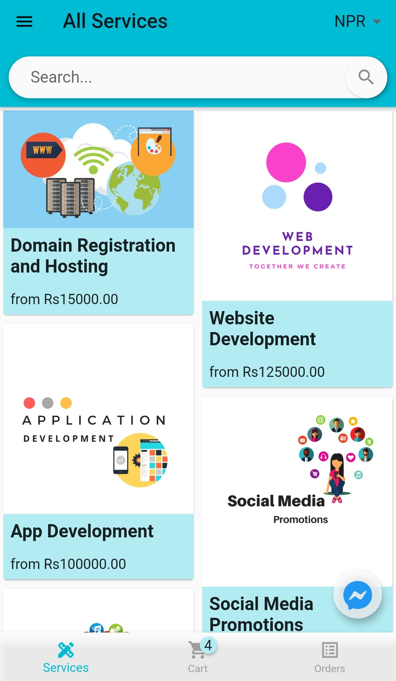

Figure Home page/ Product Catalog

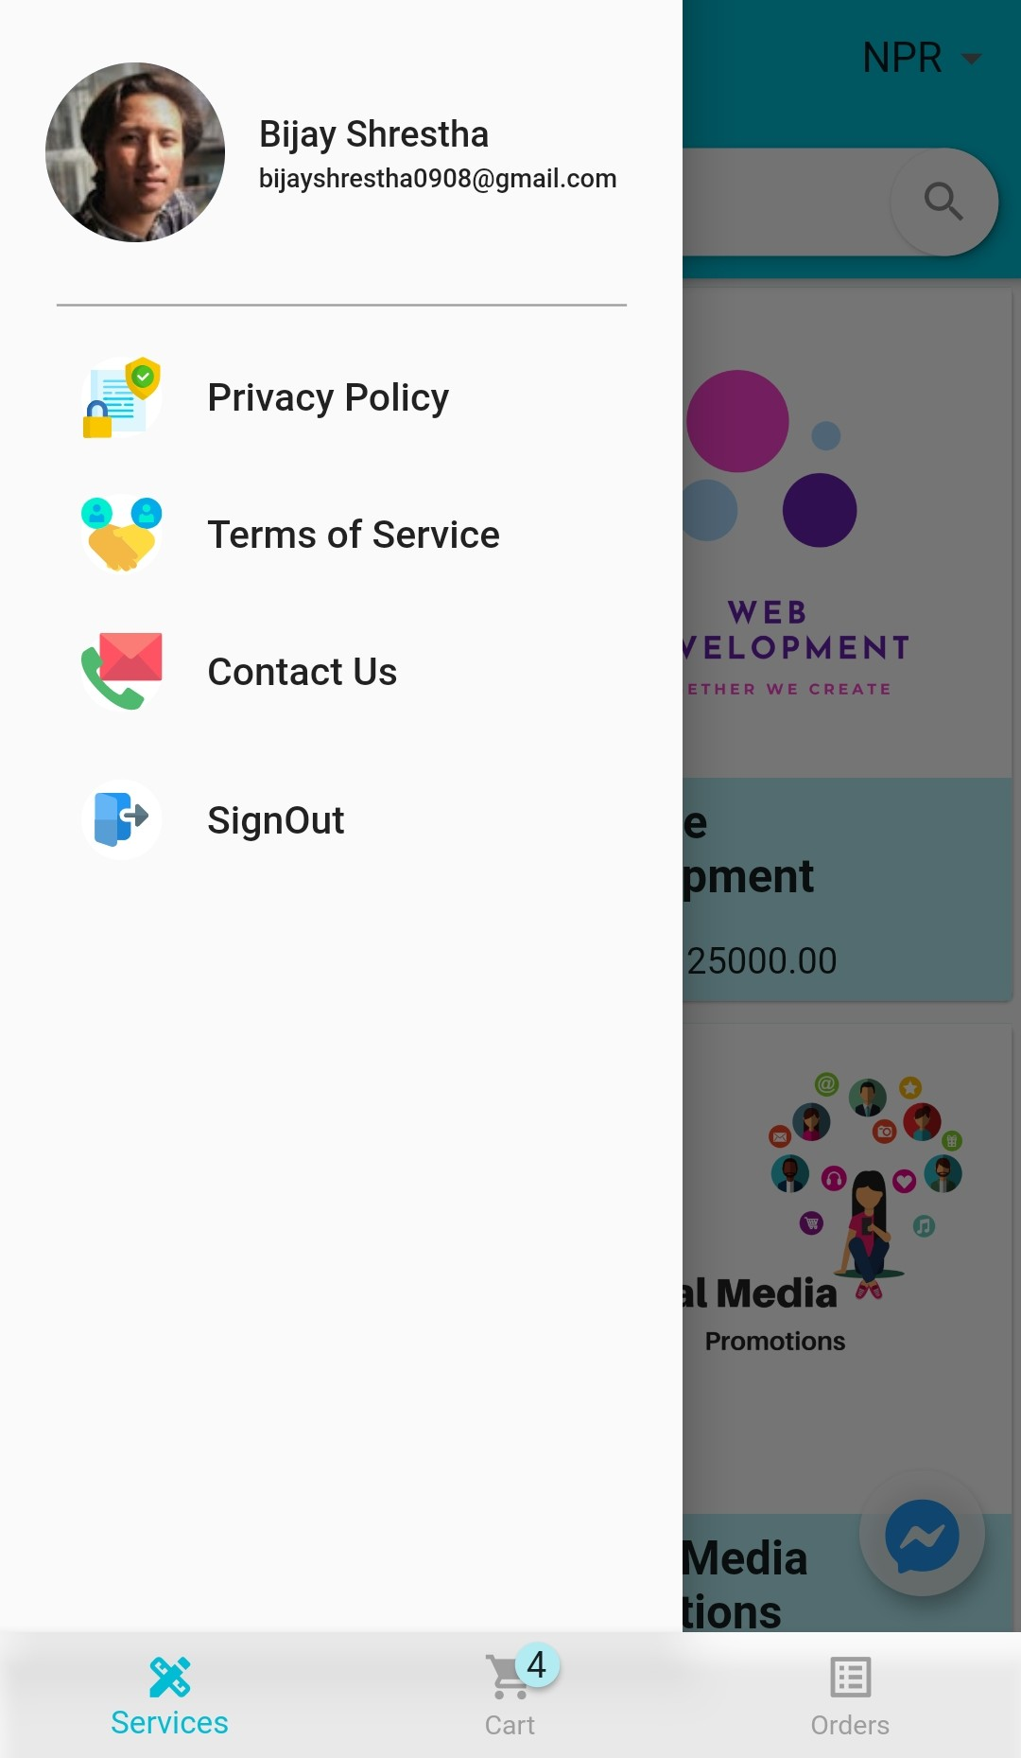

Figure Menu/Drawer

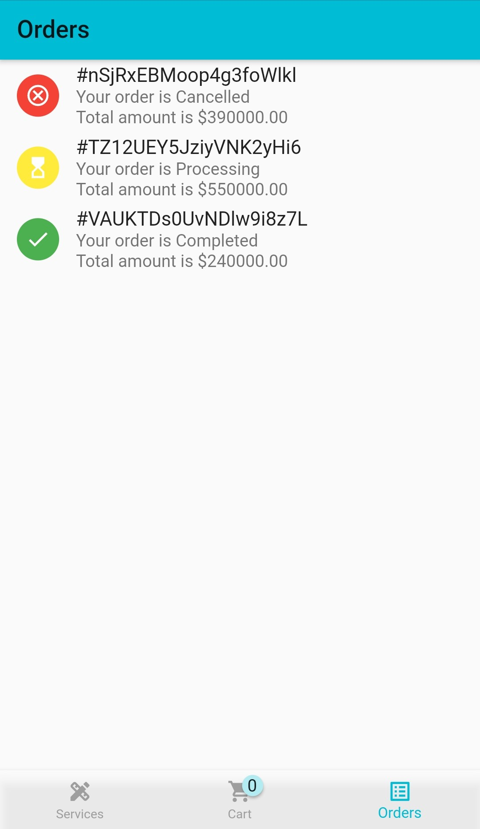

Figure Orders

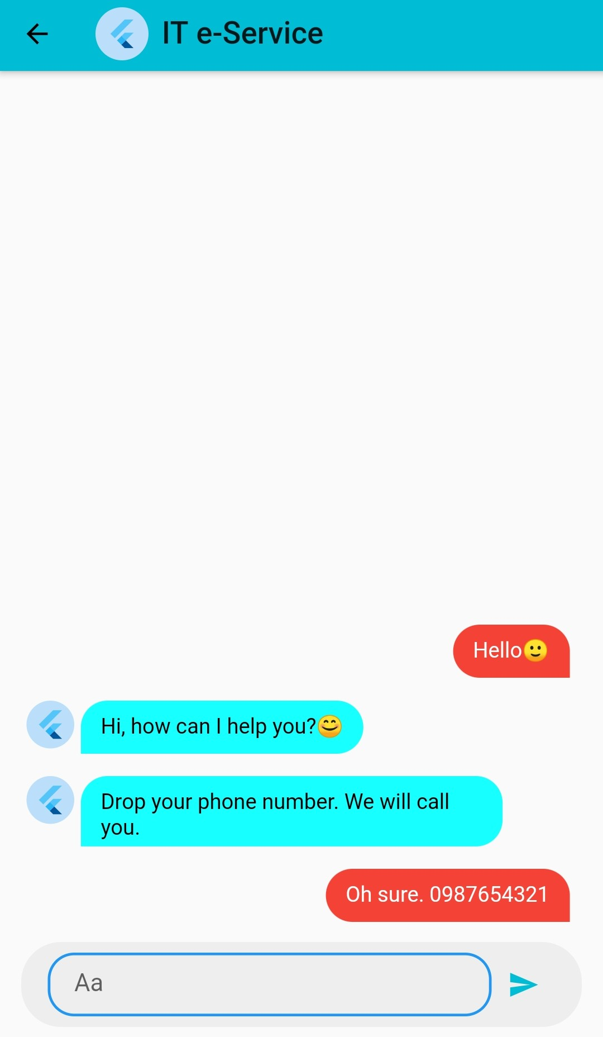

Figure Chat with owner/admin

## **3.4. Firebase:**

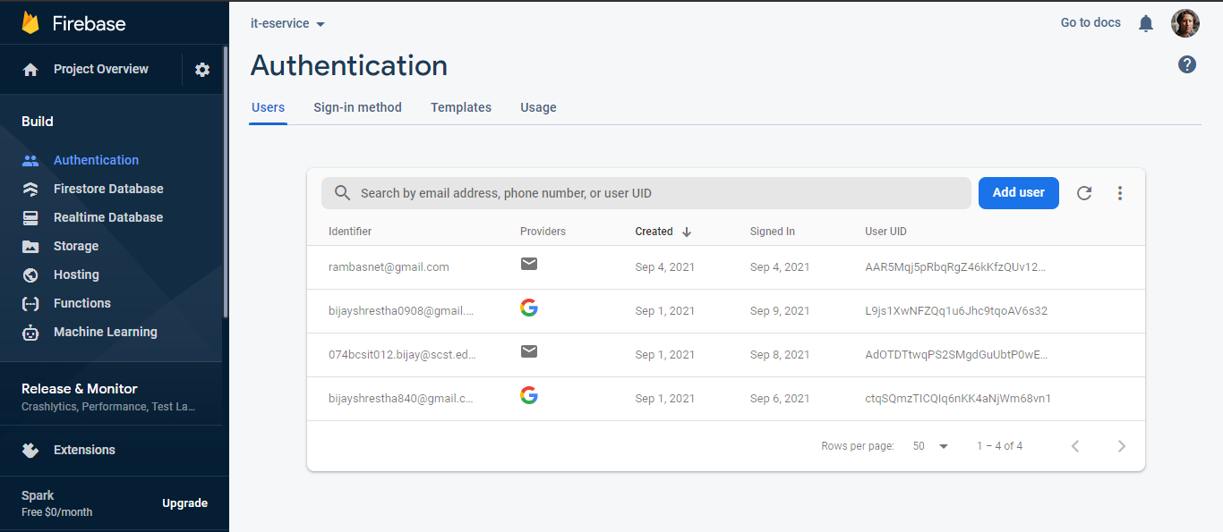

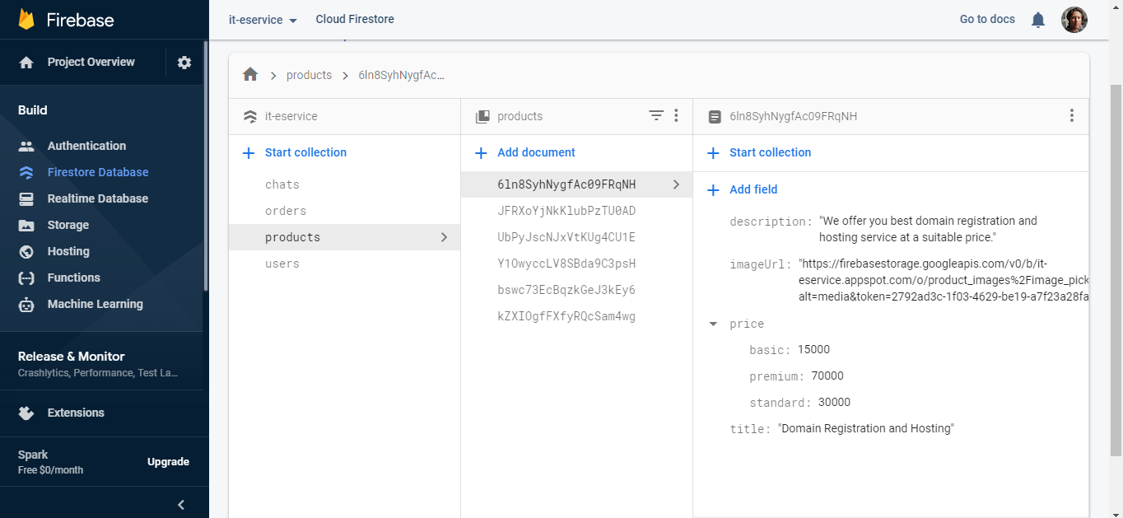

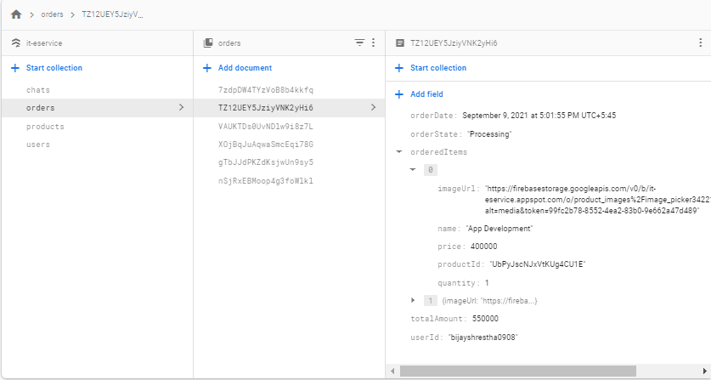

# CHAPTER 4

# IMPLEMENTATION

## **4.1. Implementation**

### 4.1.1. Flutter

Flutter is an open-source UI software development kit created by Google. It is used to develop cross platform applications for Android, iOS, Linux, Mac, Windows, Google Fuchsia, and the web from a single codebase. The first version of Flutter was known as codename "Sky" and ran on the Android operating system. Flutter also offers many ready to use widgets (UI) to create a modern application. These widgets are optimized for mobile environment and designing the application using widgets is as simple as designing HTML. To be specific, Flutter application is itself a widget. Flutter widgets also supports animations and gestures. The application logic is based on reactive programming. Widget may optionally have a state. By changing the state of the widget, Flutter will automatically (reactive programming) compare the widget’s state (old and new) and render the widget with only the necessary changes instead of re-rendering the whole widget

### 4.1.2. Dart

Dart is an open-source general-purpose programming language. It is originally developed by Google. Dart is an object-oriented language with C-style syntax. Dart is a client-optimized language for developing fast apps on any platform. Its goal is to offer the most productive programming language for multi-platform development, paired with a flexible execution runtime platform for app frameworks.

### 4.1.3. Firebase

Firebase is a product of Google, which helps developers to build, manage, and grow their apps easily. It helps developers to build their apps faster and in a more secure way. No programming is required on the firebase side, which makes it easy to use its features more efficiently. It provides services to android, iOS, web, and unity. It provides cloud storage. It uses NoSQL for the database for the storage of data.

## **4.2. Software Used**

* VS Code
* Flutter
* Dart
* Android Studio

# CHAPTER 5

# CONCLUSION AND RECOMMENDATION

## **5.1. Conclusion**

The project entitled IT eService was completed successfully. The system has been developed with much care and free of errors and at the same time it is efficient and less time consuming. The purpose of this project was to develop a mobile application services for IT. This project enabled me to gain valuable information and practical knowledge on Services, usage of flutter, firebase. The entire system is secured. In addition, the project helped me understand about the development phases of a project and software development life cycle. I learned how to test different features of a project. This project has given me great satisfaction in having designed an application, which can be implemented to any nearby shops or branded shops selling various kinds of products by simple modifications. However, it was very challenging learning and developing an application using a new technology. From my perspective the cart system and checkout process is not feasible in such cases because the products are not tangible i.e(they are the services, not goods/items which can be bought or sold). So we can show only information about the product/services from which the user can contact for the service through the contact page via email/phone or chat with admin or we can redirect the user to webpage. We can make users able to manage carts and place orders.

## **5.2 Recommendation**

There is a scope for further development in our project largely. A number of features can be added to this system in the future like providing. A feature we wished to implement was providing classes for customers so that different offers can be given to each class. The system may keep track of the history of purchases of each customer and provide suggestions based on their history using Machine Learning Algorithm. These features could have been implemented if time and skills did not limit us.

## Reference

[1]"Laudon & Traver, Pearson eText E-Commerce 2019: Business, Technology and Society -- Instant Access | Pearson", *Pearson.com*, 2021. [Online]. Available: https://www.pearson.com/us/higher-education/product/Laudon-Pearson-e-Text-E-Commerce-2019-Business-Technology-and-Society-Instant-Access-15th-Edition/9780135790885.html. [Accessed: 07- Sep- 2021].

[2]"Flutter for Beginners: An introductory guide to building cross-platform mobile applications with Flutter and Dart 2 by Alessandro Biessek - Paperback - from Bonita (SKU: 1788996089.S)", *Biblio.com*, 2021. [Online]. Available: https://www.biblio.com/book/flutter-beginners-introductory-guide-building-cross/d/1355186570. [Accessed: 07- Sep- 2021].

[3]B. Flutter, R. Payne and C. Apress, "Beginning App Development with Flutter | SpringerLink", *Link.springer.com*, 2021. [Online]. Available: https://link.springer.com/book/10.1007%2F978-1-4842-5181-2. [Accessed: 07- Sep- 2021].