Experiment No : 01

Experiment Name : Installing Linux mint on PC

Aim and Objective :

Our aim is to learn about Linux Operating systems , how the work and what are the advantages of using Linux OS distributions but in order to do so we first need to install on our local computer first . So our objective is installing Linux and start our learning journey .

Installation :

Before we install linux we need to do some things first as we are going to install it from a ISO file so we need to burn it to a pen drive first to do so we use a software called linux-iso-burner so the steps are :

* Make a partition for the new Linux OS
* Burn the ISO file to a pen drive
* Boot from the pen drive
* Install the OS to the machine

We are going to install linux mint ISO for installation the steps are described below

1.Make a Partition on Hard Disk

To install linux we first need to make room for it on our hard drive , we can use partition master to do so or we can do it manually . As for this installation 50 GB from the hard drive was taken to make the linux partition .

2. Burn the ISO file to USB Drive

We need to burn the ISO file to install , linux-iso-burner can be used for this process

3 .Boot from the pen drive

After we are done burning the ISO we need to boot from the pen drive . For this we first need to plug the flash drive to the PC then turn it on , while starting we need to get to the boot menu , we can do this by pressing the ESC or F12 key , after entering the boot menu we need to select the option “boot from use drive ” and hit enter then it would automatically boot into the pen drive .

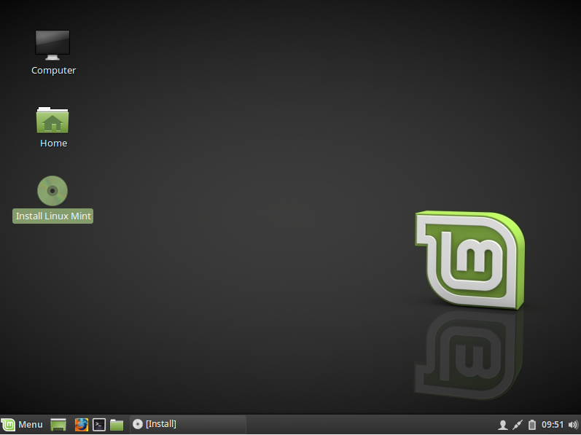

4 . Installing Linux

To install we need to select the Install Linux Mint icon .

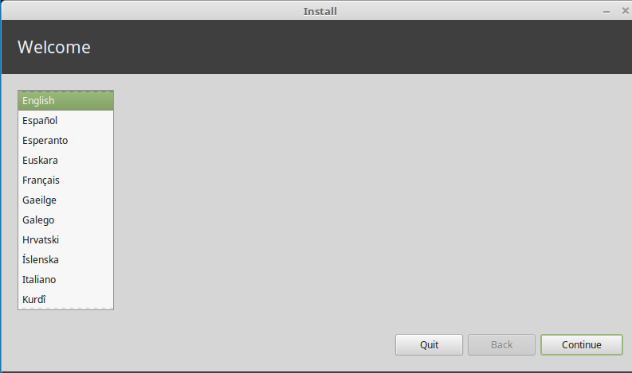

We then need to select the language after that we need to select the partition we want to install the OS

And format the disk and set it to ext4 format

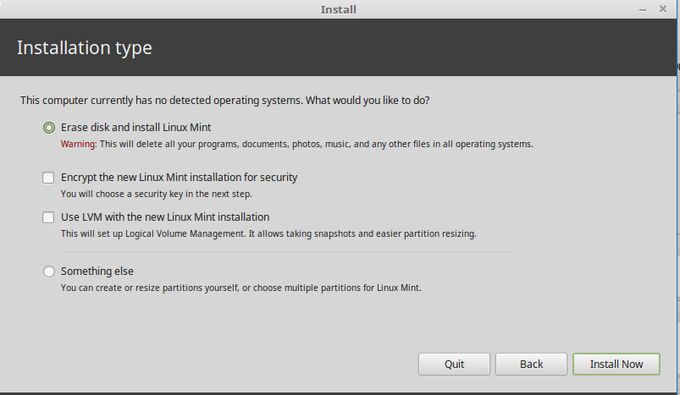

We then need to select the out region , it will be auto detected it there is internet connection to out pc

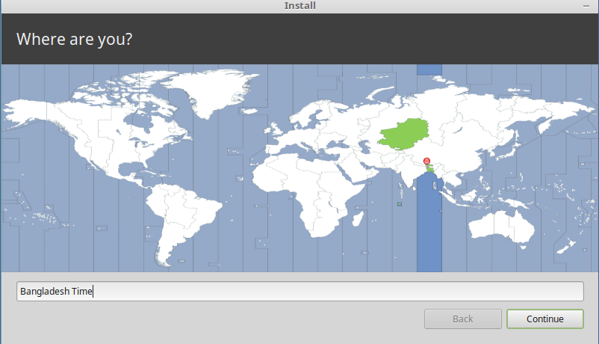

After that we need to set the key board lay out we use , as for me I selected the standard Bengali keyboard layput

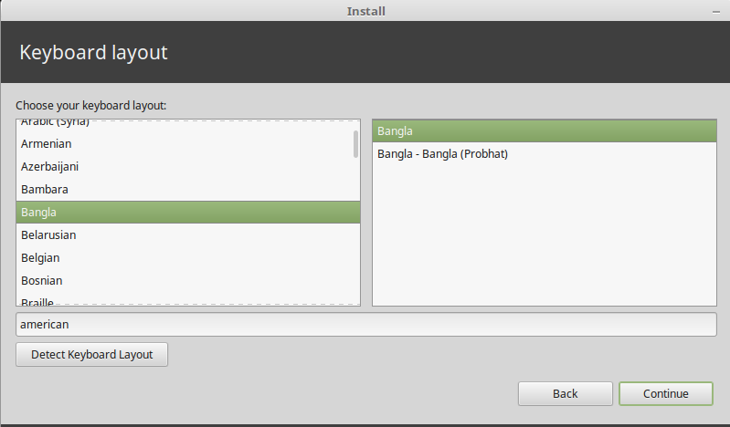

Then we need to set the PC-name , root user , root password and other information

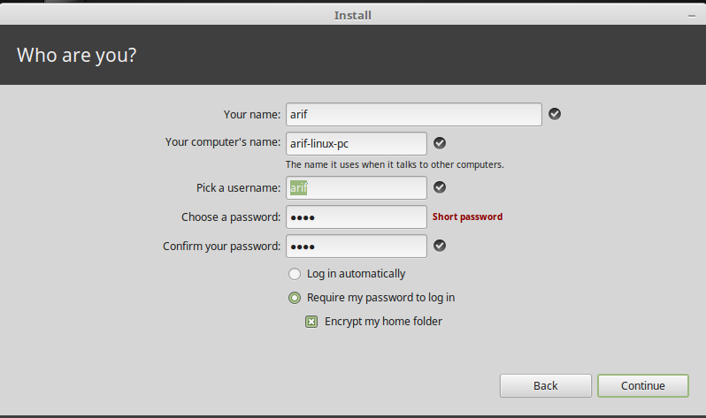

And after all this has been done we wait for it to install

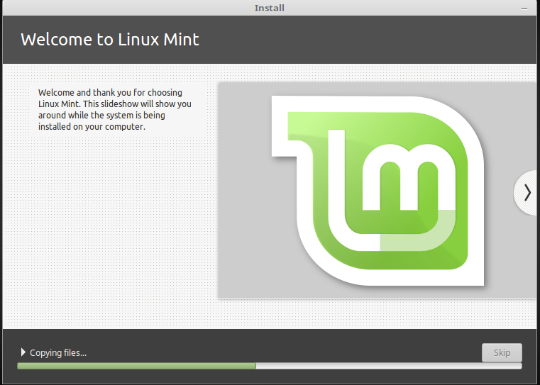

And while it is being installed to our system we can read out the documentation it sows for better understanding

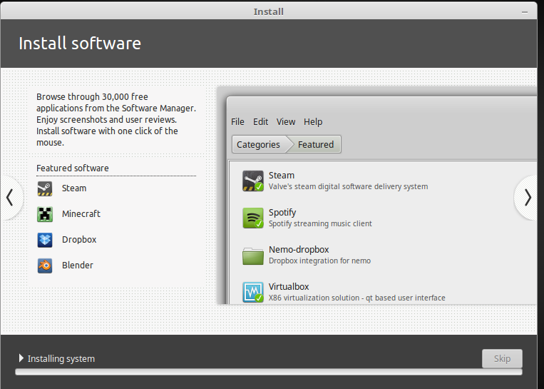

After being installed it will ask for a reboot

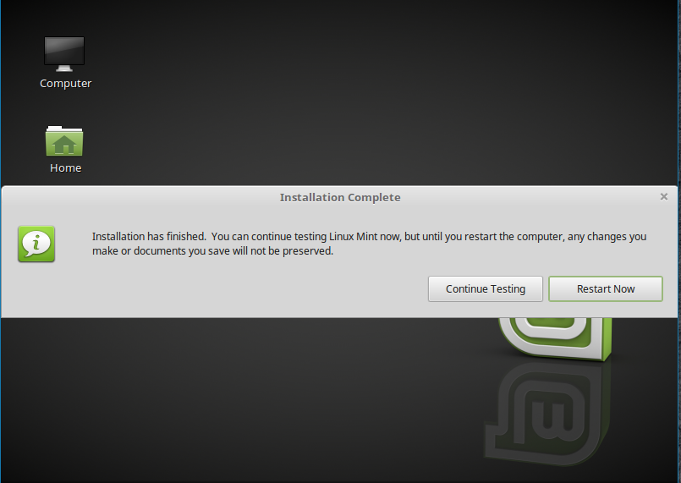

And then we will reboot and login as user

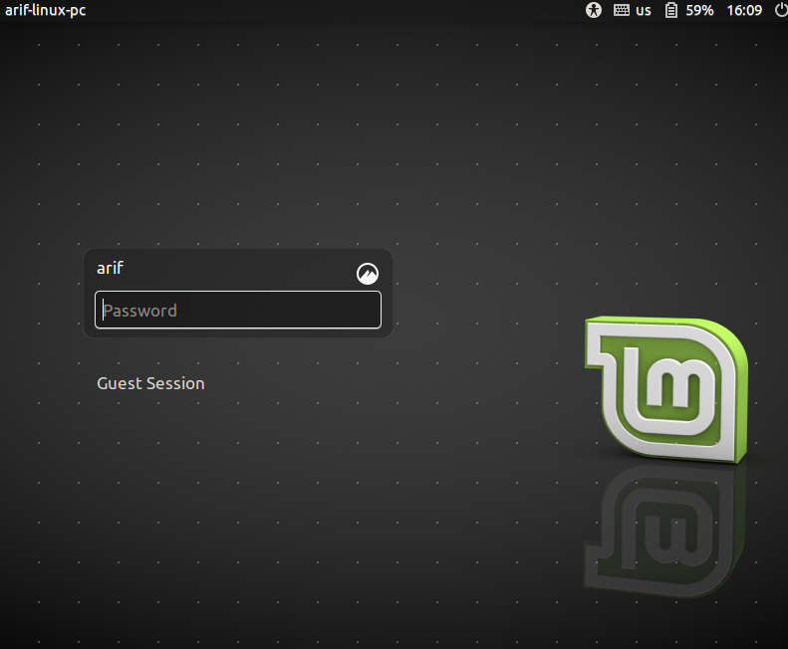

Finally mint is installed and we are good to go

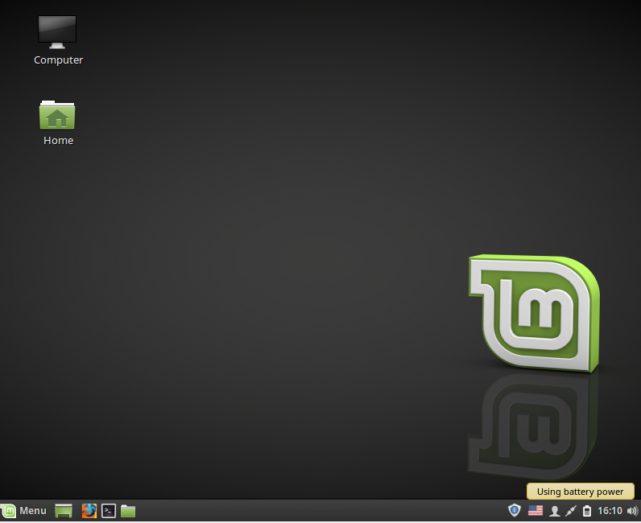

We can then update out packages by sudo apt-get update and make a directory through the terminal

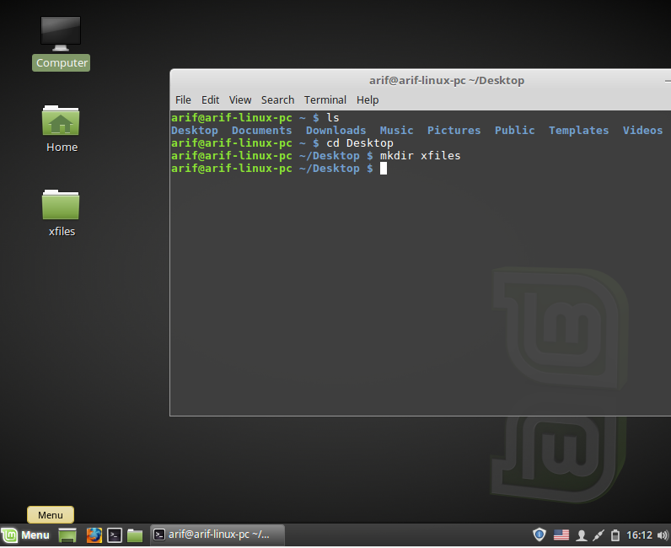

Conclusion :

Linux being an open source platform it is a great way to learn about open source and learn about operating systems the first step of beginning is to install linux we have done that in this lab and it was a very fun experience doing it