Experiment no : 02

Experiment name : Basic Linux Terminal commands

Aim and Objective :

Our aim or goal is to learn the use of Linux terminal . In Linux every thing is a file we can do our work with GNU GUI tools but in Linux everything is customizable and we can customize every possible thing with terminal . In this lab we aim to do our basic work with the terminal .

To open the terminal we can use the short cut CTRL , ALT and T or open it in KDE go System -> Konsoll

Now we can start our work

Commands :

ls :

We use the ls command to see all the files and folders in current directory and ls –al to see the extended list

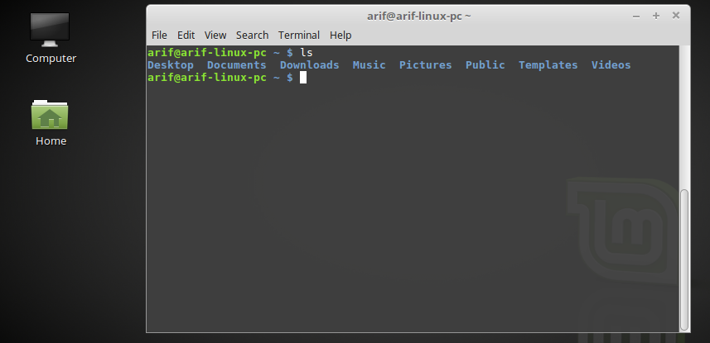

ls –al

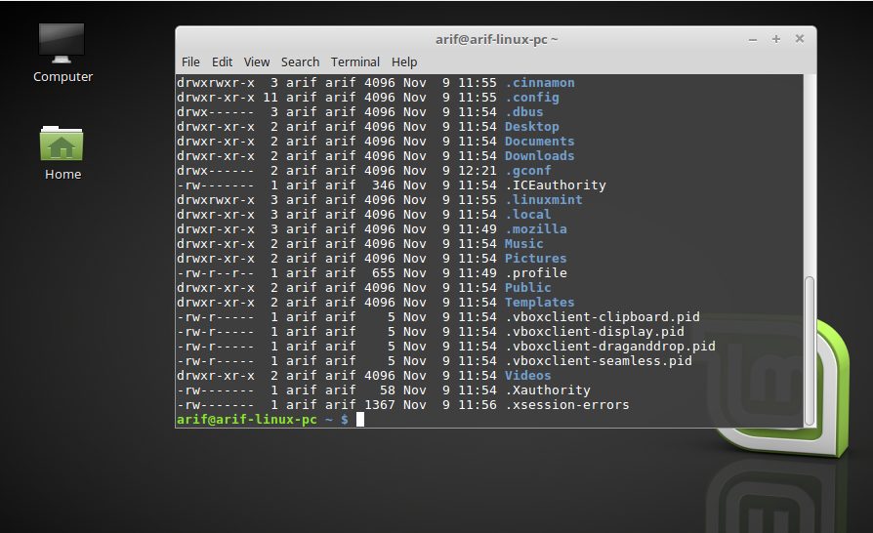

pwd :

We use the pwd command to see the current directory path

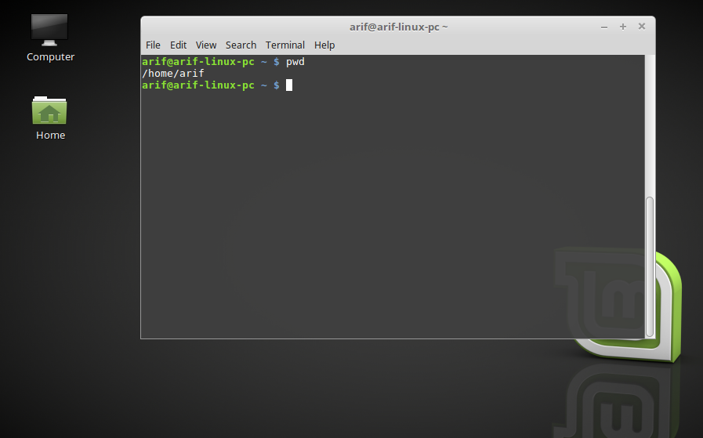

cd:

We use cd to change the directory and the syntax is file system path after cd and to get back to lower file use cd ..

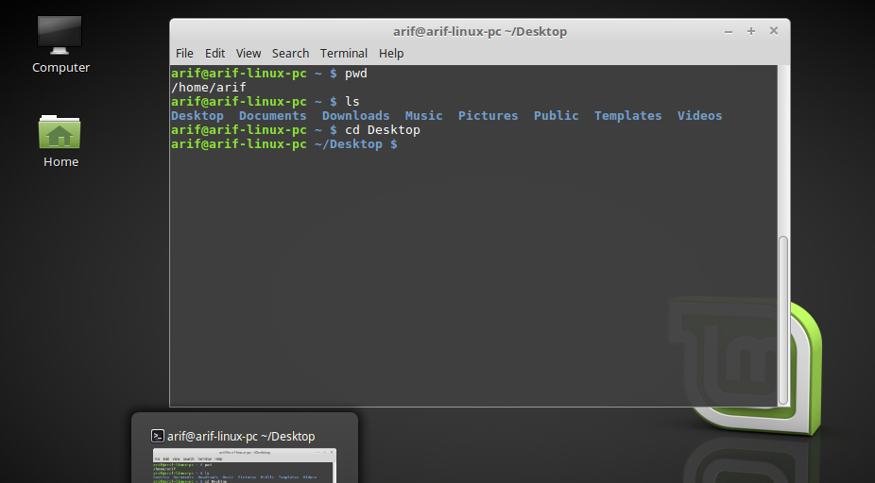

chmod :

we use chmod to make a file executable for this the syntax is chmod a+x ‘file name’ . after making the file executable we type ./’file name’ then we can see the output of the script

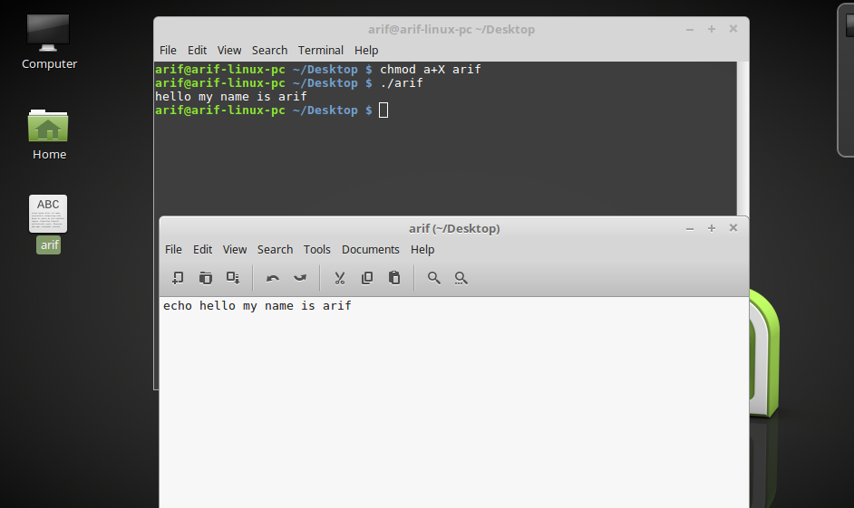

mkdir:

mkdir is used to create a folder in current path the syntax is mkdir ‘file name’ and if we want to create multiple files then mkdir {fiel1 , file2…} can be used

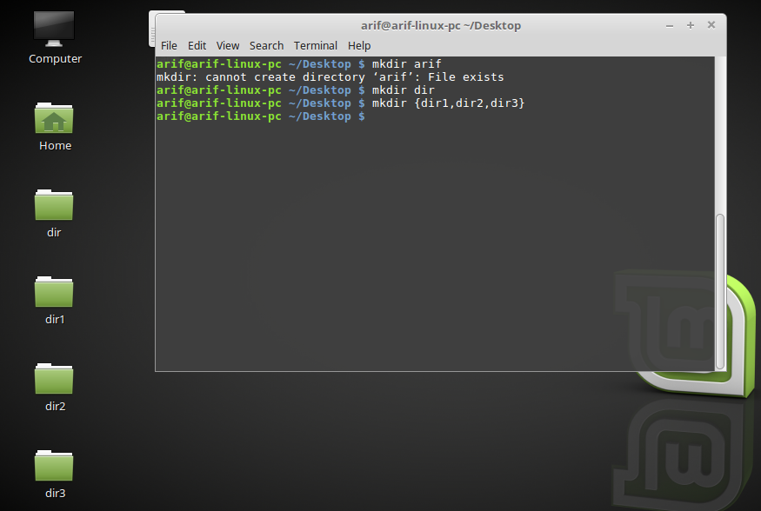

du and df :

we use df to view filesystem disk space usages and du to see a files disk space usages we can see a files we can use du –m ‘file name ’ to see the file size in megabytes

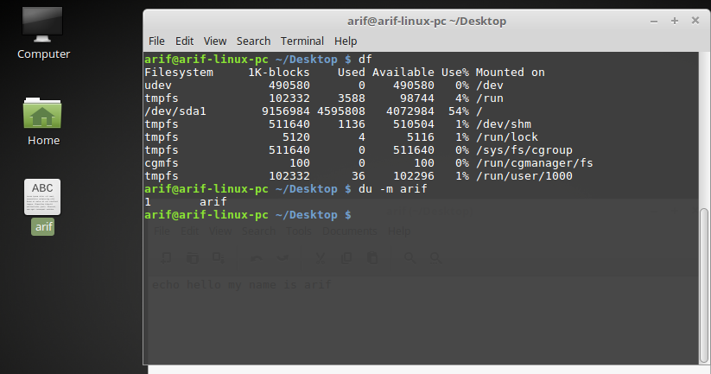

rm :

if a file is to be removed then rm is used , if it is a folder then rm –r ‘file ’ name is used , all files in a directory by rm –r \*

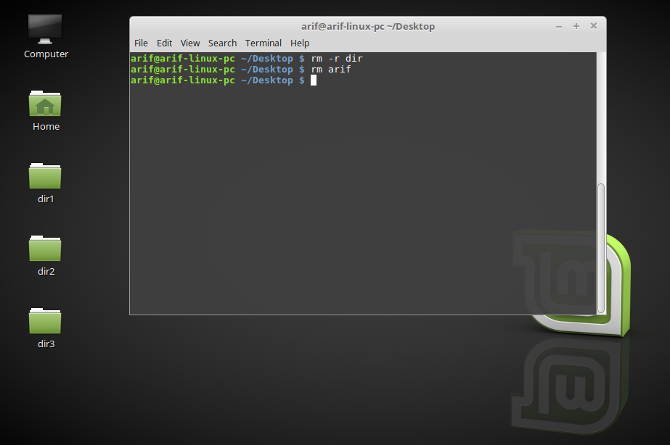

ln :

this command is used to link one file or folder to another or other files or folders , if we edit one then the others will automatically be updated

ln dir1/hello arif



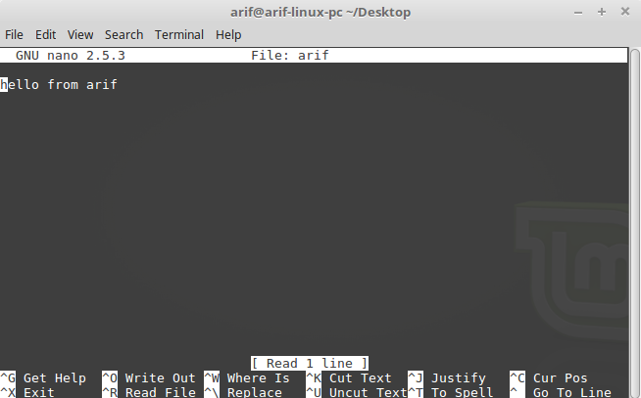

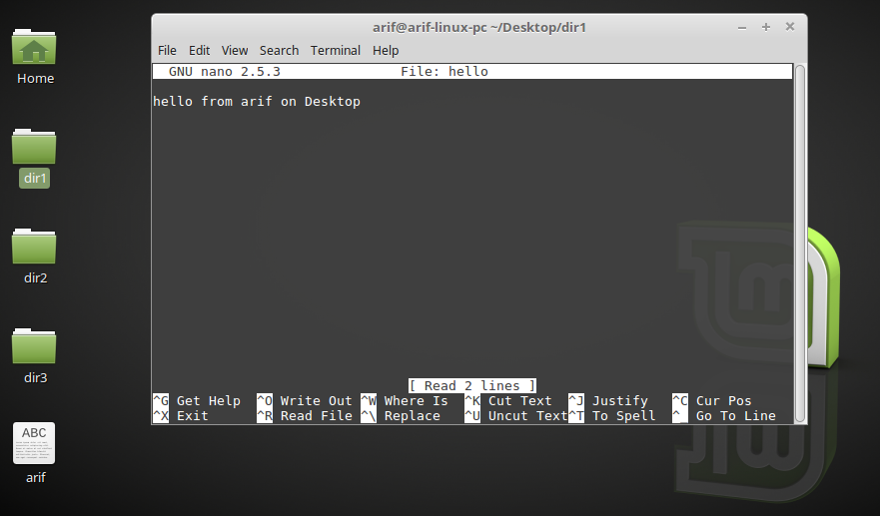

Conclusion :

By having the knowledge of Linux terminal we can perform our tasks with more power and flexibility . we need less time if we do a task with terminal instead of GUI . To understand how the operating system works we need to have good knowledge about the command line