Experiment name : Implementation of FCFS algorithm

Aim and Objectives :

To learn about First Come First Server also know as FCFS algorithm , and implement it with a c programm

Code :

#include<stdio.h

int main()

{

int n,bt[20],wt[20],tat[20],avwt=0,avtat=0,i,j;

printf("Enter total number of processes(maximum 20):");

scanf("%d",&n);

printf("\nEnter Process Burst Time\n");

for(i=0; i<n; i++)

{

printf("P[%d]:",i+1);

scanf("%d",&bt[i]);

}

wt[0]=0; //waiting time for first process is 0

//calculating waiting time

for(i=1; i<n; i++)

{

wt[i]=0;

for(j=0; j<i; j++)

wt[i]+=bt[j];

}printf("\nProcess\t\tBurst Time\tWaiting Time\tTurnaround Time");

//calculating turnaround time

for(i=0; i<n; i++)

{

tat[i]=bt[i]+wt[i];

avwt+=wt[i];

avtat+=tat[i];

printf("\nP[%d]\t\t%d\t\t%d\t\t%d",i+1,bt[i],wt[i],tat[i]);

}

avwt/=i;

avtat/=i;

printf("\n\nAverage Waiting Time:%d",avwt);

printf("\nAverage Turnaround Time:%d",avtat);

return 0;

}

Output :

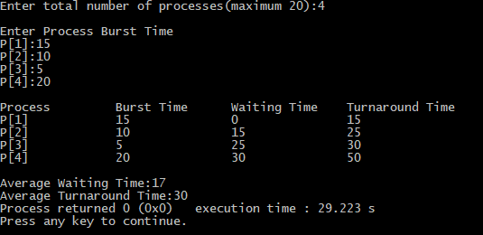

Conclusion :

FCFS is the simplest scheduling algorithm. FIFO simply queues processes in the order that they arrive in the ready queue. Hope this will be of great help in future work