Experiment Name : Implementation of FIFO page replacement algorithm in c

Aim and Objectives :

To learn about FIFO page replacement algorithm and implement it with a C program

Code :

#include<stdio.h>

int main()

{

int i,j,n,a[50],frame[10],no,k,avail,count=0;

printf("\n ENTER THE NUMBER OF PAGES:\n");

scanf("%d",&n);

printf("\n ENTER THE PAGE NUMBER :\n");

for(i=1;i<=n;i++)

scanf("%d",&a[i]);

printf("\n ENTER THE NUMBER OF FRAMES :");

scanf("%d",&no);

for(i=0;i<no;i++)

frame[i]= -1;

j=0;

printf("\tref string\t page frames\n");

for(i=1;i<=n;i++)

{

printf("%d\t\t",a[i]); avail=0; for(k=0;k<no;k++)

if(frame[k]==a[i]) avail=1; if(avail==0) { frame[j]=a[i]; j=(j+1)%no; count++; for(k=0;k<no;k++) printf("%d\t",frame[k]);

}

printf("\n");

}

printf("Page Fault Is %d",count);

return 0;

}

Output :

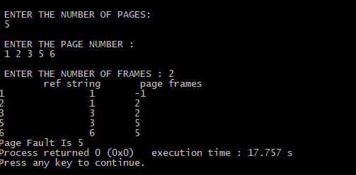

Conclusion :

In operating systems that use paging for memory management, page replacement algorithm are needed to decide which page needed to be replaced when new page comes in. Whenever a new page is referred and not present in memory, page fault occurs and Operating System replaces one of the existing pages with newly needed page. Different page replacement algorithms suggest different ways to decide which page to replace. The target for all algorithms is to reduce number of page faults.