Experiment Name : Implementation of Priority Scheduling Algorithm in C .

Amin and Objectives :

To learn about Priority Scheduling Algorithm and implement it with a C program .

Code :

#include<stdio.h>

int main()

{

int bt[20],p[20],wt[20],tat[20],pr[20],i,j,n,total=0,pos,temp,avg_wt,avg_tat;

printf("Enter Total Number of Process:");

scanf("%d",&n);

printf("\nEnter Burst Time and Priority\n");

for(i=0;i<n;i++)

{

printf("\nP[%d]\n",i+1);

printf("Burst Time:");

scanf("%d",&bt[i]);

printf("Priority:");

scanf("%d",&pr[i]);

p[i]=i+1; //contains process number

}

//sorting burst time, priority and process number in ascending order using selection sort

for(i=0;i<n;i++)

{

pos=i;

for(j=i+1;j<n;j++)

{

if(pr[j]<pr[pos])

pos=j;

}

temp=pr[i];

pr[i]=pr[pos];

pr[pos]=temp;

temp=bt[i];

bt[i]=bt[pos];

bt[pos]=temp;

temp=p[i];

p[i]=p[pos];

p[pos]=temp;

}

wt[0]=0; //waiting time for first process is zero

//calculate waiting time

for(i=1;i<n;i++)

{

wt[i]=0;

for(j=0;j<i;j++)

wt[i]+=bt[j];

total+=wt[i];

}

avg_wt=total/n; //average waiting time

total=0;

printf("\nProcess\t Burst Time \tWaiting Time\tTurnaround Time");

for(i=0;i<n;i++)

{

tat[i]=bt[i]+wt[i]; //calculate turnaround time

total+=tat[i];

printf("\nP[%d]\t\t %d\t\t %d\t\t\t%d",p[i],bt[i],wt[i],tat[i]);

}

avg_tat=total/n; //average turnaround time

printf("\n\nAverage Waiting Time=%d",avg_wt);

printf("\nAverage Turnaround Time=%d\n",avg_tat);

return 0;

}

Output:

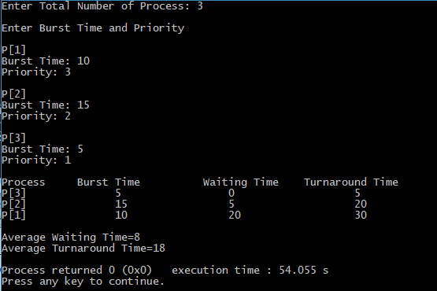

Conclusion :

Priority scheduling is a non-preemptive algorithm and one of the most common scheduling algorithms in batch systems. Each process is assigned apriority. Process with the highest priority is to be executed first and so on. Processes with the samepriority are executed on first come first served basis.