**Shared clip**

Issue#4 error running the exe file after package installation

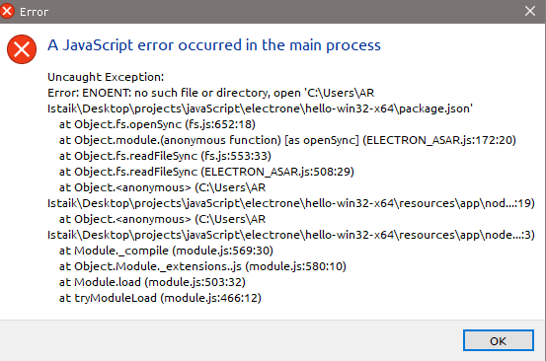

Solve :

Copy the package.json file to the exe folder *[npm init wond work , data base (electron-db) is nod found if we use npm init ]*

Link :

<https://stackoverflow.com/questions/24468041/npm-install-gives-error-cant-find-a-package-json-file>

Issue#3 (how to package app and make a native installder )

Solve :

First we have to specify the electron version by adding

"devDependencies": {

"electron": "^1.4.1"

},

To the ***package.json*** file

electron-packager <sourcedir> <appname> --platform=<platform> --arch=<arch> [optional flags...]

***creating exe***

Issue#2 (can not connect electron with sqlit3 databse , the require(‘sqlite3’) can`t be resolved )

Issu#1 ( electron-db data insertion problem )

Solve : to create the table properly we have to run the command

electron db.js

then ,

node db.js