安装或升级Git
https://phoenixnap.com/kb/how-to-update-git

git --version
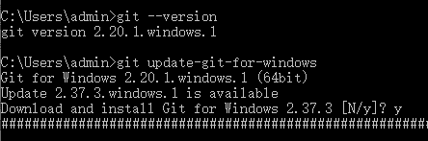

git update-git-for-windows
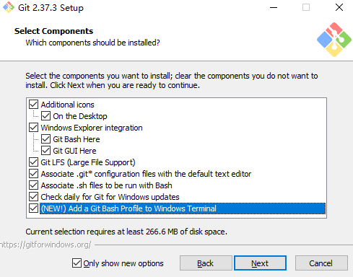

安装Composer
https://getcomposer.org

下载并运行：Composer-Setup.exe
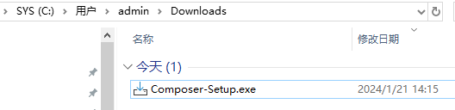

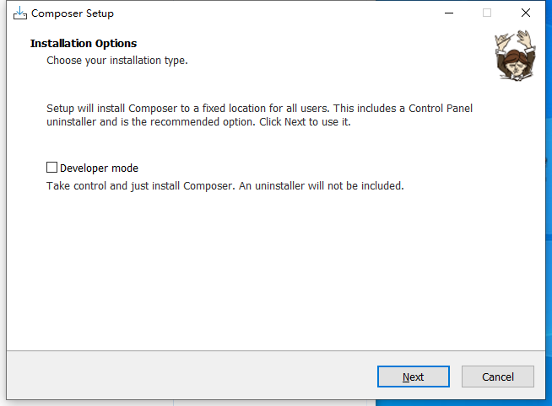
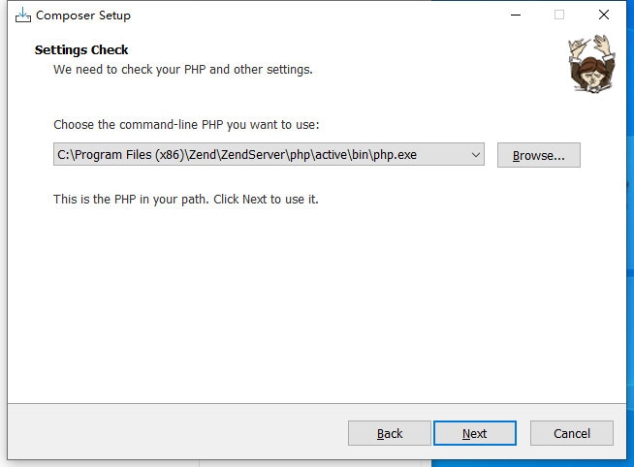

查看版本：composer -V
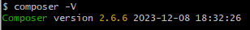

检查升级版本：composer self-update

出错：OpenSSL Error messages
error:1407742E:SSL routines:SSL23_GET_SERVER_HELLO:tlsv1
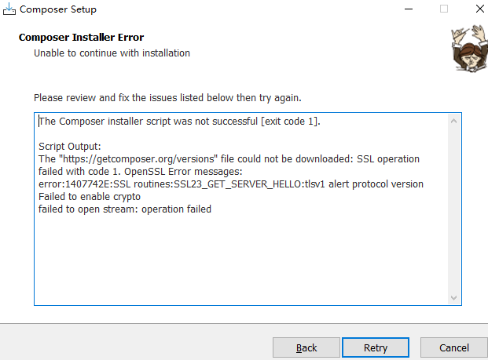

https://github.com/composer/composer/issues/8657

You are running Composer with SSL/TLS protection disabled.
Checking platform settings: The OpenSSL library (0.9.8zf) used by PHP does not support TLSv1.2 or TLSv1.1.
If possible you should upgrade OpenSSL to version 1.0.1 or above.

原因：
由于 Github 18年2月1日 发布通告称 Weak cryptographic standards removal notice
简而言之就是，不在支持 TLSv1/TLSv1.1 因此导致上述错误！
解决办法如下：
使用如下命令检查 TLS 版本
git config http.sslVersion
执行上述操作，命令行中如果什么都没有或者版本不是 tlsv1.2 的话，就执行如下命令：
git config --global http.sslVersion tlsv1.2

注意：PHP5 不支持 openssl1.1，所以不能用ZendServer8自带的PHP5.6.5（含OpenSSL 0.9.8）
OpenSSL 0.9.8 in ZendServer8 does not support TLS 1.2. Painting with a broad brush TLS 1.2 first appeared in OpenSSL 1.0.1

TLS 1.2 support is from OpenSSL version 1.0.1.
OpenSSL 0.9.8x is lower than 1.0.1 so it does not support TLS 1.2

更换ZendServer2019后安装成功
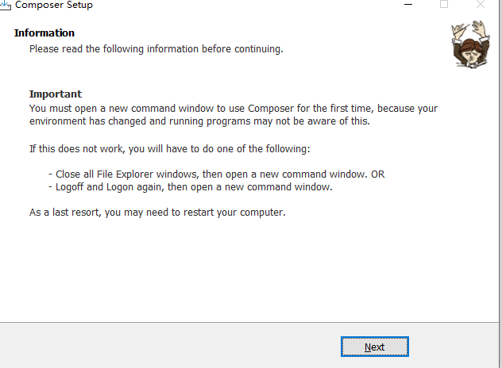

问题：composer 2.3.0 dropped support for php 7.2.5
先ZendServer2019切换php版本：7.2.15
以管理员身份运行CMD后执行composer self-update --2.2
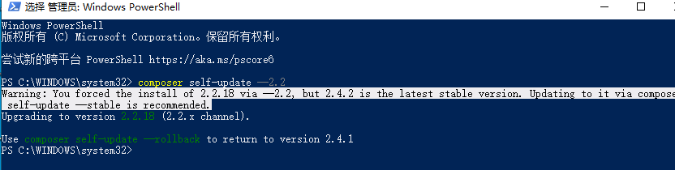
然后再切换回来php版本7.1

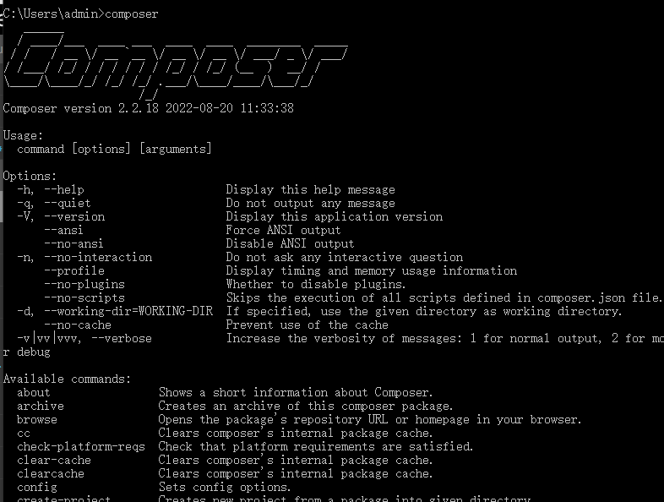

安装Yii2
- The minimum required PHP version of Yii is PHP 5.4
- It works best with PHP 8
https://www.yiiframework.com/doc/guide/2.0/en/start-installation
https://github.com/yiisoft/yii2

composer create-project --prefer-dist yiisoft/yii2-app-basic basic
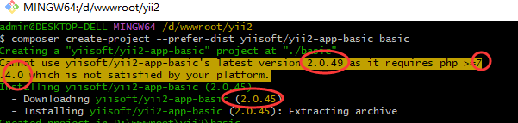

测试：http://localhost/yii2/basic/web/
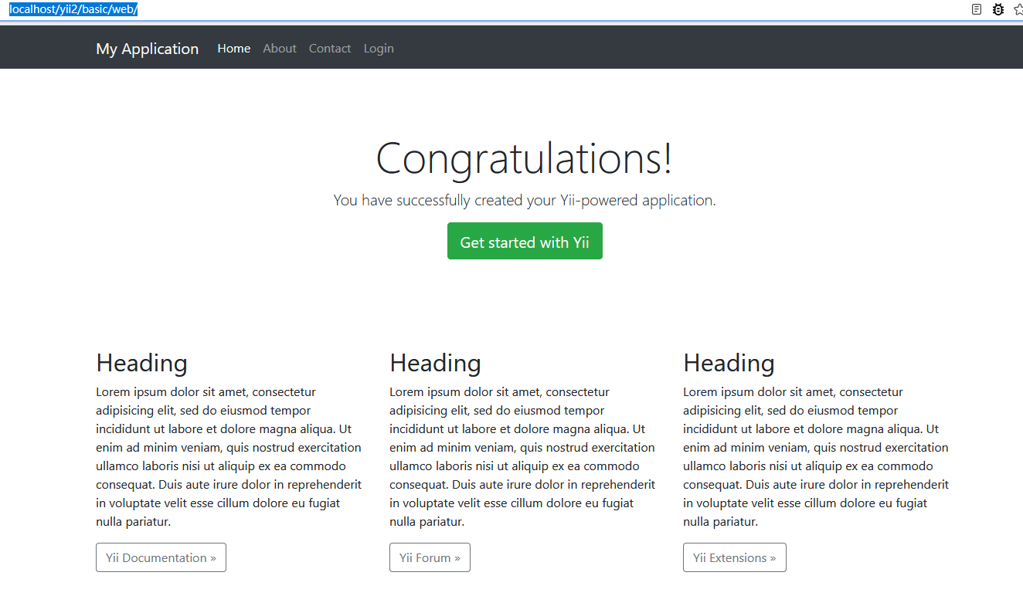

If not, please check if your PHP installation satisfies Yii's requirements.
cd basic
php requirements.php
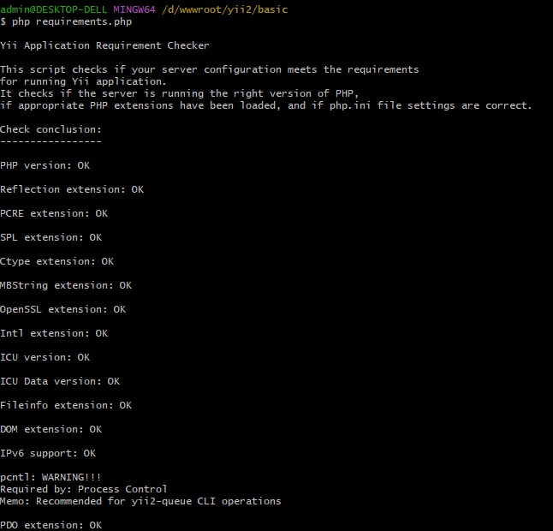

Recommended Apache Configuration
https://www.yiiframework.com/doc/guide/2.0/en/start-installation#recommended-apache-configuration

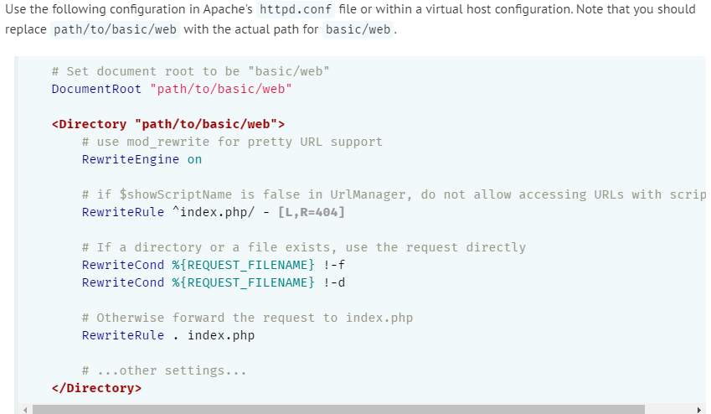

更新项目：composer update
例如当从PHP 7.2改为7.4时，yii也需要更新项目！
