Comcast Small Business：

IP：73.170.35.83

Modem: Netgear CM500
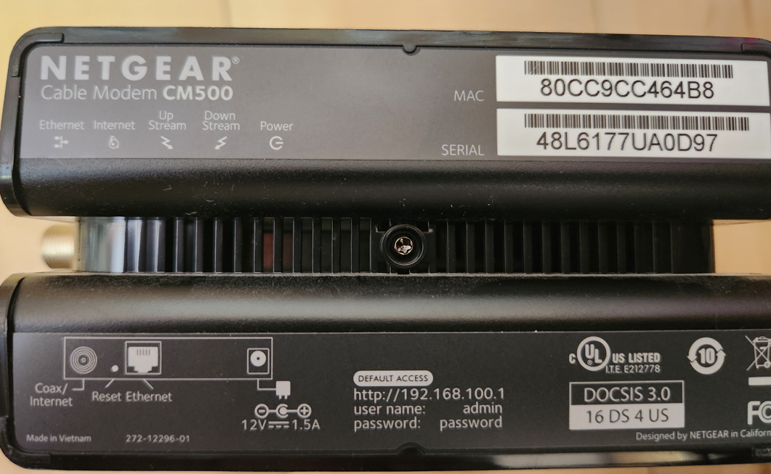

Router：Netgear AX1800 Wifi Router – Model：RAX10
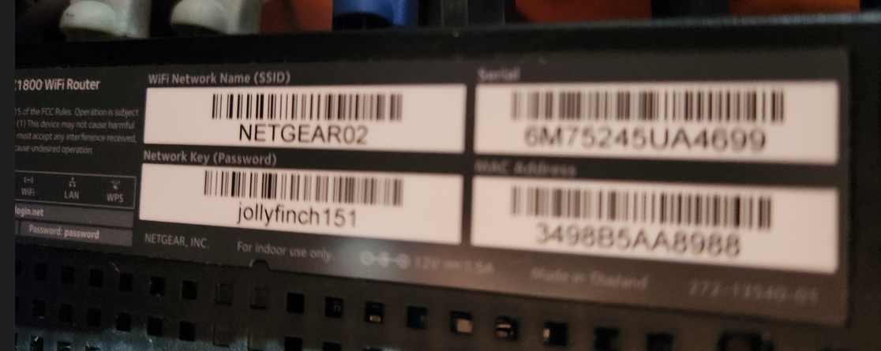
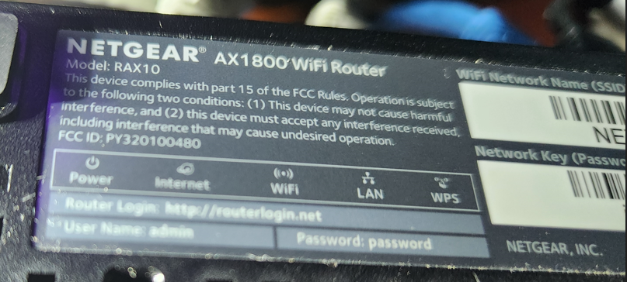

192.168.50.1 admin / A_wwxxx4
安全问题：robert / weiwei

Guest: MSC CONSTRUCTION / 1qazxsw2
5G: MSC / awxxx4

NAS：Synology DS412
Synology账号：sunboy2544@gmail.com
Quickconnect ID: msc666666

https://msc666666.myds.me:5001/ admin / A_wwxxx4

DESKTOP-X370

BIOS
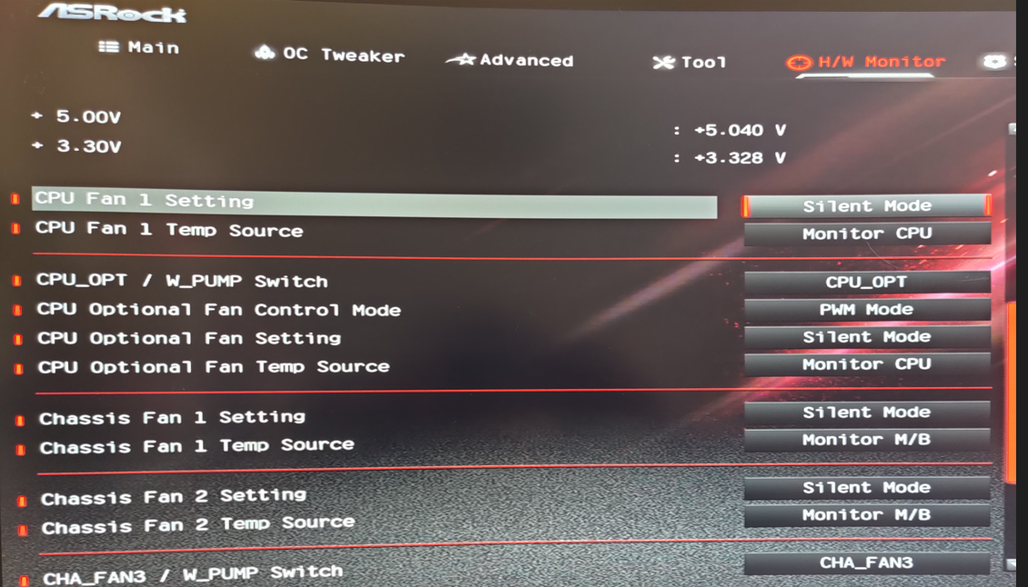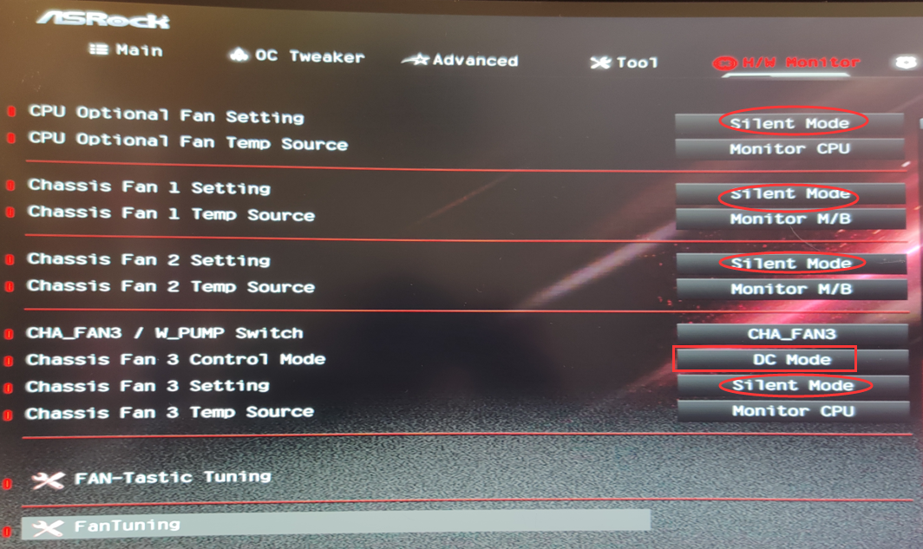

RustDesk ID：37 711 924 / A_wwxxx4

外网远程WOL唤醒：http://67.169.74.213:9090/wol?mac=70-85-c2-3f-70-34
