# What is NLP - defination

Natural language processing (NLP) is a branch of artificial intelligence that helps computers understand, interpret and manipulate human language.

# NLP is growing

the technology is rapidly advancing and natural language models are growing larger and performing better.

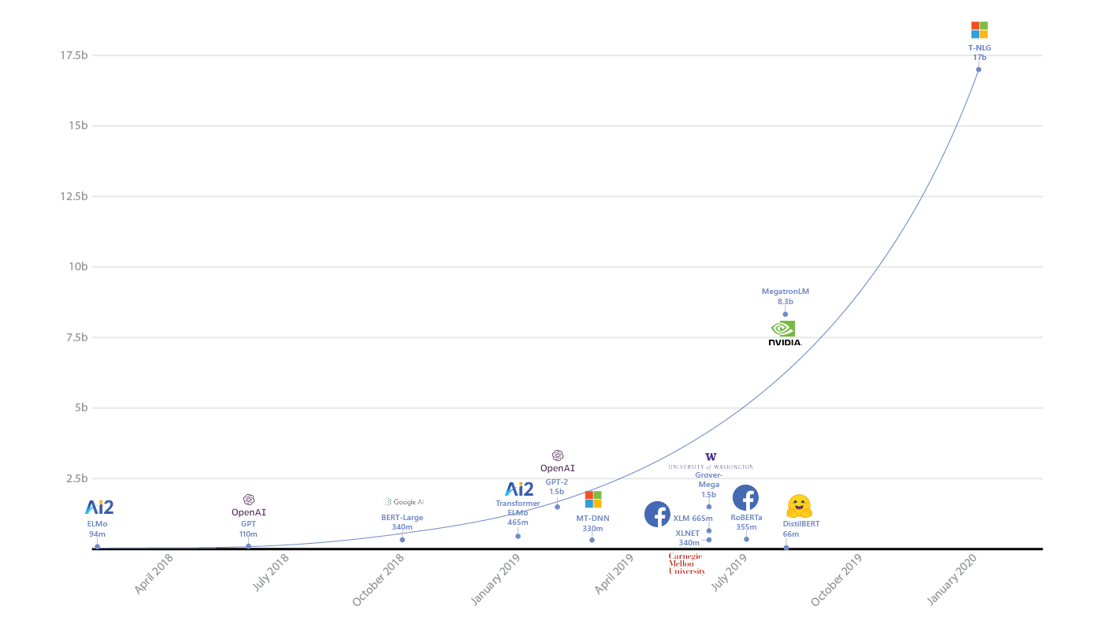

Ref: https://www.microsoft.com/en-us/research/blog/turing-nlg-a-17-billion-parameter-language-model-by-microsoft/

# Introduction - Fact: computer’s native language is different from human language

As a human, you may speak and write in English, Spanish or Chinese. But a computer’s native language – known as machine code or machine language – is largely incomprehensible to most people. At your device’s lowest levels, communication occurs not with words but through millions of zeros and ones that produce logical actions.

# Introduction - Fact: performance

Today’s machines can analyze more language-based data than humans, without fatigue and in a consistent, unbiased way. Today’s machines can analyze more language-based data than humans, without fatigue and in a consistent, unbiased way.