1) Write shell script to show various system configuration like
• Currently logged user and his log in name
•Your current shell
•Your home directory
•Your operating system type
•Your current working directory

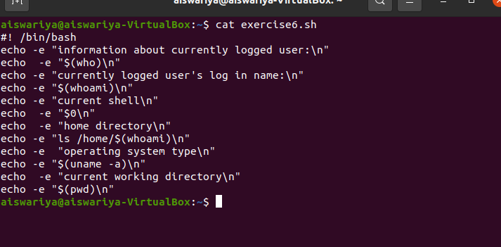

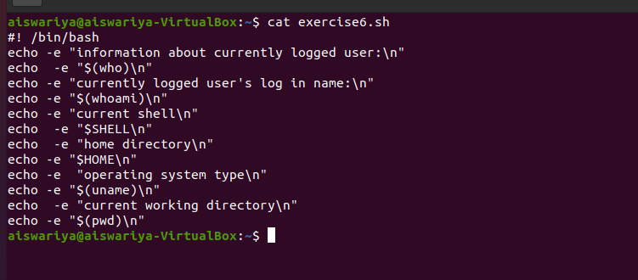

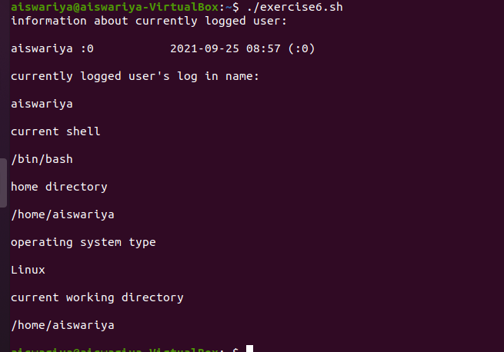

2) Write shell script to show various system configurations like
• your OS and version, release number, kernel version
•all available shells
• File system (Mounted)

