Hotel Revenue Analysis Using Power BI
Milestone 4: Visualization, Storytelling and AI Insights
- by Moravaneni Aiswarya Lakshmi
Team-B

1. Introduction
The hospitality industry generates large volumes of data through hotel bookings, reservations, and customer interactions. With the increasing availability of digital booking platforms and online travel agencies, hotels collect significant amounts of data related to customer behavior, booking patterns, room pricing, cancellations, and revenue generation.
However, raw data alone does not provide meaningful insights. Organizations require data analytics tools and visualization techniques to transform raw data into actionable insights that support business decisions.
This project focuses on analyzing hotel booking data using Power BI, a powerful business intelligence tool that enables interactive dashboards and advanced data visualization. By analyzing booking patterns, revenue performance, occupancy rates, and cancellation behavior, the project aims to help hotel management understand key performance metrics and improve operational efficiency.
The project also demonstrates how data storytelling and visualization can help stakeholders easily interpret complex datasets and identify important trends that impact hotel performance.

2. Project Background
Hotels operate in a highly competitive market where pricing strategies, occupancy rates, and customer satisfaction significantly impact profitability. Managing hotel operations requires continuous monitoring of booking data to identify demand fluctuations, revenue patterns, and customer preferences.
Traditional reporting methods often fail to capture the complexity of booking data because they rely on static reports that are difficult to interpret. Modern analytics platforms like Power BI allow businesses to build interactive dashboards that provide real-time insights and data exploration capabilities.
This project uses the Hotel Booking Dataset from Kaggle to simulate a real-world hospitality analytics scenario. The dataset contains booking information for both City Hotels and Resort Hotels over a period of three years. Using this data, various dashboards were developed to analyze revenue performance, occupancy patterns, cancellation trends, and forecasting models.

3. Problem Statement
Hotel management teams often face challenges when trying to understand complex booking data. Without proper analytical tools, it becomes difficult to identify patterns related to demand, revenue generation, and customer behavior.
Some common challenges faced by hotels include:
• Difficulty identifying peak booking seasons
• High booking cancellation rates leading to revenue loss
• Inefficient pricing strategies due to lack of demand forecasting
• Limited visibility into customer segments and booking channels
• Difficulty monitoring overall hotel performance
To address these challenges, this project focuses on building interactive Power BI dashboards that transform hotel booking data into meaningful visual insights. These dashboards enable hotel managers to track performance metrics and make informed decisions.

4. Objectives of the Project
The main objectives of this project are:
• To analyze hotel booking data and identify important trends and patterns
• To develop interactive dashboards using Power BI
• To study revenue performance across different hotel types
• To analyze occupancy rates and booking demand patterns
• To evaluate the impact of booking cancellations on revenue
• To implement forecasting techniques to predict future revenue trends
• To demonstrate how data visualization supports data-driven decision making
By achieving these objectives, the project highlights the importance of data analytics in improving operational efficiency within the hospitality industry.

5. Methodology
The project was completed through a structured data analytics workflow consisting of several stages:
Data Collection
The dataset used for the project was obtained from Kaggle and contains detailed booking information.
Data Cleaning and Preprocessing
The dataset was cleaned to remove missing values, duplicate entries, and inconsistencies.
Data Modeling
Relationships between different attributes were created in Power BI to ensure efficient data analysis.
Dashboard Development
Multiple dashboards were created to visualize revenue trends, occupancy rates, cancellation behavior, and forecasting.
Data Storytelling
The dashboards were designed in a way that allows users to easily interpret insights and explore different aspects of the data.

6. Dataset Overview (Milestone 1)
The dataset used in this project is the Hotel Booking Dataset available on Kaggle. This dataset provides detailed information about hotel reservations across different customer segments and booking channels.
Dataset Information
Time Period: 2015 – 2017
Total Records: Approximately 120,000 bookings
Hotel Types: City Hotel and Resort Hotel
The dataset contains multiple attributes that help analyze hotel booking patterns and revenue performance.
Access the dataset here:
🔗 https://www.kaggle.com/code/farzadnekouei/hotel-booking-cancellation-prediction/input

Key Attributes
• Customer type
• Market segment
• Room category
• Average Daily Rate (ADR)
• Length of stay
• Booking cancellations
• Country of origin
• Lead time (days before arrival)
These attributes allow analysts to study customer behavior, pricing patterns, and revenue performance.
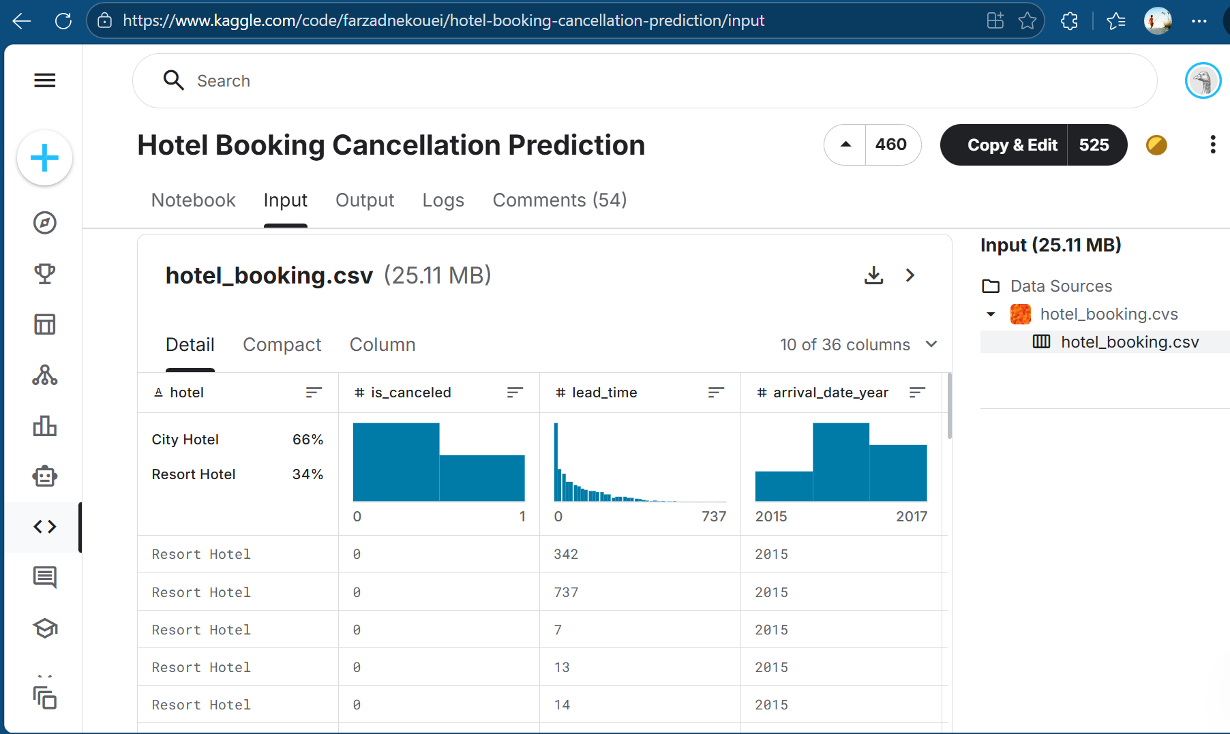
7. Data Preprocessing (Milestone 2)
Before performing analysis, the dataset underwent several preprocessing steps to ensure data quality and consistency.
Data Cleaning
Missing values were identified and handled appropriately. Some missing records were replaced using logical values, while others were removed when necessary.
Removing Duplicate Records
Duplicate records were identified and removed to ensure the accuracy of analysis.
Data Transformation
Certain columns were converted into appropriate formats, especially date fields, to allow time-based analysis.
Creating Calculated Fields
Additional calculated columns and measures were created to support KPI calculations such as:
• Total revenue
• Average daily rate
• Occupancy rate
• Cancellation rate
These preprocessing steps ensured that the dataset was prepared for meaningful analysis.

8. Data Modeling (Milestone 2)
Data modeling is an important step in business intelligence projects because it organizes the dataset in a way that allows efficient querying and analysis.
In Power BI, relationships were created between different tables and calculated measures were defined using DAX (Data Analysis Expressions).
Key aspects of the data model include:
• Defining relationships between tables
• Creating measures for revenue and booking metrics
• Structuring the dataset to improve performance
• Ensuring consistency in calculations across dashboards
The data model forms the foundation for building interactive dashboards.
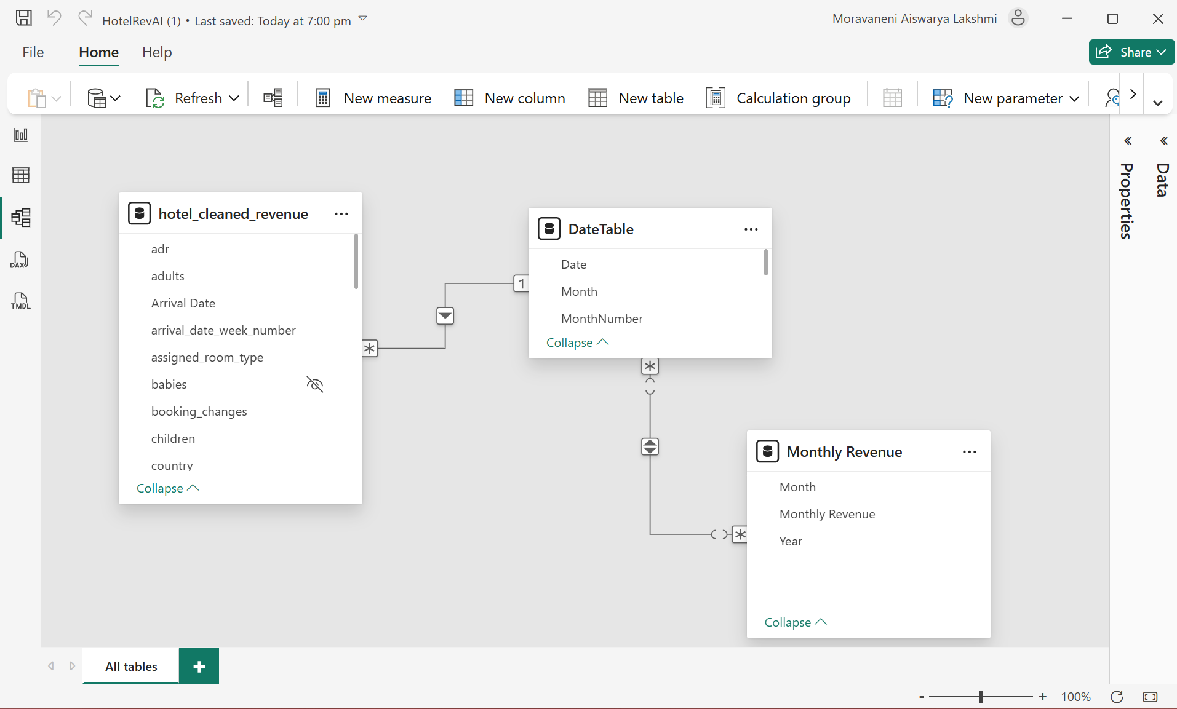
9. Key Performance Indicators (KPIs)
To measure hotel performance effectively, several KPIs were defined.
Total Revenue
Total revenue generated from hotel bookings.
Average Daily Rate (ADR)
The average price paid per room per night.
Occupancy Rate
The percentage of available rooms that are occupied.
Total Bookings
The total number of confirmed reservations.
Cancellation Rate
The percentage of bookings that were cancelled.
Revenue Loss
Total financial loss caused by cancelled bookings.
These KPIs help hotel managers evaluate business performance and identify areas that require improvement.

10. Revenue Performance Dashboard (Milestone 3)
The Revenue Performance Dashboard provides insights into the financial performance of the hotels over time.
This dashboard includes the following visualizations:
• Total revenue generated from bookings
• Average Daily Rate (ADR) trends across months
• Comparison between city hotels and resort hotels
• Revenue distribution across customer segments
• Geographic visualization of revenue by country
The analysis shows that city hotels generate higher revenue compared to resort hotels, and revenue fluctuates based on seasonal demand.
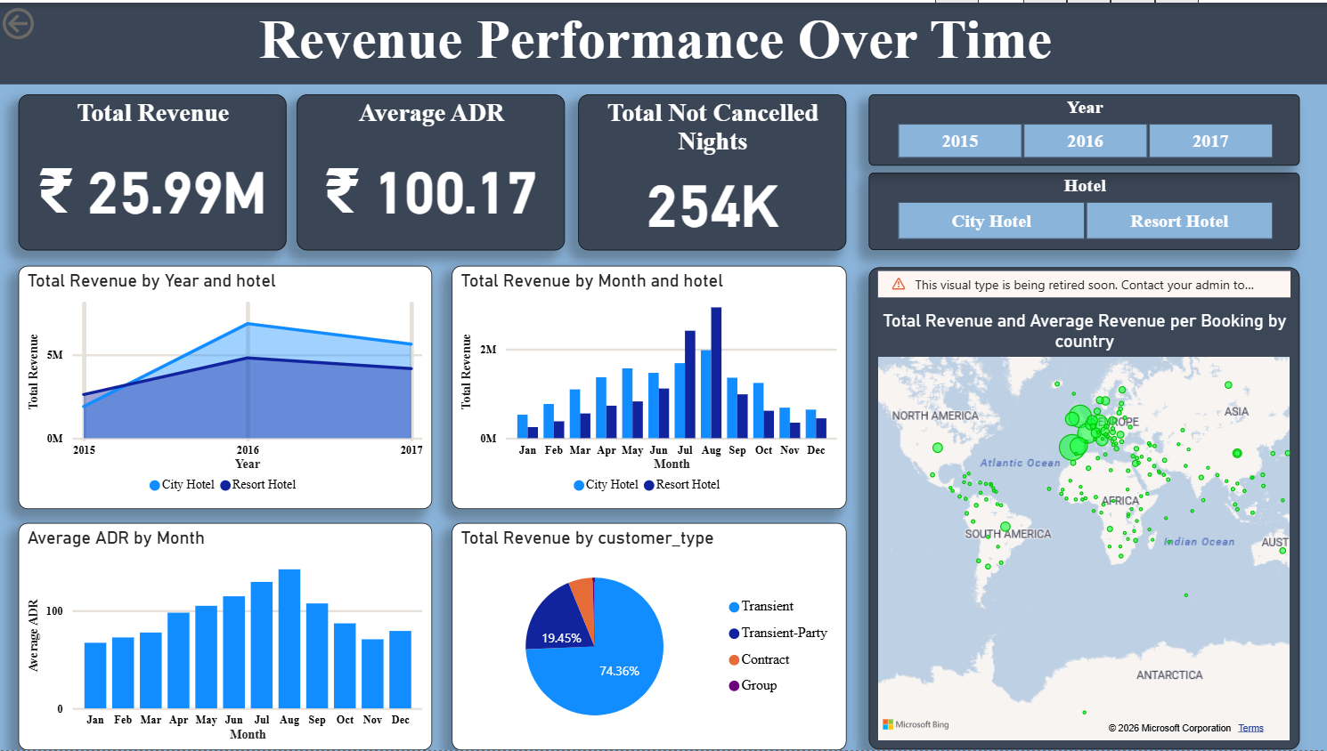
11. Occupancy and Demand Analysis
The Occupancy and Demand Analysis Dashboard focuses on understanding booking demand and room utilization.
Key metrics displayed in the dashboard include:
• Occupancy rate
• Total bookings
• Room capacity
Monthly booking trends reveal seasonal demand patterns where peak occupancy occurs during mid-year months.
The dashboard also compares occupancy rates between city hotels and resort hotels, helping hotel managers understand differences in demand.
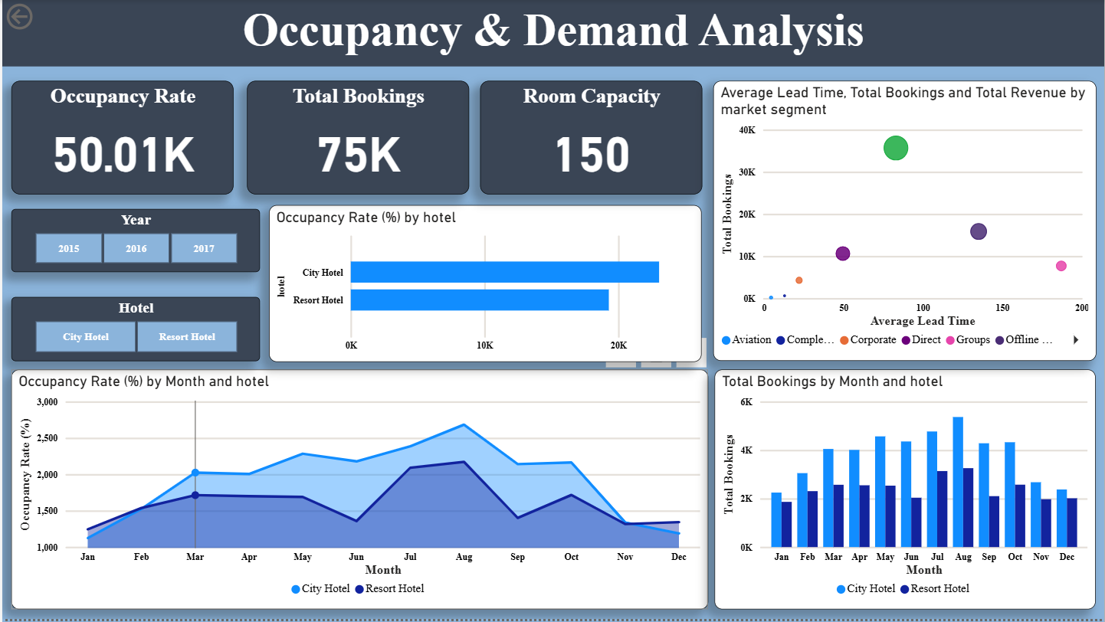

12. Cancellation Behaviour and Revenue Loss
Booking cancellations are a major challenge in the hospitality industry because they lead to significant revenue losses.
The Cancellation Behaviour Dashboard analyzes:
• Cancellation rate
• Total cancelled bookings
• Revenue lost due to cancellations
• Market segments with the highest cancellations
The analysis shows that certain booking channels, such as online travel agencies, contribute significantly to cancellations.
Additionally, bookings made far in advance tend to have a higher cancellation probability.
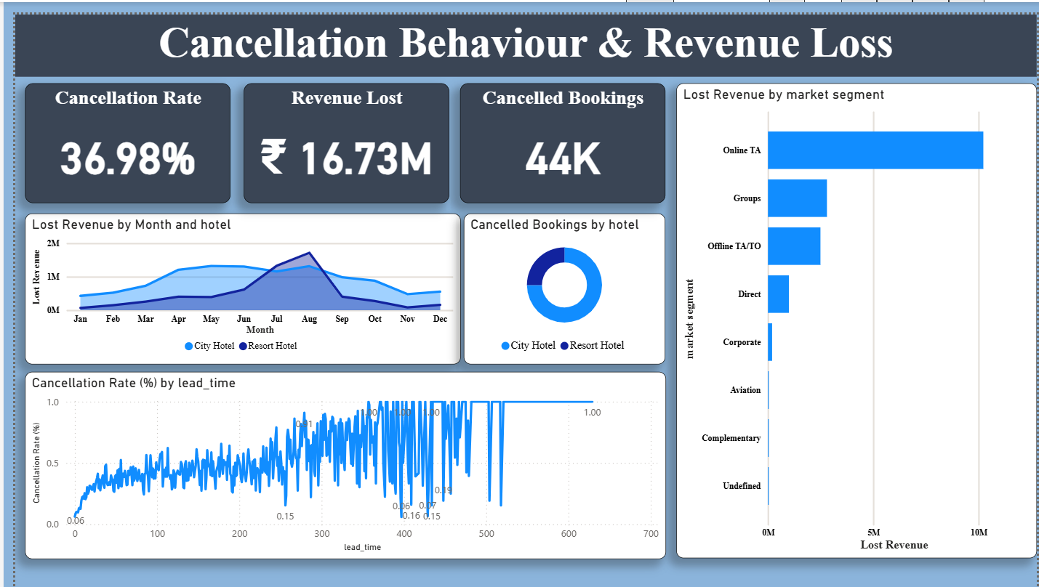
13. Revenue Forecasting (Milestone 4)
The Revenue Forecasting Dashboard predicts future revenue trends using historical booking data.
Forecasting enables hotel managers to:
• Predict future revenue patterns
• Identify expected growth trends
• Prepare for seasonal demand fluctuations
• Optimize pricing strategies
Power BI forecasting models analyze historical trends and generate projections for future revenue.
This allows hotels to improve strategic planning and financial managem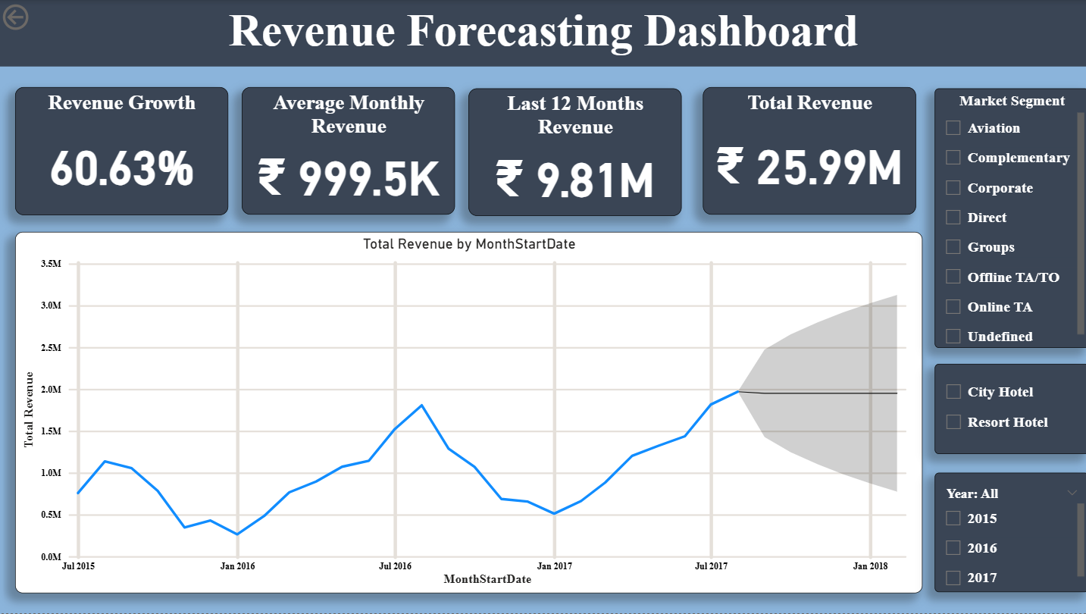
14. Key Insights
The analysis revealed several important insights:
• City hotels attract a higher number of bookings compared to resort hotels
• Revenue peaks during certain months due to seasonal travel demand
• Online booking platforms contribute significantly to hotel reservations
• Booking cancellations result in substantial revenue losses
• Forecasting indicates potential revenue growth over time
These insights can help hotels improve pricing strategies, marketing efforts, and operational planning.

15. Business Impact
The dashboards developed in this project provide valuable benefits for hotel management:
• Improved visibility into booking patterns
• Better understanding of customer segments
• Reduced financial losses due to cancellations
• Enhanced forecasting and revenue planning
• Data-driven decision making
By leveraging data analytics, hotels can optimize their operations and maximize profitability.

16. Conclusion
This project demonstrates how data analytics and business intelligence tools can transform raw booking data into meaningful insights.
Using Power BI dashboards, we successfully analyzed hotel booking patterns, revenue trends, occupancy rates, and cancellation behavior.
The project highlights the importance of data visualization and storytelling in helping organizations understand complex datasets and make informed decisions.
Overall, the project provides a practical example of how data analytics can improve business performance in the hospitality industry.

17. Future Scope
Future enhancements for this project may include:
• Integrating machine learning models for advanced demand forecasting
• Implementing dynamic pricing strategies based on demand patterns
• Developing real-time analytics dashboards
• Incorporating customer sentiment analysis from reviews
• Expanding the dataset to include additional hotels and time periods
These improvements can further enhance the effectiveness of data analytics in hotel management.

