Infosys Springboard Virtual Internship 6.0 Completion Report

Team Details
Batch Number: 13(group-2/ team-b)
Start date: 2 February 2026
Names: Moravaneni Aiswarya Lakshmi
Syed Naveed Muzammil
Lakshmi kalyani Akula
Internship Duration: 8 Weeks

1. Project Title: HotelRevAI AI Driven Revenue Analysis for Hotels

2. Project Objective
The main objective of this project is to analyze hotel booking data to understand revenue trends, customer behavior, and booking patterns using Power BI.
The project aims to develop interactive dashboards that help hotel management:
- Monitor revenue performance
- Analyze occupancy trends
- Identify customer segments
- Evaluate cancellation behavior
- Predict future revenue using forecasting
This project is relevant to the hospitality industry as it enables data-driven decision-making and improves operational efficiency.

3. Project description in detail
This project focuses on analyzing hotel booking data using Power BI, a business intelligence tool used for data visualization and analytics.
Approach
The project was executed in multiple stages:
- Data Collection
The dataset was collected from Kaggle and contains hotel booking data from 2015 to 2017 for both city hotels and resort hotels.
- Data Cleaning and Preprocessing
  - Handled missing values
  - Removed duplicate records
  - Converted data types
  - Created calculated columns such as total nights and revenue
- Data Modeling
  - Established relationships between tables
  - Created measures using DAX
  - Designed a structured data model
- Dashboard Development
Developed multiple dashboards:
  - Revenue Performance Dashboard
  - Occupancy & Demand Analysis
  - Cancellation Behaviour Analysis
  - Revenue Forecasting Dashboard
- Visualization & Storytelling
The dashboards were designed to present insights clearly and support business decision-making.
- AI & Forecasting
Power BI forecasting was used to predict future revenue trends based on historical data.
Technologies Used
- Power BI
- DAX (Data Analysis Expressions)
- Kaggle Dataset
- Data Visualization Techniques
Real-World Impact
This project can help hotel managers:
- Optimize pricing strategies
- Improve occupancy planning
- Reduce revenue losses due to cancellations
- Predict future demand

4. Timeline Overview
Week | Activities Planned | Activities Completed
Week 1 | Understanding project and dataset | Collected dataset and explored data
Week 2 | Data cleaning and preprocessing | Handled missing values and formatted data
Week 3 | Data modeling | Created relationships and measures
Week 4 | KPI development | Defined revenue, ADR, occupancy metrics
Week 5 | Dashboard creation | Built revenue and occupancy dashboards
Week 6 | Advanced dashboards | Built cancellation and forecasting dashboards
Week 7 | Insights and storytelling | Derived business insights
Week 8 | Final documentation & PPT | Completed report and presentation

5a. Key Milestones
Milestone | Description | Date Achieved
Project Kickoff | Started internship and selected project | 5 February 2026
Prototype/First Draft | Completed data modeling and KPIs | 11 February 2026
Mid-Term Review | Initial dashboards created | 20 February 2026
Final Submission | Completed dashboards and report | 13 March 2026
Presentation | Presented project to mentor | 24 March 2026

5b. Project execution details
The project was executed using a structured workflow.
- Initially, the dataset was collected and cleaned to ensure accuracy. Missing values were handled and unnecessary data was removed.
- Next, data modeling was performed in Power BI by establishing relationships between tables and creating calculated measures using DAX.
- After modeling, multiple dashboards were developed to visualize key metrics such as revenue, occupancy, and cancellations.
- Finally, forecasting techniques were applied to predict future revenue trends. Insights were derived from the dashboards to support decision-making.
.

6. Snapshots / Screenshots
.
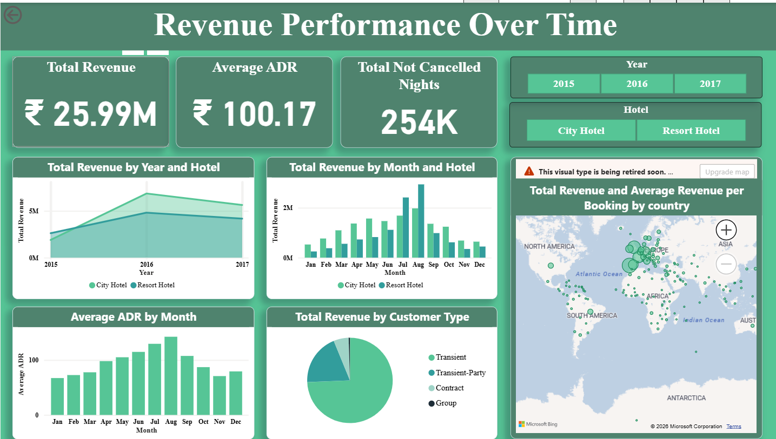

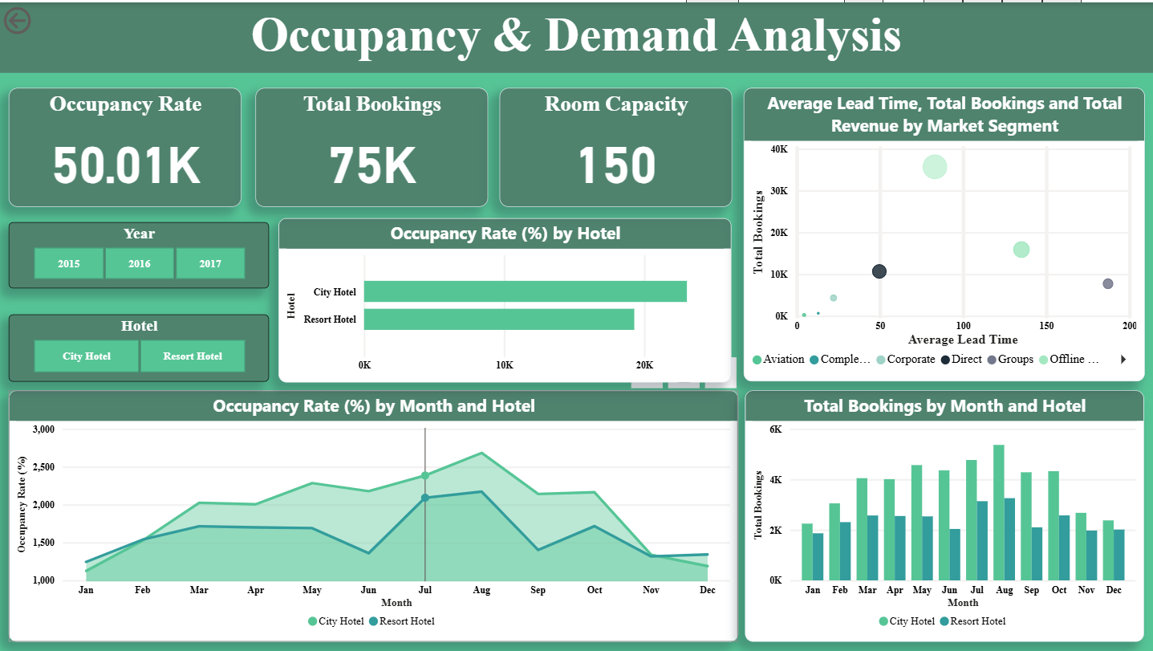
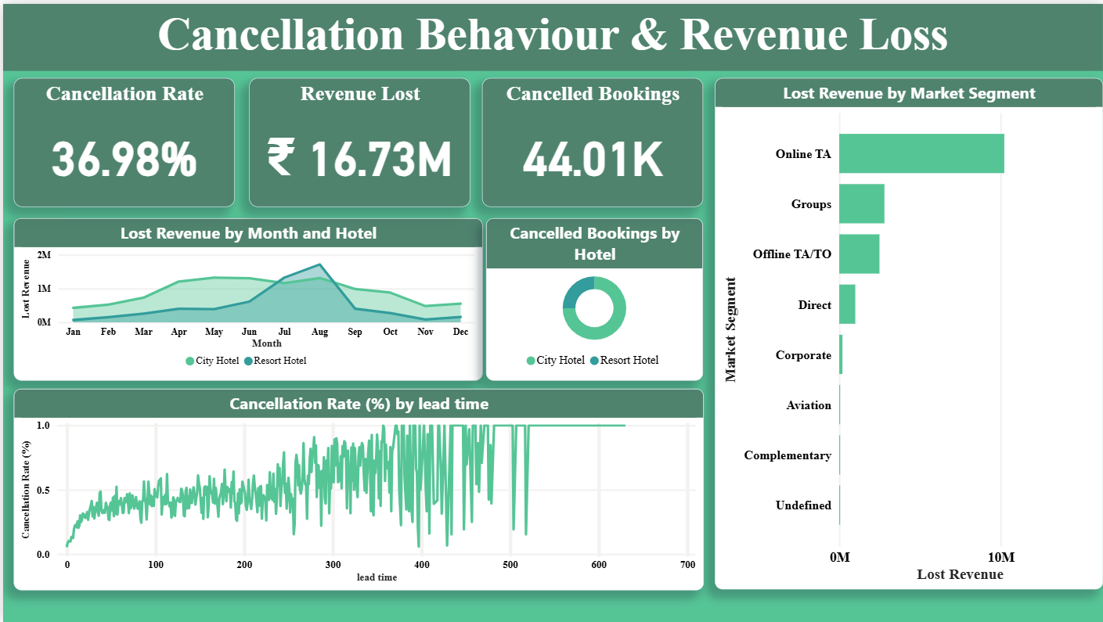
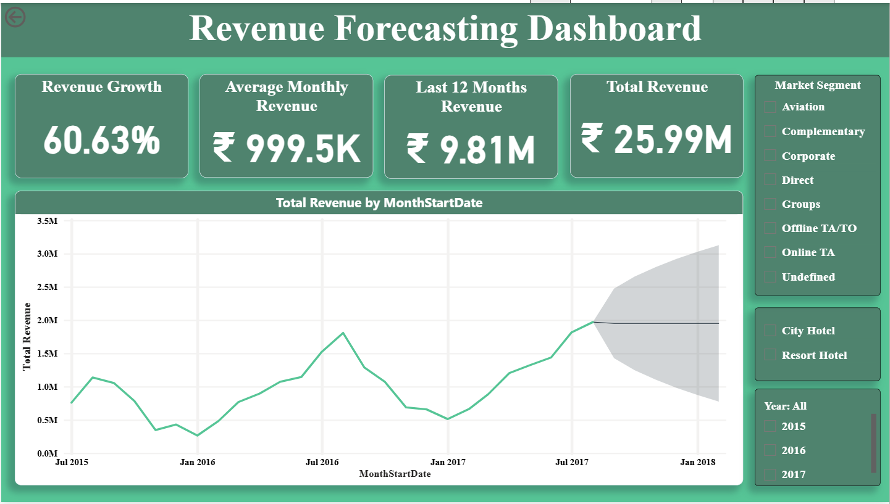

Challenges Faced
During the project, several challenges were encountered:
- Handling missing and inconsistent data
- Understanding Power BI data modeling
- Writing DAX formulas for calculations
- Designing meaningful dashboards
- Interpreting insights from large datasets
These challenges were resolved through practice, online resources, and continuous learning.

8. Learnings & Skills Acquired
Highlight Through this internship, the following skills were gained:
Technical Skills
- Power BI dashboard development
- Data cleaning and preprocessing
- Data modeling and DAX
- Data visualization techniques
- Forecasting and trend analysis

9. Testimonials from team
Working on this project as a team was a valuable learning experience.
We collaborated effectively to complete different stages of the project, from data preprocessing to dashboard development.
This project helped us improve our technical skills and gain practical knowledge in data analytics.

10. Conclusion
This internship project provided hands-on experience in data analytics and visualization using Power BI.
By analyzing hotel booking data, we gained insights into revenue trends, occupancy patterns, and cancellation behavior.
The dashboards developed in this project demonstrate how data-driven insights can help businesses improve decision-making and operational efficiency.
Overall, this internship has strengthened our understanding of real-world data analytics applications.

11. Acknowledgements
We would like to express our sincere gratitude to Infosys Springboard for providing this internship opportunity.
We also thank our mentor for their valuable guidance and support throughout the project.
We appreciate our team members for their collaboration and contribution to the successful completion of this project.

