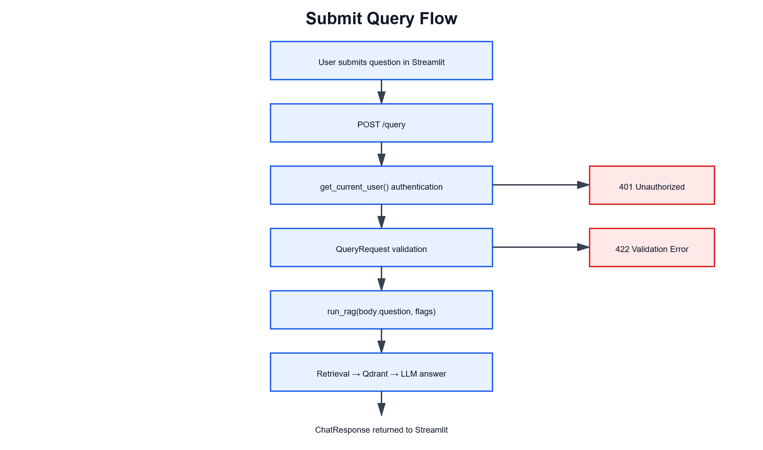

@router.post("/query", response_model=ChatResponse)
async def query(

- Authenticate using get_current_user().
- Validate the JSON as QueryRequest.
- Access the question using body.question.
- Call run_rag(...).
- Return the result as a ChatResponse.

ep | Code | Result
1 | _flag_top_k_from_flags(flags) | top_k = 3
2 | embed_texts([question]) | [[0.012, -0.045, ...]]
3 | embeddings[0] | Inner question vector
4 | search(embeddings[0], top_k=3) | Three matching document chunks
5 | build_spotlighted_context(chunks) | Context prepared for the LLM
6 | build_system_prompt() | LLM instructions created
7 | generate(system, user_msg) | LLM answer generated
8 | ChatResponse(...) | Final API response returned

question = "What is retrieval augmented generation?"
flags = {"top_k": 3}

response = run_rag(question, flags)

[
RetrievedChunk(
text="RAG combines document retrieval with language generation.",
source="rag-guide.pdf",
score=0.94
),
RetrievedChunk(
text="A vector database stores document embeddings.",
source="vector-db.pdf",
score=0.88
)
]

{
"answer": "Retrieval augmented generation combines document retrieval with language generation to provide context-aware answers.",
"sources": [
"rag-guide.pdf",
"vector-db.pdf"
],
"confidence": 0.7,
"metadata": {
"route": "rag",
"retrieved_chunks": []
}
}

Sample response

