***Question 1: Given some sample data, write a program to answer the following: click here to access the required data set***

On Shopify, we have exactly 100 sneaker shops, and each of these shops sells only one model of shoe. We want to do some analysis of the average order value (AOV). When we look at orders data over a 30 day window, we naively calculate an AOV of $3145.13. Given that we know these shops are selling sneakers, a relatively affordable item, something seems wrong with our analysis.

**a)Think about what could be going wrong with our calculation. Think about a better way to evaluate this data.**

Error in the calculation is because we are using count() instead of sum() for getting the total number of items.

sum() function calculates the total of all numerical values in an iterable.

count() will just count number of rows.

Correct way to calculate AOV is: To calculate the sum of the column ‘order_amount’ divided by the sum of the column ‘total_items’

**b)What metric would you report for this dataset?**

Correct way to calculate AOV is:

To calculate the sum of the column ‘order_amount’ divided by the sum of the column ‘total_items’.

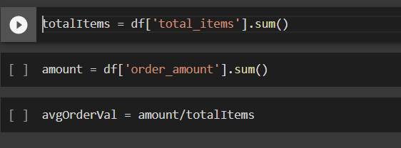

**c)What is its value?**

357.92152221412965

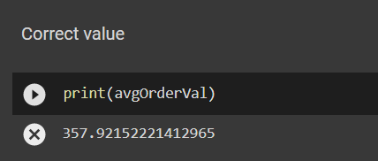

***Question 2: For this question you’ll need to use SQL. Follow this link to access the data set required for the challenge. Please use queries to answer the following questions. Paste your queries along with your final numerical answers below.***

**a)How many orders were shipped by Speedy Express in total?**

SELECT O.OrderID FROM [OrderDetails] OD  
INNER JOIN [Orders] O  
ON OD.OrderID = O.OrderID  
WHERE O.ShipperID = 1;

**Number of orders shipped by Speedy Express is 149**

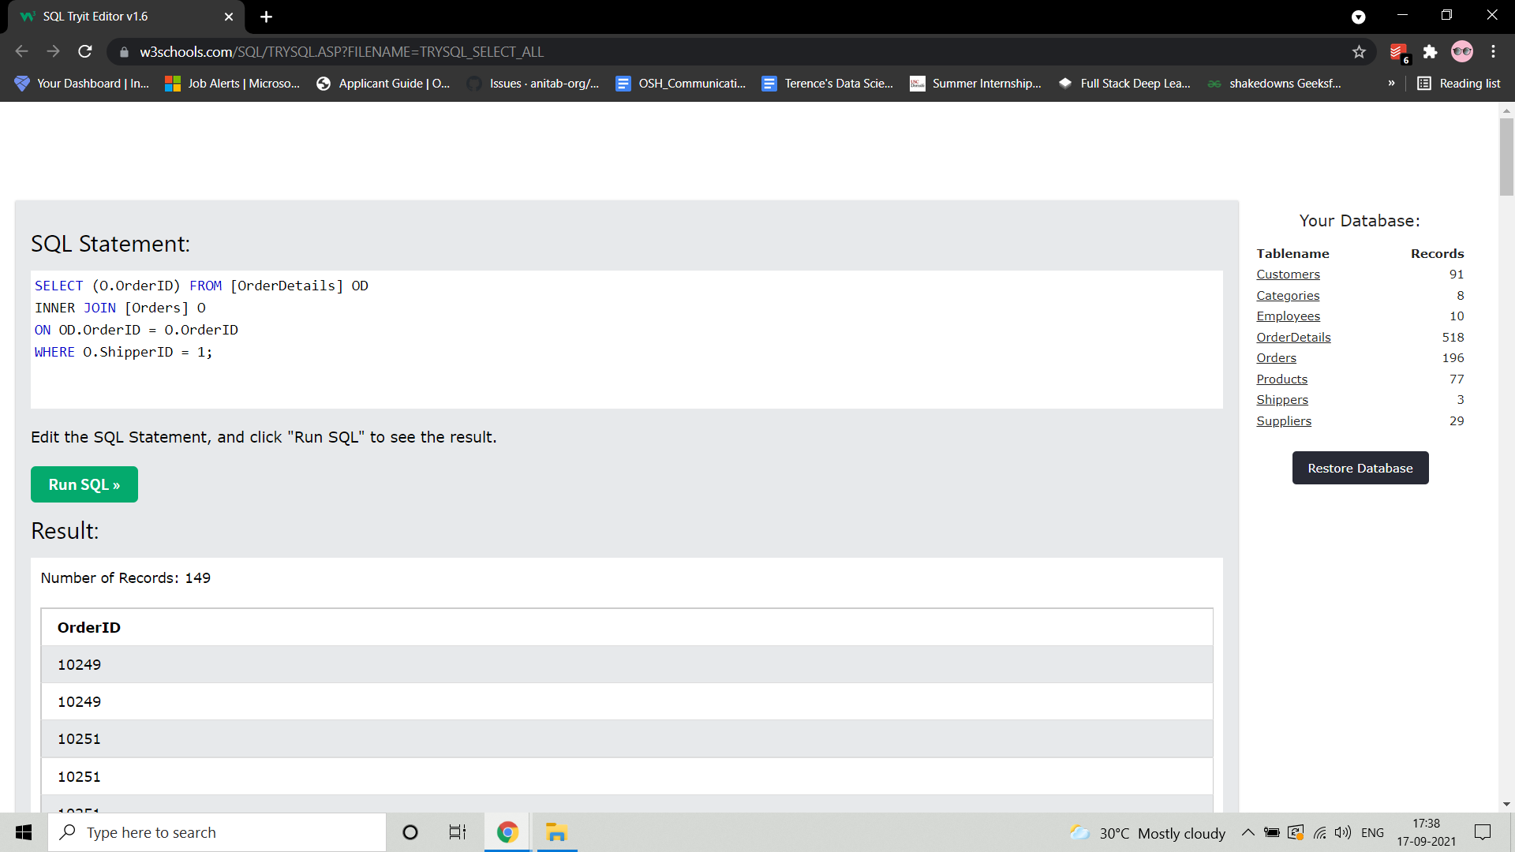

**b)What is the last name of the employee with the most orders?**

SELECT * FROM [Employees] E  
INNER JOIN [Orders] O  
ON E.EmployeeID = O.EmployeeID  
GROUP BY LastName  
ORDER BY COUNT(*) DESC

**Last name of the employee with the most orders is Peacock.**

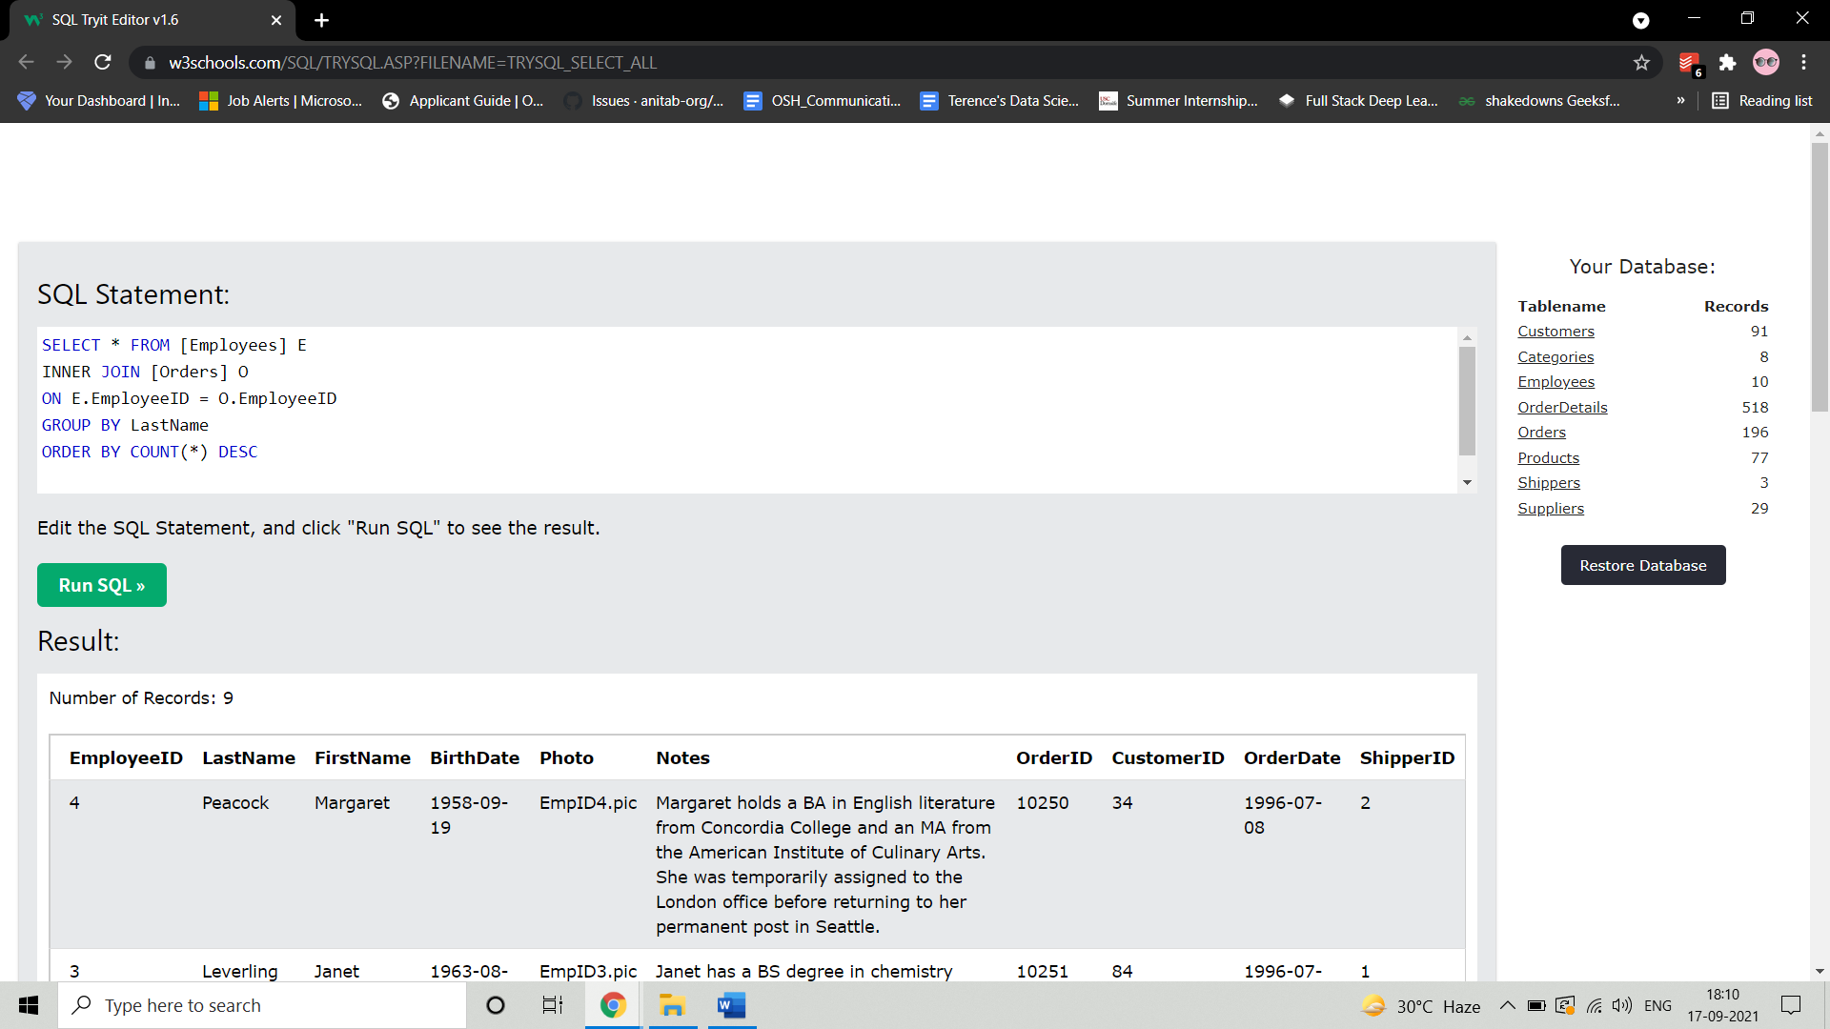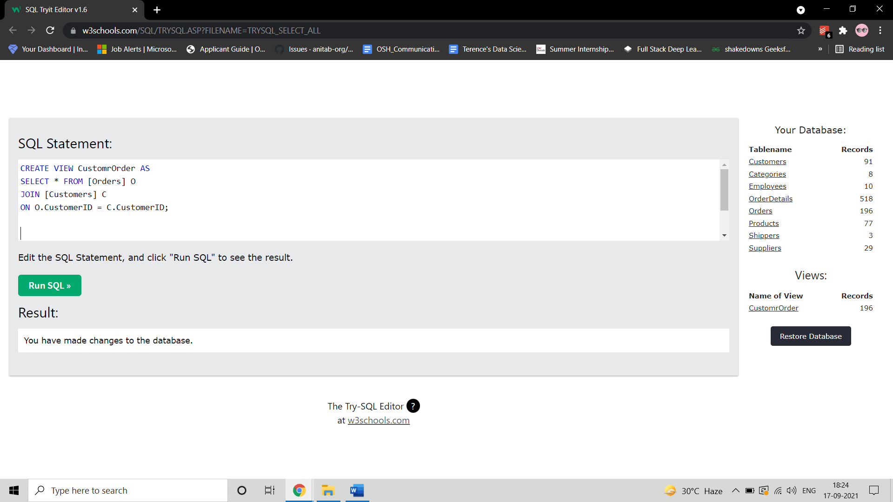

**c)What product was ordered the most by customers in Germany?**

CREATE VIEW CustomOrder AS

SELECT * FROM [Customers] C  
INNER JOIN [Orders] O  
ON C.CustomerID = O.CustomerID

CREATE VIEW ProdOrderDetails AS

SELECT * FROM [Products] P  
INNER JOIN [OrderDetails] OD  
ON P.ProductID = OD.ProductID

SELECT P.ProductID, P.ProductName, P.Quantity, C.Country  
FROM [ProdOrderDetails] P  
JOIN CustomOrder C  
ON C.OrderID = P.OrderID  
WHERE Country = 'Germany'  
GROUP BY ProductID  
ORDER BY SUM(Quantity) DESC, ProductName ASC

**Product ordered the most by customers in Germany is Boston Crab Meat.**



