Prototype-Ready / Concept Design Files
- CAD and Mechanical Design :
The Smart Pen and Holographic Pin were designed as two physically independent but electronically linked devices.
The Smart Pen was modeled as a multi-part cylindrical tool consisting of:
-Outer metal shell
-Internal plastic support sleeves
-Rubber grip
-Ink cartridge (D1 standard)
-Internal PCB stack
-Sensor and battery housing
The CAD was created in a parametric design environment so that length, diameter, and shell thickness can be easily adjusted for ergonomics and manufacturing. The pen design supports real ink refills so it can be used on normal paper.
The Holographic Pin was designed as a compact cylindrical wearable module. It contains:
- An internal structural frame
- A stacked electronics layout
- A magnetic mounting system for wearing on clothing

- A rigid outer shell

- Exploded Views
Exploded CAD views were created for both devices showing:
- Outer housing
- Internal support frames
- Sensor modules
- PCBs
- Battery
- Mechanical components
These exploded views allow anyone to understand how the device is assembled and how each electronic component fits inside the mechanical structure. The exploded views also make it possible to manufacture or repair the devices.

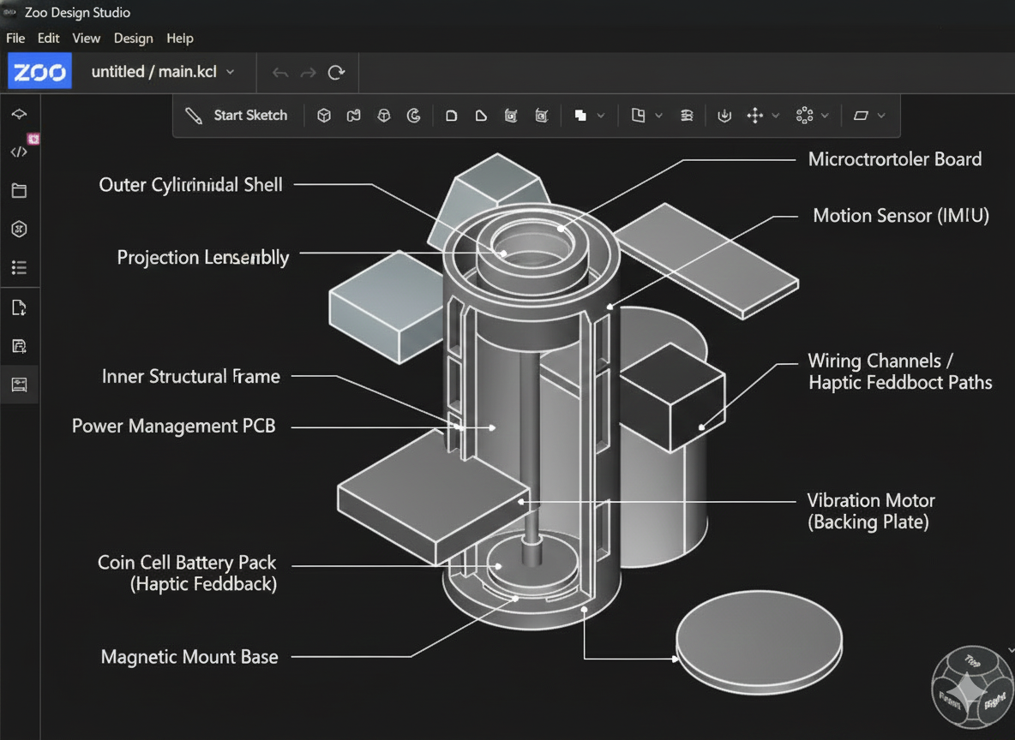
Exploded view and labelling diagram for the holographic pin:

Exploded view and labelling of the Smart pen :
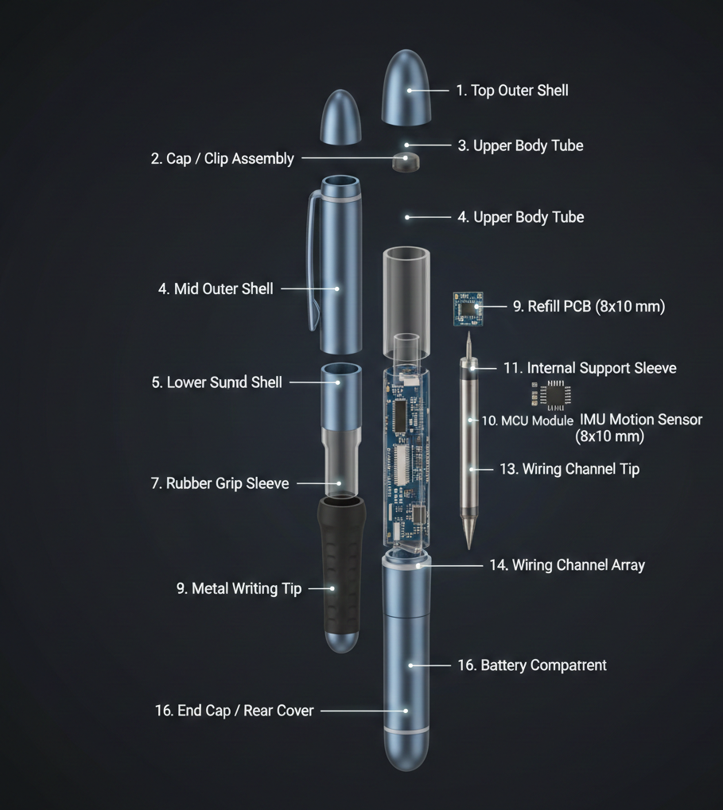

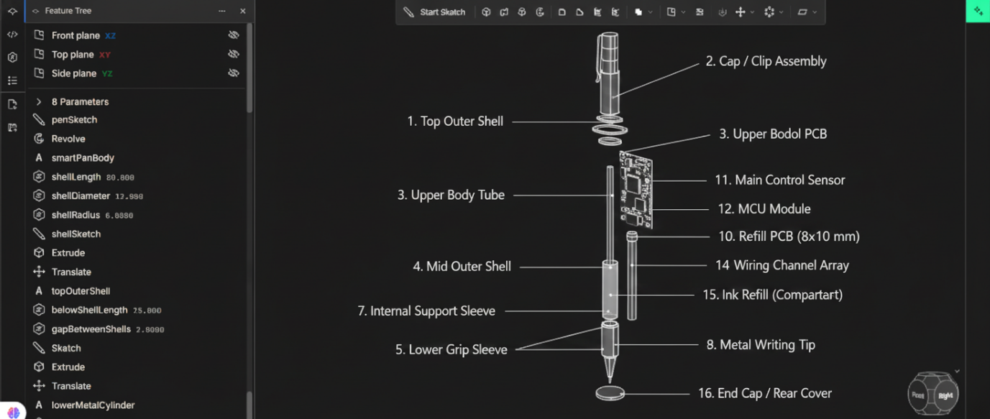

- Manufacturing / Fabrication
The prototype version of both devices can be manufactured using:
- 3D printed plastic frames
- CNC-machined or 3D-printed shells
- Standard PCBs
- Off-the-shelf electronic components
For scaling:
- The plastic parts can be injection-molded
- The metal shells can be extruded or CNC-machined
- The electronics can be mass-produced on standard PCB assembly lines
No proprietary or copyrighted hardware designs are copied — all parts are based on generic mechanical and electronic modules.
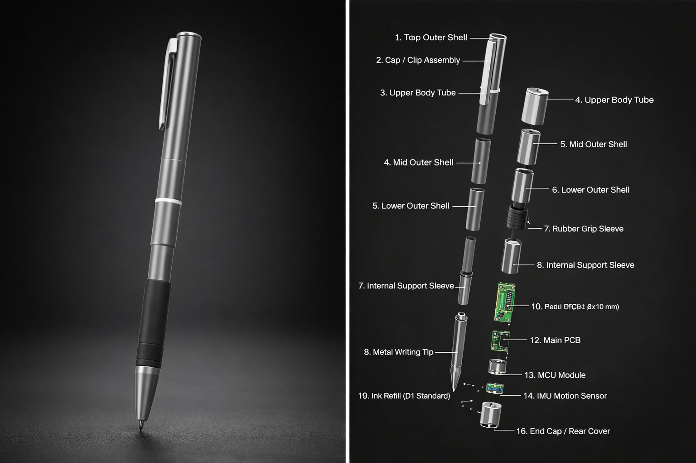

2. Technical System Documentation
2.1 Component and Circuit Layout
The system consists of two electronic devices: the Smart Pen and the Holographic Pin. Each device has its own microcontroller and sensors, and they communicate wirelessly.
Smart Pen electronics:
The Smart Pen contains:
- A microcontroller (MCU) to read sensor data
- An IMU (gyroscope + accelerometer) to track pen movement
- A pressure sensor in the tip to detect how hard the pen is pressed
- A small Bluetooth module for wireless data transmission
- A rechargeable battery
These components are placed on a compact PCB that fits inside the pen body. The IMU is placed near the center of the pen to get stable motion readings, and the pressure sensor is located near the tip to accurately measure writing force.
Holographic Pin electronics:
The Holographic Pin contains:
- A microcontroller
- An IMU for tracking hand and body movement
- A small camera or IR sensor for hand detection
- A projection or display module for holographic output
- A Bluetooth / Wi-Fi module
- A battery and power management circuit
These components are stacked inside the cylindrical pin housing. The projection module is placed at the front, while the electronics and battery are placed behind it to keep the device balanced when worn.

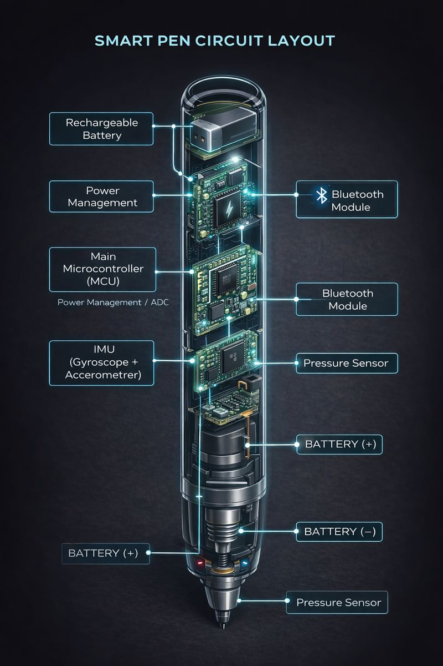
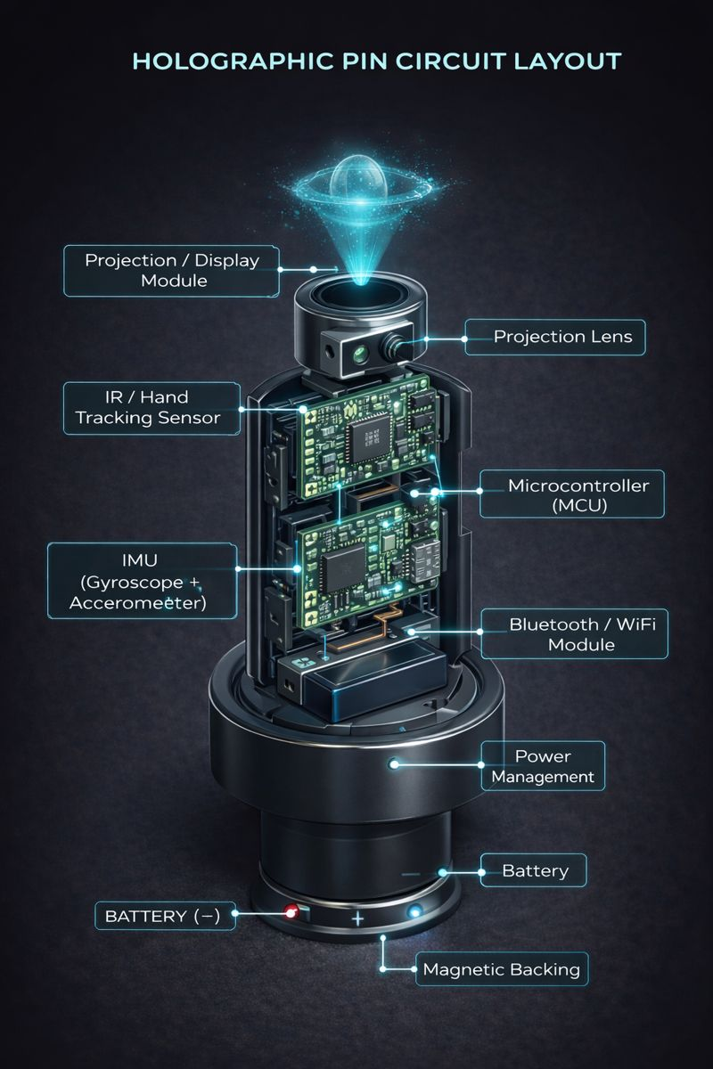
2.2 Firmware and Software Flow (Gesture → Signal → Output)
The system works by combining data from both devices.
1.When the user writes on paper or in the air, the Smart Pen measures:
- Movement of the pen
- Pressure applied
- Tilt and direction
2. The Smart Pen sends this data wirelessly to the Holographic Pin.
3. At the same time, the Holographic Pin tracks:
- Hand position
- Arm and body movement
- Orientation of the pen in space
4. The Holographic Pin runs a sensor fusion algorithm that combines:
- Pen motion data
- Hand position data
5. This creates a 3D digital stroke that represents what the user is writing or drawing.
6. The result is displayed as a holographic drawing in front of the user and can also be sent to a connected computer, tablet, or cloud application.
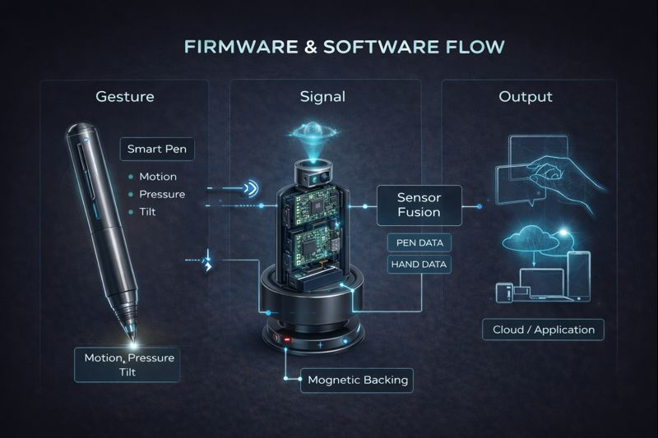

2.3 Motion Tracking and Calibration Method
The system uses two levels of motion tracking.
The Smart Pen provides high-precision tracking of small movements, which is ideal for handwriting and drawing. The IMU inside the pen measures acceleration and rotation, while the pressure sensor ensures the system knows when the pen is touching a surface.
The Holographic Pin provides larger-scale spatial tracking. Its IMU and optical sensor track the position of the user’s hand and the pen in 3D space.
During calibration:
- The user holds the pen still in front of the pin
- The system sets this as the zero reference
- Small test strokes are used to align pen motion with hand position
This helps reduce drift and improves accuracy when writing or drawing in the air.

Cost Breakdown & Sourcing Strategy
Bill of Materials (BOM)
Smart Pen
Component | Description | Est. Cost (USD)
Microcontroller (MCU) | Small low-power MCU (ESP32 / nRF52 class) | $3
IMU Sensor | 6-axis Gyro + Accelerometer (MPU6050 class) | $2
Pressure Sensor | Force sensitive resistor in pen tip | $1
Bluetooth Module | BLE integrated with MCU | Included
Battery | Small Li-ion / Li-Po cell | $2
Charging Circuit | USB charging IC | $1
PCB | Custom small PCB | $3
Ink Refill | D1 standard refill | $0.50
Mechanical Parts | Shell, grip, support sleeves | $4

Smart Pen Prototype Cost ≈ $16–18

Holographic Pin
Component | Description | Est. Cost (USD)
Microcontroller | Main processing unit | $4
IMU Sensor | Motion tracking | $2
IR Camera / Sensor | Hand detection | $6
Projection Module | Mini LED / laser projector | $12
Lens Assembly | Focus lens | $3
Wireless Module | Wi-Fi / Bluetooth | $3
Battery | Rechargeable cell | $4
Power Circuit | Voltage regulation | $2
PCB | Main board | $4
Magnets & Housing | Mounting and shell | $4

Holographic Pin Prototype Cost ≈ $40–45

Total Prototype System Cost
Smart Pen + Pin ≈ $55–65
This is very reasonable for a first working prototype.

Cost Tiers
Stage | Cost
Prototype (hand-built, 3D printed) | ~$60 per unit
Small batch (100 units) | ~$35 per unit
Scaled manufacturing (1000+ units) | ~$18–25 per unit

Costs drop because:
- PCBs become cheaper
- Plastic parts become injection-molded
- Components bought in bulk
Component Sourcing Strategy:
All components are chosen from open, common suppliers:
- Microcontrollers: ESP32 / Nordic / STM32 (Digikey, Mouser, LCSC)
- IMU sensors: MPU6050, ICM-20948
- Pressure sensors: FSR from Adafruit / SparkFun
- Projector modules: mini LED projectors (Alibaba, Seeed)
- PCBs: JLCPCB / PCBWay
- Batteries: standard Li-Po cells
- Housing: 3D printed (prototype) → injection molded (scale)
No copyrighted or locked hardware is used. Everything is replaceable and open-market.

Innovation Rationale
Most learning and creative tools today force users to switch between physical writing and digital screens. Students write on paper but lose digital benefits, while tablets remove the natural feeling of pen and hand movement. This breaks focus, slows learning, and limits creativity. Our Smart Pen + Holographic Pin system solves this by allowing users to write naturally while seeing and saving their work digitally in real time.
The Smart Pen captures fine-grained motion, pressure, and tilt during writing or drawing. At the same time, the Holographic Pin worn on the body tracks hand position and orientation in space. By fusing these two data sources, the system creates accurate 3D digital strokes that appear as holograms and can be saved, shared, or edited on any device. This allows users to write on paper, draw in the air, or sketch in three dimensions without needing a screen.
The design is feasible and scalable because it uses only off-the-shelf components such as IMU sensors, microcontrollers, Bluetooth modules, small projectors, and standard batteries. The mechanical parts can be 3D-printed for prototypes and later injection-molded for mass production. No custom silicon or expensive sensors are required, making the system easy to manufacture and repair.
The expected tracking resolution is sub-millimeter for pen strokes using the pen IMU and pressure sensor, and centimeter-level accuracy for hand position using the holographic pin’s motion and optical sensors. Latency is expected to be below 50 milliseconds, which is fast enough for real-time writing and holographic display without noticeable lag. Use cases include note-taking, design sketching, math and science visualization, remote teaching, and spatial brainstorming.
This device benefits:
- Students who want to take handwritten notes that instantly become digital
- Artists and designers who sketch in 3D space
- Engineers who visualize shapes and diagrams
- Disabled users who need gesture-based or reduced-effort input
- Storytellers and teachers who want to present ideas visually
The system can expand into a full platform with cloud syncing, AI handwriting cleanup, digital whiteboard integration, and support for AR/VR learning tools. Over time, software updates can add transcription, translation, and collaborative features.
Cost and Timeline Planning
For a working prototype:
- R&D and design engineering: ~$300 (mechanical + electronics design)
- PCB design and testing: ~$200
- Raw materials and components: ~$65 per unit
- Fabrication (3D printing, PCB assembly): ~$150
- Testing and calibration: ~$100
A functional prototype can be built in 4–6 weeks using student labs and local fabrication services.
At scale, costs drop significantly through bulk component purchasing and injection-molded parts, allowing the system to be sold at consumer-friendly prices.
This makes the Smart Pen + Holographic Pin not just a concept, but a realistic, buildable product for the future of learning and creativity.
For all the CAD design files of the exploded and normal views are present in this repo in STL format
https://github.com/aiswaryanayak/smartpen-and-holographicpin-combo-

