Chapter1

Introduction

The ever-growing evolution and adaptation of imageguided surgeries and interventions  
(IGI) underscore the need for effective and intuitive visualization and use of three-dimensional  
(3D) or multi-slice imaging sets for diagnosis and planning procedures. Procedure plan-  
ning requires accurate mapping of the spatial relationships between anatomical structures  
to accurately target the tissue-of-interest and avoid harming healthy tissue or vital struc-  
tures (such as blood vessels). In neurosurgery, magnetic resonance imaging (MRI) is a  
valuable modality offering features important for surgical planning: a plethora of contrast  
mechanisms, operator-selected orientation and position of multi-slice and true-3D scan-  
ning, and an inherent coordinate system generated by the native magnetic field gradients  
of the scanner. State-of-the-art scanners further enable interactive computer control of  
the imaging parameters on-the-fly while images are collected. This level of interactive  
processing during procedures makes MRIs unique.

* 1. Acquisition of Real-time information  
     Today augmented reality devices allow physicians to incorporate data visualization into  
     diagnostic and treatment procedures to improve work efficiency, safety, and cost and to  
     enhance surgical training. The latest development in medical imaging technology focuses on  
     the acquisition of real-time information and data visualization. Improved accessibility of  
     real-time data is becoming increasingly important as their usage often makes the diagnosis and treatment faster and more reliable. This is especially true in surgery, where the real-  
     time access to 2D or 3D reconstructed images during an ongoing surgery can prove to be  
     crucial. This access is further enhanced by the introduction of augmented reality (AR)—a  
     fusion of projected computer-generated (CG) images and real environment.
  2. AR in Surgery

The first experiments with medical images date back to the year 1895, when W. C. Röntgen discovered the existence of X-ray. This marks the starting point of using medical images in the clinical practice. The development of ultrasound (USG), computed tomography (CT), magnetic resonance imaging (MRI), and other imaging techniques allows physicians to use two-dimensional (2D) medical images and three-dimensional (3D) reconstructions in diagnosis and treatment of various health problems. Further development of medical technology has given an opportunity to combine anatomical and functional (or physiological) imaging in advanced diagnostic procedures, that is, functional MRI (fMRI) or single photon emission computed tomography (SPECT/CT). These methods allowed physicians to better understand both the anatomical and the functional aspects of a target area.

The ability to work in symbiosis with a computer broadens horizons of what is possible in surgery, as AR can alter the reality we experience in many ways. The wide range of possibilities it offers to surgeons challenges us to develop new techniques based on AR. In the future, AR may fully replace many items required to perform a successful surgery today, that is, navigation, displays, microscopes, and much more, all in a small wearable piece of equipment. However, the awareness of AR implementation and what it may offer is generally low, as at current state, it cannot fully replace most of long established surgical methods. The main aim of this work is to focus on the latest trends of the rapidly developing connection between augmented reality and surgery.

An increasing amount of research has focused on using augmented reality (AR) in

image-guided surgery (IGS) applications. In AR, real and virtual objects are combined

into a comprehensive visualization. In image-guided surgery (IGS) the virtual objects

correspond to patient-specific models, plans and preoperative images. The real world

corresponds to the surgical field of view, which may be captured using an external

camera, surgical microscope or endoscope. This real world is then merged with the

virtual objects to create the augmented visualization. The motivation behind using

augmented reality in IGS is twofold: (i) AR provides a visualization that maps the

preoperative images from the IGS (or navigation) display onto the patient, and (ii) AR

allows the surgeon to see pertinent anatomy below the visible surface of the patient. AR

visualizations therefore, have the potential to improve the surgical workflow, allow for

easier intraoperative planning, and improve surgical guidance to the anatomy of interest

thus contributing to the minimization of the invasiveness of these procedures.

* 1. MRI Scanner

Magnetic resonance imaging (MRI) is a medical imaging technique that uses a magnetic field and computer-generated radio waves to create detailed images of the organs and tissues in your body.

Most MRI machines are large, tube-shaped magnets. When you lie inside an MRI machine, the magnetic field temporarily realigns water molecules in your body. Radio waves cause these aligned atoms to produce faint signals, which are used to create cross-sectional MRI images — like slices in a loaf of bread.

The MRI machine can also produce 3D images that can be viewed from different angles.

Types of MRI

* Open Mri
* Closed MRI

An open (or “open bore”) MRI refers to the type of machine that takes the images. Typically, an open MRI machine has two flat magnets positioned over and under you with a large space between them for you to lie. This allows for open space on two sides and alleviates much of the [claustrophobia](https://my.clevelandclinic.org/health/diseases/21746-claustrophobia) many people experience with closed-bore MRI machines.

However, open MRIs don’t take as clear images as closed-bore MRI machines. Closed-bore MRI machines have a ring of magnets that forms an open hole or tube in the middle where you’d lie to get the images. Closed-bore MRIs are narrow with tight head-to-ceiling space. This can cause anxiety and discomfort for some people, but these MRI machines take the best quality images.

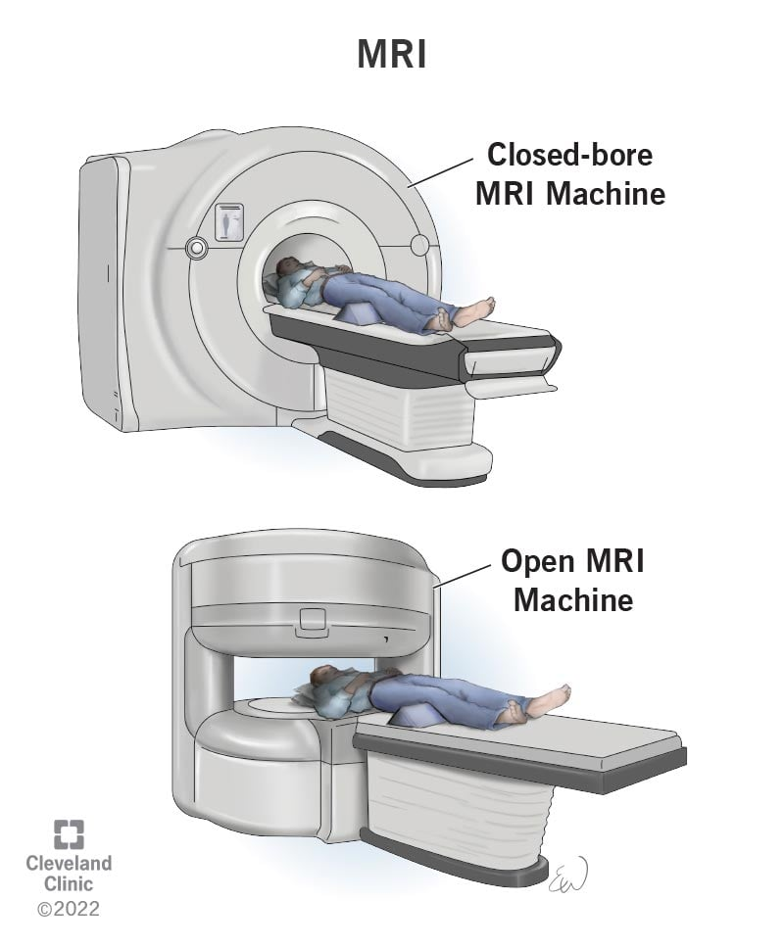

In neurosurgery, magnetic resonance imaging (MRI) is a valuable modality offering features important for

surgical planning: a plethora of contrast mechanisms,

operator-selected orientation and position of multi-slice

and true-3D scanning, and an inherent coordinate system

generated by the native magnetic field gradients of the

scanner [8–12]. State-of-the-art scanners further enable

interactive computer control of the imaging parameters

on-the-fly while images are collected. This level of

interactive processing during procedures makes MRIs

unique

Chapter 2

Challenges in Existing System

While MRI guidance offers a vast volume of 3D

information, clinical practitioners need to view and plan

in two-dimensional (2D) displays. A significant challenge

for clinicians is to mentally extract 3D features and their

spatial relationships by viewing multiple 2D MRI slices

from 3D or multi-slice sets [17, 20–22]. Understanding

the complex 3D architecture of the tissue, especially

considering multi-contrast 3D imaging data sets, is

challenging and time-consuming. Many groundbreaking

rendering techniques have been introduced to enable 3D

visualization, such as maximum intensity projections

in angiography and virtual colonoscopy or angioscopy

(e.g., [2–4] and references therein), but 2D visualization

remains the standard practice. Augmented reality (AR)

visualization has been hailed as a potential solution to the

above challenges. By fusing and co-registering images,

segmented anatomical structures, patient models, vital

signs, and other data into a combined model projected

onto the physical world, information is contextualized.

Most recently, this concept of operator immersion

into information has been further enhanced with AR

holographic scenes through head-mounted displays

(HMD). Furthermore, because these are wireless devices,

they become practical for use in the operating room (OR).

A growing number of pioneering studies demonstrate

the potential of AR through HMD in different medical

domains, including IGI

Chapter 3

Proposed System

This work introduces a generic computational platform

that establishes a data and command pipeline that integrates

the MRI scanner/data, computational modules for image

processing and rendering, and the operator via a holographic

AR (HAR) interface for performing MRI-guided

interventions. The platform has certain software-architecture

and computational features selected based on operational

needs and criteria set by collaborating clinicians: (i)

speed of data access, (ii) interactive manipulation of images

and objects, and (iii) interaction with the system front-end

as hands-free as possible. Secondary to these aspects, the

proposed platform’s design expanded upon the concept that

the HMD acts as a human and data interface. Simultaneously,

a separate processor (the Host PC) performs most of

the processing to eliminate latencies and enable efficient

computation. Specifically, in this work, the HMD is used to immerse the operator into a holographic surgical scene

(HoloScene) and interactive manipulation of MRI data for

planning neurosurgical procedures. The HoloScene includes

the combination of original MRI data (DICOM format),

renderings of the segmentation of anatomical structures

extracted from the MRI data, and virtual graphical objects,

such as paths, annotations, and forbidden regions. Moreover,

to ensure safe planning, we implemented virtual fixtures

extracted from the MRI sets, which in turn were fed into the

collision detection module.

While the interface is platform-independent, in this

work, it was implemented on and optimized for the

commercially available HMD Microsoft HoloLens [24].

Using the native HoloLens voice and hand gesture control,

the interface enables the operator to interactively, i.e.,

on-the-fly, select the presented objects, and manipulate

them to appreciate 3D anatomies. The operator can select

on-the-fly MRI slice(s), segmented structures, and perform

standard visualization actions, such as 3D rotations and

zooming. The HoloScene was further endowed with the

capability to adjust its scale, offering the capability to walk

inside the brain structures. Inherent to our implementation

is that all objects in the HoloScene are co-registered to the

MRI space. In addition to realism, the direct matching of

holographic and MRI spaces can be used in planning as

well as in intraoperative co-registration of HoloScene and tracked interventional tools [23, 25–27]. The platform was

tested in silico by clinical and research personnel at the four

collaborating sites regarding latencies and functionality for

the specific neurosurgical clinical paradigm of accessing

a brain meningioma with a needle-based tool. Specific

workflow protocols were developed and are reported in

this paper.

Chapter 4

Methodology

**4.1 Holographic Augmented Reality Platform**

Figure 1a shows a cartoon impression of the entities’

topology in the holographic scene, including the hologram

and a virtual 2D display centered around the operator to

specific locations inside the room (a default functionality of

the HoloLens device). Figure 1b is a capture of the HoloLens

output, i.e., what the operator sees, including the hologram,

the 2D virtual display, and the real world. The virtual 2D

display is used inside the HAR scene for conventional

visualization of individual slices on which the operator may

prefer to perform certain tasks, such as annotation of targets,

setting trajectories, or marking boundaries.

The system’s computational component was deployed

in a two-CPU fashion: part run on the HoloLens and part

run on an external PC (Host-PC) connected via a 2-way wi-fi TCP/IP connection with the HoloLens. The use of

the Host-PC, instead of a only-HoloLens single CPU

implementation, was adopted to address the limited capabilities

of the HoloLens Processor and enable real-time

interactive manipulation of the HAR scene based on a

computational framework, called the Framework for Interactive

Immersion into Imaging Data (FI3D), described in

Velazco-Garcia et al. [28]. The Host-PC was a laptop running

Windows 10 Pro (processor Intel Core i7-7820HQ

Quad-Core 2.9/3.9 GHz; RAM 64 GB) with an NVIDIA

Quadro P5000 GPU (2560 NVIDIA CUDA® Cores and

16 GB GDDR5X RAM). The Microsoft HoloLens HMD

has a custom Microsoft holographic processing unit, an

Intel 32-bit architecture CPU, 2 GB of RAM and runs

the Windows Mixed Reality operating system. The FI3D

framework handles most foundational computational tasks,

e.g., communication of the two devices and renderings,

allowing us to focus on visualization and interactions with

the holograms. This dual CPU implementation offers (i)

a platform-independent implementation of the computational

core and (ii) expansion and customization with additional

image processing and planning facilities (as shown

in [26, 28–31]). Figure 2a and b illustrate the two-way

communication between the Host-PC and the HoloLens based on messages that (i) carry data (i.e., MRI images in

the form of textures, segmented anatomical structures, and

messages to the operator) from the Host-PC to the Holo-

Lens and (ii) carry instructions (commands and parameters)

from the HoloLens to the Host-PC. The feed received

by the HoloLens is supplied to the HoloScene application

that updates the HAR scene presented to the operator. The

instructions from the operator are supplied to the modules

that perform the activated task.





Fig. 1 Cartoon impression (**a**)

and single frame captured from

the HoloLens HMD (**b**) of the

HAR scene depicting the operator

(1), holographic structures

(2), and an embedded 2D virtual

window (3). In (**b**), a volunteer

subject (4) stands in-front of

the operator who wears the

HMD; note how the augmented

reality objects are fused with

real-space

4.1.1 Modules

The Host-PC is composed

of three primary modules: MRI input, rendering, and communication.

4.1.1a MRI input Module

The MRI input module receives data from either a storage

device and/or directly from the MRI scanner via a dedicated

TCP/IP connection with the scanner’s local area network.

First, the module extracts spatial information (position

and orientation of the slice relative to the MRI scanner

coordinate system) from the corresponding DICOM header.

The extracted information is fed to the rendering module,

which generates the objects to be presented in the HAR

scene, and the communication module to prepare and send

the data to the HoloLens.

4.1.1b Rendering Module

Segmentation and rendering are performed in the MRI

processing module based on the work in Kensicher et al. [32].

In brief, the module includes three routines for the segmentation

of the tumor, skin, and vessels. The tumor was extracted from a

post-contrast T1-weighted fast field echo (post-T1FFE) multislice

dataset using a manually seeded region-growing algorithm.

Then, the tumor was segmented using the criteria introduced by

Pohle and Toennies [33], and its surface was smoothed using a

morphological closing with a sphere mask to erase small gaps

produced by noise. The blood vessels were extracted from a

time-of-flight (TOF) multi-slice set based on high-pass filtering

with two manual threshold levels. The first level was applied to

the processed image, and the second was obtained from applying

a Frangi filter for detailed vessels [33]. The third routine was

used to extract the patient skin (the routine was applied to all

data sets of the same patient to verify head motion between

scans). Skin extraction included two steps: (i) high-pass filtering

with a manual threshold to segment the whole visible skin and

(ii) a morphological closing was applied with a spherical mask

to eliminate any Rician noise surrounding the skin [34]. All

renderings were based on surface rendering.

4.1.1c Communication Module

The communication module manages the connection

and interaction between the Host-PC and the HoloLens.

These two elements are in constant communication, i.e.,

the HoloLens constantly sends its current status, and

the Host PC responds with the requested information.

The functionalities described in Table 1 are mapped to

a set of gestures described in Table 2. When triggered

by the user, the HoloLens translates these gestures into a request message formatted in JSON [35] and sent to the

Host-PC. Subsequently, the Host-PC decodes the JSON

string, performs the required tasks, and transmits the process’s

result (e.g., contrast changes to an image) to the

HoloLens.