1. Project Title
SMART ATTENDANCE PORTAL
2. Introduction
This project is a digital attendance management system designed to replace manual roll calls. Using Streamlit for the UI and Supabase as the backend, the system allows students to mark attendance securely while enabling administrators to manage classes, attendance codes, and analytics.It ensures transparency, reduces errors, and prevents attendance fraud using roll-number locking and daily limits.
3. Aim
To develop a simple, secure, and efficient web-based attendance system that allows real-time tracking and prevents duplicate or fraudulent attendance submissions.
4. Dataset Involved
Dataset Name | Format | Description
attendance | Table (Supabase/Postgres) | Stores daily attendance of students with class, roll number, name, and date.
roll_map | Table | Maps roll numbers to names to prevent impersonation.
classroom_settings | Table | Stores class names, daily attendance codes, and attendance limits.
attendance matrices | CSV (auto-generated) | Exported daily/weekly attendance summaries.

5. Tools & Technologies Used
Category | Tools
Programming Language | Python
Frontend / UI | Streamlit
Backend / Database | Supabase (PostgreSQL)
Utilities | Logging, Custom Modules, Timezone Handling
Data Export | CSV files
Deployment | Streamlit Cloud
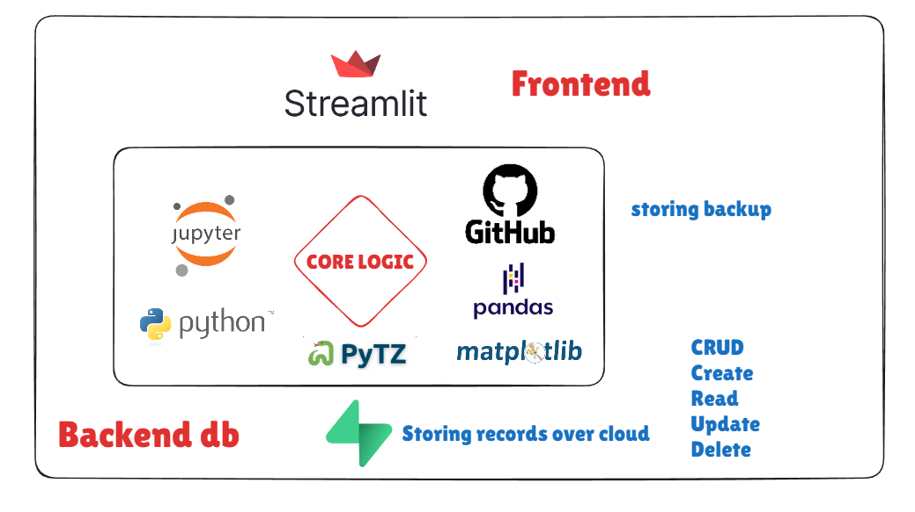

6. Architecture Diagram

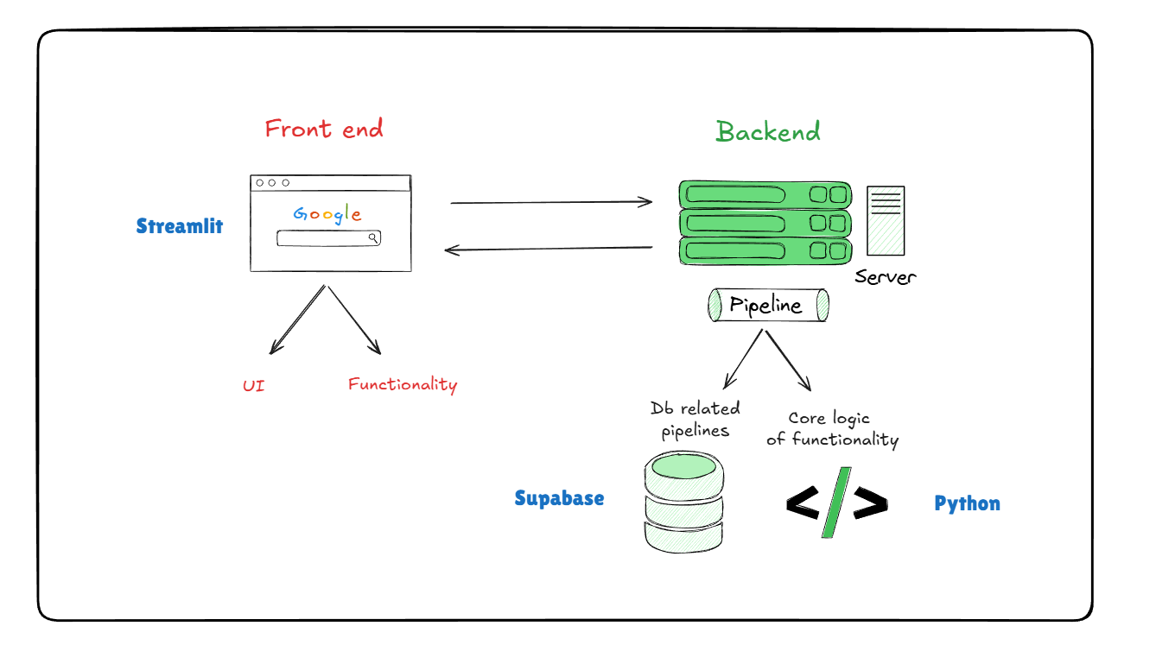

7. Key Steps / Modules
1. Supabase Client Initialization
Connects Python application to the backend database using API keys.
2. Admin Module
Allows the admin to:
- Open/close classroom attendance
- Set attendance codes and limits
- View analytics
- Download attendance matrices
3. Student Module
Allows students to:
- Select class
- Enter roll number and name
- Enter attendance code
- Submit attendance if validation succeeds
4. Roll Number Locking System
Once a roll number is used, the name is stored and cannot be changed.
5. Attendance Duplication Check
Prevents multiple entries for the same student on the same day.
6. Attendance Limit Feature
Blocks submissions once the maximum daily limit for a class is reached.
7. Analytics & CSV Export
Generates attendance matrices for a given range of dates.
8. Centralized Logging System
Every action (errors, warnings, submissions) is logged to file and console with filename & line numbers.

8. Learning Outcomes
By completing this project, students will learn:
- How to build a modular Python application with multiple files.
- How to use Streamlit to create interactive dashboards.
- How to connect Python to a Supabase database.
- CRUD operations: Insert, Read, Filter, Count.
- How to implement real-world logic like:
  - Input validation
  - Duplicate checks
  - Secure code verification
  - Roll-number/name locking
- How to design a clean folder structure for long-term maintenance.
- How to generate CSV analytics from database records.
- How to build and use a custom logging system for debugging.
- Understanding of client-server interaction in web apps.

9. Optional Add-ons (Future Improvements)
- OTP-based student verification
- Auto-generation of daily attendance codes
- Teacher login system
- Detailed attendance analytics graphs
- Face recognition integration
- Mobile-friendly UI
- Schedule-based auto open/close classroom attendance
- Email alerts for low attendance

10. Resource Links
Topic | Link
Streamlit Documentation | https://docs.streamlit.io
Supabase Documentation | https://supabase.com/docs
Python Logging Basics | https://docs.python.org/3/library/logging.html
Pandas CSV Manipulation | https://pandas.pydata.org/docs/

