1. Introduction
Project Title: SmartSDLC – AI-Powered SDLC Assistant
Team Members:
- Aiswarya Subramanyam – Gen AI & IBM cloud

2. Project Overview
Purpose:
SmartSDLC automates key phases of the Software Development Life Cycle—requirements analysis, code generation, bug fixing, test creation, summarization, and real-time assistance—leveraging NLP and generative AI to speed up development, reduce manual work, and improve accuracy .
Features:
- Upload & classify requirements into SDLC stages
- Generate production-ready code from prompts
- Fix bugs in Python/JavaScript
- Create unit/integration test cases
- Summarize code for documentation
- AI-powered chatbot assistant

3. Architecture
Frontend:
- Built with Streamlit (Python), modular pages for each feature
- Components: Upload & classify, Code Generator, Bug Fixer, Test Generator, Code Summarizer, Chatbot interface
Backend:
- FastAPI with Uvicorn
- Routes for classification, generation, bug-fixing, summarization, chat, feedback, GitHub integration
Database:
- Likely uses lightweight storage (e.g., SQLite or JSON files) for logging and session tracking. AI usage via IBM Watsonx Granite-20B for NLP and code generation

4. Setup Instructions
Prerequisites:
- Python 3.9+
- IBM Watsonx API credentials (API_KEY, PROJECT_ID, MODEL_ID)
- Other dependencies from requirements.txt
Installation:
bash
Copy code
git clone https://github.com/aiswaryasubramanyam7/SmartSDLC---AI-Powered-SDLC-Assistant.git
cd SmartSDLC---AI-Powered-SDLC-Assistant
python3 -m venv
source venv/bin/activate # Windows: venv\Scripts\activate
pip install -r requirements.txt
Set up .env file with:
ini
Copy code
WATSONX_API_KEY=...
WATSONX_PROJECT_ID=...
WATSONX_MODEL_ID=granite-20b-code-instruct

5. Folder Structure
bash
Copy code
/app/ (FastAPI backend)
├── ai_story_generator.py
├── code_generator.py
├── bug_resolver.py
├── doc_generator.py
├── conversation_handler.py
├── chat_routes.py
├── feedback_routes.py
├── github_service.py
└── main.py # App entrypoint

/frontend/ (Streamlit UI)
├── Home.py
├── Upload_and_Classify.py
├── Code_Generator.py
├── Test_Generator.py
├── Bug_Fixer.py
├── Code_Summarizer.py
├── Feedback.py
└── api_client.py
requirements.txt
.env.example
README.md
LICENSE

6. Running the Application
- Backend:
bash
Copy code
uvicorn app.main:app --reload
- Frontend:
bash
Copy code
streamlit run frontend/Home.py
The frontend runs at http://localhost:8501, backend API docs at http://127.0.0.1:8000/docs.

7. API Documentation
All endpoints are defined with FastAPI and documented via /docs.
Key endpoints include:
- POST /classify – Upload PDF, classify into SDLC phases
- POST /generate-code – Prompt to generate code
- POST /bug-fix – Submit code, get fixes
- POST /generate-tests – Generate unit/integration tests
- POST /summarize-code – Get human-readable summary
- POST /chat – Query chatbot assistant
- POST /feedback – Submit user feedback
(Parameters & schemas auto-documented in Swagger UI.)

8. Authentication
- Typically handled via API keys in environment variables
- FastAPI may use token/session-based auth to secure endpoints
- Authentication with IBM Watsonx for AI API calls via credentials in .env

9. User Interface
(You can include screenshots or GIFs here illustrating each Streamlit page: upload/classify, code generator, bug fixer, test generator, summarizer, chatbot.)

10. Testing
- Backend: use pytest for unit tests on generators, bug fixer, summarizer
- Frontend: manual feature test via Streamlit UI
(Recommend adding CI integration & coverage reporting)

11. Screenshots or Demo
- Include screenshots of each UI feature (classification, generation, chat).
- Optionally provide a live demo link if hosted (e.g., Streamlit app URL).
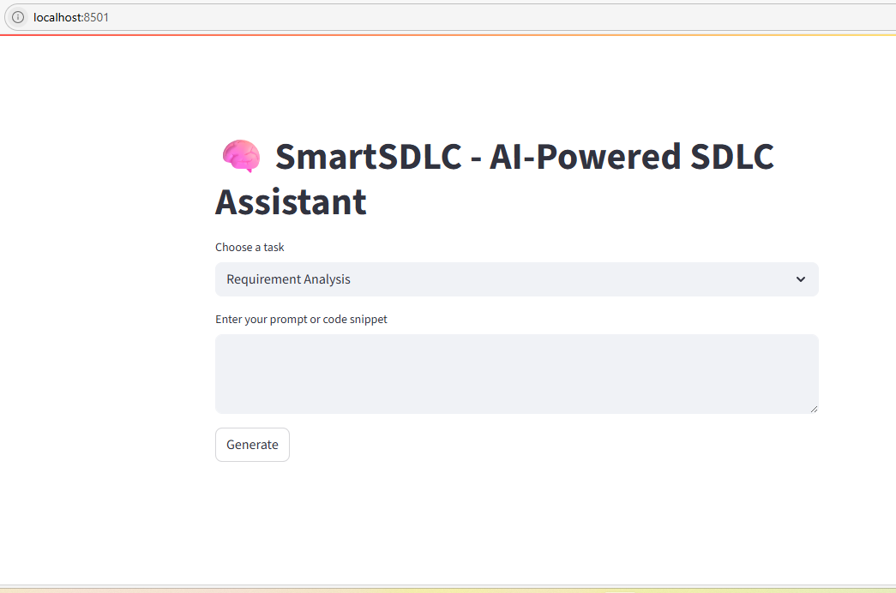

12. Known Issues
- Dependency on IBM Watsonx model availability
- Limited language support (Python/JS only)
- PDF text extraction may misclassify complex documents
- No CI/CD or production deployment scripts yet

13. Future Enhancements
- Add Docker + deployment pipeline
- Support more languages (Java, C#)
- Enhance chat context handling with LangChain memory
- Add role-based user authentication & access control
- Integrate CI/CD (GitHub Actions, Docker Registry)
- Add usage metrics dashboard & analytics

