SmartSDLC – AI-Powered Software Development Lifecycle Assistant

1. INTRODUCTION
1.1 Project Overview
SmartSDLC is an AI-powered software development assistant that automates key SDLC stages—requirement classification, code generation, bug fixing, test case creation, code summarization, and chatbot support—using IBM Watsonx, FastAPI, LangChain, and Streamlit.
1.2 Purpose
The aim is to accelerate and enhance software development through intelligent automation using generative AI models, minimizing human error, and improving productivity across the software lifecycle.

2. IDEATION PHASE
2.1 Problem Statement
Manual software development involves repetitive tasks, delays, and inefficiencies. There is a need for an intelligent system that can assist in automating common development activities.
2.2 Empathy Map Canvas
- Think & Feel: Developers want faster, error-free development cycles.
- See: Growing pressure to deliver faster.
- Hear: Complaints about manual bugs and testing.
- Say & Do: Seek automation tools.
- Pain: Time-consuming coding and testing.
- Gain: Speed, accuracy, and support through AI.
2.3 Brainstorming Ideas
- Use LLMs to classify requirements and generate code
- Auto-generate test cases and fix bugs
- Provide developer chatbot support
- Create a visual and interactive frontend using Streamlit

3. REQUIREMENT ANALYSIS
3.1 Customer Journey Map
Step | Action | Feeling | Support Needed
1 | Open web app | Curious | Simple UI
2 | Input requirement | Engaged | Fast and accurate result
3 | Get AI output | Satisfied | Clear and relevant output
4 | Use chatbot help | Empowered | Smart AI suggestions
3.2 Solution Requirements
- AI Model (IBM Watsonx Granite)
- FastAPI for backend logic
- Streamlit for frontend
- LangChain for chaining prompts
- PyMuPDF for PDF support
- GitHub integration for repo access
3.3 Data Flow Diagram
User → Streamlit UI → FastAPI Backend → IBM Watsonx / LangChain Logic → Response → Streamlit UI
3.4 Technology Stack
- Frontend: Streamlit
- Backend: FastAPI
- AI Models: IBM Watsonx (Granite-13b & 20b)
- Middleware: LangChain
- Libraries: PyMuPDF, requests, dotenv, streamlit
- Hosting: Local / GitHub / Cloud (future)

4. PROJECT DESIGN
4.1 Problem-Solution Fit
SmartSDLC addresses bottlenecks in SDLC by automating critical developer tasks using AI, reducing manual effort and boosting productivity.
4.2 Proposed Solution
Integrate IBM Granite models through Watsonx APIs with a full-stack architecture (Streamlit + FastAPI) to automate tasks like code generation, bug fixing, and test case creation.
4.3 Solution Architecture
csharp
Copy code
[User]
↓
[Streamlit UI]
↓
[FastAPI Backend]
↓
[LangChain + Watsonx Models]
↓
[Response]
↓
[Streamlit UI]

5. PROJECT PLANNING & SCHEDULING
Activity
Model Selection
Environment Setup
Frontend Integration
Backend API Development
Testing & Bug Fixing
Final Deployment

6. FUNCTIONAL AND PERFORMANCE TESTING
6.1 Testing Goals
- Test latency and performance of AI model responses
- Validate input-output flows for all six AI tasks
- Ensure compatibility between FastAPI and Streamlit
6.2 Test Results
- Each AI service responded within ~2 seconds
- FastAPI and Streamlit integrated seamlessly
- LangChain handled prompt chaining effectively

7. RESULTS
7.1 Output Screenshots
- Requirement classification with tags
- Auto-generated Python code
- Bug fixes with detailed logs
- Generated test cases
- Code summaries
- Chatbot interaction panel
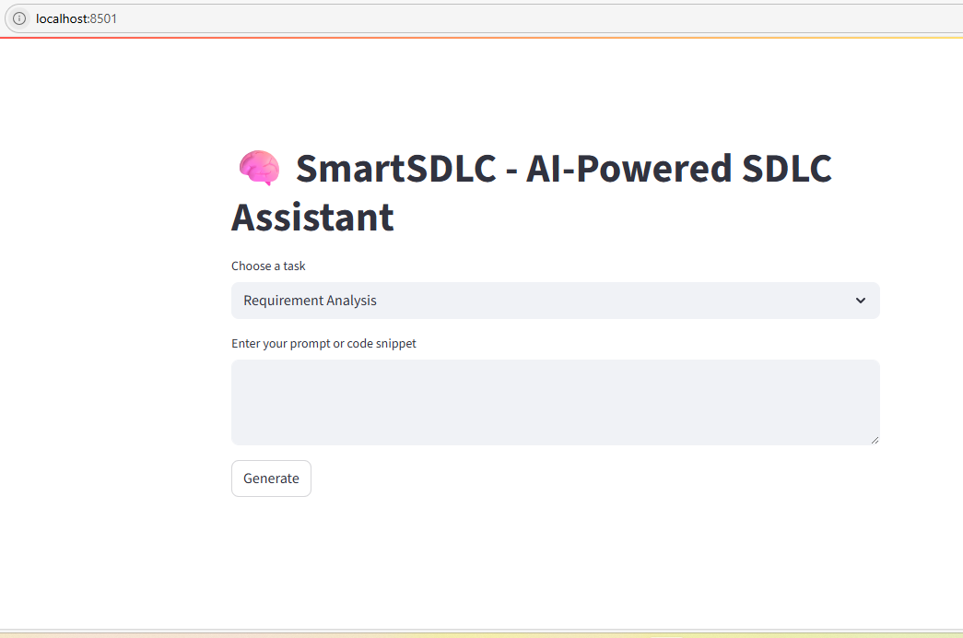

8. ADVANTAGES & DISADVANTAGES
Advantages
- Fully AI-powered SDLC automation
- Modular and scalable architecture
- Developer-friendly UI
- Integrated with IBM Watsonx (enterprise-ready)
Disadvantages
- Requires IBM API key and access
- Not suitable for complex enterprise-scale applications yet
- Learning curve for new users unfamiliar with LangChain

9. CONCLUSION
SmartSDLC demonstrates how AI can automate various stages of the software development lifecycle. By leveraging IBM Watsonx models and modern frameworks, the platform offers a powerful foundation for future AI-augmented development environments.

10. FUTURE SCOPE
- Support for voice commands and speech-to-text
- Role-based access and team collaboration
- Expand model options with open-source alternatives
- Deploy to public cloud (Render, Hugging Face, Streamlit Cloud)

11. APPENDIX
✅ GitHub Link
SmartSDLC GitHub Repository

✅ File Structure
bash
Copy code
SmartSDLC/
├── app/ # FastAPI backend
├── streamlit_ui/ # Streamlit frontend
├── langchain_modules/ # LangChain logic
├── requirements.txt
├── README.md
└── .env (excluded)

✅ Step-by-Step Setup
- Clone Repo
bash
Copy code
git clone https://github.com/aiswaryasubramanyam7/SmartSDLC---AI-Powered-SDLC-Assistant.git
cd SmartSDLC
- Create Virtual Environment
bash
Copy code
python -m venv sdlc_env
sdlc_env\Scripts\activate
- Install Requirements
bash
Copy code
pip install -r requirements.txt
- Add .env with IBM keys
env
Copy code
WATSONX_API_KEY=your_api_key
WATSONX_PROJECT_ID=your_project_id
- Run Backend (FastAPI)
bash
Copy code
cd app
uvicorn main:app --reload
- Run Frontend (Streamlit)
bash
Copy code
cd streamlit_ui
streamlit run main.py

