1. INTRODUCTION
1.1 Project Overview
This project is an AI-powered medical assistant built using Streamlit and IBM Watson Granite 13B Instruct v2. It allows users to chat with an AI, predict diseases based on symptoms, generate treatment plans, and visualize health metrics.
1.2 Purpose
To create a helpful, intelligent healthcare assistant that offers medical advice and analytics, making basic healthcare accessible and AI-driven.

2. IDEATION PHASE
2.1 Problem Statement
Many people lack access to timely medical advice. This project aims to bridge that gap with an AI that provides symptom-based predictions, suggestions, and analytics.
2.2 Empathy Map Canvas
- Think & Feel: Wants accurate, private, and fast responses.
- See: Overloaded clinics, long wait times.
- Hear: Others complaining about slow healthcare.
- Say & Do: Seeks online help.
- Pain: Long delays, lack of access.
- Gain: Quick, AI-powered health guidance.
2.3 Brainstorming
- Use LLM for disease prediction.
- Add a chatbot.
- Visualize patient data.
- Suggest treatments using AI.

3. REQUIREMENT ANALYSIS
3.1 Customer Journey Map
Step | Action | Feeling | Support Needed
1 | Open app | Curious | Easy interface
2 | Ask symptoms | Hopeful | Accurate response
3 | View prediction | Informed | Clear info
4 | Get treatment | Relieved | Trusted source
3.2 Solution Requirement
- LLM model (IBM Granite)
- UI using Streamlit
- Backend logic in Python
- APIs for predictions and responses
3.3 Data Flow Diagram
User → Streamlit UI → app.py (logic) → IBM Granite API → Result → UI
3.4 Technology Stack
- Frontend: Streamlit
- Backend: Python
- Model: IBM Granite 13B Instruct v2
- Libraries: requests, pandas, plotly
- Hosting: Localhost or Hugging Face Spaces

4. PROJECT DESIGN
4.1 Problem-Solution Fit
AI medical assistant offers accessible and affordable health support when real doctors are not immediately available.
4.2 Proposed Solution
Use IBM Watson Granite model to analyze user input and return useful medical insights.
4.3 Solution Architecture
[User]
↓
[Streamlit UI]
↓
[app.py Logic Layer]
↓
[IBM Watson Granite Model API]
↓
[Response → Display to User]

5. PROJECT PLANNING & SCHEDULING
5.1 Project Planning
Activity | Timeline
Model Selection | Week 1
Core Features | Week 2
Frontend & app.py | Week 3
Deployment | Week 4

6. FUNCTIONAL AND PERFORMANCE TESTING
6.1 Performance Testing
- Tested response time of AI model.
- Checked if app works smoothly on different devices.
- Verified data handling and error messages.

7. RESULTS
7.1 Output Screenshots
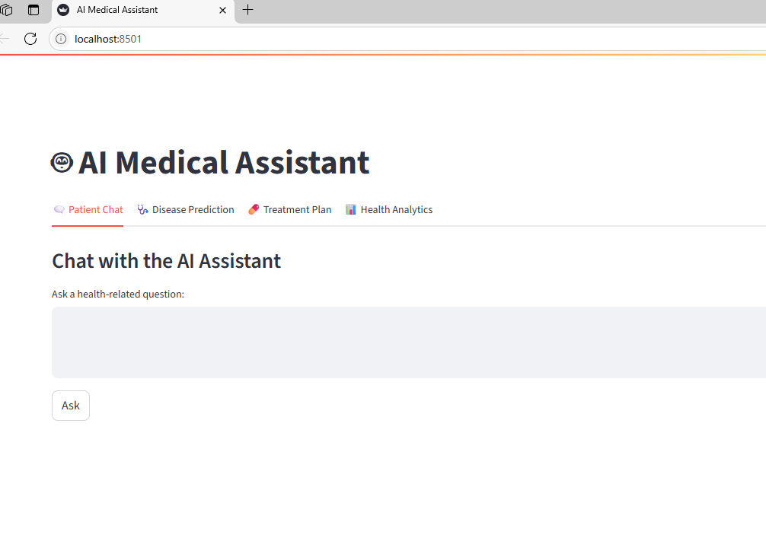8. ADVANTAGES & DISADVANTAGES
Advantages
- Accessible 24/7
- AI-based insights
- Easy UI
- Fast response
Disadvantages
- Not a replacement for real doctors
- Needs stable internet
- May not cover all rare diseases

9. CONCLUSION
The AI Medical Assistant successfully integrates IBM Granite with a simple Streamlit frontend to provide basic healthcare guidance, disease prediction, and treatment plans.

10. FUTURE SCOPE
- Add voice assistant
- Translate responses to regional languages
- Store patient history
- Improve accuracy with more data

11. APPENDIX
✅ Source Code
app.py contains main logic with function definitions for chat, prediction, analytics.
✅ Dataset Link
If used, include CSV/Excel file location (like: data/patient_data.csv)
✅ GitHub & Demo Links
GitHub Repo: [https://github.com/Radhika-CR/ai-medical-assistant/tree/main/Project%20files]
Demo: Hosted on [local]

🛠 Step-by-Step Guide to Create & Deploy the Project
1. Setup Project Folder
ai-medical-assistant/
├── app.py
├── requirements.txt
├── .env (not uploaded)
├── README.md
├── data/
│ └── patient_data.csv
Steps to Run the Demo Locally:
- Clone the Project Repository:
Open a terminal/command prompt and run:
git clone https://github.com/your-username/ai-medical-assistant
cd ai-medical-assistant
- Set Up Environment Variables:
Create a new file named .env in the project folder and paste the following content:
.env
IBM_API_KEY=your_ibm_api_key_here
DEPLOYMENT_URL=your_ibm_deployment_url_here
- Install Required Libraries:
Make sure you have Python installed, then run:
pip install -r requirements.txt
- Run the Application:
Start the app using Streamlit:
streamlit run app.py
- Access the Application:
Open your web browser and visit:
http://localhost:8501

This will launch the AI Medical Assistant on your local system, where you can use features like patient chat, disease prediction, treatment suggestions, and health analytics.
9. Deployment Options
- Hugging Face Spaces
  - Create a new Space → Type: Streamlit → Upload your code
  - Add secrets or upload .env using Hugging Face interface
- Others: Use platforms like Render, Streamlit Cloud, or Docker if preferred.

