Cloned simple-whale-demo into my repository

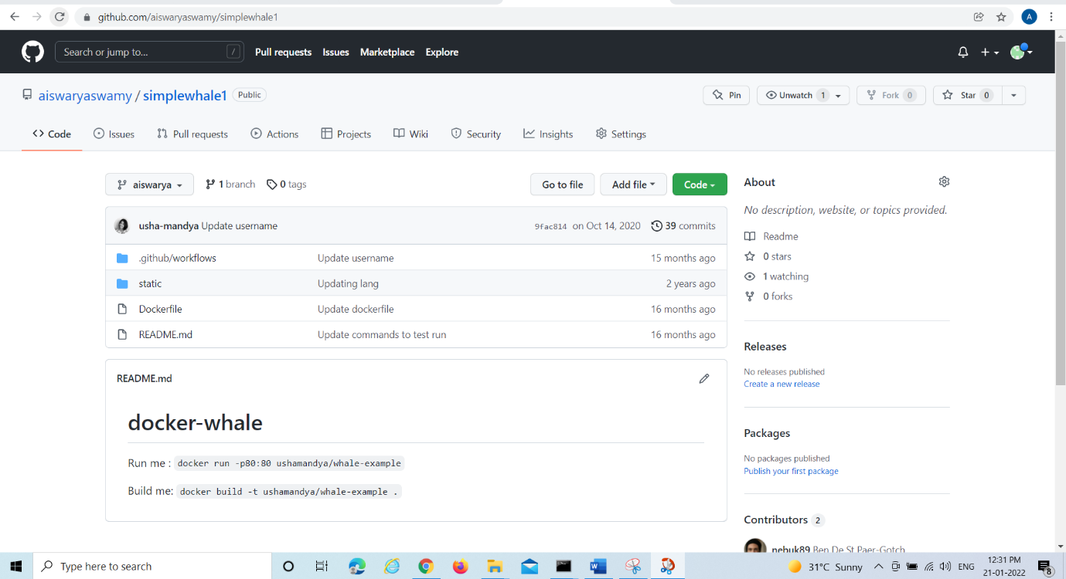

Created secret keys

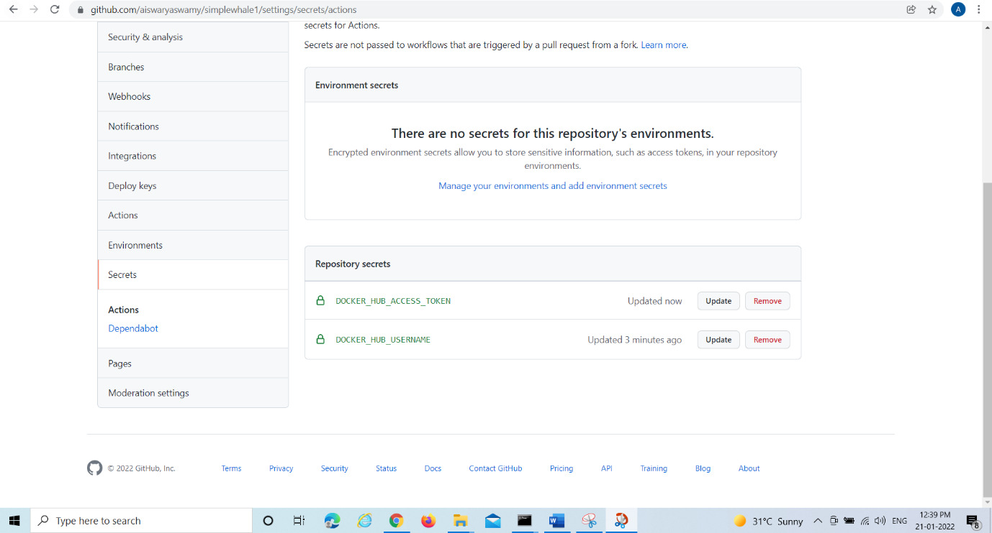

Workflow-1

|  |
| --- |
| name: CI to Dockerhub |
|  | on: |
|  | push: |
|  | branches: |
|  | - 'aiswarya' |
|  | pull_request: |
|  | branches: [ aiswarya ] |
|  | workflow_dispatch: |
|  | jobs: |
|  | build: |
|  | runs-on: ubuntu-latest |
|  | steps: |
|  | - |
|  | name: Checkout |
|  | uses: actions/checkout@v2 |
|  | - |
|  | name: Login to Docker Hub |
|  | uses: docker/login-action@v1 |
|  | with: |
|  | username: ${{ secrets.DOCKER_HUB_USERNAME }} |
|  | password: ${{ secrets.DOCKER_HUB_ACCESS_TOKEN }} |
|  | - |
|  | name: Set up Docker Buildx |
|  | uses: docker/setup-buildx-action@v1 |
|  | - |
|  | name: Build and push |
|  | uses: docker/build-push-action@v2 |
|  | with: |
|  | context: . |
|  | file: ./Dockerfile |
|  | push: true |
|  | tags: ${{ secrets.DOCKER_HUB_USERNAME }}/simplewhale:latest |

Workflow-2

|  |
| --- |
| name: CI to Dockerhub |
|  | on: |
|  | push: |
|  | branches: |
|  | - 'aiswarya' |
|  | pull_request: |
|  | branches: [ aiswarya ] |
|  | workflow_dispatch: |
|  | jobs: |
|  | build: |
|  | runs-on: ubuntu-latest |
|  | steps: |
|  | - |
|  | name: Checkout |
|  | uses: actions/checkout@v2 |
|  | - |
|  | name: Login to Docker Hub |
|  | uses: docker/login-action@v1 |
|  | with: |
|  | username: ${{ secrets.DOCKER_HUB_USERNAME }} |
|  | password: ${{ secrets.DOCKER_HUB_ACCESS_TOKEN }} |
|  | - |
|  | name: Set up Docker Buildx |
|  | uses: docker/setup-buildx-action@v1 |
|  | - |
|  | name: Build and push |
|  | uses: docker/build-push-action@v2 |
|  | with: |
|  | context: ./ |
|  | file: ./Dockerfile |
|  | builder: ${{ steps.buildx.outputs.name }} |
|  | push: true |
|  | tags: ${{ secrets.DOCKER_HUB_USERNAME }}/simplewhale:latest |
|  | cache-from: type=registry,ref=${{ secrets.DOCKER_HUB_USERNAME }}/simplewhale:buildcache |
|  | cache-to: type=registry,ref=${{ secrets.DOCKER_HUB_USERNAME }}/simplewhale:buildcache,mode=max simp  **OPTIMIZING THE WORKFLOW** |

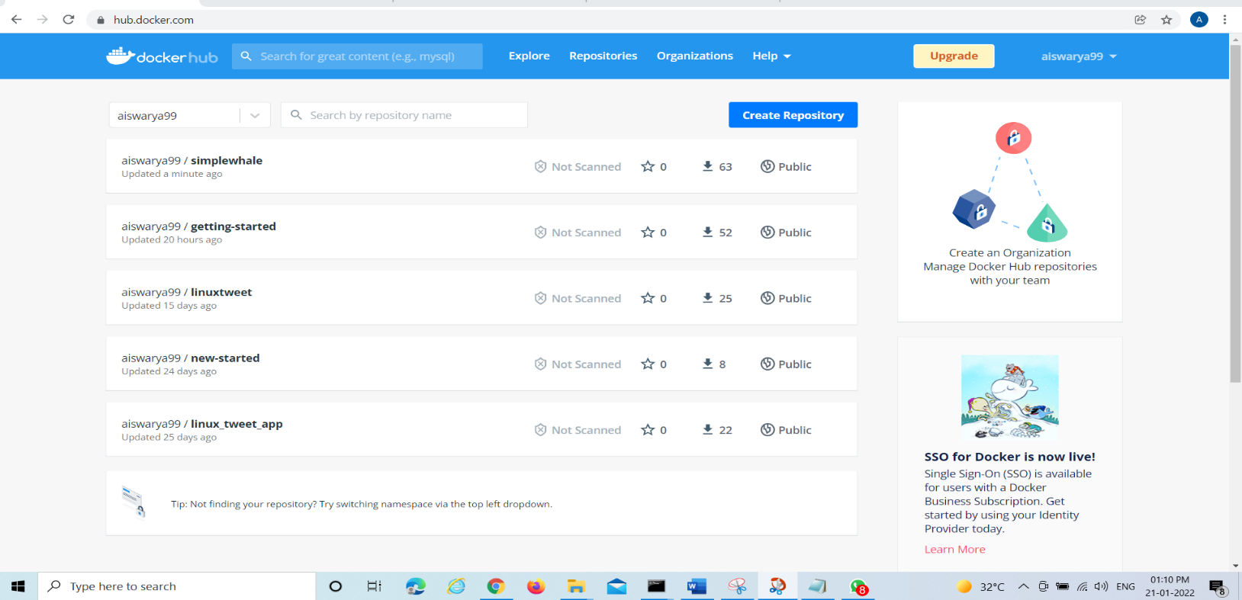

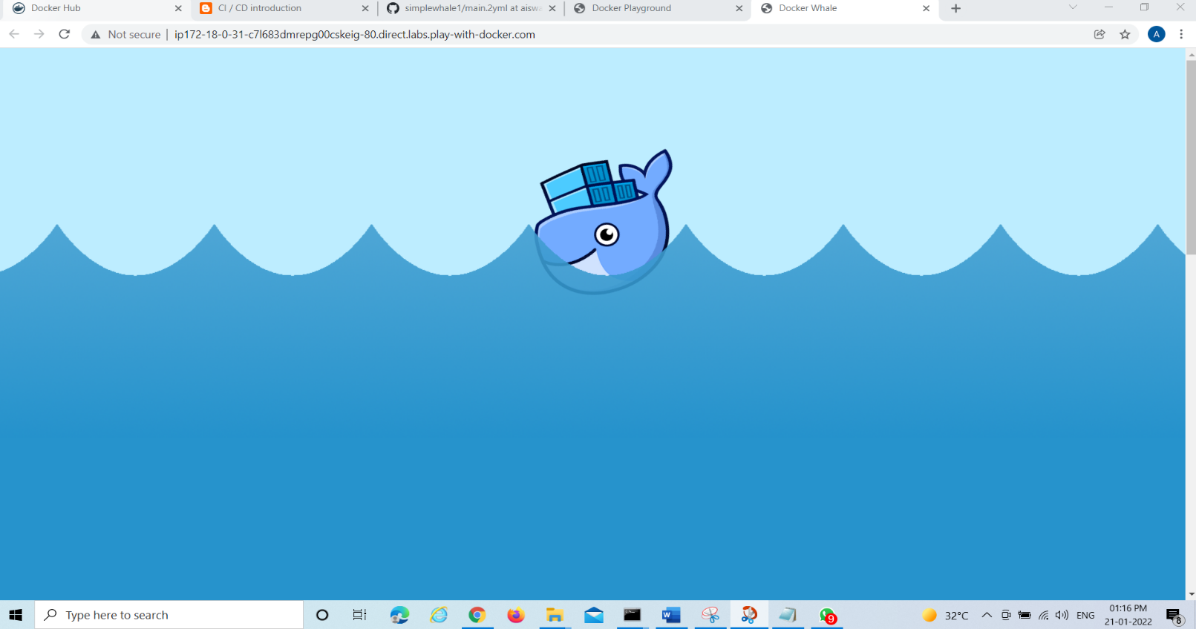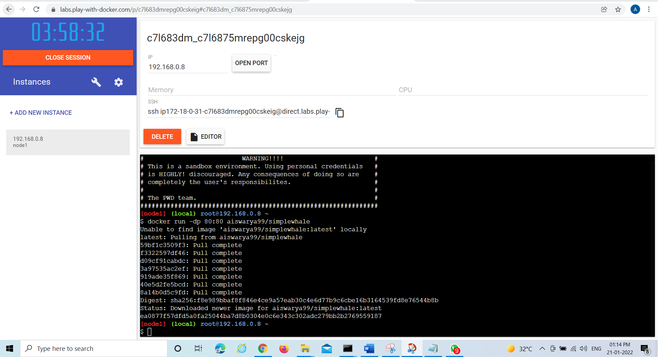

**Workflow 3**

# This is a basic workflow to help you get started with Actions

name: CI

# Controls when the workflow will run

on:

# Triggers the workflow on push or pull request events but only for the aiswarya branch

push:

branches:

'aiswarya'

tags:

'v*'

# Allows you to run this workflow manually from the Actions tab

workflow_dispatch:

# A workflow run is made up of one or more jobs that can run sequentially or in parallel

jobs:

# This workflow contains a single job called "build"

build:

# The type of runner that the job will run on

runs-on: ubuntu-latest

# Steps represent a sequence of tasks that will be executed as part of the job

steps:

# Checks-out your repository under $GITHUB_WORKSPACE, so your job can access it

- name: Checkout

uses: actions/checkout@v2

- name: Login to Docker Hub

uses: docker/login-action@v1

with:

username: ${{ secrets.DOCKER_HUB_USERNAME }}

password: ${{ secrets.DOCKER_HUB_ACCESS_TOKEN }}

- name: Set up Docker Buildx

uses: docker/setup-buildx-action@v1

- name: Build and push

uses: docker/build-push-action@v2

with:

context: ./

file: ./Dockerfile

builder: ${{ steps.buildx.outputs.name }}

push: true

tags: ${{ secrets.DOCKER_HUB_USERNAME }}/simplewhale:latest

cache-from: type=registry,ref=${{ secrets.DOCKER_HUB_USERNAME }}/simplewhalee:buildcache

cache-to: type=registry,ref=${{ secrets.DOCKER_HUB_USERNAME }}/simplewhale:buildcache,mode=max

**Workflow 4**

# This is a basic workflow to help you get started with Actions

name: CI

# Controls when the workflow will run

on:

# Triggers the workflow on push or pull request events but only for the aiswarya branch

push:

branches:

'aiswarya'

tags:

'v*'

pull_request:

branches:

'aiswarya'

# Allows you to run this workflow manually from the Actions tab

workflow_dispatch:

# A workflow run is made up of one or more jobs that can run sequentially or in parallel

jobs:

# This workflow contains a single job called "build"

build:

# The type of runner that the job will run on

runs-on: ubuntu-latest

# Steps represent a sequence of tasks that will be executed as part of the job

steps:

# Checks-out your repository under $GITHUB_WORKSPACE, so your job can access it

- name: Checkout

uses: actions/checkout@v2

- name: Login to Docker Hub

uses: docker/login-action@v1

with:

username: ${{ secrets.DOCKER_HUB_USERNAME }}

password: ${{ secrets.DOCKER_HUB_ACCESS_TOKEN }}

- name: Set up Docker Buildx

uses: docker/setup-buildx-action@v1

- name: Build and push

uses: docker/build-push-action@v2

with:

context: ./

file: ./Dockerfile

builder: ${{ steps.buildx.outputs.name }}

push: true

tags: ${{ secrets.DOCKER_HUB_USERNAME }}/simplewhale:latest

cache-from: type=registry,ref=${{ secrets.DOCKER_HUB_USERNAME }}/simplewhale:buildcache

cache-to: type=registry,ref=${{ secrets.DOCKER_HUB_USERNAME }}/simplewhale:buildcache,mode=max

