**PS C:\Users\LENOVO\Downloads\getting-started-master\getting-started-master> cd app**

**PS C:\Users\LENOVO\Downloads\getting-started-master\getting-started-master> docker build aiswarya99/getting-started .**

[+] Building 336.5s (11/11) FINISHED

=> [internal] load build definition from Dockerfile 0.1s => => transferring dockerfile: 32B 0.0s => [internal] load .dockerignore 0.0s => => transferring context: 2B 0.0s => [internal] load metadata for docker.io/library/node:12-alpine 18.7s => [internal] load build context 0.4s => => transferring context: 2.49kB 0.1s => CACHED [1/5] FROM docker.io/library/node:12-alpine@sha256:c3e7817c8fd124f1597cd66124d247db8e138e8ef311ba085b7104d900129d0b 0.0s => [2/5] RUN apk add --no-cache python2 g++ make 196.9s => [3/5] WORKDIR /app 1.1s => [4/5] COPY . . 2.1s => [5/5] RUN yarn install --production 89.6s => exporting to image 27.6s => => exporting layers 27.6s => => writing image sha256:2042ce66d6174db6a19abac20a1df65ff4830967bb67d564c0efe62a935e4c1f 0.0s=> => naming to docker.io/aiswarya99/getting-started 0.0s Use 'docker scan' to run Snyk tests against images to find vulnerabilities and learn how to fix them

**PS C:\Users\LENOVO\Downloads\getting-started-master\getting-started-master\app> docker run -dp 3002:3000 aiswarya99/getting-started**

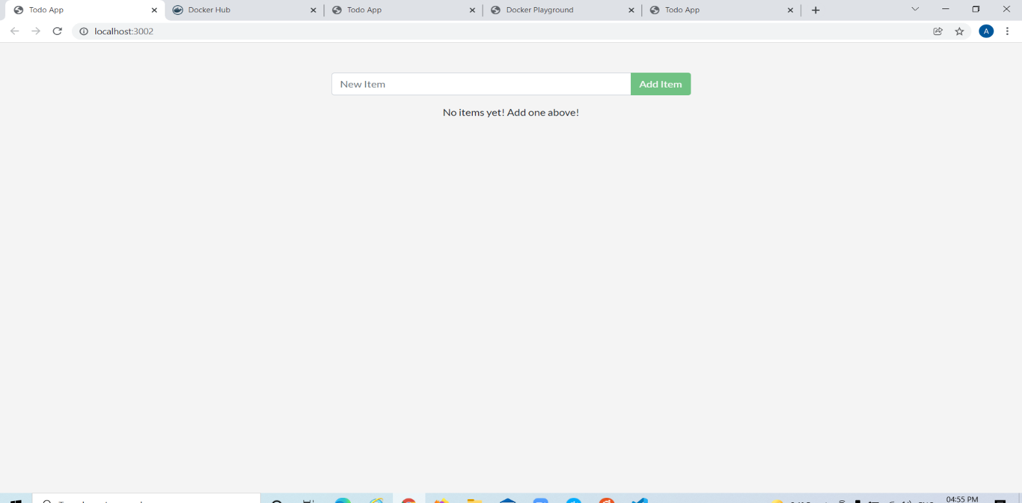**9f43db531d1979623f395dcf1340a38058169e99be774e3ac5cba78b585f16a5**

**PS C:\Users\LENOVO\Downloads\getting-started-master\getting-started-master\app> docker build aiswarya99/getting-started .**

"docker build" requires exactly 1 argument.

See 'docker build --help'.

Usage: docker build [OPTIONS] PATH | URL | -

Build an image from a Dockerfile

[+] Building 299.7s (11/11) FINISHED

=> [internal] load build definition from Dockerfile 0.1s => => transferring dockerfile: 32B 0.0s => [internal] load .dockerignore 0.0s=> => transferring context: 2B 0.0s => [internal] load metadata for docker.io/library/node:12-alpine 30.1s => [auth] library/node:pull token for registry-1.docker.io 0.0s => [1/5] FROM docker.io/library/node:12-alpine@sha256:c3e7817c8fd124f1597cd66124d247db8e138e8ef311ba085b7104d900129d0b 0.0s => [internal] load build context 7.0s => => transferring context: 7.86kB 3.5s => CACHED [2/5] RUN apk add --no-cache python2 g++ make 0.0s => [4/5] COPY . . 1.3s => [5/5] RUN yarn install --production 218.1s => exporting to image 42.6s => => exporting layers 42.6s => => writing image sha256:59fceb465fcd596c35b486af4543808af5da1e1ac039145bd724526c5aa496cc 0.0s => => naming to docker.io/aiswarya99/getting-started 0.0s

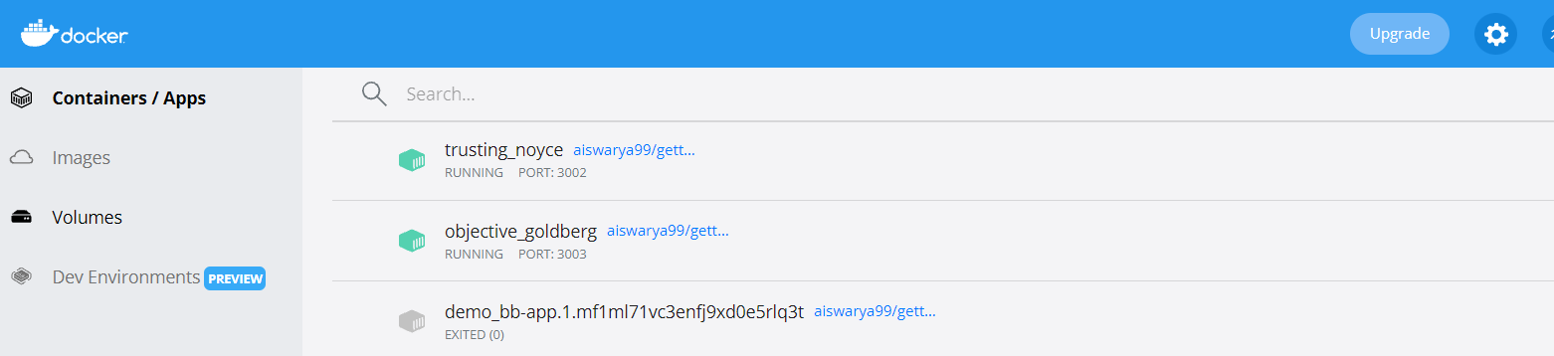Use 'docker scan' to run Snyk tests against images to find vulnerabilities and learn how to fix them

**PS C:\Users\LENOVO\Downloads\getting-started-master\getting-started-master\app> docker run -dp 3003:3000 aiswarya99/getting-started**

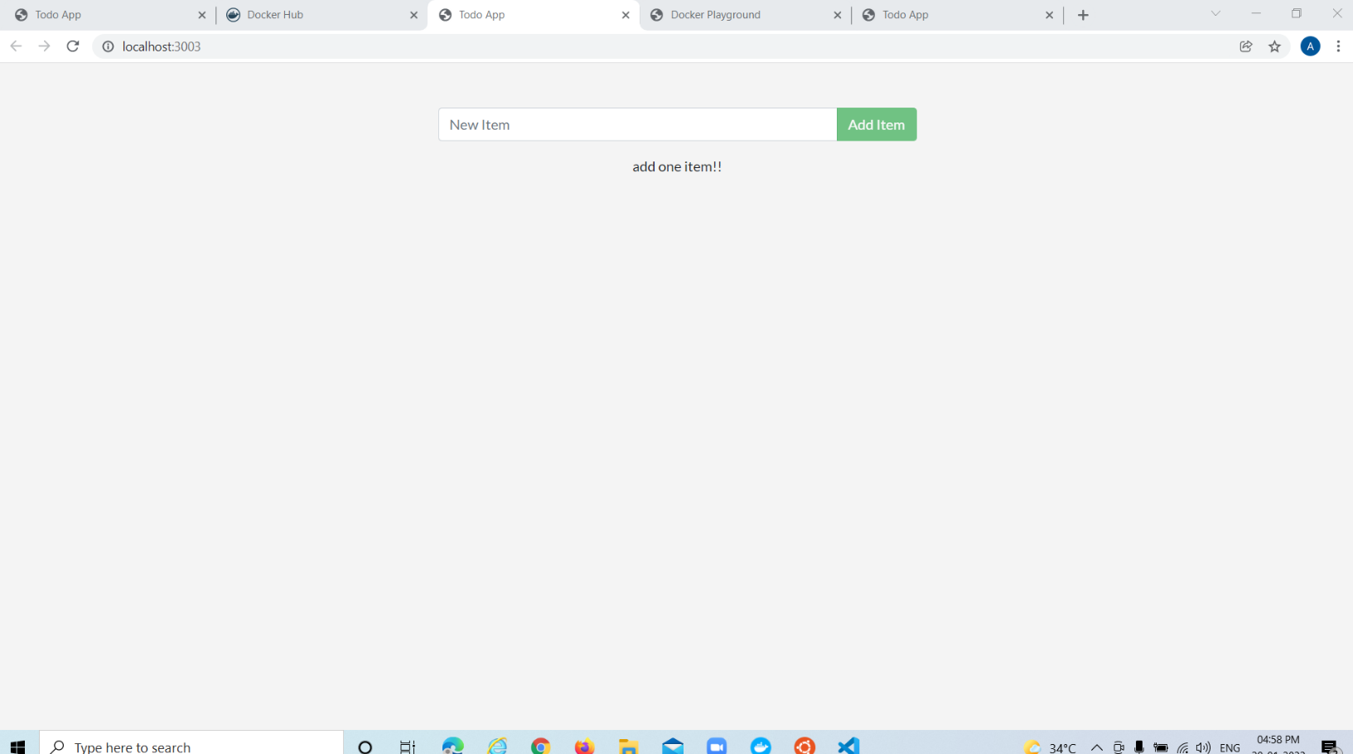**cbea419503daaea47676fbc1745f10144f2483351779a385ac486752efff1acb**

**PS C:\Users\LENOVO\Downloads\getting-started-master\getting-started-master\app> docker push aiswarya99/getting-started**

Using default tag: latest

The push refers to repository [docker.io/aiswarya99/getting-started]

9c8b2d1af3ad: Pushed

efabbf5a8ad6: Pushed

aeb48ef963f9: Pushed

f11ef954ed28: Pushed

cc7d7abf9a7f: Mounted from library/node

4eb06231aba4: Mounted from library/node

62549ded9a31: Mounted from library/node

8d3ac3489996: Mounted from library/node

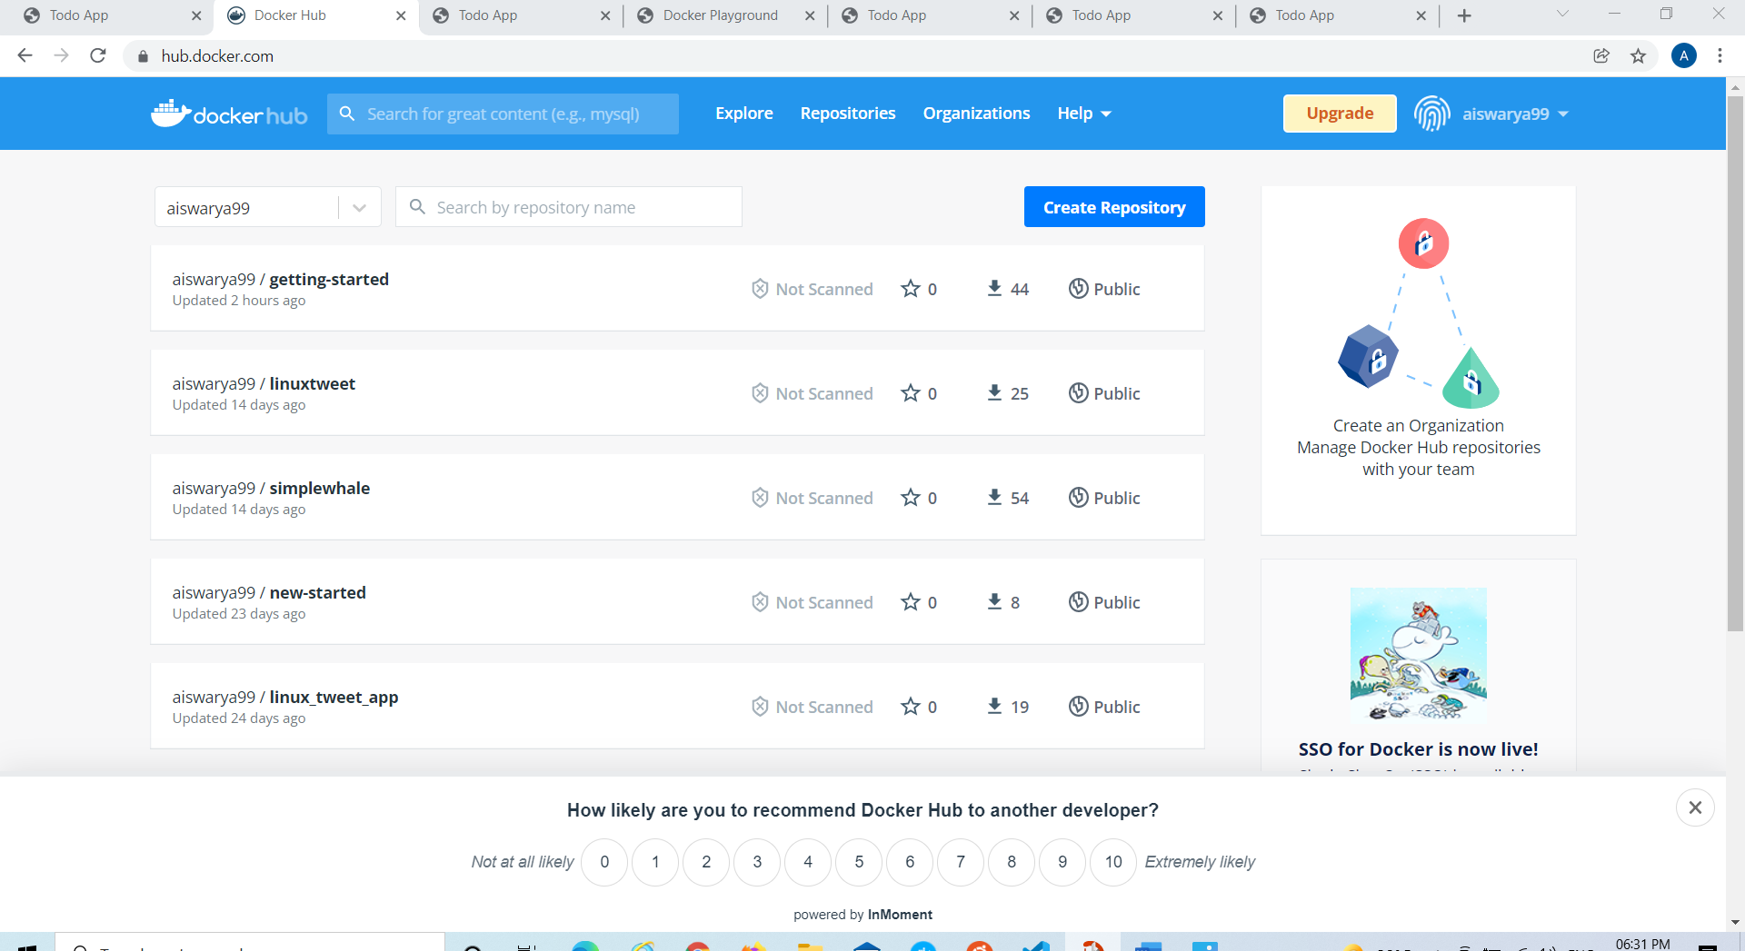latest: digest: sha256:8cf72ddf49879f826f8e3b612e60aceacf14df7ecca9e9bfaf30810b3963563f size: 2000

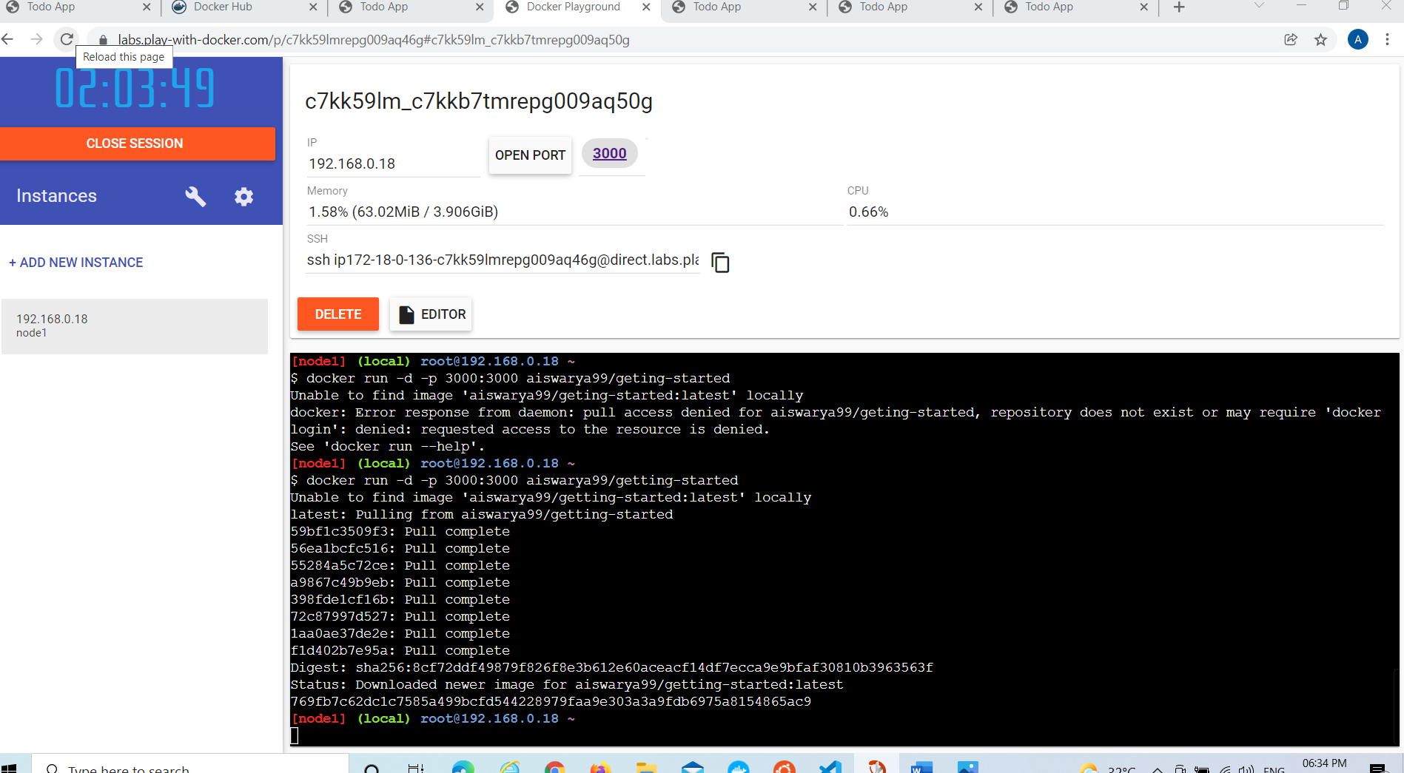**RUN THE IMAGE IN PLAY WITH DOCKER:**

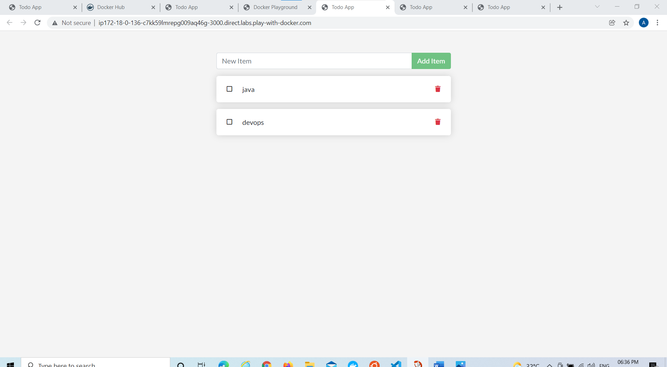

**PS C:\Users\LENOVO\Downloads\getting-started-master\getting-started-master\app> docker run -d ubuntu bash -c "shuf -i 1-10000 -n 1 -o /data.txt && tail -f /dev/null"**

Unable to find image 'ubuntu:latest' locally

latest: Pulling from library/ubuntu

ea362f368469: Pull complete

Digest: sha256:b5a61709a9a44284d88fb12e5c48db0409cfad5b69d4ff8224077c57302df9cf

Status: Downloaded newer image for ubuntu:latest

39ad5e05a23895e47172311405e3f16a19e1f1cef50d86c7ab2e1ec2fc290852

CONTAINER ID IMAGE COMMAND CREATED STATUS PORTS NAMES

91rykm76y

c7pz4d3pe

7y48ohn87wt

cbea419503da aiswarya99/getting-started "docker-entrypoint.s…" 59 minutes ago Up 59 minutes 0.0.0.0:3003->3000/tcp objective_goldberg



**PS C:\Users\LENOVO\Downloads\getting-started-master\getting-started-master\app> docker exec 39ad5e05a238 cat /data.txt**

83

**PS C:\Users\LENOVO\Downloads\getting-started-master\getting-started-master\app> docker run -it ubuntu ls**

bin dev home lib32 libx32 mnt proc run srv tmp var

boot etc lib lib64 media opt root sbin sys usr

**PS C:\Users\LENOVO\Downloads\getting-started-master\getting-started-master\app> docker volume create todo-db**

todo-db

**PS C:\Users\LENOVO\Downloads\getting-started-master\getting-started-master\app> docker run -dp 3004:3000 -v todo-db:/etc/todos aiswarya99/getting-started**

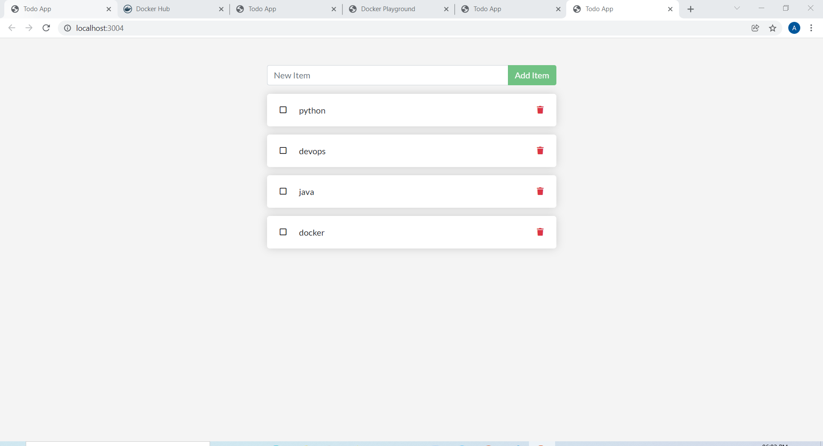0b0f6e76a9a4380a1d0aa3ac61610ff05b5cbe22dd7ccb368b1e2fe03fdfcbff

**CREATING VOLUME**

**PS C:\Users\LENOVO\Downloads\getting-started-master\getting-started-master\app> docker run -dp 3004:3000 -v todo-db:/etc/todos aiswarya99/getting-started**

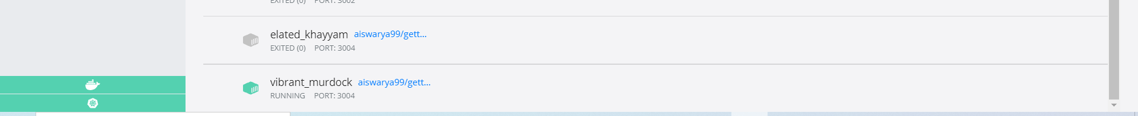508ce52141f2d13e95bfdb8446770b94d9c7d4b5ad915c519fb6e23e7bfe35b3

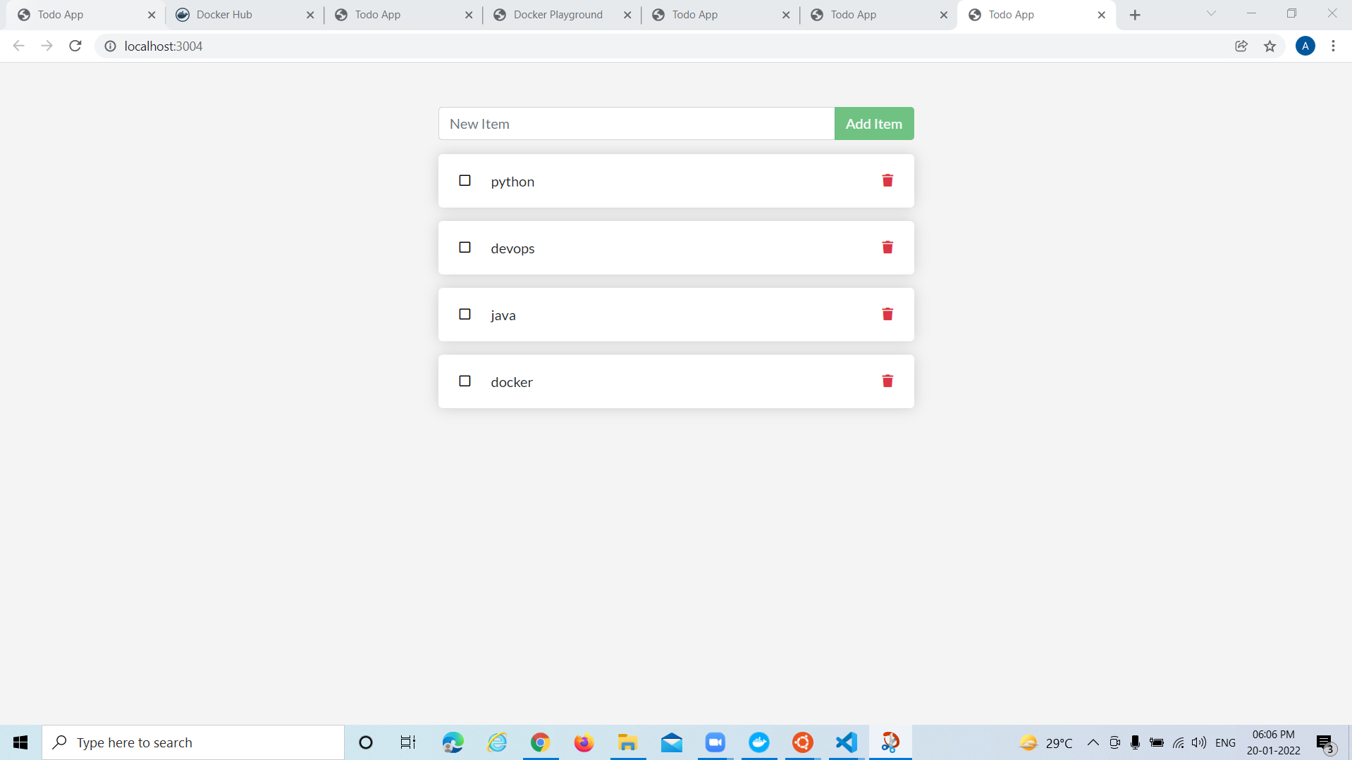

**PS C:\Users\LENOVO\Downloads\getting-started-master\getting-started-master\app> docker volume inspect todo-db**

[

{

"CreatedAt": "2022-01-20T12:28:25Z",

"Driver": "local",

"Labels": {},

"Mountpoint": "/var/lib/docker/volumes/todo-db/_data",

"Name": "todo-db",

"Options": {},

"Scope": "local"

}

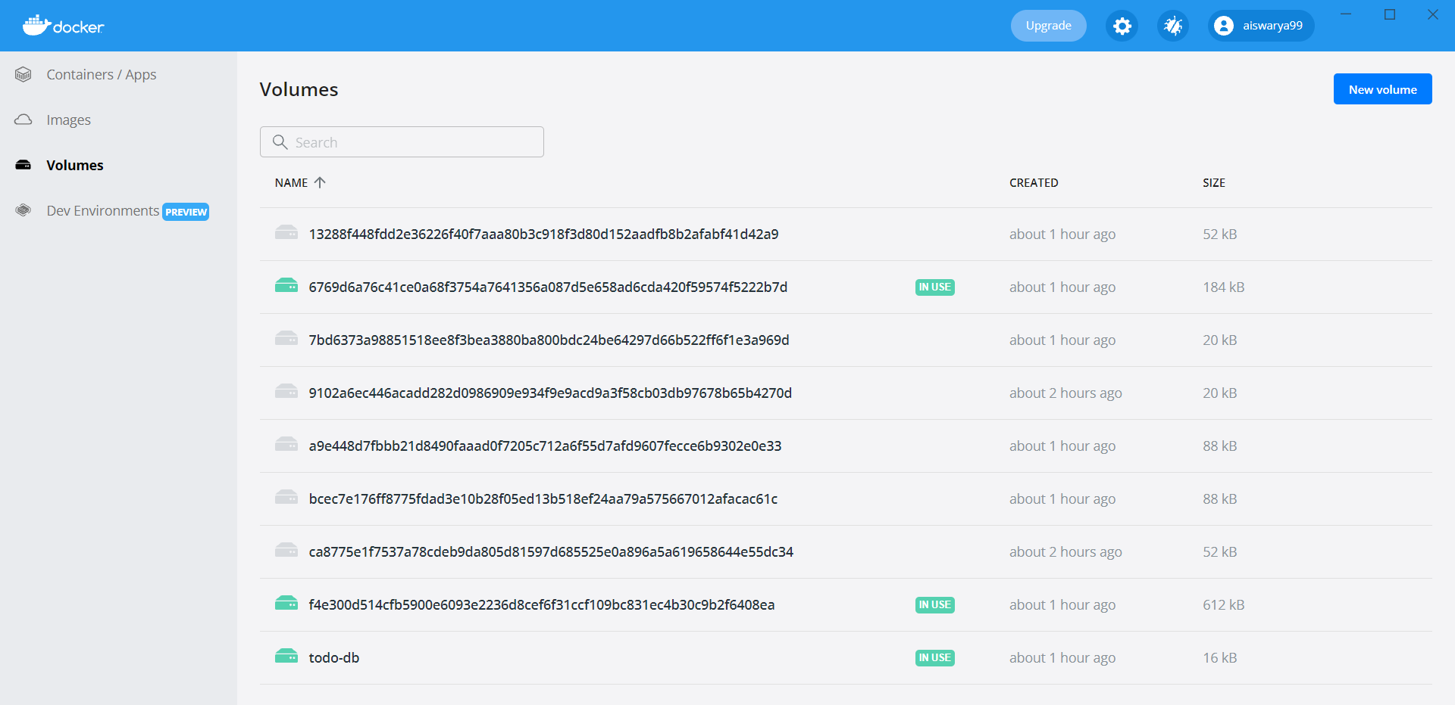]

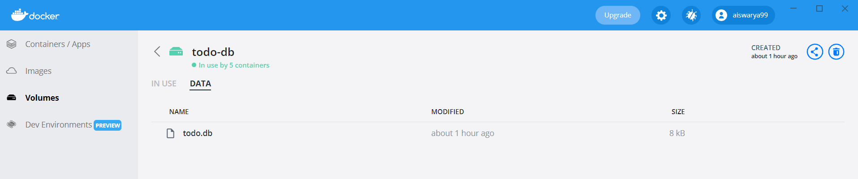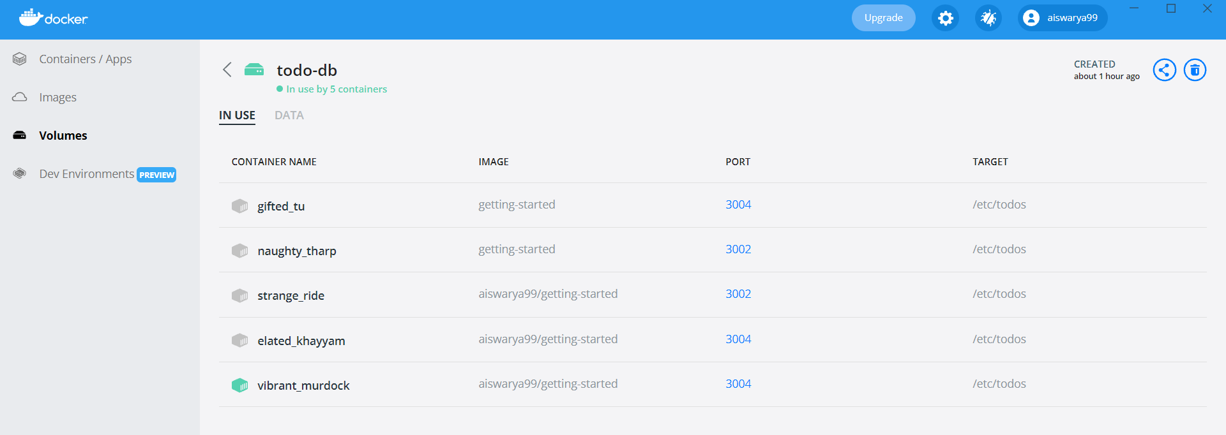

**PS C:\Users\LENOVO\Downloads\getting-started-master\getting-started-master\app> docker run -dp 3000:3000 `**

**>> -w /app -v "$(pwd):/app" `**

**>> node:12-alpine `**

**>> sh -c "yarn install && yarn run dev"**

Unable to find image 'node:12-alpine' locally

12-alpine: Pulling from library/node

59bf1c3509f3: Already exists

56ea1bcfc516: Already exists

55284a5c72ce: Already exists

a9867c49b9eb: Already exists

Digest: sha256:c3e7817c8fd124f1597cd66124d247db8e138e8ef311ba085b7104d900129d0b

Status: Downloaded newer image for node:12-alpine

1e946b77c635e0bf9a810e7facaaa65e3bdbdf64eb87690371d4201ef076283b

**PS C:\Users\LENOVO\Downloads\getting-started-master\getting-started-master\app> docker ps**

CONTAINER ID IMAGE COMMAND CREATED STATUS PORTS NAMES

1e946b77c635 node:12-alpine "docker-entrypoint.s…" 3 minutes ago Up 3 minutes 0.0.0.0:3000->3000/tcp reverent_fermat

508ce52141f2 aiswarya99/getting-started "docker-entrypoint.s…" 56 minutes ago Up 56 minutes 0.0.0.0:3004->3000/tcp vibrant_murdock

**PS C:\Users\LENOVO\Downloads\getting-started-master\getting-started-master\app> docker logs -f 1e946b77c635**

yarn install v1.22.17

[1/4] Resolving packages...

warning Resolution field "ansi-regex@5.0.1" is incompatible with requested version "ansi-regex@^2.0.0"

warning Resolution field "ansi-regex@5.0.1" is incompatible with requested version "ansi-regex@^3.0.0"

warning sqlite3 > node-gyp > tar@2.2.2: This version of tar is no longer supported, and will not receive security updates. Please upgrade asap.

warning sqlite3 > node-gyp > request@2.88.2: request has been deprecated, see https://github.com/request/request/issues/3142

warning sqlite3 > node-gyp > request > har-validator@5.1.5: this library is no longer supported

warning sqlite3 > node-gyp > request > uuid@3.4.0: Please upgrade to version 7 or higher. Older versions may use Math.random() in certain circumstances, which is known

to be problematic. See https://v8.dev/blog/math-random for details.

[2/4] Fetching packages...

[3/4] Linking dependencies...

[4/4] Building fresh packages...

success Saved lockfile.

Done in 342.04s.

yarn run v1.22.17

$ nodemon src/index.js

[nodemon] 2.0.13

[nodemon] to restart at any time, enter `rs`

[nodemon] watching path(s): *.*

[nodemon] watching extensions: js,mjs,json

[nodemon] starting `node src/index.js`

Using sqlite database at /etc/todos/todo.db

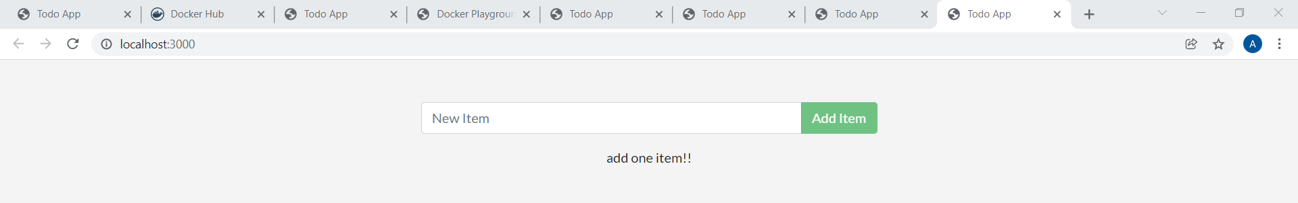Listening on port 3000

**CONTAINER NETWORKING**

**PS C:\Users\LENOVO\Downloads\getting-started-master\getting-started-master\app> docker network create todo-app**

7011c56f73e50994bdc2c04a44b2b7ab70452c413ee946a4629751cd0f71e850

**PS C:\Users\LENOVO\Downloads\getting-started-master\getting-started-master\app> docker run -d --network todo-app --network-alias mysql -v todo-mysql-data:/var/lib/mysql `**

**>> -e MYSQL_ROOT_PASSWORD=secret `**

**>> -e MYSQL_DATABASE=todos `**

**>> mysql:5.7**

Unable to find image 'mysql:5.7' locally

5.7: Pulling from library/mysql

72a69066d2fe: Already exists

93619dbc5b36: Already exists

99da31dd6142: Already exists

e5c707858ec0: Already exists

fc41578cbf60: Already exists

4785d896ef10: Already exists

7d250cdc93be: Already exists

2efe6ef3579a: Pull complete

40dc4a5ca43a: Pull complete

cd6f90222f59: Pull complete

031e631e9021: Pull complete

Digest: sha256:66480693e01295d85954bb5dbe2f41f29ebceb57d3d8098ea0c9d201473f2d8b

Status: Downloaded newer image for mysql:5.7

a85a578620eccb6b6d2aef3ea1025e8c0724d3ff283d4439335a55a69ed162f5

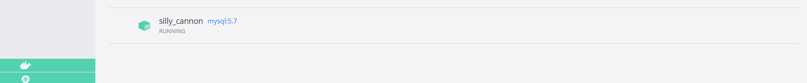

**PS C:\Users\LENOVO\Downloads\getting-started-master\getting-started-master\app> docker ps**

CONTAINER ID IMAGE COMMAND CREATED STATUS PORTS NAMES

a85a578620ec mysql:5.7 "docker-entrypoint.s…" 2 minutes ago Up 2 minutes 3306/tcp, 33060/tcp silly_cannon

PS C:\Users\LENOVO\Downloads\getting-started-master\getting-started-master\app> docker exec -it a85a578620ec mysql -u root -p

Enter password:

Welcome to the MySQL monitor. Commands end with ; or \g.

Your MySQL connection id is 2

Server version: 5.7.37 MySQL Community Server (GPL)

Copyright (c) 2000, 2022, Oracle and/or its affiliates.

Oracle is a registered trademark of Oracle Corporation and/or its

affiliates. Other names may be trademarks of their respective

owners.

Type 'help;' or '\h' for help. Type '\c' to clear the current input statement.

mysql> SHOW DATABASES;

+--------------------+

| Database |

+--------------------+

| information_schema |

| mysql |

| performance_schema |

| sys |

| todos |

+--------------------+

5 rows in set (0.24 sec)

**PS C:\Users\LENOVO\Downloads\getting-started-master\getting-started-master\app>**docker run -it --network todo-app nicolaka/netshoot

dP dP dP

88 88 88

88d888b. .d8888b. d8888P .d8888b. 88d888b. .d8888b. .d8888b. d8888P

88' `88 88ooood8 88 Y8ooooo. 88' `88 88' `88 88' `88 88

88 88 88. ... 88 88 88 88 88. .88 88. .88 88

dP dP `88888P' dP `88888P' dP dP `88888P' `88888P' dP

Welcome to Netshoot! (github.com/nicolaka/netshoot)

e32feabfe86b  ~  dig mysql

; <<>> DiG 9.16.22 <<>> mysql

;; global options: +cmd

;; Got answer:

;; ->>HEADER<<- opcode: QUERY, status: NOERROR, id: 26889

;; flags: qr rd ra; QUERY: 1, ANSWER: 1, AUTHORITY: 0, ADDITIONAL: 0

;; QUESTION SECTION:

;mysql. IN A

;; ANSWER SECTION:

mysql. 600 IN A 172.18.0.2

;; Query time: 10 msec

;; SERVER: 127.0.0.11#53(127.0.0.11)

;; WHEN: Thu Jan 20 12:07:19 UTC 2022

;; MSG SIZE rcvd: 44

e32feabfe86b  ~  exit

**PS C:\Users\LENOVO\Downloads\getting-started-master\getting-started-master\app> docker run -dp 3002:3000 -w /app -v "$(pwd):/app" `**

**>> --network todo-app `**

**>> -e MYSQL_HOST=mysql `**

**>> -e MYSQL_USER=root `**

**>> -e MYSQL_PASSWORD=secret `**

**>> -e MYSQL_BD=todos `**

**>> node:12-alpine `**

**>> sh -c "yarn install && yarn run dev"**

8f936c3951b9fbb08f99d4aebce6007f114c1d752a2c7d6a25190b43a1b551d7

**PS C:\Users\LENOVO\Downloads\getting-started-master\getting-started-master\app>** docker ps

8f936c3951b9 node:12-alpine "docker-entrypoint.s…" 2 minutes ago Up 2 minutes 0.0.0.0:3002->3000/tcp objective_taussig

14a36d7f10c6 prom/prometheus:latest "/bin/prometheus --c…" 14 minutes ago Up 14 minutes 9090/tcp my-prometheus.1.xb1ia0buwdzgu78dtbtcujpvp

01de2b3c1cd8 alpine:3.5 "ping 8.8.8.8" 15 minutes ago Up 14 minutes demo.1.i2oxipu4b42vrewxyfs13r41f

4f9b230da7d8 aiswarya99/getting-started:latest "docker-entrypoint.s…" 15 minutes ago Up 13 minutes demo_bb-app.1.jqmiis9vffw9kgl5ko00u526l

a85a578620ec mysql:5.7 "docker-entrypoint.s…" 23 minutes ago Up 23 minutes 3306/tcp, 33060/tcp silly_cannon

1e946b77c635 node:12-alpine "docker-entrypoint.s…" About an hour ago Up About an hour 0.0.0.0:3000->3000/tcp reverent_fermat

508ce52141f2 aiswarya99/getting-started "docker-entrypoint.s…" 2 hours ago Up 2 hours 0.0.0.0:3004->3000/tcp vibrant_murdock

39ad5e05a238 ubuntu "bash -c 'shuf -i 1-…" 3 hours ago Up 3 hours recursing_babbage

cbea419503da aiswarya99/getting-started "docker-entrypoint.s…" 4 hours ago Up 4 hours 0.0.0.0:3003->3000/tcp objective_goldberg

a5fb0f9aeb09 aiswarya99/getting-started "docker-entrypoint.s…" 5 hours ago Up 5 hours k8s_bb-s

**PS C:\Users\LENOVO\Downloads\getting-started-master\getting-started-master\app>**docker logs 01de2b3c1cd8

yarn install v1.22.17

[1/4] Resolving packages...

warning Resolution field "ansi-regex@5.0.1" is incompatible with requested version "ansi-regex@^2.0.0"

warning Resolution field "ansi-regex@5.0.1" is incompatible with requested version "ansi-regex@^3.0.0"

success Already up-to-date.

Done in 0.92s.

yarn run v1.22.17

$ nodemon src/index.js

[nodemon] 2.0.13

[nodemon] to restart at any time, enter `rs`

[nodemon] watching path(s): .

[nodemon] watching extensions: js,mjs,json

[nodemon] starting `node src/index.js`

Waiting for mysql:3306.

Connected!

Connected to mysql db at host mysql

Listening on port 3000

**PS C:\Users\LENOVO\Downloads\getting-started-master\getting-started-master\app>** docker exec -it 9a2863811350 mysql -p todos

Enter password:

Reading table information for completion of table and column names

You can turn off this feature to get a quicker startup with -A

Welcome to the MySQL monitor. Commands end with ; or \g.

Your MySQL connection id is 5

Server version: 5.7.36 MySQL Community Server (GPL)

Copyright (c) 2000, 2021, Oracle and/or its affiliates.

Oracle is a registered trademark of Oracle Corporation and/or its

affiliates. Other names may be trademarks of their respective

owners.

Type 'help;' or '\h' for help. Type '\c' to clear the current input statement.

mysql> select * from todo_items;

+--------------------------------------+---------+-----------+

| id | name | completed |

+--------------------------------------+---------+-----------+

| 1b047d80-e67a-4151-a4f1-4baf10a6b1a9 | java | 0 |

| c01323ef-e59f-42ab-89c9-4c5931cc9a35 | devops | 0 |

| 7321597e-ed29-48e7-89a3-0f473322b60e | python | 0 |

+--------------------------------------+---------+-----------+

3 rows in set (0.00 sec)

mysql> exit

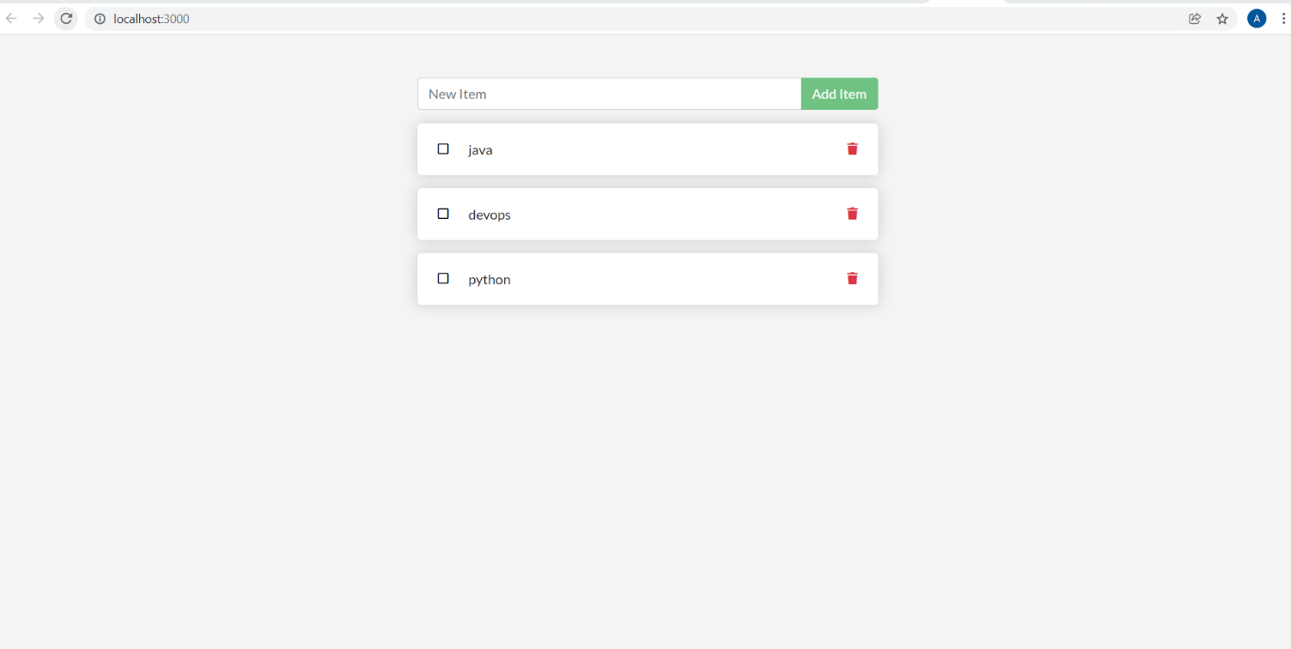

**DOCKER COMPOSE**

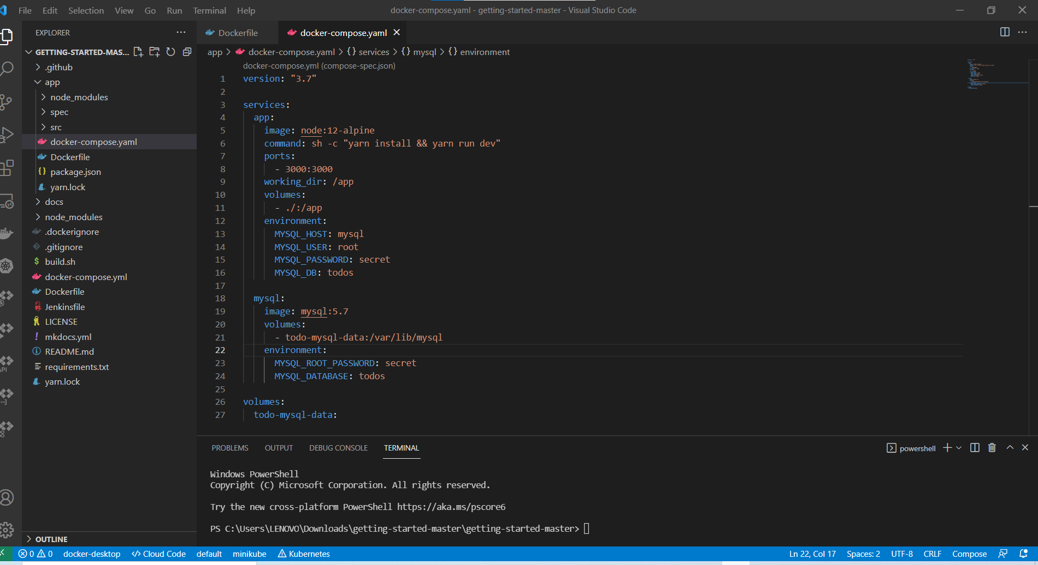

**PS C:\Users\LENOVO\Downloads\getting-started-master\getting-started-master\app>** docker-compose up -d

Creating network "app_default" with the default driver

Creating app_mysql_1 ... done

Creating app_app_1 ... done

**PS C:\Users\LENOVO\Downloads\getting-started-master\getting-started-master\app>** docker-compose logs -f

Attaching to app_mysql_1, app_app_1

app_1 | Waiting for mysql:3306.

app_1 | Connected!

app_1 | Connected to mysql db at host mysql

app_1 | Listening on port 3000

**PS C:\Users\LENOVO\Downloads\getting-started-master\getting-started-master\app>**docker-compose down

Removing app_mysql_1 ... done

Removing app_app_1 ... done

Removing network app_default

