IT-Documentation

This document provides an overview of Plumetech's internal network architecture. It is intended for IT personnel and authorized employees only. Any unauthorized access, disclosure, or distribution of this document is strictly prohibited.

Network Topology

Plumetech's corporate and operational technology (OT) networks are divided into multiple subnets to enhance security and reliability. Each subnet serves a specific purpose, isolating enterprise systems from OT environments while maintaining controlled communication between critical components.

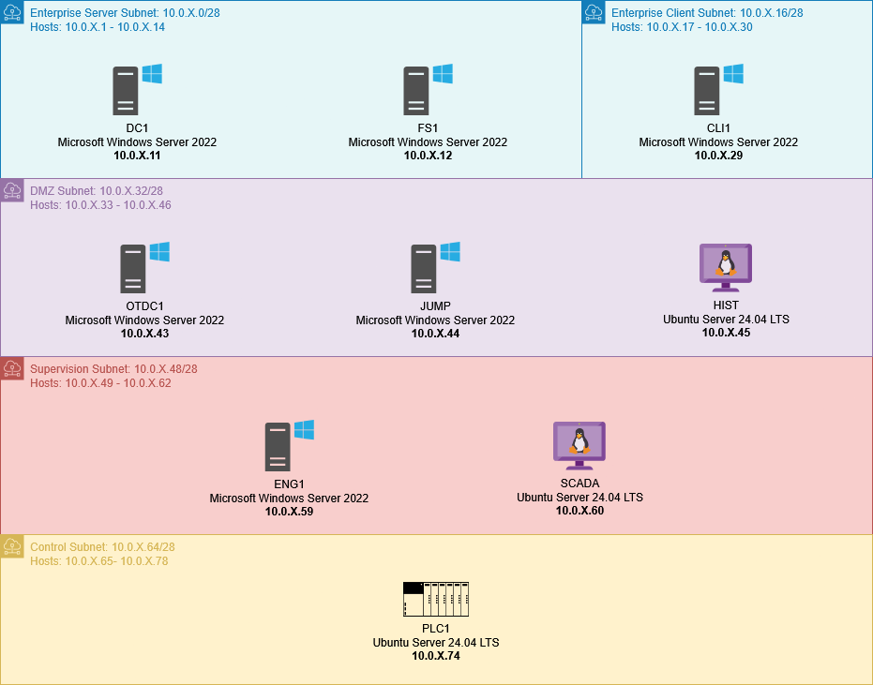

Web Services

Several internal web services are hosted within the network, accessible via internal DNS:

* SCADA-LTS Web Interface: <http://scada.plumetech-ot.local:8080/Scada-LTS>
* Grafana Dashboard: <http://hist.plumetech-ot.local:3000>
* Phoenix Contact Web Panel: <http://plc1.plumetech-ot.local>