# BIO-DATA

**Name: G.V.L.Narayana**

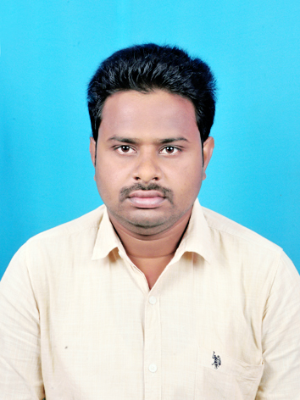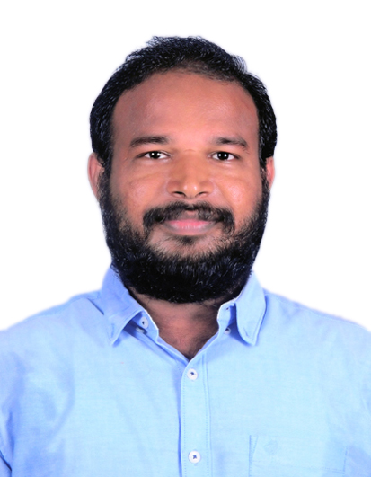

**AITAM Employee ID: A5INT00T30**

**Designation:** Assistant Professor

# Department: IT

**Date of Birth:** 18-08-1988

**Father Name:G.Ugadi Naidu**

**Mother Name:G.Annapurna**

**Reservation Category:** BC-‘D’

**Address:** D/No: 3-15, Main Street,Rayiningari Peta vill,Tamvada Post,Laveru Mandal, Srikakulam, 532403

**Mobile Number:** 9014067149

**Email id: gvlnarayana.it@adityatekkali.edu.in**

**Date of Joining in the Institution:** 23-12-2021

# Academic Excellence:

|  |  |  |  |  |
| --- | --- | --- | --- | --- |
| **Course** | **School/College** | **University/Board** | **Period** | **Percentage of Marks** |
| **(Ph.D)** | Veer Surendra Sai University of Technology | -- | -- | Pursuing |
| **M.Tech** | S.R.K.R Engineering College,Bhimavaram | Andhra University,Visakhapatanam | 2009-11 | 7.26 CGPA |
| **B.Tech** | GMR Institute of Technology,Rajam | JNTU Kakinada | 2005-09 | 58.99% |
| **XII** | Aditya Junior College,Kakinada | Board of Intermediate Education | 2003-05 | 88.1% |

**Total Years of Experience:** 10 years

|  |  |  |  |
| --- | --- | --- | --- |
| **Period** | | **Organization/Institution** | **Designation** |
| December 23rd , 2021 | Till date | AITAM, Tekkali | Asst. Professor |
| Nov 05th 2020 | Sep 30th , 2021 | Sri Vasavi Engineering College(Autonomous), Tadepalligudem. | Asst. Professor |
| Dec 05th 2019 | Nov 04th 2020 | Sasi Institute of Technology and Engineering, Tadepalligudem. | Asst. Professor |
| Aug 24th 2011 | Mar 26th 2019 | Sri Sivani Group of Colleges,Chilakapalem. | Asst. Professor |

# Areas of Interest:

* + Design and Analysis of Algorithms
  + Cryptography & Network Security
  + Computer organization
  + Computer Networks
  + Database Management System
  + Web Technologies
  + Distributed Systems
  + Data Structures and Algorithms
  + Formal Language and Automata Theory
  + Compiler Design
  + Artificial Intelligence
  + C programming Language

**Research Papers Published:**

* Published Springer International Conference on **“Emperical Analysis on Cancer Dataset with Machine Learning Algorithms” f**or **Soft Computing on Data Analytics (SCDA-2018).**
* Published International Journal of Research Trends in Engg and Tech on **“Improved Trusted Third Party Auditing in Shared Cloud Environment( IJRTET VOL I ISSUE I, AUG-SEP 2015ISSN (Online): 2371-xx78)”.**

**Workshops & Faculty Development Program:**

* One-Week Online Faculty Development Programme on “**Artificial Intelligence and Machine Learning**” organized by E&ICT Academy IIT Guwahati held from 25 to 30 October, 2021 in association with Aditya Institute of Technology and Management, Tekkali, Andhra Pradesh and support from Imarticus Learning, Mumbai.
* An AICTE Sponsored STTP On “**Practicing Cloud with AWS**” Organised by the Dept. of CSE&IT From 13-09-2021 to 18-09-2021 at KL Deemed to be University,Vijayawada.
* An AICTE Training and Learning (ATAL) Academy Online Elementary FDP on” **FOUNDATIONS OF OF CYBER SECURITY & DIGITAL FORENSICS**” from 26-07-2021 to 30-07-2021 at VR SIDDHARTHA ENGINEERING COLLEGE, Vijayawada.
* An AICTE Sponsored One Week Online Short Term Training Programme on “**Privacy and Security in IOT**” Organised by the Dept. of CSE,ANITS,Visakhapatnam from 27th July to 1st August 2020.
* A 3-Day FDP on “**Research Insight Zones in Machine Learning**” Organised by the Dept. of CSE,Sri Vasavi Engineering College,Tadepalligudem from 25th to 27th June 2020.
* A One Week FDP on “**Cyber Security**” Organised by the Dept. of CSE,JNTUK UCEV,Vijianagaram in association with UCEV CSI from 11th to 16th June 2020.
* A One Week FDP on “**Intelligent Computing in Data Science(ICDS-2020)**” Organised by the Dept. of CSE,AITAM,Tekkali on 16th to 20th June 2020.
* A One Week FDP on “**Block Chain Security and Smart Contracts**” Organised by the Dept. of CSE under AICTE MARGADHARSHAN,VR SIDDHARTHA College during 15th to 20th June 2020.
* Attended a 3-Day workshop on “**Applications of Machine Learning and Big Data (AMLBD-2K18)**” from 18th september to 20th september 2018.
* Attended a 2-Day International Conference on “**Soft Computing on Data Analytics (SCDA-2K18)**” from 10th march to 11th march 2018.
* Attended a 10-Day Faculty Development Programme on “**Data Mining(DM-2K16)**” in Association with NIT Warangal from 07th may to 16th may 2016
* A Three Day workshop on ”**Outcome Based Education OBE-2015**” December at SSCE chilakapalem.
* A Three Day workshop on “**Advances in Image Processing and Visualization Techniques AIPVT-2015**” November at SSCE chilakapalem.
* One Day workshop on “**Big Data Analytics on Cloud computing BAC-2015**” july at SSCE chilakapalem.

# Achievements:

* I got 158 rank in PGECET -2009.
* Ratified as Assistant Professor in JNTU Kakinada in the year 2013.

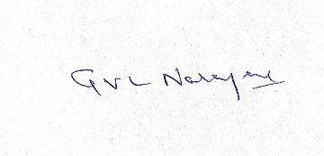

**(G.V.L.Narayana)**