Global mobile prices
Fundamentals of Statistics and Data Visualisation
Domokos fandom
Asel Aitkulova(XYB1KH), Sezim Bolotkanova (Y97VP0), Aisaule Shamil(S1W44H)
Course code: ADIN008NABB

Table of Contents
Table of Contents 1
1.1 Background of the Topic 2
1.2 Description of the Dataset 2
1.3 Codebook 2
1.4 Research Questions / Hypotheses 3
2. Analytical Process 3
3. Excel-Based Statistical Analysis 4
3.1 Analysis of the Dependent Variable 4
3.2. Outlier Detection 7
3.3 Grouping and Concentration Analysis (Lorenz Curves & Gini Indices) 8
4. Tableau Visualisations 12
4.1 Brand Distribution (Pie Chart) 12
4.2 Average Price by Brands (Bar Chart) 12
4.3 Average Price by Storage (Bar Chart) 13
4.4 Average Price by Camera MP (Bar Chart) 14
4.5 Operating System Distribution (Packed Bubble Chart) 15
4.6 Brand Rating Distribution (Heatmap) 15
4.7 Average ratings of brands (Bar Chart) 16
4.8 Price vs Display Size (Scatter Plot) 16
4.9 5G Support by Brand (Stacked Bar Chart) 17
4.6 Combined Dashboard Interpretation 17
5. Conclusions 18

1.1 Background of the Topic
Smartphones have become essential tools in everyday life, shaping how people communicate, work and access information. The market offers an enormous variety of devices that differ in price, technical features and overall performance. These differences often reflect broader social and economic trends, including technological adoption, consumer behavior, affordability, and brand positioning. Analyzing smartphone characteristics through descriptive statistics allows us to understand how factors such as display size, storage capacity, battery performance and ratings relate to price. It also provides insight into how manufacturers segment the market and how consumers respond to different price levels.

1.2 Description of the Dataset
The dataset used in this analysis originates from Kaggle and contains information on 1,000 smartphone models available globally in 2025. It is a cross-sectional dataset, meaning each device is recorded once without repeated measurements over time. The dataset combines technical specifications and market-related attributes such as price, storage, camera quality, battery capacity, operating system, 5G support and user ratings. While the original data source does not provide detailed information about collection methods, the structure strongly suggests that it was compiled from online retailers and specification databases.
The dataset meets the requirements of the assignment, as it contains more than six variables, includes several quantitative and qualitative attributes, and provides a suitable quantitative variable - price in USD - that can serve as the dependent variable for descriptive analysis and concentration measures, including the Lorenz curve and Gini index.

1.3 Codebook
Variable name | Type | Scale level | Unit / Categories
brand | qualitative | nominal | Samsung, Apple, Xiaomi, etc.
model | qualitative | nominal | Device model names
price_usd | quantitative | ratio | US dollars
storage_gb | quantitative | ratio | Gigabytes
camera_mp | quantitative | ratio | Megapixels
battery_mah | quantitative | ratio | mAh
display_size_inch | quantitative | ratio | Inches
5g_support | qualitative | nominal | Yes / No
os | qualitative | nominal | Android / iOS
rating | quantitative | interval | 0–5 scale
price_category | qualitative | ordinal | Economy / Standard / Premium
Unnamed: 10 | irrelevant | - | Removed due to missing values
Unnamed: 11 | irrelevant | - | Removed due to missing values
Unnamed: 12 | irrelevant | - | Removed due to missing values

1.4 Research Questions / Hypotheses
Based on the variables included in the dataset, the following research questions were formulated:
- How is the global distribution of smartphone prices shaped, and what do descriptive statistics reveal about the typical price levels of phones in 2025?
- Do price levels differ meaningfully across the categories “Economy”, “Standard” and “Premium”, and how concentrated is price within each category according to the Lorenz curve and Gini index?
- How do key technical characteristics - such as display size, storage capacity and user rating - relate to the price of a device?
- How do brands differ in their average price, rating and 5G support, and what patterns emerge when comparing these attributes visually?
These questions guide the descriptive statistical analysis performed in Excel and the visual exploration carried out in Tableau.

2. Analytical Process
The analysis followed a structured workflow that combined data preparation, statistical exploration in Excel and visual examination in Tableau. The first step was identifying a suitable dependent variable that met the assignment requirements. Price in USD (price_usd) was chosen because it is continuous, strongly skewed, and central to understanding differences between smartphone models. Price is also meaningfully influenced by technical characteristics such as display size, storage, battery capacity and user rating, making it an appropriate variable for further exploration and visualization.
Before beginning the analysis, the dataset was cleaned by removing three empty columns (Unnamed: 10, Unnamed: 11, Unnamed: 12). All remaining variables were checked for missing values and consistency. Since each row represents a unique smartphone model, the dataset required no further structural adjustments.
To enable concentration analysis and comparison across price levels, the continuous variable price_usd was divided into three meaningful categories: Economy, Standard, and Premium. These categories formed the basis of the grouping variable used in the Lorenz curve and Gini index calculations.
The descriptive statistical analysis was carried out in Excel. Care was taken to ensure that no more than 10% of the observations were deleted, preserving the representativeness of the dataset.
For the concentration analysis, Lorenz curves were created for each price category using deciles of the dependent variable. Gini indices were calculated to quantify the degree of inequality within each group. This approach made it possible to compare how price values are distributed among Economy, Standard, and Premium devices.
Tableau was used to expand the analysis visually. Several visualizations were created to examine how selected variables influence price and how different smartphone characteristics relate to one another. A dashboard was assembled to present these charts together, along with an interactive filter that allows users to explore patterns with or without 5G support.
Overall, the analytical process was designed to follow a logical progression: from understanding the dataset, to performing statistical analysis, to visually interpreting the relationships between variables. Each step supported the aim of answering the research questions and providing a clear understanding of price dynamics in the 2025 smartphone market.

3. Excel-Based Statistical Analysis

3.1 Analysis of the Dependent Variable
To begin, a frequency table was created to examine how prices are distributed across the dataset. The table summarizes the number of phones falling into each price interval and provides a first indication of how the market is shaped across different price levels (Figure 3.1).
As shown on the table, frequencies are relatively evenly distributed with slightly rising in the higher bins. The computed value sums reflect the uneven distribution of shares among smartphone models: half of the mobiles have around 30% of the total price, and overall, the value sum is concentrated in higher price brackets, even though frequencies are quite evenly spread.
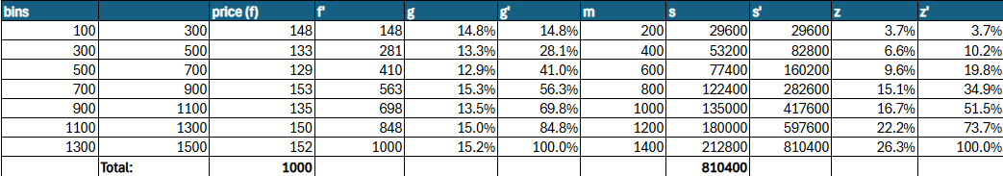Figure 3.1.
The resulting histogram (Figure 3.2) shows multiple peaks, with the highest frequencies observed in bins 1 (100–300 USD), 4 (700–900 USD), 6 (1,100–1,300 USD), and 7 (1,300–1,500 USD), while bins 2, 3, and 5 have noticeably lower frequencies. This pattern indicates that the price distribution is multimodal, reflecting several distinct price concentrations rather than a single dominant price range. It is clear that there is no single dominant segment such as Premium or Economy smartphones, but rather an uneven distribution between different price ranges.

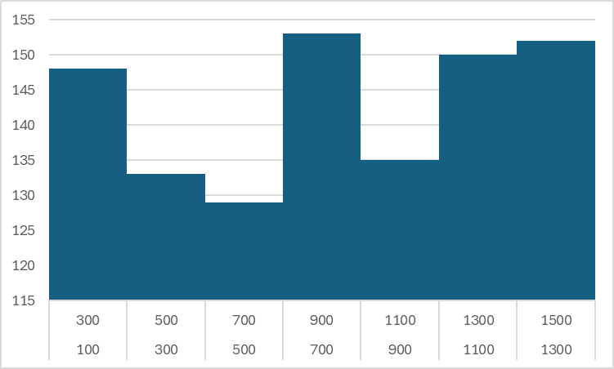
Figure 3.2.
We created a Lorenz Curve for the prices distribution (Figure 3.3). From the diagram itself, it is clearly visible that the price values are unevenly distributed among the bins. The lower 40% of smartphones account for only 20% of price shares, while the upper 10% have almost 20% of the total value.
The calculated Gini index (28.52%), however, indicates that the concentration is rather slight than moderate, as Gini index always lies between 0 and 1 (or 0%-100%) and 0-30% concentration is considered slight.
We also compared the Herfindahl index, which reflects the extent of the concentration based on the cumulative sales value (z’), to its minimal value – as a result, we proved again that the concentration is moderate. In other words, there is some concentration of the price value in certain groups, but it is not extreme.
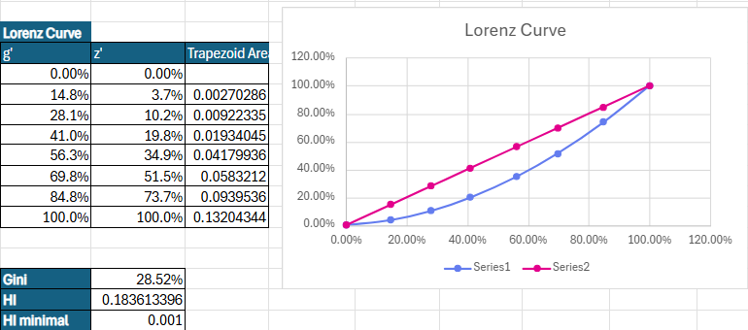
Figure 3.3.
To provide a more detailed summary of the distribution, descriptive statistical measures were calculated and presented in a single table (Figure 3.4). These include the mean, median, mode, minimum and maximum values, quartiles, deciles, variance, standard deviation, skewness and kurtosis.
- Our dataset is bimodal having the most frequent price values of 342 USD and 627 USD, however in the continuous dataset as ours, the mode is of limited interpretative value and these values should be understood as reflecting clustering around common price points rather than true modal prices.
- The median (822 USD) is slightly greater than mean (814 USD), but the difference is negligible, and thus we cannot really say if the shape of the distribution is left-skewed; it is rather just unequal.
- The range of the set is 1398 USD (minimal value is 101 USD; maximal value is 1499 USD). In terms of quartiles, we calculated D1, D9, Q1, and Q3. Tukey Fences are going to be described in section 3.2
- Interquartile range of the middle 50% is 719 USD, so we can say that half of the models sold in 2025 are priced lower than 719 USD. Additionally, the 90th percentile is around 1148 USD, meaning that 80% of phones were sold at or below this price.
- The calculated standard deviation, which was 411.5 USD, tells us that on average the price differs from the mean – here we can see that prices vary significantly from mean. V (relative standard deviation) measures spread relative to the mean. V in our case was 0.5 (50%), indicating the prices are fairly spread in the set, and not wrapped around the mean. This large spread shows that smartphone prices in 2025 are quite different, ranging from cheap to high-end models, likely because the market has separate groups of devices for different types of customers.
- As for the skewness, we used a couple of measures to determine the skewness of the set. Pearson's skewness was negative, pointing out the long left tail in the price distribution. However, as Alpha 3 is more precise than P - because it measures the skewness using the whole shape of distribution, not just mean/median - we proceed with the results of that measure. A3 appeared to be negative (-0.06), proving the same result as Pearson’s, but is it extremely small, in other words it is negligible (just like the median and mean difference).
- On the other hand, a3 is outlier sensitive. Although there are no outliers in the dependent variable, we will interpret the robust measure F0.1 (F0.25) to determine the skewness (or its absence). F0.1’s (-0.03) and F0.25’s (-0.04) negative nature point to the left skewness of the shape distribution, but the values of measures are very low, or in other words close to 0, which would indicate the symmetric distribution. Here, we can conclude that the skewness measures altogether indicate that we have no skewness, no long tail on either side of the distribution.
- Negative Alpha 4 (general measure of Kurtosis) indicates that the prices are evenly/flatty distributed compared to normal distribution with no extreme outliers.

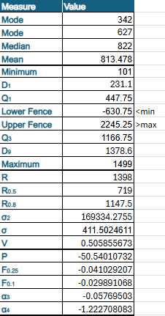
Figure 3.4.

3.2. Outlier Detection
After detecting the quartiles, we proceeded with the outliers calculation. For this, we used Tukey’s formula. Both the lower and the upper fences turned out to exceed the set range (minimum and maximum), indicating that there are no outliers in our dataset.
To fully prove that point, we created a Box-Plot of the variable (figure 3.5). It shows that 50% of the phone prices lie between around 250 USD and 1150 USD with a median line of about 800 USD. The absence of outliers is also clearly visible on the box-plot.
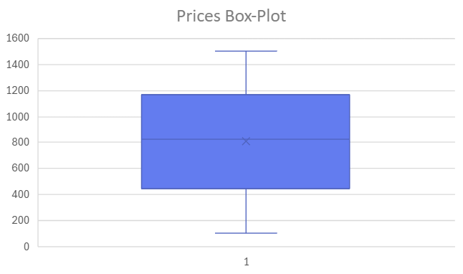
Figure 3.5.
Visual box-plot inspection was also performed for the remaining quantitative variables (storage capacity, camera resolution, battery capacity, display size and user rating), no invalid outliers were identified. All of our quantitative variables are ratios except for rating which is interval (as it carries the rank of popularity and the difference between them is meaningful). Among them, only ‘dizplay_size_inch” is continuous and the rest of them are discrete. In other words, each of those variables have a range of standard values.
For example, in “camera_mp” the range of picture width is (12, 48, 50, 64, 108 and 200). On the box-plot created for this variable, there is one outlier – 200. This is because 200 in fact differs significantly comparing to other values, however we cannot exclude it, as this is a standard size of the picture width, many of the mobile phones in the dataset have this parameter.
“camera_mp” was the only one with an outliers, but we concluded that we cannot eliminate that outlier, as it is necessary for the analysis. As for the rest, everything was good.
Altogether, calculated measures imply the fact that our dataset is consistent, without extreme models, and slightly biased toward higher-priced devices with a less preferable selection of cheaper alternatives.

3.3 Grouping and Concentration Analysis (Lorenz Curves & Gini Indices)
This section focuses on the distribution of price value within the dataset and examines how concentration differs across the market. Figure 3.6 presents the total price value accumulated within each group, indicating that higher-priced devices account for the largest share of total amount of price value in the dataset.
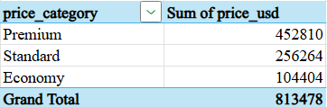
Figure 3.6.
For each of the three categories, deciles were calculated to prepare the data for the construction of Lorenz curves. These decile tables show how the cumulative share of devices compares to the cumulative share of total price value within each group. The full decile calculations for the Economy, Standard and Premium categories are shown in Figures 3.7, 3.8, and 3.9 respectively.

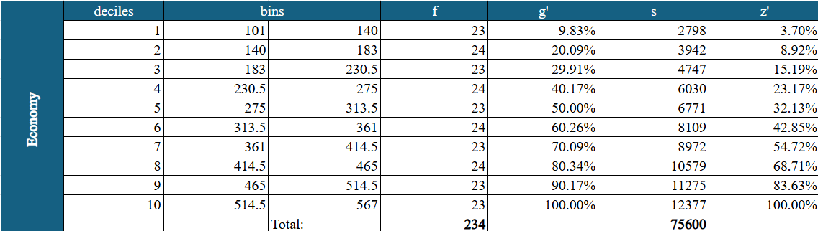Figure 3.7.

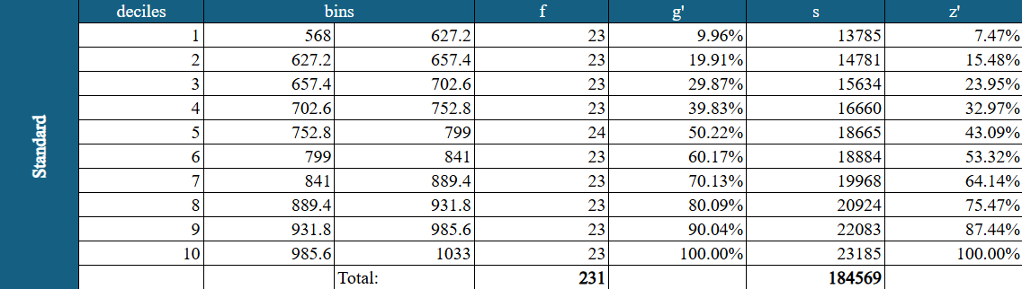Figure 3.8.

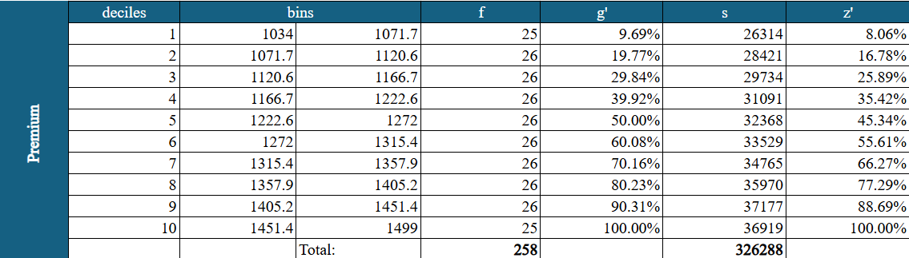Figure 3.9.
Using these values, individual Lorenz curves were created for each segment. The curves compare the cumulative proportion of devices (horizontal axis) with the cumulative proportion of total price value (vertical axis). The Economy category (Figure 3.10) has the strongest deviation from the equality line out of the three price categories, depicting higher concentration of values. In this group, half of the smartphones receive 32% of the total share, and 90% receive 84% of the total share.
The Gini-Index is 41,69% - the shares among cheap smartphones are moderately unequal as the total area between the concentration curve and the equality line is quite large.
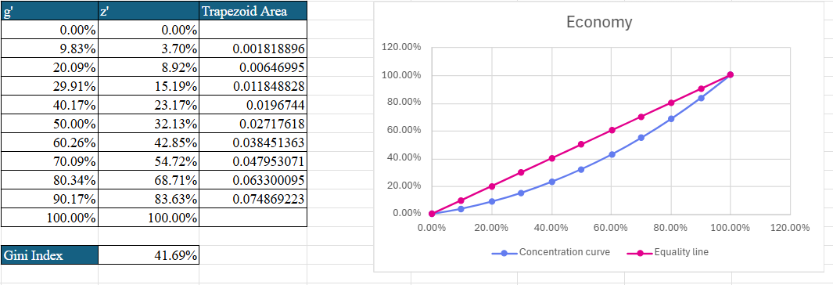Figure 3.10.
The Medium group (Figure 3.11) shows a noticeably flatter Lorenz curve. This is because the cumulative share of total price value increases relatively proportionally with the cumulative share of devices, as shown in the Lorenz table: within this group, 50% of devices account for 43.09% of total price value, and 90% account for 87.44%. As a result, price value is spread more evenly across devices, leading to a lower level of concentration than in the Economy category.
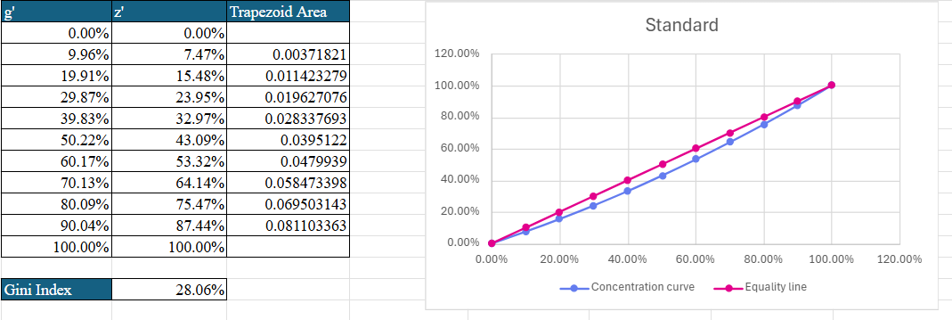Figure 3.11.

The Premium group (Figure 3.12) displays the flattest Lorenz curve of the three categories. Although high-priced phones are generally associated with greater dispersion in the overall dataset, within the Premium category itself, prices are distributed relatively evenly. This is because the cumulative share of total price value closely follows the cumulative share of devices within this group. According to the Lorenz table, 50% of devices account for 45.34% of total price value, and 90% account for 88.69%, showing that price value is distributed relatively proportionally across devices. As a result, no small subset of models dominates the total price value, which explains the low Gini index of 24.45% and the near-equality shape of the curve.
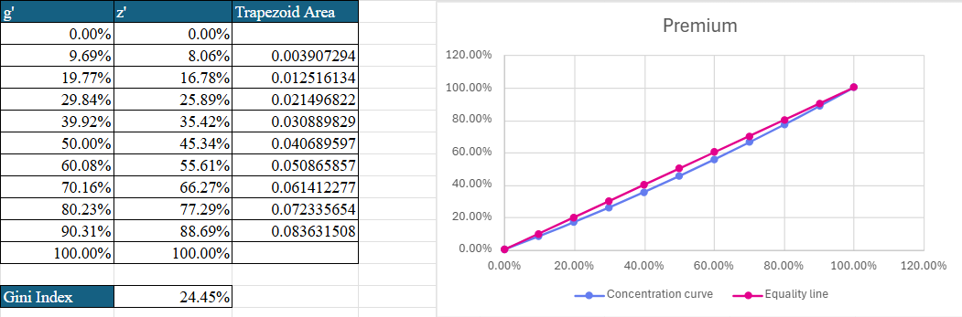Figure 3.12.

Gini indices, calculated from the trapezoidal areas under each Lorenz curve, provide a numerical summary of price inequality within each category. The Economy group exhibits the highest level of concentration (Gini = 41.69%), followed by the Standard group (Gini = 28.06%) and the Premium group (Gini = 24.45%). These values quantify the differences already visible in the shapes of the Lorenz curves, indicating that price inequality is greatest in the Economy category and lowest in the Premium category.
To support comparison across groups, a unified Lorenz diagram was created (Figure 3.13). This combined chart presents the three curves on the same axes. The Economy curve lies furthest from the equality line, followed by the Standard curve, while the Premium curve is closest to the line, demonstrating the lowest concentration.
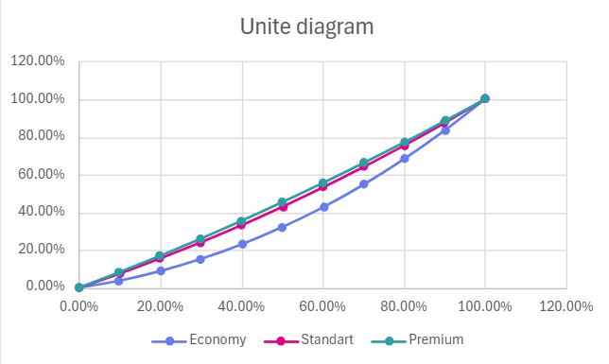
Figure 3.13
Overall, the concentration analysis shows that price inequality is highest among low-cost devices and progressively decreases as prices rise. This pattern suggests that Economy models vary widely in price within the lower range, while high-priced devices are relatively similar in value within the premium segment.

4. Tableau Visualisations
This section presents the visual results of the analysis, highlighting key patterns in pricing and smartphone characteristics across brands.

4.1 Brand Distribution (Pie Chart)
The pie chart illustrates the distribution of smartphone brands within the dataset. Each brand accounts for approximately 10–12% of the observations, indicating a deliberately balanced sample composition. This distribution reflects the construction of the dataset rather than real-world market shares and therefore chart does not provide information about brand dominance in reality. It confirms that no single brand dominates the sample, allowing for descriptive within-sample comparisons across brands, with all conclusions strictly limited to the dataset itself.
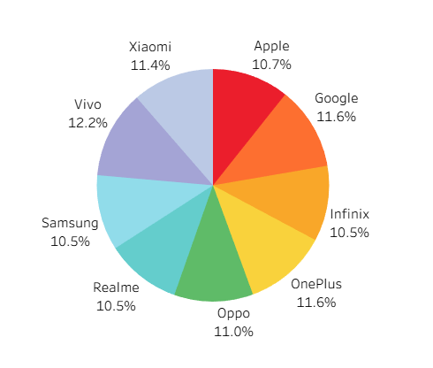
Figure 4.1: Brand Distribution

4.2 Average Price by Brands (Bar Chart)
The bar chart compares the average smartphone price across brands, revealing a narrow price range between $771 and $839. Such compression is consistent with a dataset in which extreme low-end and ultra-premium devices are underrepresented. This restriction reduces variability and limits the influence of brands with broad product portfolios on aggregate price measures, thereby facilitating clearer within-sample comparisons. The chart highlights pattern: Infinix is the most expensive brand in the dataset. While Samsung and Realme have the lowest average prices.
While the visual might initially appear counterintuitive, the pattern is explained by the composition of the dataset. Infinix has shifted toward premium models in 2024–2025 and dataset includes primarily these newer, higher-spec devices, with almost no ultra-budget Infinix models represented. As a result, the brand appears with highest average price.
In contrast, Samsung’s representation includes a large number of mid-range devices. This selective inclusion is consistent with the dataset’s narrow price range and suggests a curated sample rather than a reflection of Samsung’s full market positioning. Including Samsung’s higher-end devices would likely increase overall price dispersion and could make Samsung an outlier in terms of average price, which further supports interpreting the observed pattern as a consequence of sample composition rather than real-world pricing differences.
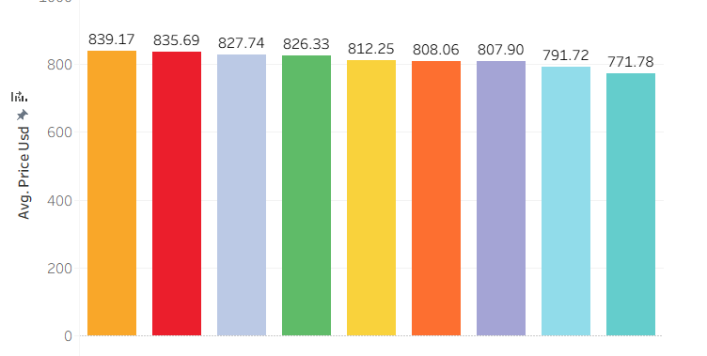
Figure 4.2: Average Price by Brands

4.3 Average Price by Storage (Bar Chart)
The relationship between storage capacity and price is positive but not perfectly linear. 64 GB models have the lowest average price at 783.86 USD, reflecting their role as entry-level storage options. The largest increase in average price occurs at 128 GB (838.97 USD), reflecting a shift toward higher-specification devices within the dataset where it is new minimum viable storage for most consumers in 2025.
Above 128 GB, progression becomes irregular. The 256 GB and 512 GB categories do not show further price increases, suggesting that higher storage alone does not guarantee a higher price. This pattern is consistent with the idea of law of diminishing returns, meaning that beyond a certain level, additional storage capacity contributes progressively less to the overall value of the device, as reflected in average prices within the dataset.
Pricing peaks around 128 GB and 256 GB, as these storage options are the most widely adopted across brands and satisfy the needs of most users. Storage capacities beyond this level are typically relevant only for a narrow group of users(such as influencers) meaning that it does not add much value for the majority of devices. Still the differences between group averages are small and occur within a generally narrow price range, suggesting that they are driven mainly by the composition of models within each storage category rather than statistically significant pricing differences.
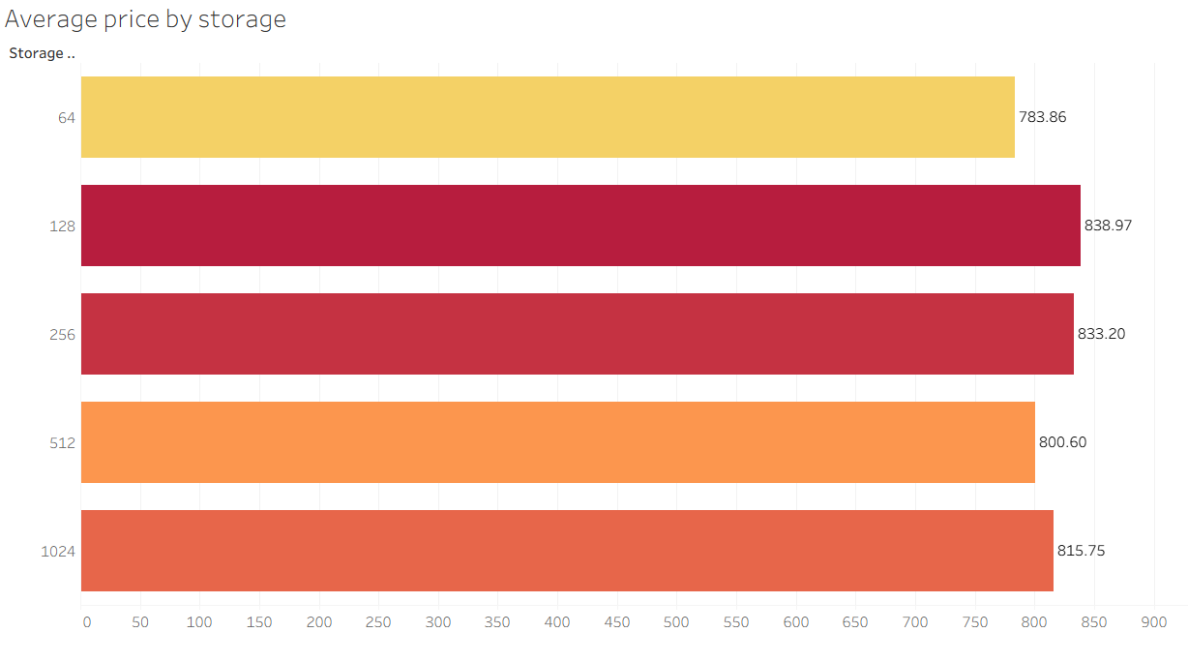
Figure 4.3: Average Price by Storage

4.4 Average Price by Camera MP (Bar Chart)
The co-movement between camera megapixels and average smartphone price is weak and non-linear. Differences between average prices across megapixel categories are small and non-monotonic, partly because smartphone prices in the dataset fall within a relatively narrow range, which compresses group averages. The lowest average appears in the 48 MP category, reflecting the prevalence of mid-range devices, while the relatively high average in the 12 MP group can be explained by premium brands, such as Apple, using lower megapixel sensors. Although higher averages occur in the 64 MP and 200 MP categories, these megapixel values also appear in mid-range models, indicating that camera resolution alone does not systematically explain price differences.
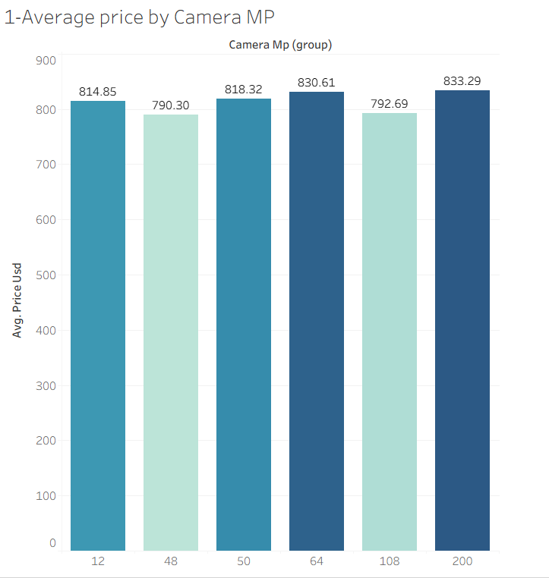
Figure 4.4: Average Price by Camera MP

4.5 Operating System Distribution (Packed Bubble Chart)
The visualization compares the presence of IOS and Android devices in the dataset. iOS is represented solely by Apple, while all other brands operate on Android. As a result, Android dominates the distribution, reflecting its significantly broader ecosystem and wider range of manufacturers.Visualisation made for fulfilling the requirement to analyze relationships between nominal variables.
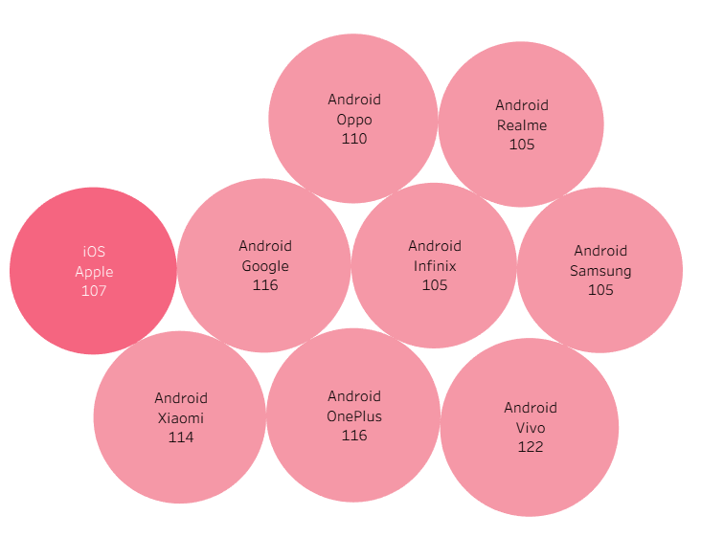
Figure 4.5: Operating System Distribution (IOS vs Android)

4.6 Brand Rating Distribution (Heatmap)
The heatmap shows the distribution of user ratings across smartphone brands. Ratings are concentrated between 3 and 4 stars, with no observations below 3. This truncated distribution is consistent with the dataset’s restricted price and quality range, which limits the presence of extreme dissatisfaction.
Four-star ratings dominate across all brands, accounting for approximately 55–68% of reviews, while three-star ratings represent around 25–40%. Five-star ratings remain rare (1–8%), indicating limited dispersion at the upper end of the scale. Differences between brands are small and inconsistent, reflecting low overall variability rather than meaningful differences in perceived quality. As a result, the visualization supports descriptive within-sample comparison only.
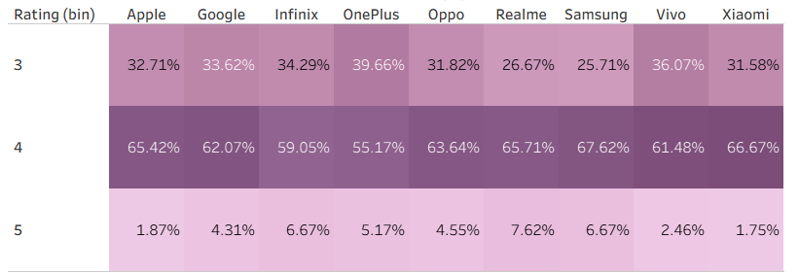
Figure 4.6: Brand Rating Distribution (Heatmap)

4.7 Average ratings of brands (Bar Chart)
The bar chart shows consistently high average ratings across all brands, ranging narrowly between 4.18 and 4.31. The differences between brand averages are very small, indicating that no strong conclusions about relative brand quality can be drawn from this visualization alone.
Realme and Samsung exhibit slightly higher average ratings, which raises the trendline, however, this difference is minimal and should not be interpreted as evidence of superior performance. All remaining brands cluster closely around the overall average, suggesting that perceived quality is relatively uniform within the dataset.
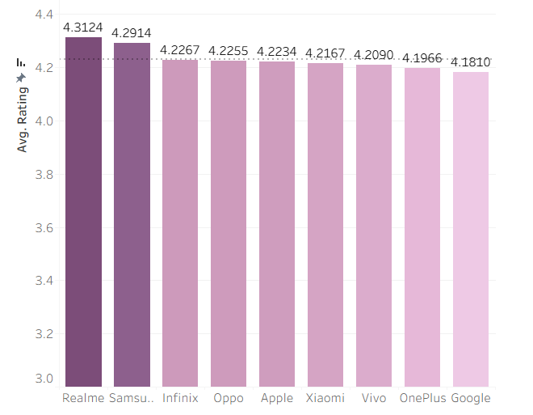
Figure 4.7: Average ratings of brands (Bar Chart)

4.8 Price vs Display Size (Scatter Plot)
The scatter plot shows the relationship between price (USD) and display size (inches) with the qualitative variable brand used to color the data points. The data points are spread across the entire price range and display size spectrum (roughly between 4 and 7 inches). There is no discernible upward or downward trend, meaning that display size does not appear to have a strong correlation with price in this dataset.
Upon closer inspection, the points are highly mixed, with phones of both small and large displays appearing at all price levels (low, medium and high). The color differentiation by brand indicates that different brands are distributed across various price points and display sizes, further reinforcing that there isn't a clear connection between price and display size. This lack of a clear pattern is consistent with the limited price variation and the heterogeneous composition of devices in the dataset.

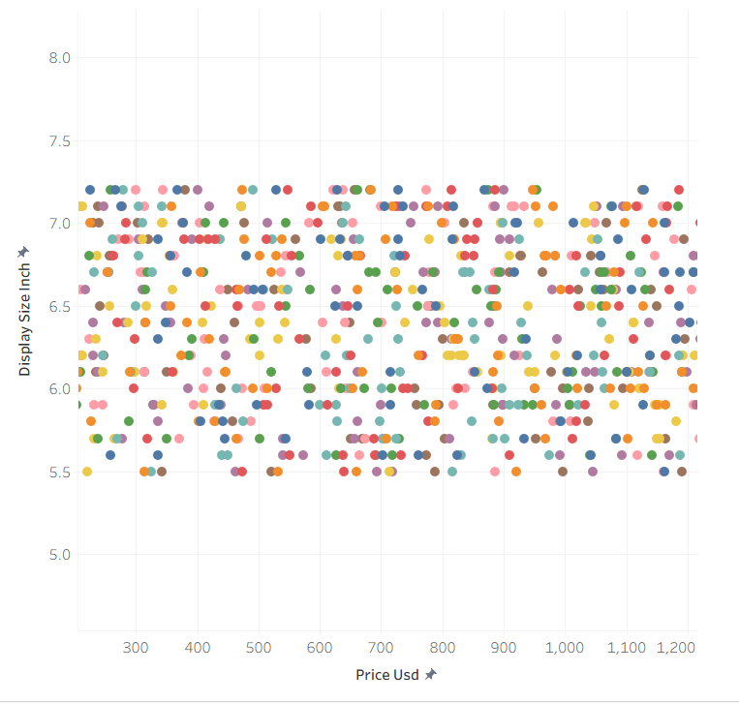
Figure 4.8: Price vs Display Size Scatter Plot

4.9 5G Support by Brand (Stacked Bar Chart)
The stacked bar chart illustrates the proportion of 5G-enabled and non-5G devices within each brand.
Each bar is divided into:
Green = 5G supported Red = 5G not supported
The numbers vary by brand, but all brands have a mix of both 5G and non-5G devices. Some brands such as Infinix and Vivo appear to have a slightly higher number of 5G models compared to others.This pattern is consistent with earlier pricing results, where these brands were represented by relatively higher-specification models within the dataset, which are more likely to include 5G support. The observed differences, however, remain moderate and should be interpreted as a result of sample composition rather than brand-level technological leadership.
While alternative groupings (for example by region or market segment) could provide more insight into 5G adoption, such variables are not available in the dataset. Consequently, brand-level comparison represents the most meaningful analysis possible given the data.
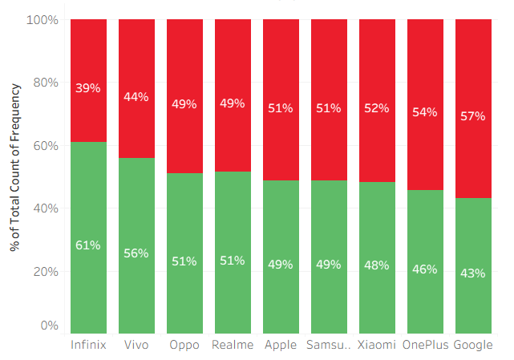
Figure 4.9: 5G Support Across Brands

4.6 Combined Dashboard
One filter. Total control. Real insight.
This dashboard is designed around simplicity, with analytical power beneath the surface.
Filtering turns complexity into clarity.
Instead of scanning dozens of data points or jumping between charts, the view adapts to you. With a single selection, the entire dashboard realigns to reflect your perspective:
- Select one brand → see its true pricing power, customer ratings, feature adoption, and product positioning in isolation
- Select multiple brands → benchmark competitors in real time
- Select all brands → understand the overall market structure without bias
You decide the question, the dashboard gives the answer.
That’s what transforms this from a reporting dashboard into an interactive analysis experience. Insights stay aligned, comparisons stay fair, and conclusions are easy to trust and easy to explain.
One interface. Seamless exploration.
Freedom to slice the market intelligently and surface insights that traditional dashboards quietly hide.
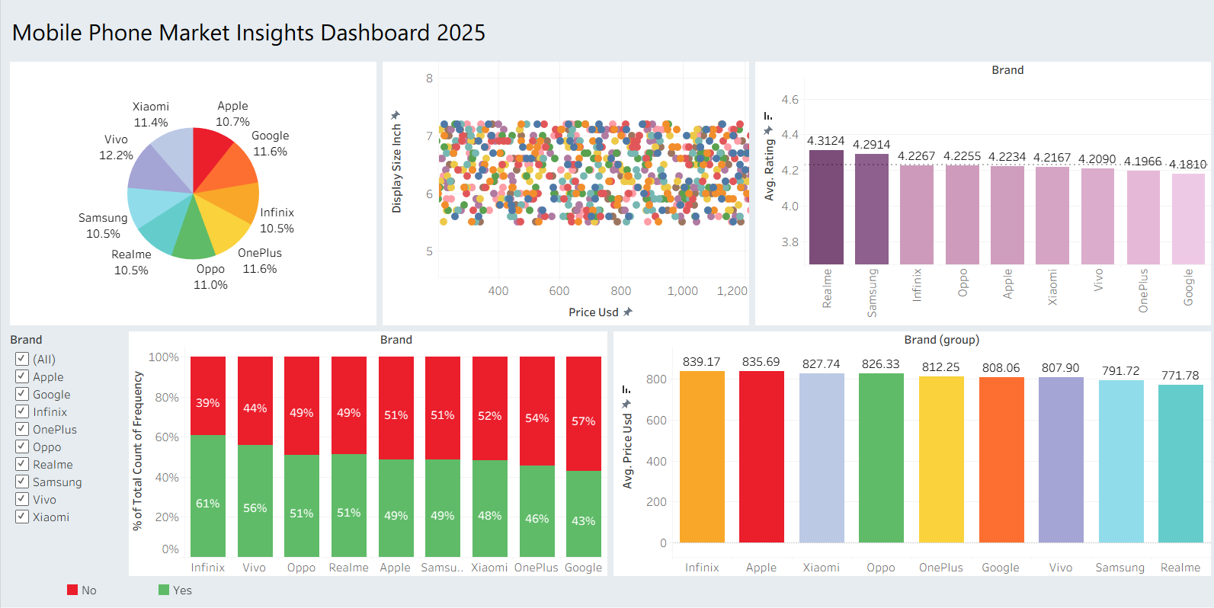
Figure 4.10: Combined Dashboard

5. Conclusions
This study addressed the research questions by examining price distribution, price concentration across segments, and the role of technical and brand-related characteristics in the 2025 global smartphone market. In response to the first research question, descriptive statistics show that smartphone prices are unevenly distributed, with most devices concentrated in the lower and middle price ranges and a smaller number of high-priced models extending the upper tail, indicating substantial but structured price variability.
Regarding the second research question, the concentration analysis demonstrates clear differences across the Economy, Standard and Premium segments. Price inequality is highest in the Economy segment and decreases progressively in the Standard and Premium segments, as shown by the Lorenz curves and Gini indices, indicating increasing price homogeneity at higher market tiers.
Addressing the third research question, visual analysis shows that individual technical characteristics such as display size, storage capacity and user ratings exhibit weak associations with price.
Finally, in relation to the fourth research question, brands differ only moderately in average price, ratings and 5G support, with no single brand dominating across all dimensions. Overall, the findings describe a mature and competitive market in which pricing is shaped primarily by segment positioning rather than by any single technical feature.

